
Sultan Qaboos University
Department of Computer Science
COMP4206: Mobile Applications Development
(Spring 2026)

Triplexa
Project Part 1

Amna Albalushi - 136368
Ghaida Alkindi - 140845

Table of contents

Table of contents 2
Project Overview 3
Motivation 3
Project Objectives 3
Target Audience and Stakeholders 3
Target Audience 3
Stakeholders 4
Similar Mobile Application/Website 5
Triplt from going.com website 5
Structure and Main Features 5
Limitations 5
Comparison 5
Application Features and Functionalities 6
Feature 1: Hierarchical Trip Planning Structure 6
Feature 2: Place Details with Google Maps Link, Cost & Notes 6
Feature 3: Trip Status Tracking (Active, Planning, History) 7
Feature 4: Secure User Accounts and Trip Sharing 7
Application Screen Design 7
Application Pages 7
Visual Design For Each Page Using Figma 9
Database Design and Data Management 10
Types of data managed by triplexa: 10
Database schema 11
Data Exchange 12
Security measures 12
Mobile Application Logo Design 12
Logo 12
Color Palette 13
Typography 13
Shapes 14
Dart Application Description 14
Flutter Application Description 15
Team Contribution 15

Project Overview
Triplexa is a travel planning mobile application, which helps users plan and view previous trips. The application helps users organize a trip by adding the cities, and each city will have a number of days, each day lists specific places where users can attach a Google Maps navigation link for seamless directions and write personal notes such as weather expectations. All this data for each trip can be shared between multiple users.

Motivation
Omani travelers tend to visit many countries for several days to spend a vacation. Yet, they tend to rely on saved notes, a bunch of google map pointed places and others’ recommendations, which causes an unorganized plan that may confuse the traveler.
Triplexa is a more intelligent and well organized approach to plan a trip, or several trips, that shows a precise plan for each day allowing the traveler to fully enjoy the trip without any worries.

Project Objectives
- Provide a structured, hierarchical planning system
Triplexa aims to organize the framework by structuring the trip from the country level down to cities, days, and individual places within the city.
- Centralize all trip-related information in one platform
The application consolidates the trip details, Google Maps navigation links and personal notes. Users should be able to plan, navigate and reference the entire trip.
- Support personal preparation through providing notes
Triplexa helps the users to prepare meaningfully for each destination, by allowing them to add personal notes such as weather conditions, dress codes and remainders, Moreover specifying the estimated cost for that place.
- Enable secure user accounts and trip sharing
Triplexa allows users to create their personal account to securely save and access their application data across multiple devices. Users may also exchange the planned trip between them.

Target Audience and Stakeholders

Target Audience

User group | Description
Travelers | Users who plan their trips using the app by creating trips, adding cities, organizing daily places to visit, attaching Google Maps links, and writing personal notes
Group Travelers / Trip Collaborators | Friends, family members, or travel partners who are invited to a shared trip and can view or contribute to the trip plan by adding places and notes.
Travel Enthusiasts / Bloggers | Users who enjoy documenting their trips and keeping detailed records of places visited, notes, and travel experiences.

Stakeholders
Stakeholder Interview 1
Background:
A traveler who frequently plans trips and wants a more organized way to manage travel plans.
Q1: How do you currently plan your trips?
A: I usually save locations in Google Maps and write notes on my phone, but everything ends up scattered across different apps.
Q2: What problems do you face while planning trips?
A: My plans are not organized in one place, so it’s hard to see the full itinerary for the trip.
Q3: What features would you like in a travel planning app?
A: I would like to organize trips by cities and days, add places to visit, attach Google Maps links, and write personal notes.
Q4: Would sharing the trip plan with others be useful?
A: Yes, it would be very helpful when traveling with friends or family so everyone can see the plan
Stakeholder Interview 2
Background:
A person who usually travels with friends or family and contributes to planning group trips.
Q1: Do you usually participate in planning trips?
A: Yes, when traveling with friends we all suggest places to visit
Q2: What difficulties do you experience when planning trips with others?
A: It’s hard to keep track of everyone’s suggestions because they are shared through messages or different apps.
Q3: What features would help you collaborate better?
A: Being able to add places and notes to a shared trip plan would make planning much easier.
Q4: What else would you like to see in the app?
A: A clear daily itinerary so everyone knows what places we will visit each day.

Similar Mobile Application/Website

Triplt from going.com website
https://www.going.com/guides/tripit-review

Structure and Main Features
The application is widely used in IOS and android mobiles for travel planning. It works by sharing booking confirmation emails to the application. The application by itself will generate a plan from the scanned content, the trip revolves around the flights, hotels, car rentals and restaurant bookings. And it can be integrated with Google Calendar, users in this application can share their trip with their companions.

Limitations
The application depends on email confirmations, meaning users do not manually create the plan, and the app does not support hierarchy structure from the country to the city to each day. And users cannot specify personal things such as comments or notes, and estimated cost of the place. Moreover, features are not fully accessed unless paid for. Lastly this application is targeted for business travelers mostly.

Comparison
Triplexa was designed to address the gaps in Triplt's, with more features such as the Google Map link attachment, users can add a place details for each day in each city, where in Triplt’s its hard to specify the trip details.
From the design Triplexa is more exciting in colors and adventures and it follows an interesting structure that is visually appealing, while triplt’s interface prioritizes information displaying more than visual comfort.
Table comparisons for some features:

Feature | Triplt | Triplexa
Structure | By booking type | Hierarchical from the country to the city to the dat to the place
Planning | By email confirmations | Manually by users
Day by day journey | partial | Fully distributed in days
Design style | Functional, formal | Userfriendly, warm, modern
Targeted users | Business travelers | Multi-city travelers
Google Map links by place | No | Yes
Personalized notes | No | Yes
Estimating place cost | No | Yes
Google calender | Yes | No
Trip sharing | Yes | Yes

Application Features and Functionalities

Feature 1: Hierarchical Trip Planning Structure
What it does: Triplexa organizes travel plans in a structured hierarchy from the Trip (country level) Cities > Days > Individual Places. Users create a trip, add cities with a set number of days, and then populate each day with specific places to visit.
Alignment with Objectives: This fulfills Objective 1 (structured, hierarchical planning system), as the app breaks down the entire journey into manageable levels rather than a flat list of notes.
Stakeholder Need: Both stakeholders expressed frustration with scattered, unorganized plans across multiple apps. This feature gives them a single, clear structure. As Stakeholder 1 said, they wanted to "organize trips by cities and days" this feature delivers exactly that.

Feature 2: Place Details with Google Maps Link, Cost & Notes
What it does: Each place added to a day includes its name, category (Landmark, Restaurant, Activity, Hotel, Transport, Shopping), estimated cost, an optional Google Maps link for navigation, and a personal notes field for reminders like weather or dress code.
Alignment with Objectives: This fulfills Objective 2 (centralize all trip-related information) and Objective 3 (support personal preparation through notes), as all relevant information for each stop is stored in one card rather than spread across multiple apps.
Stakeholder Need: Stakeholder 1 specifically asked for Google Maps links and personal notes per place. This was also a key differentiator from TripIt, which offers neither personalized notes nor per-place cost estimation.

Feature 3: Trip Status Tracking (Active, Planning, History)
What it does: The Home Page automatically categorizes each trip into one of three statuses, Active (current date falls within trip dates), Planning (upcoming trips), and History (past trips). A summary bar at the top shows total trips, cities, and places at a glance.
Alignment with Objectives: This fulfills Objective 3(centralize all trip-related information in one platform), giving users a live dashboard of all their travel plans past, present, and future without manual sorting.
Stakeholder Need: Stakeholder 2 needed a clear overview so "everyone knows what places we will visit each day." The status system ensures travelers always know at a glance which trip is currently active and which is still being planned.

Feature 4: Secure User Accounts and Trip Sharing
What it does: Users register and log in with email and encrypted passwords. Each trip is tied to a specific user account, accessible across devices. Users can share an entire trip with friends or family, allowing collaborators to view and contribute places and notes to the same shared itinerary.
Alignment with Objectives: This directly fulfills Objective 4(enable secure user accounts and trip sharing), ensuring data is both protected and accessible to authorized collaborators in real time.
Stakeholder Need: Both stakeholders highlighted the need for collaboration. Stakeholder 1 said sharing "would be very helpful when traveling with friends or family." Stakeholder 2 struggled with tracking suggestions shared through messages, trip sharing solves this by keeping everything in one synchronized plan.

Application Screen Design

Application Pages
Triplexa has 6 pages which are:

The Login and Sign Up pages
These 2 pages serve as the entry of the app for the first time only. The Sign Up page will create a new user with the given credentials, where the Login page will authorize the user’s credentials to load their data on the application, with an option for forgotten password. Both pages have the logo displayed with a slogan “Plan Every Step”. And a toggle tabs to switch between the pages.

This page contributes to the application’s functionality by fulfilling the 4th objective, enabling secure user accounts, to save the user’s data and access them across devices. All the data from the trips, cities to the individual places are connected to a specific user.

HomePage (User’s Trips)
This page opens directly after the login/sign up or if the user is already logged in. It displays a greeting for the user and a summary statistics of how many trips the user has, how many cities and places in total, there’s also a user’s icon to navigate back to the Login or Sign Up pages. This page will include a list of the trips contributed in 3 sections: Active trips are the trips that is currently active (current date is within that trip date), Planning trips are the upcoming and unready trips, and the History trips will include the old trips with expired dates.then we’re gonna have a floating button for adding a new trip. At the button we’ll have the navigation bar that will take me to the first listed trip or the first listed city.

This page allows the users to see all of their plans listed in one place, fulfilling objective 2 that we centralized the trips-related information, such as the starting and ending dates, number of cities and days. When the list is too large the status bar will help us identify where the trip belongs.

Trip (the Cities)
On the navigation bar we’ll have the country or trip name, with the date and again a summary statistics, along with a button for sharing the whole trip with another user. This page will list the cities, each city with a specific number of days, and a calculated number of places by the backend logic using the upcoming pages data. At the end of the list we’re gonna allow the user to easily add a new place specifying the number of days. The bottom navigation bar will be added too.

This page supports objective 1 and 4, by having a hierarchical structure planning from the trip, to cities and days, and by having a button for sharing the whole trip to other users.

DayPlanner
This page will start with the city name and some statistics, it will have the days on the top of the content and each day with its different planned places. The day and the date of each day will be added and the places are listed below, each place will display its number of the stop (e.g. 1, 2, 3..) with the place’s name and an estimated cost of that place, then we’re gonna have the type (Landmark, Restaurant, Activity ,Hotel, Transport, Or Shopping), there could be a note or a comment added for the place by the user, and eventually a Google Maps link to access the directions, or crowds checks faster and easier. At the bottom of each day we’re gonna have a button for adding a new place, the user can also hold and drag the places to change their precedence.
This page is the heart of triplexa that supports the first 3 objectives, it shows the hierarchical structure, shows the detailed plan with Google map links, notes, estimated cost for each place and users can specify more planning details from this page.

AddPlace
This page will mention at the top bar the city, the day, and the stop count, it will provide for the user 5 entries, first an input field for the place’s name, then 6 options for the place’s type, whether it’s a landmark, a restaurant, an activity, a hotel, a transport related, or a shopping place, then we’re going to have a cost input field that will take float numbers. Then a field for pasting the Google Map link, and it can be optional (if available), last field is for adding extra comments or notes from the user, then 2 buttons for whether saving the place and adding it to the database or canceling and returning to the city without any new modifications.
The page supports objectives 2 and 3, by allowing the user add all relevant information to the place, including its location, notes, and cost, the user can also access this page as editing by clicking the place in the dayPlanned page.

Visual Design For Each Page Using Figma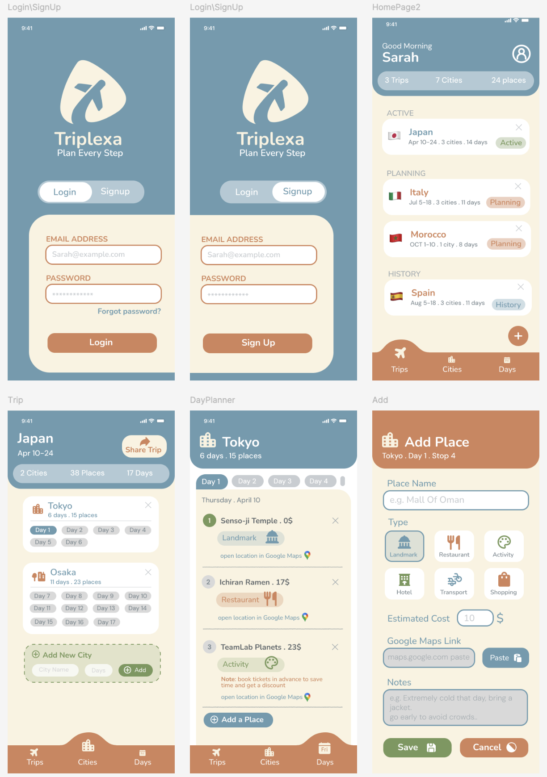



Database Design and Data Management

Types of data managed by triplexa:
- User Data
This includes user information such as name, email, and login credentials. This data is used to identify users, allow them to log in, and associate trips with the correct account
- Trip Data
Trip data contains information about each trip created by the user, such as the trip name, destination country, start and end dates, trip status (planning or active), and the overall budget.
- City Data
Each trip can contain multiple cities. City data stores the city name and the number of days the user plans to stay in that city.
- Place Data
Each city contains places to visit for each day. This includes the place name, category (landmark, restaurant, activity), visit date, cost, Google Maps link, and personal notes.

Database schema
Users table
Schema: user ID (primary key), name, email, password
Sample data :

User ID | Name | Email | Password
u1 | Amna | amna12@gmail.com | hashed_pw
u2 | Ghaida | ghaida01@gmail.com | hashed_pw

Trips table
Schema : trip ID (primary key), user ID(foreign key), trip_name, country, start_date, end_date,
status.
Sample data:

trip ID | user ID | trip_name | country | start_date | end_date | status
t1 | u1 | Summer 25 | austria | July 12 | August 3 | Active
t2 | u2 | Japan 26 | japan | October 25 | November 10 | Planning

City table
Schema: city ID (primary key), trip ID (foreign key), city_name, days_count
Sample data:

City ID | Trip ID | city_name | days_count
c1 | t1 | Vienna | 4
c2 | t2 | Tokyo | 5

Place table
Schema: place ID (primary key), city ID (foreign key), place_name, day_number, category, cost,
maps_link, notes
Sample data:

Place ID | City ID | place_name | day_number | category | cost | maps_link | notes
p1 | c1 | Schönbrunn Palace | 2 | Castle | 16 OMR | Schönbrunn Palace | -
p2 | c2 | Meiji Jingu | 3 | Landmark | Free | Meiji Jingu | -

Data Exchange
Triplexa allows users to share trips with friends or family members. When a trip is shared, multiple users can access the same trip and contribute to planning.
For example, one user may add cities while another user adds places to visit or personal notes. All changes are stored in the central database and synchronized across users so that everyone sees the updated trip plan.
This collaboration allows travelers to organize trips together in real time and ensures that everyone has access to the same itinerary.

Security measures
- Password Encryption
User passwords are stored as encrypted hashes instead of plain text to protect login information.
- User Authentication
Only registered users can log into the system and access their trips.
- Secure Data transmission
All communication between the mobile app and the server uses secure protocols such as HTTPS to prevent data interception.
- Input validation
User input is validated before being stored in the database to prevent security issues such as SQL injection.

Mobile Application Logo Design

Logo

The logo features a round triangular shield shape, centered with a bold airplane, symbolizing easy traveling and movement.The choice of steel blue color reflects the sky, calmness and well-organized.

Color Palette

Color |  | Role
#6A9BAF | Steel Blue | Logo, Navigation, map links and headers
#C8CDD1 | Light Gray | Dividors, secondary elements, inactive tabs and icons
#FAF3E0 | Cream | Page backgrounds, cards
#D4845A | Warm Terracotta | Bottom bar, buttons, headers, input field border, active highlights
#76985B | Sage Green | Active trip badge, add new city, save button

Triplexa application uses 4 colors to maintain a clean mobile interface. Steel blue is the primary brand color, reflecting an open sky with a sense of calm and organization, it is used across headers, map links, logo, and active states. Light gray is used for dividers, and secondary elements to avoid hard contrasts. The Cream color provides a comfortable background making it easy for the eyes to follow up. And the Warm Terracotta is the accent color in this application to reflect the excitement of exploration and traveling.

Typography

Triplexa’s mobile interface will use 2 fonts, Nunito bold font, that is with rounded corners to match the logo perfectly. And it will be used for the application name, screen titles and a semibold with the city and places names. The second font is DM Sans regular font, that is readable and pairs naturally with Nunito font, it will be used for descriptions, notes and dates, and a semibold font for the buttons.

Shapes
Triplexa follows a no sharp corners rule, to stay visually consistent that will create friendliness. The roundness also aligns with the modern UX principles, since it's easier and more comfortable to tap.

shape |  | Role
 | Rounded rectangles | Buttons, input fields and listing cards for trips and cities
 | Rounded pills | Pill tags, such as the days
 | Flat with rounded top rectangles | Top and bottom navigation bar
 | Circles | Floating add buttons, and user avatar

Dart Application Description
Triplexa Console Application is a terminal-based system that manages the core travel planning data defined in Part A. It handles three entities that match the database tables: Trips, Cities, and Places.
Users can interact with the system through a menu to add, display, and delete records. Each record is automatically assigned a unique ID upon creation. Relationships between tables are enforced, a City requires a valid Trip ID, and a Place requires a valid City ID , matching the foreign key structure defined in the database schema.
The Place entity captures all fields from the schema including place name, day number, category, estimated cost, Google Maps link, and personal notes. The Trip entity stores the destination, country, dates, and status. The City entity records the city name, its parent trip, and the number of planned days.
All data is stored dynamically in memory and all user input is validated, ensuring the application reflects the same data integrity rules defined in Triplexa's database design.

Flutter Application Description
Triplexa’s UI is built entirely using flutter widgets system providing Scaffold, Appbar, ListView, Row, Column and Container to structure all the pages, we have used design components to cover the intuitive design part such as: Elevated button, floating action button, text field and circle avatar, with detailed fixes using the shape, borders, text styles to achieve a better design, warm and easy to follow. Flutter also allowed us to switch between the pages and configure animations for the buttons and the scrolling effects.

Team Contribution

Team member | Project parts
Ghaida Alkindi (140845) | - Cover page  - Project overview and Objectives  - Comparative Analysis of a similar website  - Application screen design  - Logo design, color palette and fonts  - Flutter part implementation, UI, and description
Amna Albalushi (136368) | - Target audience and stakeholder  - Application Features and Functionalities  - Database Design  - Data Management and Security measures  - Dart Console Based Application and its description

