

Digital Design ENCS2340

**VERILOG PROJECT**

20 / 6 / 2024

**__________________________________________________________**

**Project Report**

Student Name: Ghaith Haj-Ali No.: 1220612

**__________________________________________________________**

* This pdf contains the Project Verilog Description, Simulation Screenshots and Quartus Diagram.

Contents

**1.** **Quad_Mux2x1** 3

A) Verilog Description: 3

B) Simulation Screenshot: 3

**2.** **BCD_7Segment_Driver** 4

A) Verilog Description: 4

B) Simulation Screenshot: 4

**3.** **Decoder2x4** 5

A) Verilog Description: 5

B) Simulation Screenshot: 5

**Quartus Diagram** 6

1. **Quad_Mux2x1**
2. Verilog Description:

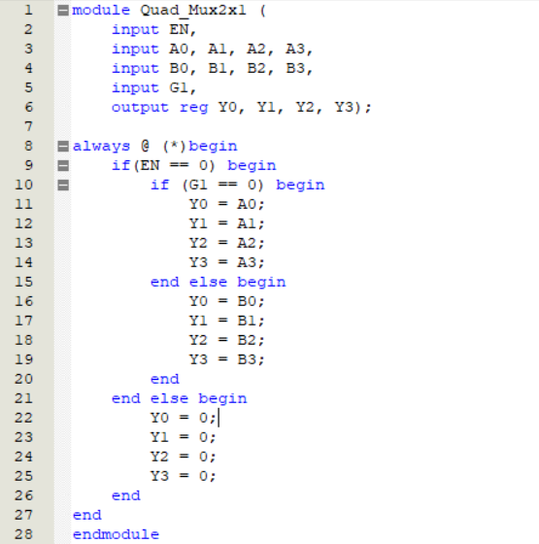

1. Simulation Screenshot:

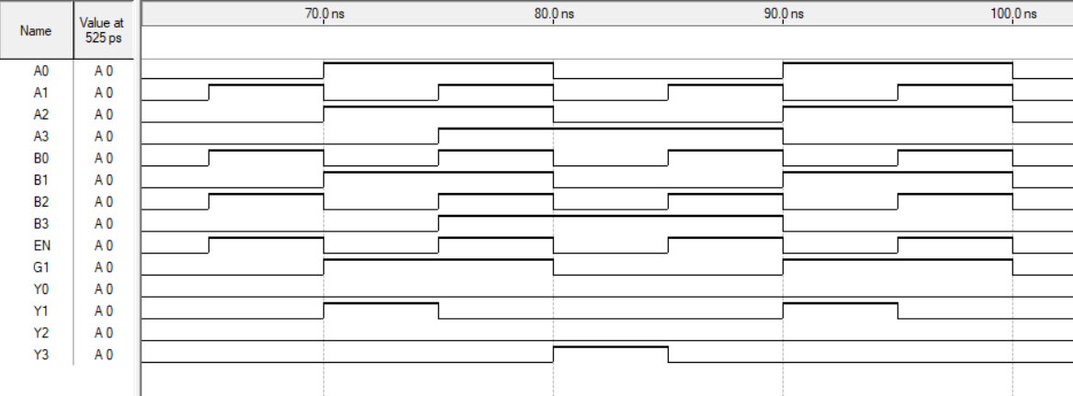

1. **BCD_7Segment_Driver**
2. Verilog Description:

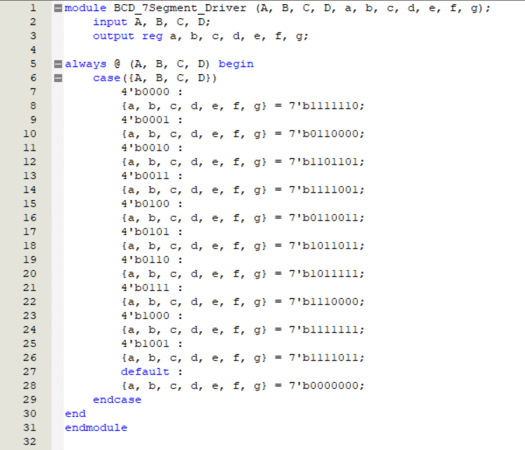

1. Simulation Screenshot:

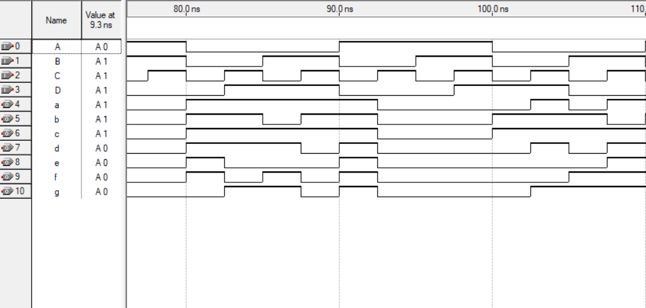

1. **Decoder2x4**
2. Verilog Description:

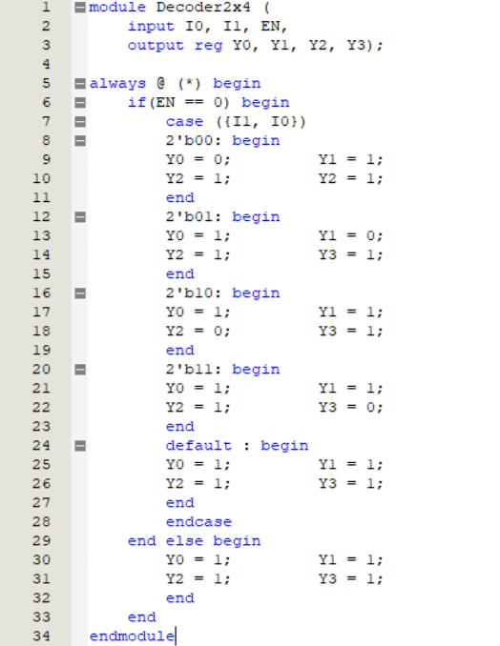

1. Simulation Screenshot:

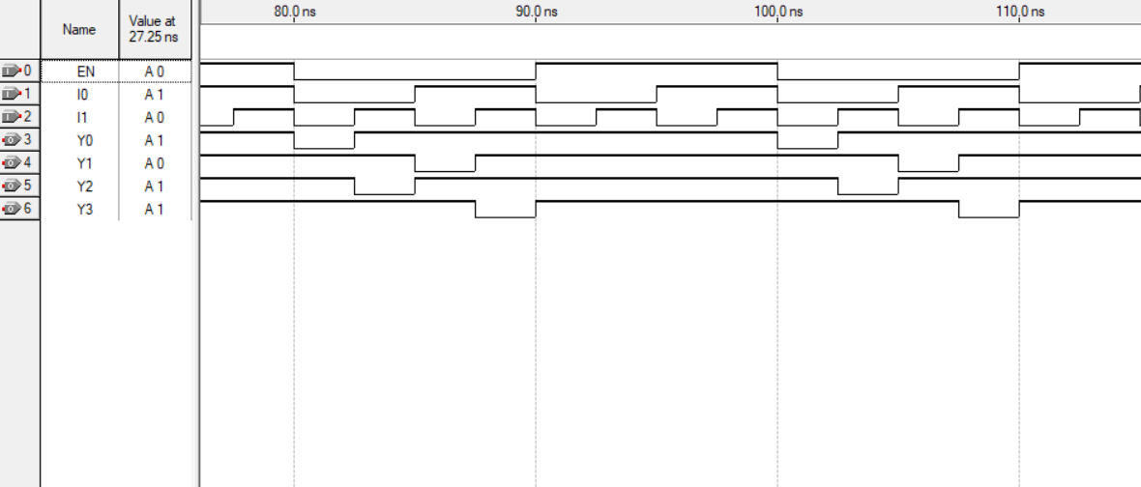

**Quartus Diagram**

