Project Title

Web-Based Attendance Management System

Presented to you by:

Youssef Mahmoud Ghallab – 23100615
Khaled Mohamed Yehia - 231001055

1. Introduction
-This project is a web-based Attendance Management System designed to help faculty members efficiently manage courses and record student attendance. The system automates attendance tracking using a PHP and MySQL backend with AJAX-based communication.

2. System Description
-The system allows faculty members to authenticate, manage courses, and record attendance records. It ensures secure login, session handling, and persistent storage using a relational database.

3. System Requirements
- Web Server: Apache (via XAMPP recommended)
- PHP: Version 7.0 or higher
- MySQL: Version 5.7 or higher
- Browser: Modern browser with JavaScript enabled

4. Test Cases
  - -Faculty authentication: Secure login system for faculty members
  - 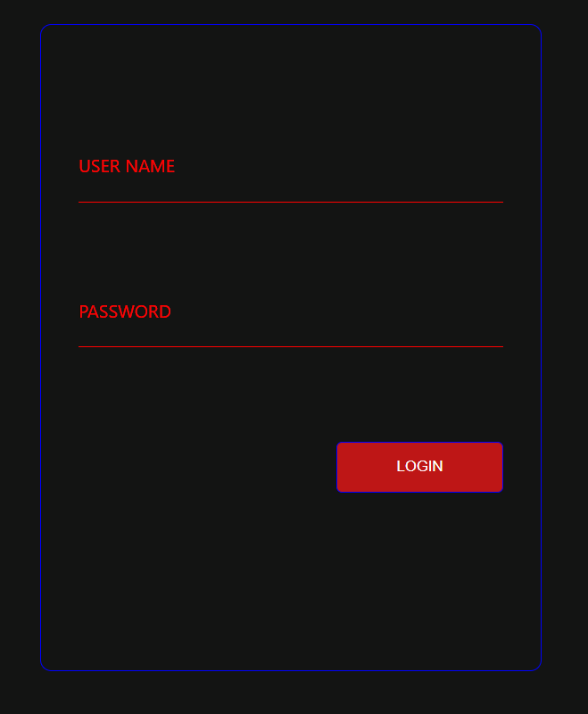

-Session management: Support for multiple academic sessions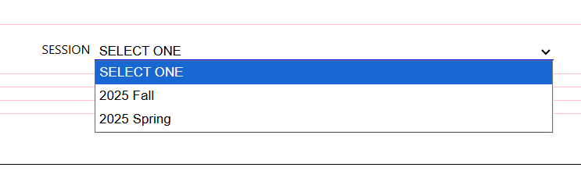
-Course management: View and manage courses assigned to faculty
-Student attendance: Mark attendance for students in real time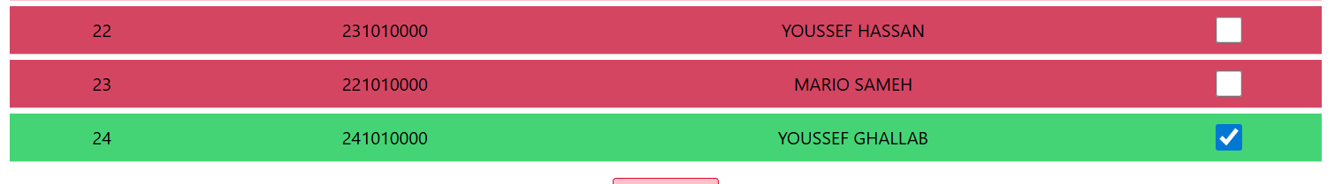
-CSV Export: Export attendance reports in CSV format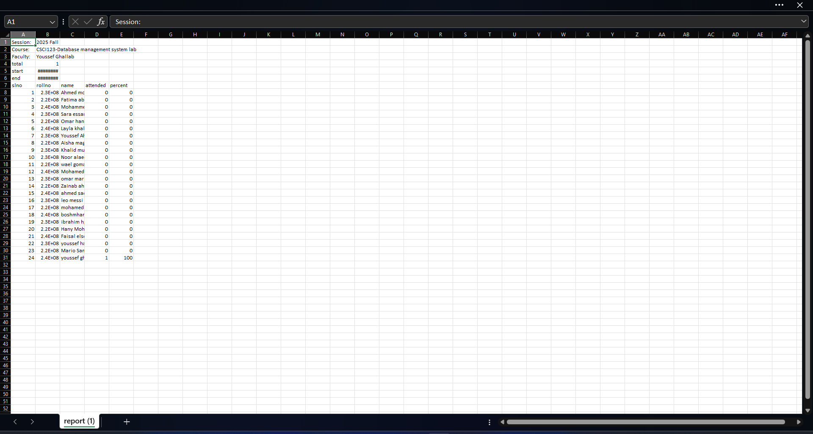

5. Actors
- Faculty: Logs in, manages courses, records and views attendance.

6. Functional Requirements
- Faculty login and logout
- View assigned courses
- Register new courses
- Record student attendance
- View attendance records

7. Diagrams
  - Use-Case Diagram:
-The Use Case Diagram illustrates the interaction between the faculty and the system. The faculty can log in, manage courses, record attendance, and log out.
Visual presentation:
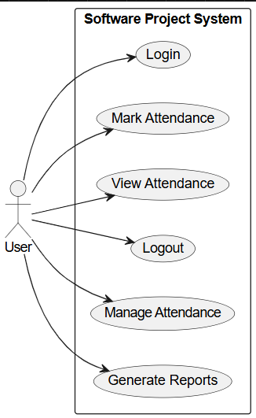
  - Class Diagram:
-The Class Diagram represents the system’s static structure, including Faculty, Course, Attendance, and Session classes and their relationships.
Visual presentation: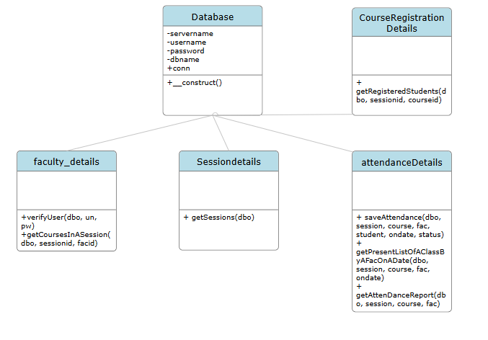
  - Sequence Diagram:
-Sequence diagrams demonstrate the system behavior for key scenarios such as faculty login and attendance recording using AJAX communication.
Visual presentation[Login sequence]: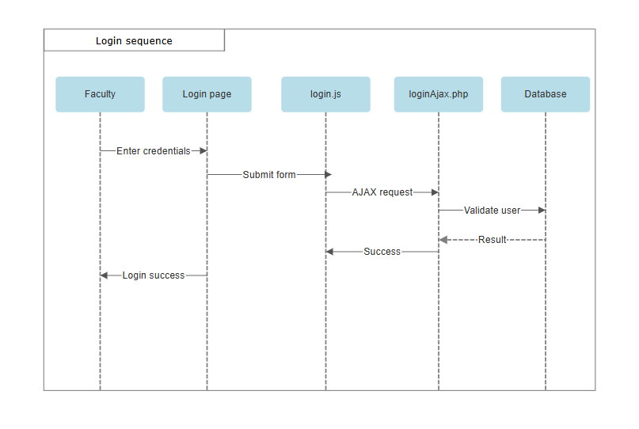
Visual presentation[Attendance sequence]:
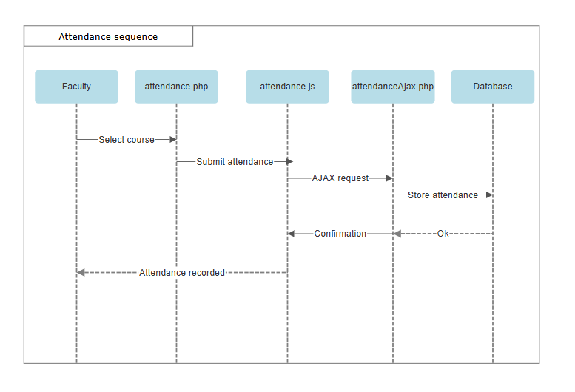
  - Entity Relationship Diagram (ERD):
-The ERD shows database entities and relationships between faculty, courses, and attendance records using primary and foreign keys.
Visual presentation: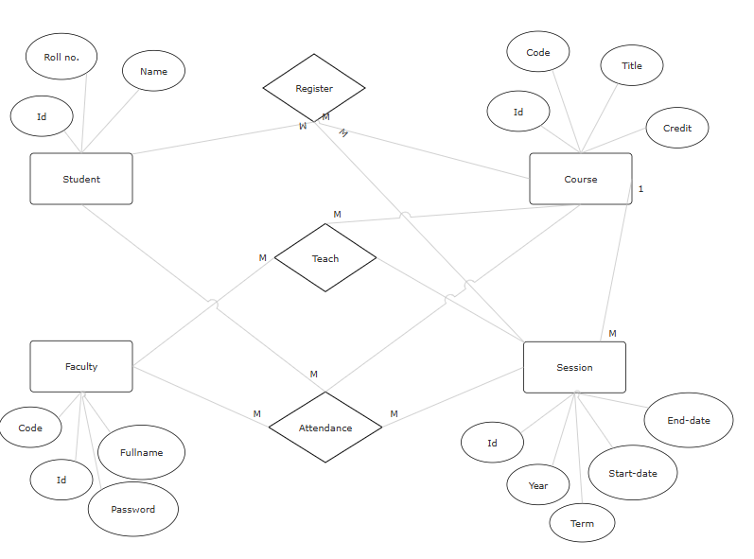

8. Technologies Used
-Frontend: HTML, CSS, JavaScript
-Backend: PHP
-Database: MySQL
-AJAX: jQuery
-Version Control: GitHub

9. Conclusion
-The Attendance Management System provides a reliable and scalable solution for academic attendance tracking and demonstrates effective use of web technologies and UML modeling techniques.

