Brief n°7: Cabinet Medical

# Front-End:

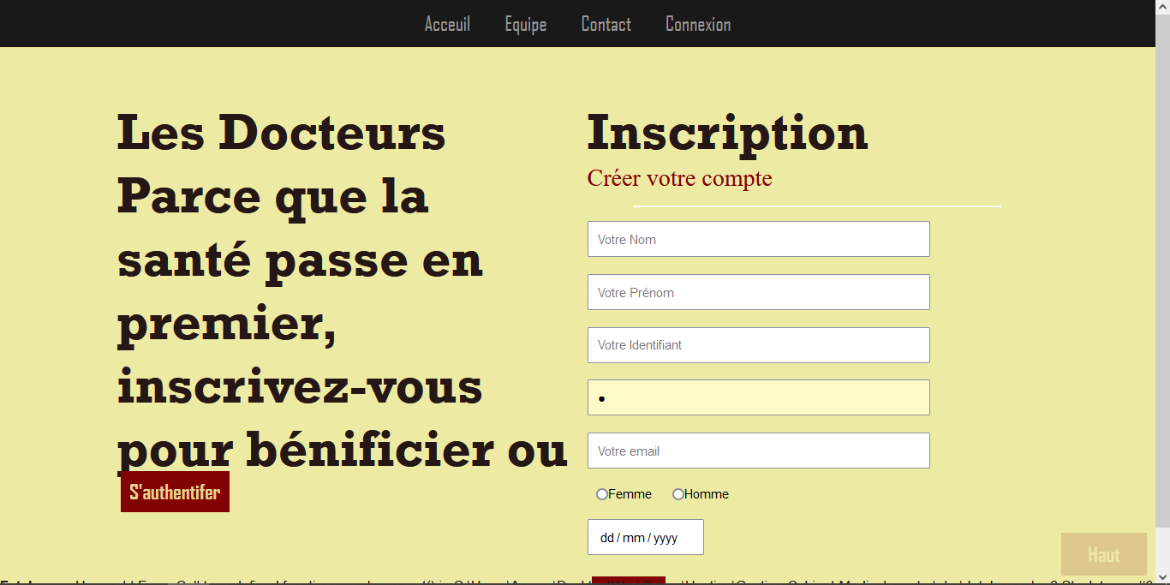

# Back-End: