

User Guide
Dashboard
Your Real-Time Command Center for Property Operations
لوحة التحكم

Version 1.0 | March 2026
Mimaric PropTech Co. | mimaric.com

Table of Contents

1. Module Overview

The Dashboard is your operational command center — the first screen you see after logging in. It aggregates real-time key performance indicators (KPIs) from across all modules into a single, at-a-glance view of your entire property portfolio.
The Dashboard is designed for Company Admins, Project Managers, Property Managers, and Finance Officers who need portfolio-wide visibility without navigating into individual modules.

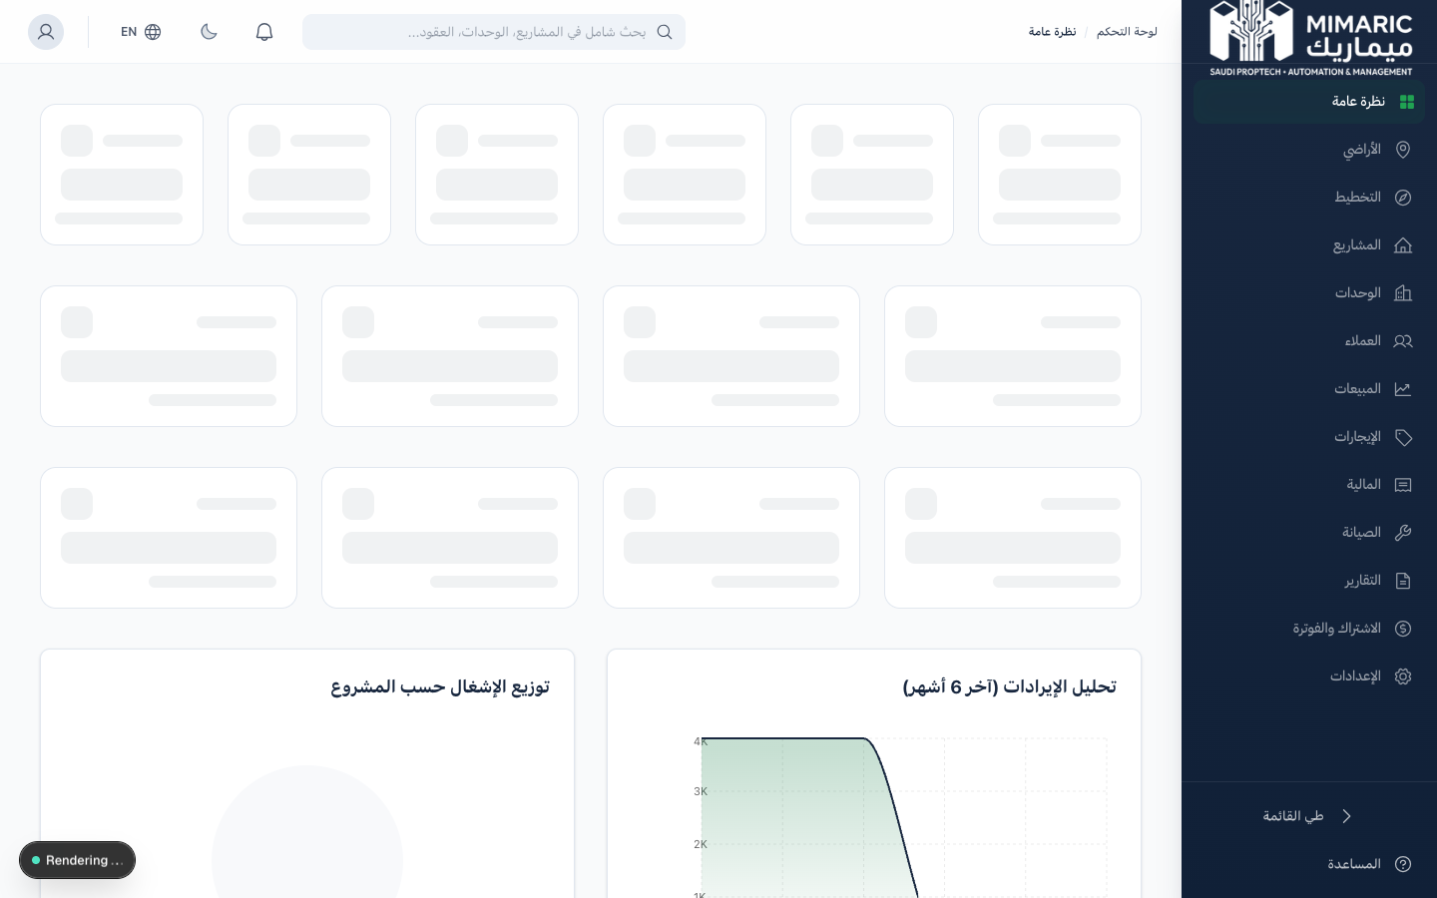
Figure: Dashboard overview showing KPI cards, revenue charts, and occupancy analytics

Where Dashboard Fits in the Platform
The Dashboard sits at the center of Mimaric, pulling data from every operational module:

Module | Relationship | When to Use
Units | Feeds occupancy rate and unit status counts | Dashboard shows total units, available, rented, sold
Rentals | Feeds rental revenue and collection data | Dashboard shows rent collected, active leases, overdue amounts
Finance | Feeds revenue KPIs and cost summaries | Dashboard shows total revenue, pending invoices
Maintenance | Feeds open work order counts | Dashboard shows active maintenance requests
Sales/CRM | Feeds new customer counts and pipeline | Dashboard shows new customers this month
Land | Feeds land portfolio metrics | Dashboard shows land parcels and acquisition stats
Planning | Feeds workspace activity | Dashboard shows active planning workspaces

Note
The Dashboard is read-only. To take action on any metric (e.g., follow up on overdue rent), click the metric card to navigate directly to the relevant module.

2. Getting Started

Accessing the Dashboard
- Log in to Mimaric at your organization’s URL.
- You will automatically land on the Dashboard after authentication.
- If you’re on another page, click “Overview” (لوحة التحكم) in the right sidebar.

Tip
The Dashboard data refreshes automatically when you navigate to it. All metrics reflect real-time data from your organization’s operations.

Prerequisites
- You must have an active Mimaric account with an assigned role.
- Your organization must have at least one project with units to see meaningful KPI data.
- If the Dashboard appears empty, start by creating a project in the Projects module.

3. Core Tasks

3.1 Reading Your Portfolio KPIs
The top section of the Dashboard displays six primary KPI cards:

KPI Card | What It Shows | Action on Click
Total Units | Count of all units across all projects | Navigates to Unit Matrix module
Occupancy Rate | Percentage of units currently rented or sold | Navigates to Units filtered by status
Rent Collected | Total rent payments received in the current period | Navigates to Rentals > Payments
Active Leases | Number of currently active lease contracts | Navigates to Rentals module
Maintenance Requests | Count of open maintenance work orders | Navigates to Maintenance module
New Customers | Number of new customers added this month | Navigates to Customer CRM

3.2 Understanding Dashboard Charts
- Revenue Trend: A 6-month line chart showing monthly revenue. Hover over data points to see exact figures.
- Unit Status Distribution: A donut chart showing units by status (Available, Reserved, Sold, Rented, Maintenance).
- Maintenance by Category: A bar chart showing open work orders grouped by category.
- Occupancy Trend: A 6-month area chart tracking occupancy rate changes.

3.3 Viewing Specialized Dashboard Sections

Land Portfolio Section
Shows aggregate land acquisition metrics: total parcels tracked, parcels by status, and total land area.

Off-Plan Pipeline Section
Displays off-plan development metrics: active projects, total inventory items, conversion rates, and launch wave progress.

Planning Workspace Section
Shows active planning workspaces, scenarios under review, and compliance check results.

4. Advanced Topics

4.1 Dashboard Data Scope
The Dashboard always shows data scoped to your organization. All metrics are aggregated across all projects. Use individual module pages for project-level views.
Important
Dashboard metrics are organization-wide aggregates. For project-specific KPIs, navigate to Projects and open the individual project.

4.2 Role-Based Visibility
- Company Admin / Super Admin: Full visibility into all KPI sections.
- Project Manager: Project and construction-related KPIs.
- Sales Manager: Sales pipeline and customer metrics.
- Property Manager: Occupancy, rental, and maintenance metrics.
- Finance Officer: Revenue, collection, and financial KPIs.

5. Frequently Asked Questions

Q: Why does my Dashboard show zero for all metrics?
Your organization likely has no projects or units created yet. Start by creating a project in the Projects module.
Q: Can I customize which KPIs appear?
The Dashboard layout is currently fixed. Customizable dashboards are planned for a future release.
Q: How often does Dashboard data refresh?
Data loads fresh every time you navigate to it. Refresh the browser page to see updated data.
Q: Why can’t I see the Land or Planning sections?
These appear only if your organization has land parcels or planning workspaces, and require Project Manager or Company Admin role.
Q: Is Dashboard data available in Arabic?
Yes. Switch to Arabic using the language toggle. All labels, numbers, and chart legends display in Arabic with RTL layout.

6. Related Modules

Module | Relationship | When to Use
Projects | Create and manage development projects | Add a new project or track construction progress
Unit Matrix | View and manage individual units | Update unit status, pricing, or availability
Rentals | Manage leases and rent collection | Create leases or record payments
Finance | Detailed financial reporting | Revenue breakdowns, VAT reports, escrow tracking
Maintenance | Work order management | Create, assign, or resolve maintenance requests
Customer CRM | Sales pipeline management | Manage customer relationships and sales funnel

— End of Dashboard User Guide —

