

User Guide
Land Acquisition
Structured Evaluation and Tracking of Land Opportunities
استحواذ الأراضي

Version 1.0 | March 2026
Mimaric PropTech Co. | mimaric.com

Table of Contents

1. Module Overview

The Land Acquisition module provides a structured pipeline for evaluating, tracking, and acquiring land parcels. It replaces ad-hoc spreadsheets with a formal workflow that moves land opportunities through defined stages: Identified → Under Review → Acquired.
Designed for Project Managers and Company Admins who evaluate land opportunities and need to track due diligence, feasibility assessments, and decision gates before committing capital.

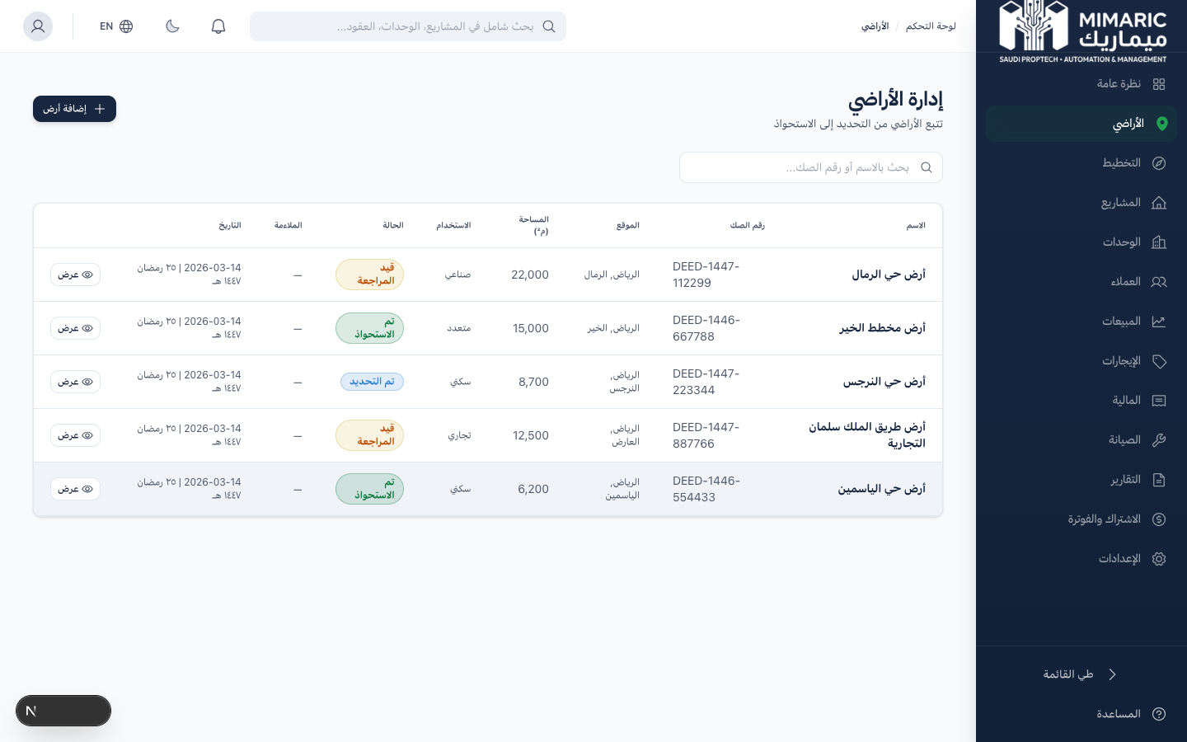
Figure: Land Acquisition pipeline showing parcels with status, area, and deed numbers

Note
Acquired land parcels can be opened directly in the Planning OS for spatial subdivision design, or promoted directly to a Project.

2. Getting Started

- Click “Land” (الأراضي) in the sidebar.
- You’ll see the Land Pipeline with all tracked parcels grouped by status.
- Click “New Land Parcel” to begin tracking a new opportunity.

Tip
The Land module uses Balady-aligned data fields, so all parcel information is pre-structured for future government integration.

3. Core Tasks

3.1 Adding a New Land Parcel
- Navigate to Land and click “New Land Parcel.”
- Enter the parcel name (e.g., “Al-Rawdah Plot 7”).
- Fill in Balady-aligned fields: Parcel Number, Deed Number, Land Use (Residential, Commercial, Mixed, Industrial, Agricultural).
- Enter the total area in square meters.
- Optionally add geographic coordinates for map display.
- Set initial status to “Identified” and click Save.

Important
Enter Parcel Number and Deed Number exactly as they appear on official documents for future government integration.

3.2 Conducting Due Diligence
- Open the land parcel detail page.
- Navigate to the “Due Diligence” tab.
- Add checklist items: title, description, status (Pending/In Progress/Complete/Failed), responsible person.
- Track completion percentage as items are resolved.

3.3 Running Feasibility Assessment
- Open the “Feasibility” tab.
- Enter assessment criteria across five weighted dimensions: Legal (25%), Commercial (25%), Technical (20%), Environmental (15%), Financial (15%).
- The system calculates a weighted suitability score automatically.
Tip
A suitability score above 70% is generally considered favorable. Below 50% typically signals significant constraints.

3.4 Updating Land Status
Identified: Initial opportunity tracked.
Under Review: Active due diligence and feasibility in progress.
Acquired: Purchase completed. Ready for planning or project creation.

3.5 Opening Land in Planning OS
- Open the acquired land parcel.
- Click “Open in Planning.” A new Planning Workspace is created and linked.
- You’ll be redirected to the Planning OS module.

4. Advanced Topics

4.1 Decision Gates
Decision gates are formal checkpoints requiring approval. The Detail page includes a “Decision Gates” tab for tracking approval milestones.

4.2 Constraint Analysis
Document physical, legal, and environmental constraints. These carry forward into Planning OS when creating a workspace.

5. Frequently Asked Questions

Q: Can I delete a land parcel after acquisition?
Parcels linked to Planning Workspaces or Projects cannot be deleted. The record is preserved for audit trail purposes.
Q: What happens to data when I create a project from it?
Parcel data (number, deed, area, coordinates, land use) is copied to the project record. The original remains linked.
Q: How does suitability scoring work?
Weighted average across 5 dimensions: Legal (25%), Commercial (25%), Technical (20%), Environmental (15%), Financial (15%).
Q: Can I import land data from external sources?
Currently parcels must be created manually. Bulk import from CSV/Excel is planned for a future release.

6. Related Modules

Module | Relationship | When to Use
Planning OS | Receives acquired land for spatial planning | Click ‘Open in Planning’ on acquired land
Projects | Receives land data for project creation | Promote acquired land to a project
Dashboard | Feeds land portfolio KPIs | Dashboard shows aggregate land metrics
Documents | Stores land-related documents | Upload title deeds, surveys, feasibility reports

— End of Land Acquisition User Guide —

