

User Guide
Planning OS
GIS-Integrated Spatial Planning with Scenario Analysis
نظام التخطيط

Version 1.0 | March 2026
Mimaric PropTech Co. | mimaric.com

Table of Contents

1. Module Overview

The Planning OS is Mimaric’s spatial intelligence module — a GIS-integrated workspace for designing land subdivisions, comparing development scenarios, checking regulatory compliance, and running financial feasibility analysis.
Designed for Project Managers, Urban Planners, and Company Admins who need to evaluate how to best develop land before creating a formal project.

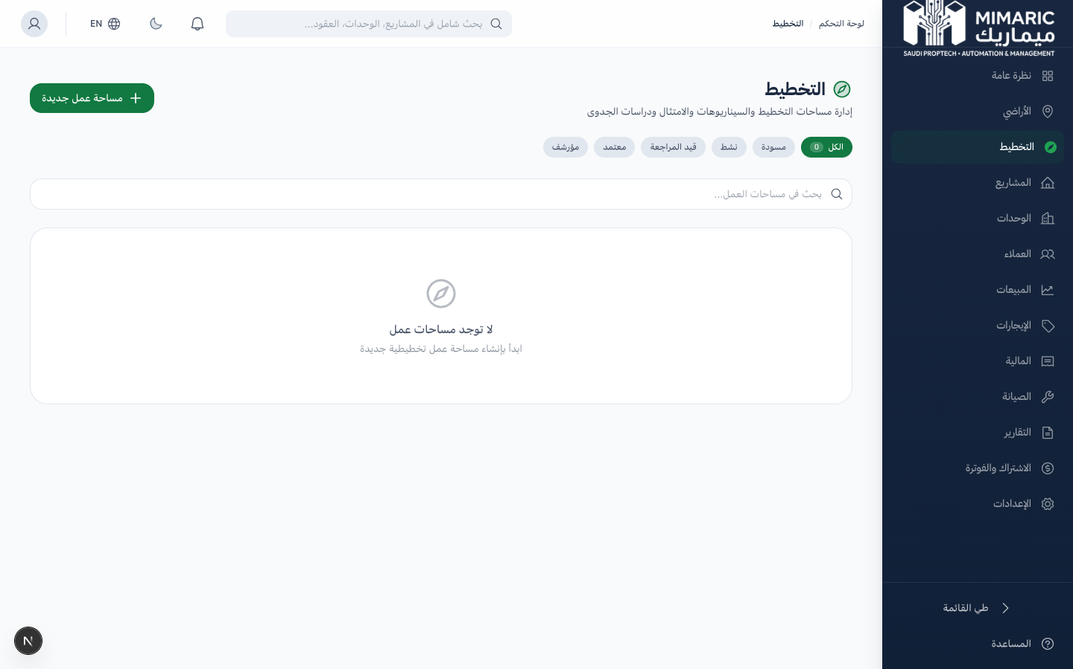
Figure: Planning OS workspace list with status filters and search

Key Capabilities
- Interactive map editor with Leaflet for drawing plots, roads, and utility corridors
- Multiple scenario creation and side-by-side comparison
- Compliance checking against Saudi planning regulations
- Weighted feasibility scoring across 5 dimensions
- GeoJSON/KML/CSV spatial data import
- Direct promotion: approved scenario → project creation
Note
Planning OS is available exclusively on the Enterprise plan.

2. Getting Started

- Navigate to “Planning” (التخطيط) in the sidebar.
- Click “New Workspace.”
- Enter name, location, area. Optionally link to an existing land record.
- Click Create. You’ll see the workspace detail with 7 tabs.
Tip
The fastest way is from the Land module: open an acquired parcel and click ‘Open in Planning.’

3. Core Tasks

3.1 Designing Subdivisions on the Map
- Open your workspace and click the “Map” tab.
- Use drawing tools to create plots (polygons).
- Draw roads as line features connecting plots.
- Add utility corridors for infrastructure planning.
- Toggle constraint overlays to visualize restrictions.

3.2 Creating and Comparing Scenarios
- Go to “Scenarios” tab and click “New Scenario.”
- Name it (e.g., “High-Density Residential” vs. “Mixed-Use”).
- Define plots, road layouts, and open spaces.
- Use the “Comparison” tab to see scenarios side-by-side.
- Approve the best scenario as the baseline.
Important
Only one scenario can be approved per workspace. Approving locks it as the baseline.

3.3 Running Compliance Checks
- Navigate to “Compliance” tab and click “Run Check.”
- System evaluates: minimum plot area, road width, open space ratio, setbacks.
- Results: Green (pass), Yellow (warning), Red (fail).

3.4 Calculating Financial Feasibility
- Open the “Feasibility” tab.
- Enter pricing assumptions, cost estimates, soft cost percentages.
- System auto-calculates: total revenue, costs, net profit, ROI.

3.5 Promoting a Scenario to a Project
- Approve the best scenario.
- Click “Promote to Project.” A new Project is created with subdivision data pre-populated.

4. Advanced Topics

4.1 Importing Spatial Data
- GeoJSON (.geojson), KML (.kml), CSV with lat/lng columns

4.2 Collaboration with Comments
The Comments tab supports threaded discussions with annotations.

4.3 Workspace Lifecycle
Draft → Active → Under Review → Approved → Archived. Only Active or Under Review can be edited.

5. Frequently Asked Questions

Q: What is the Planning OS?
It lets you plan land subdivision with multiple scenarios, compliance checks, and auto-calculated financial feasibility.
Q: How do I compare scenarios?
The Comparison tab shows a side-by-side table: plot count, sellable area, estimated revenue, and ROI.
Q: How does compliance checking work?
Click ‘Run Check’ in the Compliance tab. Results are color-coded: green (pass), red (fail), yellow (warning).
Q: Can I undo changes on the map?
No automatic undo. Create a new scenario based on the original design to revert.

6. Related Modules

Module | Relationship | When to Use
Land Acquisition | Provides land data for workspace creation | Click ‘Open in Planning’ from acquired land
Projects | Receives promoted scenarios | Approve scenario and click ‘Promote to Project’
Dashboard | Feeds planning workspace metrics | Dashboard shows active workspaces

— End of Planning OS User Guide —

