

User Guide
Projects
Full Development Lifecycle from Land to Delivery
المشاريع

Version 1.0 | March 2026
Mimaric PropTech Co. | mimaric.com

Table of Contents

1. Module Overview

The Projects module is the backbone of Mimaric — managing the entire development lifecycle from raw land through construction, sales launch, and unit delivery. Projects contain buildings, buildings contain units, and units connect to sales, rentals, maintenance, and finance.
Supports both Regular projects (traditional) and Off-Plan projects (Wafi-compliant with 12+ stages).

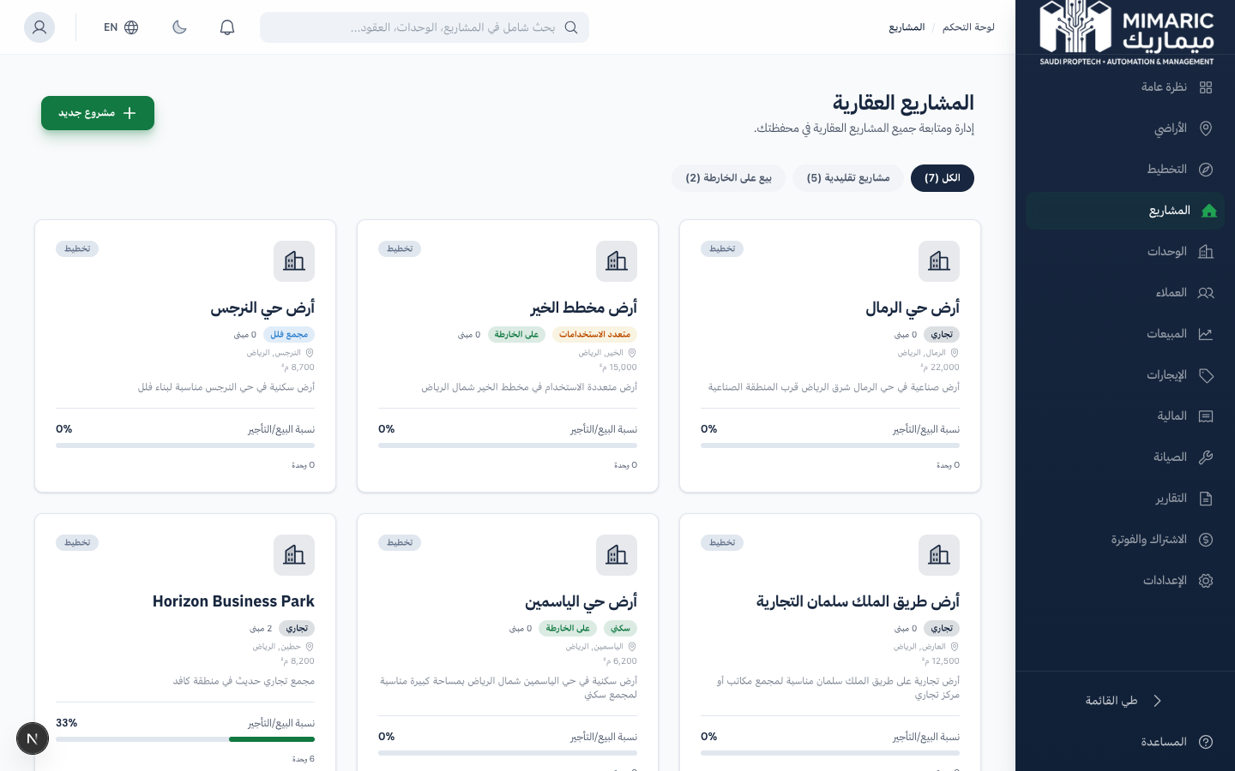
Figure: Projects module showing project cards with status indicators, type filters, and progress bars

Two Project Types
Type | Use Case | Stages
Regular | Traditional: build → complete → sell/rent | 5 phases: Land → Design → Authority → Construction → Complete
Off-Plan | Wafi-compliant: sell before construction completes | 12+ stages: Concept → Subdivision → Approvals → Launch

2. Getting Started

- Navigate to “Projects” (المشاريع) in the sidebar.
- Click “New Project.”
- Enter project name, select type (Regular or Off-Plan), fill location details.
- For Balady alignment, enter: parcel number, deed number, land use, coordinates.
Tip
You can promote land/scenarios from Land Acquisition or Planning OS directly to a project.

Adding Buildings and Units
- Go to the “Buildings” tab and click “Add Building.”
- Enter name, floors, total units, status.
- Open the building, click “Add Unit” for each unit.
- Enter: number, type, floor, area, bedrooms, bathrooms, price.
Important
Units created here automatically appear in the Unit Matrix module.

3. Core Tasks

3.1 Tracking the 14-Stage Lifecycle
- Stages 1–3: Land Identified → Under Review → Acquired
- Stage 4: Concept Development
- Stage 5: Subdivision (blocks, plots, roads)
- Stage 7: Authority Approvals (Balady, utilities, civil defense)
- Stage 8: Infrastructure Readiness
- Stages 9–12: Inventory → Pricing → Launch Waves → Sales
- Stages 13–14: Construction Execution → Handover

3.2 Managing Authority Approvals
- Go to “Approvals” tab, click “New Submission.”
- Select authority (Balady, SEC, NWC, Civil Defense).
- Track: Submitted → Under Review → Approved/Rejected.

3.3 Recording Site Logs
- Navigate to project’s “Site Logs” page.
- Click “New Log Entry” — enter date, weather, work, workers, issues.

3.4 Managing Off-Plan (Stages 9–12)
- Inventory: Create sellable items (villas, apartments) with type, area, base price. Status: Unreleased → Available → Reserved → Sold.
- Pricing: Define rules (base price/sqm, corner premium). Click ‘Calculate Prices’ to apply.
- Launch Waves: Release inventory in phases. Each wave: Planned → Launched → Closed.

4. Advanced Topics

4.1 Plot-to-Building Conversion
Auto-generate buildings from approved plots in the Subdivision tab.

4.2 Inventory-to-Unit Handoff
Convert off-plan inventory items to deliverable units using “Convert to Units.”

4.3 Post-Handover Maintenance Setup
Auto-create preventive maintenance plans for completed buildings after handover.
Tip
Use the ‘Launch Readiness’ tab to verify all prerequisites before launching sales.

5. Frequently Asked Questions

Q: What’s the difference between Regular and Off-Plan?
Regular follows build-then-sell. Off-Plan follows Wafi regulations with escrow management and milestone billing.
Q: Can I change project type after creation?
No. Project type is set at creation due to Wafi compliance requirements.
Q: How do I set pricing rules?
From the Pricing tab, add rules (base price/sqm, premiums). Click ‘Calculate Prices’ to apply across inventory.
Q: What are launch waves?
Sequential sales phases. Create a wave with name, date, and inventory count. Planned → Launched → Closed.

6. Related Modules

Module | Relationship | When to Use
Land Acquisition | Provides land data | Promote acquired land to a project
Planning OS | Provides subdivision plans | Promote approved scenario
Unit Matrix | Receives units from buildings | Units appear in cross-project view
Sales / CRM | Sells units and inventory | Create reservations and contracts
Maintenance | Work orders for properties | Maintenance requests reference units
Finance | Revenue and cost tracking | P&L per project

— End of Projects User Guide —

