

User Guide
Unit Matrix
Cross-Project Inventory Management and Unit Tracking
مصفوفة الوحدات

Version 1.0 | March 2026
Mimaric PropTech Co. | mimaric.com

Table of Contents

1. Module Overview

The Unit Matrix provides a unified view of all units across all projects in your organization. While the Projects module shows units within a single project, the Unit Matrix lets you search, filter, and manage units across your entire portfolio from one screen.
Designed for Property Managers, Sales Managers, and Company Admins who need portfolio-wide visibility into unit availability, pricing, and status.

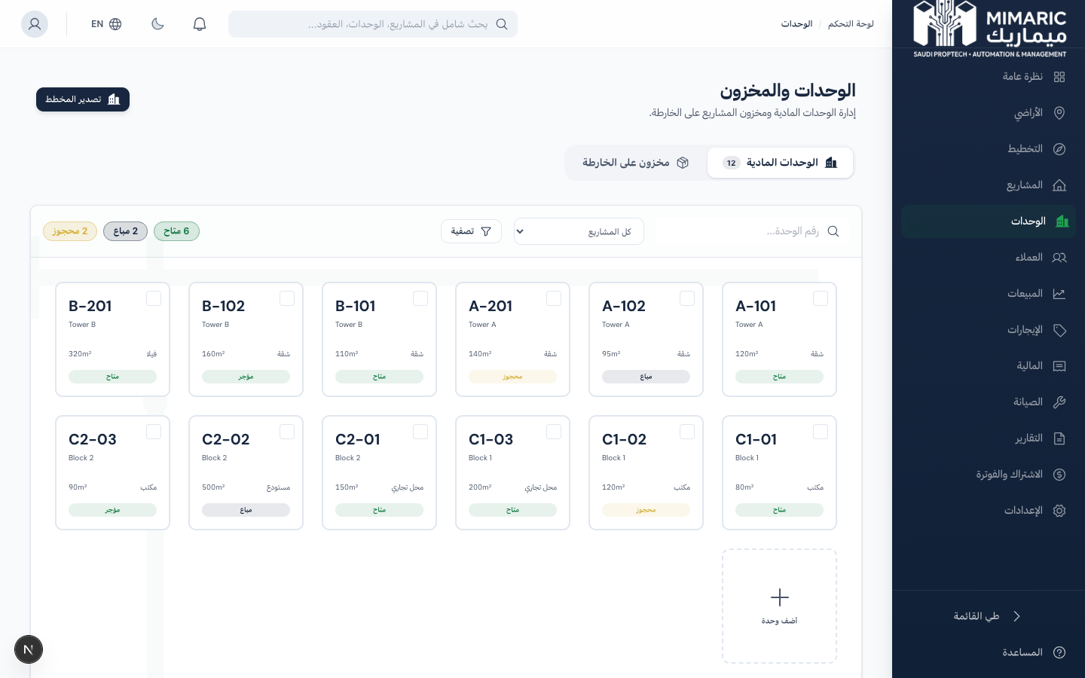
Figure: Unit Matrix showing cross-project inventory with color-coded status cards

Unit Types and Statuses
Unit Types | Unit Statuses
Apartment, Villa, Office, Retail, Warehouse, Parking | Available, Reserved, Sold, Rented, Maintenance

Note
Unit statuses update automatically when contracts are signed (Sold/Rented), reservations created (Reserved), or maintenance requested (Maintenance). You rarely need to change status manually.

2. Getting Started

- Navigate to “Units” (الوحدات) in the sidebar.
- You’ll see all units in a card grid, color-coded by status.
- Use the filters at the top to narrow by: Project, Building, Type, Status.
- Toggle between Card view and Table view using the view switcher.

Tip
The Unit Matrix supports URL-based filtering. You can bookmark filtered views (e.g., all available apartments in a specific project) for quick access.

3. Core Tasks

3.1 Viewing Unit Details
- Click the detail button on any unit card.
- A side panel opens showing: type, status, area, floor, bedrooms, bathrooms.
- View pricing: cost price, selling price (markup), rental price.
- View the Financial Summary: rent collected, sale revenue, maintenance costs, net income.
- View the active contract (if any) and maintenance history.

3.2 Editing Unit Properties
- Open the unit detail panel.
- Click “Edit” to modify: number, type, floor, area, bedrooms, bathrooms, prices.
- Update the commercial strategy (For Sale, For Rent, Both) to control how the unit appears in Sales and Rentals.
- Click Save to apply changes.

3.3 Bulk Price Updates
Update pricing across multiple units simultaneously:
- Select multiple units using the checkbox on each card.
- Click “Bulk Update” in the toolbar.
- Choose the field to update (e.g., selling price, rental price).
- Enter the new value or a percentage adjustment.
- Review the preview showing before/after values, then confirm.

Warning
Bulk price updates are immediate and affect all selected units. Double-check the preview before confirming. This action is logged in the audit trail.

3.4 Checking Unit Financial Performance
Each unit’s detail panel includes a Financial Summary section with four KPIs:
- Rent Collected: Total paid installments from lease contracts linked to this unit.
- Sale Revenue: Total signed sale contract amounts for this unit.
- Maintenance Costs: Total actual (or estimated) costs from maintenance work orders.
- Net Income: Revenue minus costs — the unit’s profitability.

3.5 Viewing Active Contracts and Maintenance
From the unit detail panel, you can see:
- Active Contract: The current lease or sale contract linked to this unit, with contract number, customer name, and status.
- Maintenance Requests: A list of all maintenance work orders for this unit, with status, category, and assigned technician.

4. Advanced Topics

4.1 Off-Plan Inventory View
When projects have off-plan inventory items, the Unit Matrix includes an Inventory tab that shows pre-handover items alongside delivered units. This provides a complete picture of your saleable portfolio.

4.2 Unit Status Automation
Status changes are triggered automatically by other modules:
- A signed LEASE contract changes the unit to “Rented.”
- A signed SALE contract changes the unit to “Sold.”
- Creating a reservation changes the unit to “Reserved.”
- Voiding a contract reverts the unit to “Available.”

5. Frequently Asked Questions

Q: How do I track unit status?
From the Units section, view all units in a color-coded card grid by status (Available, Reserved, Sold, Rented, Maintenance). Click any unit to see full details including financial summary, active contract, and maintenance history.
Q: Can I add units directly in the Unit Matrix?
Units are created within the Projects module (Project → Building → Unit). The Unit Matrix is a cross-project view. To add units, go to the relevant project.
Q: Why did a unit’s status change without me updating it?
Unit statuses update automatically when contracts are signed, reservations created, or contracts voided. Check the unit’s active contract to understand the status change.
Q: Can I export unit data?
Yes. Use the Export function in the Unit Matrix toolbar to download unit data as Excel or PDF. The export includes all visible units with their current filters applied.
Q: How is the financial summary calculated?
Rent Collected = sum of paid installments. Sale Revenue = sum of signed sale contracts. Maintenance Costs = actual/estimated costs from work orders. Net Income = revenue minus costs. All calculated automatically.

6. Related Modules

Module | Relationship | When to Use
Projects | Units are created within project buildings | Add new units in Projects > Building > Add Unit
Sales / CRM | Sales team sells or rents units | Create reservations or contracts for units
Rentals | Lease contracts link to units | Create a lease for a unit
Maintenance | Work orders reference units | Create maintenance requests for specific units
Finance | Revenue/costs aggregated per unit | View P&L per unit

— End of Unit Matrix User Guide —

