

User Guide
Customer CRM
Sales Pipeline Management and Customer Relationship Tracking
إدارة العملاء

Version 1.0 | March 2026
Mimaric PropTech Co. | mimaric.com

Table of Contents

1. Module Overview

The Customer CRM module manages your sales pipeline from first contact through conversion. It provides both Kanban (board) and List (table) views to track customers through five pipeline stages: New → Interested → Qualified → Viewing → Converted.
Designed for Sales Managers and Sales Agents who manage buyer and tenant relationships.

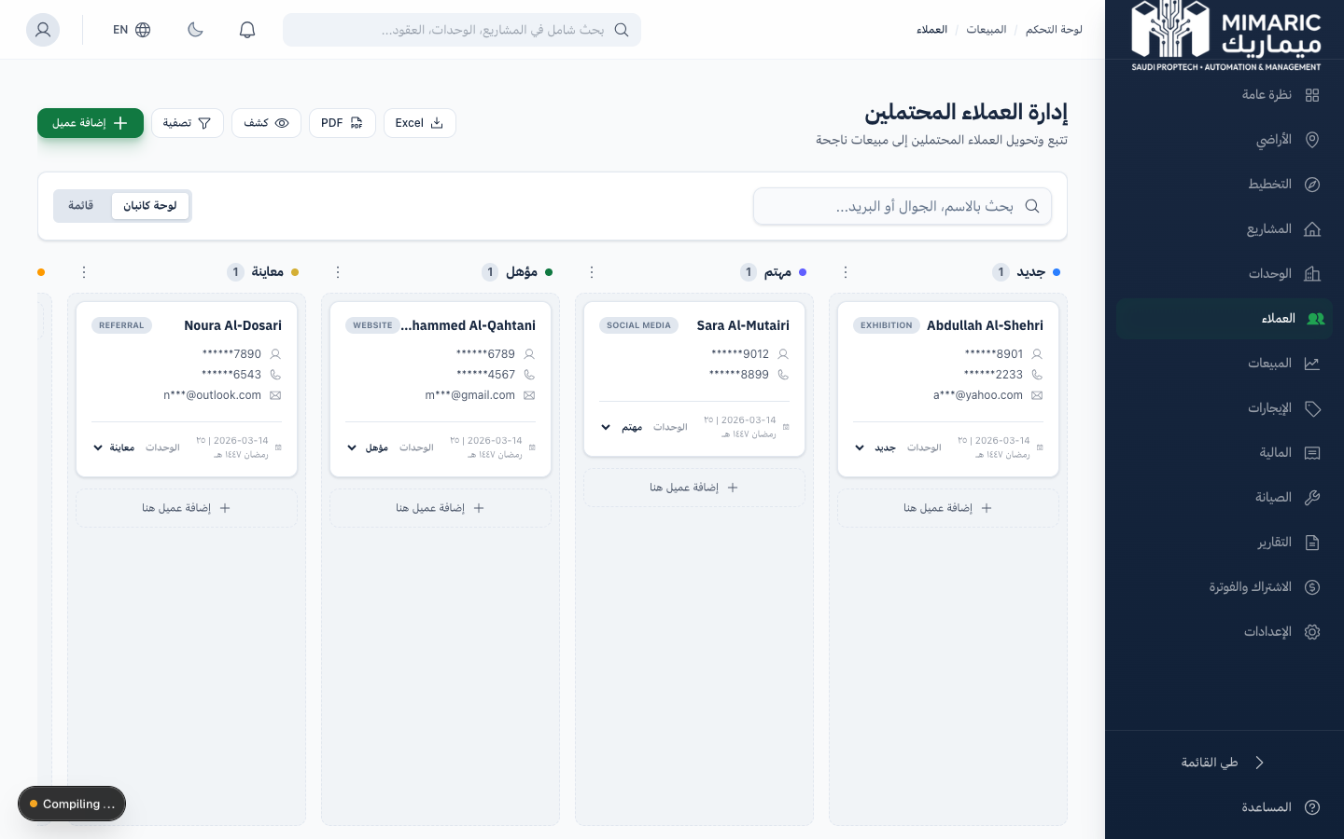
Figure: Sales hub showing Customers, Reservations, and Contracts sections

Important
Customer personal data (national ID, phone, email) is encrypted with AES-256-GCM. Only authorized roles can view decrypted PII. All PII access is logged per PDPL Article 32.

2. Getting Started

- Navigate to “Customers” (العملاء) in the sidebar.
- You’ll see the customer pipeline in Kanban view by default.
- Click “Add Customer” to create your first customer record.

Prerequisites
- Role: Sales Manager, Sales Agent, Company Admin, or Property Manager.
- Permission: customers.create for adding new customers.

3. Core Tasks

3.1 Adding a New Customer
- Click “Add Customer” from the Customers page.
- Enter the customer’s name (Arabic and/or English).
- Enter contact information: phone number and email address.
- Enter the National ID number (Absher-aligned field). This will be encrypted automatically.
- Select Person Type: Individual or Organization.
- Optionally fill gender, date of birth, and address fields.
- Click Save. The customer is created in “New” status.

Note
The customer form aligns with Absher’s data schema. Fields like National ID, Person Type, Gender, and DOB match government records for future integration.

3.2 Managing the Sales Pipeline
Move customers through pipeline stages:
Kanban View: Drag and drop customer cards between columns to change status.
List View: Click the status dropdown on any row to update.

Stage | Description | Next Action
New | Initial contact recorded | Qualify the lead: understand needs and budget
Interested | Customer has expressed interest | Schedule a property viewing or meeting
Qualified | Customer meets financial/profile criteria | Present available units and pricing
Viewing | Property viewing scheduled or completed | Create a reservation if interested
Converted | Customer has signed a contract | Process in Contracts module

3.3 Searching and Filtering Customers
- Use the search bar to find customers by name, phone, or email.
- Apply status filters to focus on specific pipeline stages.
- Sort by date added, name, or status.
- Toggle between Kanban and List views using the view switcher.

3.4 Viewing Customer Details
- Click any customer card or row to open the detail modal.
- View all contact information, interaction history, and linked records.
- See linked reservations, contracts, and leases for this customer.
- Add notes about interactions, preferences, or follow-up actions.

3.5 Exporting Customer Data
- Click the Export button in the toolbar.
- Select the format (Excel or PDF).
- PII fields are masked in exports by default for data protection.
- Admin users can request unmasked exports, which are logged in the audit trail.

Warning
Exporting unmasked customer PII triggers an audit log entry per PDPL Article 32. Only roles with explicit PII access permission can view unmasked data.

4. Advanced Topics

4.1 PII Encryption and Masking
Customer sensitive data is encrypted using AES-256-GCM before database storage. In the UI, PII is masked by default (e.g., national ID shows as ****1234). Only users with the ‘read_pii’ permission see full values. Every PII access is logged.

4.2 Agent Assignment
Sales Managers can assign customers to specific Sales Agents for follow-up. This helps distribute leads evenly and track agent performance.

4.3 Customer Deduplication
The system checks for duplicate customers based on phone number and national ID when creating new records. If a duplicate is detected, you’ll be prompted to view the existing record instead.

5. Frequently Asked Questions

Q: How do I add a new customer?
From Customers, click ‘Add Customer.’ Enter name, phone, national ID. Personal data is automatically encrypted.
Q: What’s the difference between Kanban and List view?
Kanban shows customers in columns by status (New, Interested, Qualified, Viewing, Converted). List shows them in a sortable, filterable table.
Q: Why can’t I see customer phone numbers?
PII is masked for data protection. You need the ‘read_pii’ permission to see unmasked data. Request additional permissions from your Company Admin via Help > Request Permissions.
Q: Can I import customers from a spreadsheet?
Bulk customer import is planned for a future release. Currently, customers must be added individually.
Q: How do I create a reservation for a customer?
From Reservations, click ‘New Reservation.’ Select the customer, then choose a unit or inventory item, set the expiry date, and complete the wizard.

6. Related Modules

Module | Relationship | When to Use
Reservations | Create unit holds for customers | Customer is interested in a specific unit
Contracts | Formalize sales or lease agreements | Customer is ready to sign
Rentals | Customer becomes a tenant | Lease contract signed for a customer
Unit Matrix | View available units for customers | Showing unit options to interested customers

— End of Customer CRM User Guide —

