

User Guide
Reservations
Time-Bound Unit Holds for Sales Pipeline Management
الحجوزات

Version 1.0 | March 2026
Mimaric PropTech Co. | mimaric.com

Table of Contents

1. Module Overview

The Reservations module provides a formal system for holding units or inventory items for specific customers. Reservations are time-bound — they automatically expire if not converted to a contract within the specified period.
This ensures unit availability is accurately tracked and prevents indefinite holds that block sales.

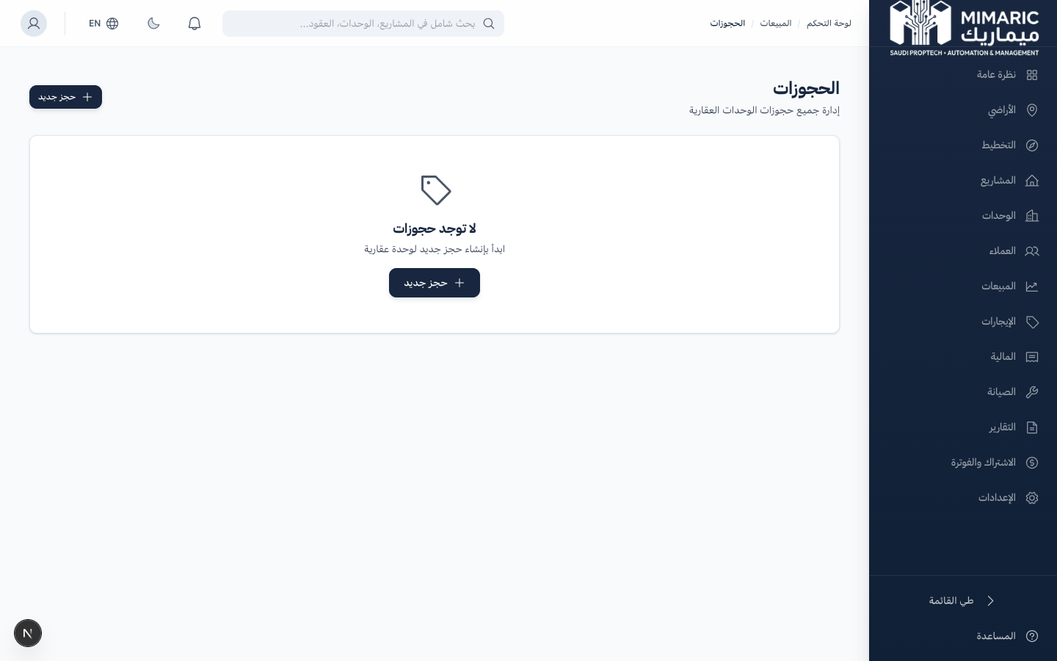
Figure: Reservations list showing active, expired, and converted reservation records

Note
Reservations update unit status to “Reserved” automatically. When a reservation expires or is cancelled, the unit reverts to “Available.”

2. Getting Started

- Navigate to “Sales” in the sidebar, then click “Reservations.”
- Click “New Reservation” to start the 4-step wizard.

Prerequisites
- At least one customer must exist in the CRM.
- At least one available unit or inventory item must exist.
- Role: Sales Manager, Sales Agent, or Company Admin.

3. Core Tasks

3.1 Creating a Reservation
The reservation wizard guides you through 4 steps:
- Step 1 — Choose Source: Select “From Units” for traditional units or “From Inventory” for off-plan items.
- Step 2 — Select Customer: Search and select the customer from your CRM database.
- Step 3 — Select Unit/Item: Browse available units/inventory and select one. Only “Available” items are shown.
- Step 4 — Set Terms: Enter expiry date, reservation amount (if applicable), and notes. Click “Create Reservation.”

Important
The expiry date is enforced. After expiry, the reservation is marked as expired and the unit becomes available again. Set realistic timelines based on your sales process.

3.2 Managing Active Reservations
- View all reservations in the list with status and expiry countdown.
- Click any reservation to see full details: customer, unit, dates, amount.
- To extend: click “Edit” and update the expiry date.
- To cancel: click “Cancel Reservation.” The unit reverts to Available.

3.3 Converting a Reservation to a Contract
- Open the active reservation.
- Click “Convert to Contract.”
- The system pre-fills a new contract form with customer and unit data.
- Complete the contract details and save. The reservation is marked as Converted.

4. Advanced Topics

Reservation Expiry Management
Monitor approaching expiry dates in the reservation list. Reservations within 3 days of expiry are highlighted with a warning indicator. Plan follow-up calls with customers before reservations expire.

Off-Plan Inventory Reservations
When reserving off-plan inventory items, the reservation links to the InventoryItem record instead of a Unit. Upon project handover and inventory-to-unit conversion, these reservations can be transferred to the new Unit records.

5. Frequently Asked Questions

Q: How do I create a reservation for a customer?
From Reservations, click ‘New Reservation.’ Choose the source (Units or Inventory), select the customer, choose the unit/item, set the expiry date, and complete the wizard.
Q: What happens when a reservation expires?
The reservation status changes to ‘Expired’ and the unit automatically reverts to ‘Available.’ The customer record is unaffected.
Q: Can I have multiple reservations for the same customer?
Yes. A customer can hold reservations on multiple units simultaneously. However, each unit can only have one active reservation at a time.
Q: Can I extend a reservation?
Yes. Open the reservation, click Edit, and update the expiry date. This is logged in the audit trail.

6. Related Modules

Module | Relationship | When to Use
Customer CRM | Provides customer data for reservations | Select a customer during reservation creation
Unit Matrix | Provides available units | Select a unit during reservation creation
Contracts | Receives converted reservations | Convert reservation to sale or lease contract

— End of Reservations User Guide —

