

User Guide
Contracts
Ejar and Wafi Compliant Contract Lifecycle Management
العقود

Version 1.0 | March 2026
Mimaric PropTech Co. | mimaric.com

Table of Contents

1. Module Overview

The Contracts module manages the full lifecycle of sale and lease agreements. It enforces Saudi regulatory compliance — Ejar for rental contracts and Wafi for off-plan sale contracts — directly in the data model and workflow.
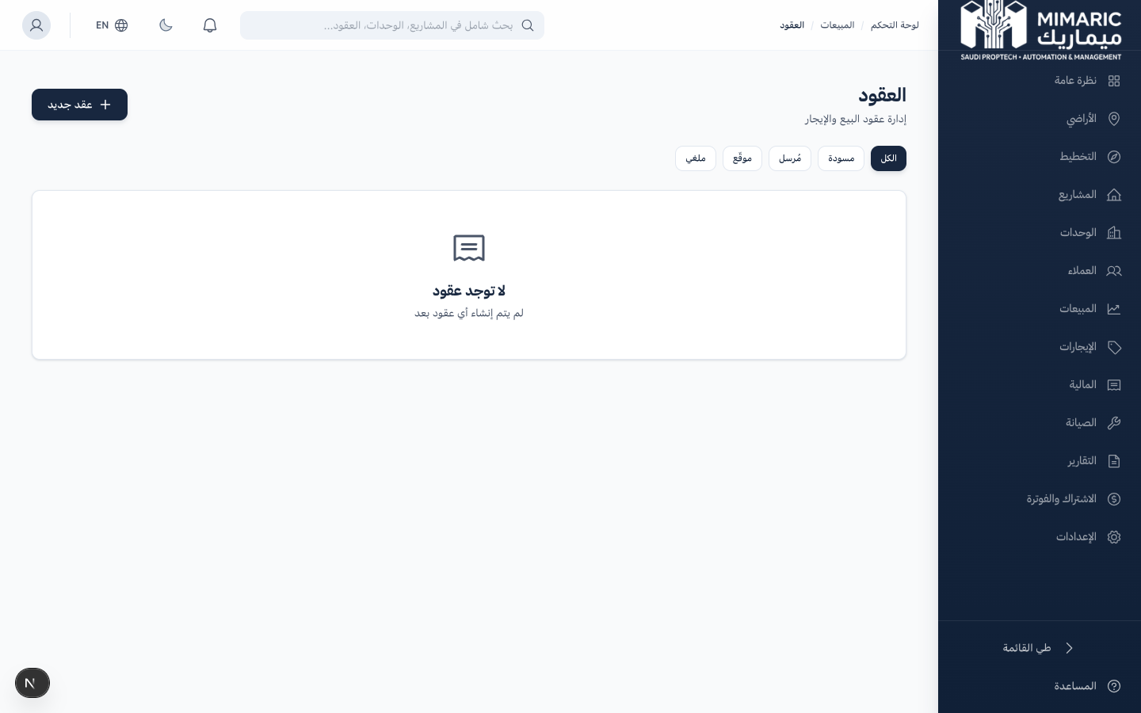
Figure: Contracts module showing sale and lease agreements with status tracking

Contracts move through a formal state machine: Draft → Sent → Signed → (optionally) Void. Status transitions trigger automatic side-effects: signing a lease creates installment schedules, signing a sale contract creates escrow deposits.

Two Contract Types
Contract Type | Regulation | Key Fields
SALE | Wafi | Delivery date, Wafi license reference, escrow account reference, contract amount, file upload
LEASE | Ejar | Start/end dates, payment frequency, security deposit (max 5%), auto-renewal, notice period, maintenance responsibility

2. Getting Started

- Navigate to “Sales” in the sidebar, then click “Contracts.”
- Click “New Contract” to create a sale or lease agreement.
- Select the contract type (Sale or Lease) to load the appropriate form.

Note
Contract numbers are auto-generated: SALE-2026-XXXX for sales, LEASE-2026-XXXX for leases. You cannot modify the contract number.

3. Core Tasks

3.1 Creating a Sale Contract (Wafi-Compliant)
- Click “New Contract” and select type: Sale.
- Select the customer (from CRM) and unit or inventory item.
- Enter the contract amount.
- Enter the expected delivery date.
- Enter Wafi license reference and escrow account reference.
- Upload the contract document (PDF, max 16MB).
- Click Save. The contract is created in Draft status.

3.2 Creating a Lease Contract (Ejar-Compliant)
- Click “New Contract” and select type: Lease.
- Select the customer and unit.
- Enter lease start date and end date.
- Set payment frequency: Monthly, Quarterly, Semi-Annual, or Annual.
- Enter the security deposit (system enforces max 5% of annual rent per Ejar).
- Configure auto-renewal toggle and notice period (default: 60 days).
- Set maintenance responsibility (Landlord or Tenant).
- Click Save. Draft lease created.

Important
The system validates that security deposit does not exceed 5% of annual rent. If you enter a higher amount, you’ll receive a validation error. This ensures Ejar compliance.

3.3 Managing Contract Status
Contracts follow a strict state machine:
Draft → Sent: Contract has been shared with the customer for review.
Sent → Signed: Customer has signed. This triggers automatic side-effects.
Signed → Void: Contract cancelled. Requires a void reason.

Side-effects on signing:
- LEASE: Auto-creates a Lease record and generates RentInstallment schedule based on payment frequency.
- SALE: Auto-creates an escrow deposit (BUYER_DEPOSIT) in the project’s escrow account.
- Both: Updates the unit status to Rented (lease) or Sold (sale).

Side-effects on voiding:
- SALE: Auto-creates an escrow reversal entry.
- Both: Reverts the unit status to Available.

3.4 Uploading Signed Documents
- Open the contract detail page.
- Click “Upload Document” in the document section.
- Upload the signed contract PDF (max 16MB).
- The uploaded file is linked to the contract record permanently.

4. Advanced Topics

4.1 Contract Numbering Convention
Contracts are auto-numbered: TYPE-YEAR-SEQUENCE. For example, LEASE-2026-0001 is the first lease contract of 2026. This numbering is unique per organization and cannot be modified.

4.2 Ejar Integration Readiness
Lease contracts store all fields required for Ejar API registration. When the Ejar API integration launches (planned Q3 2026), contracts will be registerable with Ejar directly from Mimaric.

4.3 Wafi Escrow Automation
When a sale contract is signed, the system automatically records a BUYER_DEPOSIT in the project’s escrow account. Finance Officers can track all escrow movements in the Finance > Escrow page.

5. Frequently Asked Questions

Q: What’s the maximum security deposit for Ejar leases?
5% of annual rent, enforced by the system. This is an Ejar regulation to protect tenants.
Q: Can I edit a signed contract?
No. Once a contract is signed, it cannot be edited. This is by design to maintain contractual integrity. To make changes, void the signed contract and create a new one.
Q: What happens when I void a signed contract?
The unit reverts to Available. For sale contracts, an escrow reversal is auto-recorded. A void reason is required and logged in the audit trail.
Q: How are installment schedules generated?
When a lease contract is signed, installments are auto-generated based on: contract amount, start/end dates, and payment frequency. For monthly payments on a 12-month lease, 12 installments are created with equal amounts.
Q: Can I track contracts from Wafi sales?
Yes. Sale contracts include Wafi-specific fields: license reference, escrow account, delivery date. Escrow deposits are auto-tracked in the Finance module.

6. Related Modules

Module | Relationship | When to Use
Customer CRM | Provides customer data for contracts | Select a customer during contract creation
Unit Matrix | Provides units for contracts | Select a unit during contract creation
Reservations | Reservations convert to contracts | Convert an active reservation to a contract
Rentals | Lease contracts create leases | Signing a lease auto-creates a lease record with installments
Finance | Revenue and escrow tracking | Contract amounts flow to financial reports

— End of Contracts User Guide —

