

User Guide
Rentals
Lease Management, Installment Tracking, and Rent Collection
الإيجارات

Version 1.0 | March 2026
Mimaric PropTech Co. | mimaric.com

Table of Contents

1. Module Overview

The Rentals module manages the operational side of leasing — active lease records, installment schedules, and rent collection tracking. While the Contracts module handles the agreement lifecycle, Rentals handles the day-to-day payment operations.
Designed for Property Managers and Finance Officers who manage rent collection, track overdue payments, and monitor lease renewals.

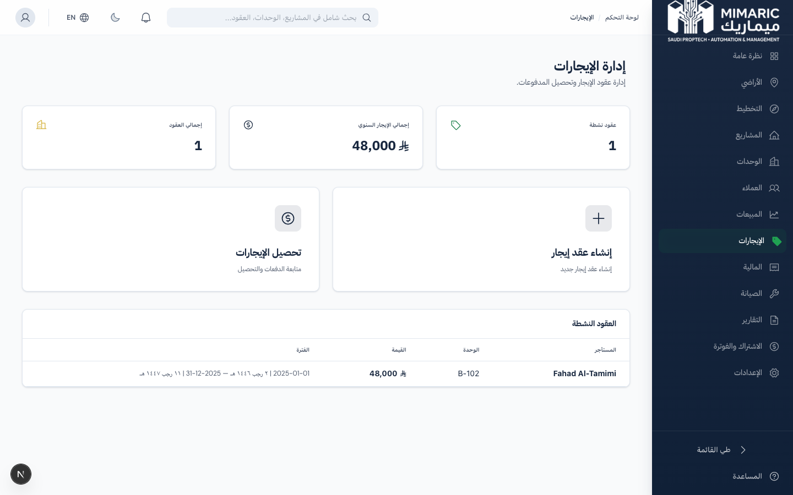
Figure: Rentals dashboard showing active leases, KPI summary, and installment tracking

Key Metrics at a Glance
- Active Leases: Number of currently active lease agreements
- Annual Rent: Total annual rent from all active leases
- Collection Rate: Percentage of due installments that have been paid
- Overdue Amount: Total outstanding overdue payments

2. Getting Started

Two Ways to Create a Lease
Method 1 — Via Contracts (Recommended): Create a LEASE-type contract in the Contracts module. When it’s signed, a lease record and installment schedule are auto-generated.
Method 2 — Direct Creation: Navigate to Rentals and click “New Lease” to use the lease creation wizard.

Tip
Method 1 (via Contracts) is recommended because it ensures the lease is linked to a formal contract with Ejar compliance. Direct creation is useful for migrating existing leases into the system.

3. Core Tasks

3.1 Creating a Lease with the Wizard
- Navigate to Rentals and click “New Lease.”
- Select the unit from the dropdown (only available units shown).
- Select the customer (tenant) from CRM.
- Set lease start and end dates.
- Enter the total lease amount.
- Select payment frequency: Monthly, Quarterly, Semi-Annual, or Annual.
- Review the auto-generated installment preview showing dates and amounts.
- Click Create. The lease, installments, and unit status update are all created.

3.2 Recording Rent Payments
- Navigate to Rentals > Payments (تحصيل الإيجارات).
- Find the installment to record payment for (filter by tenant, unit, or status).
- Click “Record Payment.”
- Select the payment method (Cash, Bank Transfer, Check, Online).
- Confirm the payment date and amount.
- Click Save. The installment status changes from DUE to PAID.

3.3 Tracking Overdue Installments
Installments automatically change to OVERDUE status when the due date passes without payment. To manage overdue payments:
- Go to Rentals > Payments and filter by status: “Overdue.”
- Review the list of overdue installments with tenant and unit details.
- Contact the tenant for follow-up.
- Record the payment when received (the system tracks the delay).

Warning
Overdue installments are highlighted in red across the platform — on the Dashboard, in Rentals, and in Finance. This ensures visibility across all team members.

3.4 Managing Lease Renewals
For leases with auto-renewal enabled:
- The system tracks the notice period (default: 60 days before lease end).
- Leases approaching renewal are highlighted in the lease list.
- To renew: create a new lease contract linked to the same unit and customer.
- To terminate: click “Terminate Lease” and provide a reason.

4. Advanced Topics

4.1 Installment Schedule Logic
Installments are calculated by dividing the total lease amount by the number of payment periods:
- Monthly: 12 installments per year
- Quarterly: 4 installments per year
- Semi-Annual: 2 installments per year
- Annual: 1 installment per year
Each installment has an equal amount (total ÷ periods), with any remainder added to the final installment.

4.2 Ejar Contract Linking
Leases created from signed LEASE contracts automatically store the Ejar contract reference. This links operational payment tracking to the regulatory contract record.

5. Frequently Asked Questions

Q: How do I track due installments?
From Rentals > Rent Collection, view all installments with status (Paid, Unpaid, Overdue). When creating an Ejar-compliant lease, installments are auto-generated based on payment frequency and linked to the contract.
Q: Can I change the installment schedule after creation?
Individual installment amounts cannot be edited. To change the schedule, terminate the current lease and create a new one with the desired terms.
Q: What payment methods are supported?
Cash, Bank Transfer, Check, and Online (Mada/SADAD integration planned for Q3 2026).
Q: How do I handle partial payments?
Currently, installments are recorded as fully paid. Partial payment tracking is planned for a future release.
Q: How do I record rental payments?
Go to Rentals > Payments, find the installment, click ‘Record Payment,’ select the method, confirm date and amount, and save.

6. Related Modules

Module | Relationship | When to Use
Contracts | Signed lease contracts create lease records | A LEASE contract is signed
Unit Matrix | Units change to Rented status | Lease is created for a unit
Customer CRM | Tenants are CRM customers | Customer is selected as tenant during lease creation
Finance | Rent payments feed revenue reports | Recorded payments appear in Finance KPIs
Maintenance | Tenants may request maintenance | Maintenance requests reference leased units

— End of Rentals User Guide —

