

User Guide
Finance
Revenue Intelligence, Cost Analysis, and Escrow Management
المالية

Version 1.0 | March 2026
Mimaric PropTech Co. | mimaric.com

Table of Contents

1. Module Overview

The Finance module is Mimaric’s financial intelligence hub. It aggregates revenue from rent collection and property sales, tracks maintenance costs, calculates VAT per ZATCA requirements, and manages Wafi escrow accounts — all without manual data entry.
Designed for Finance Officers, Company Admins, and Project Managers who need financial visibility across the portfolio.

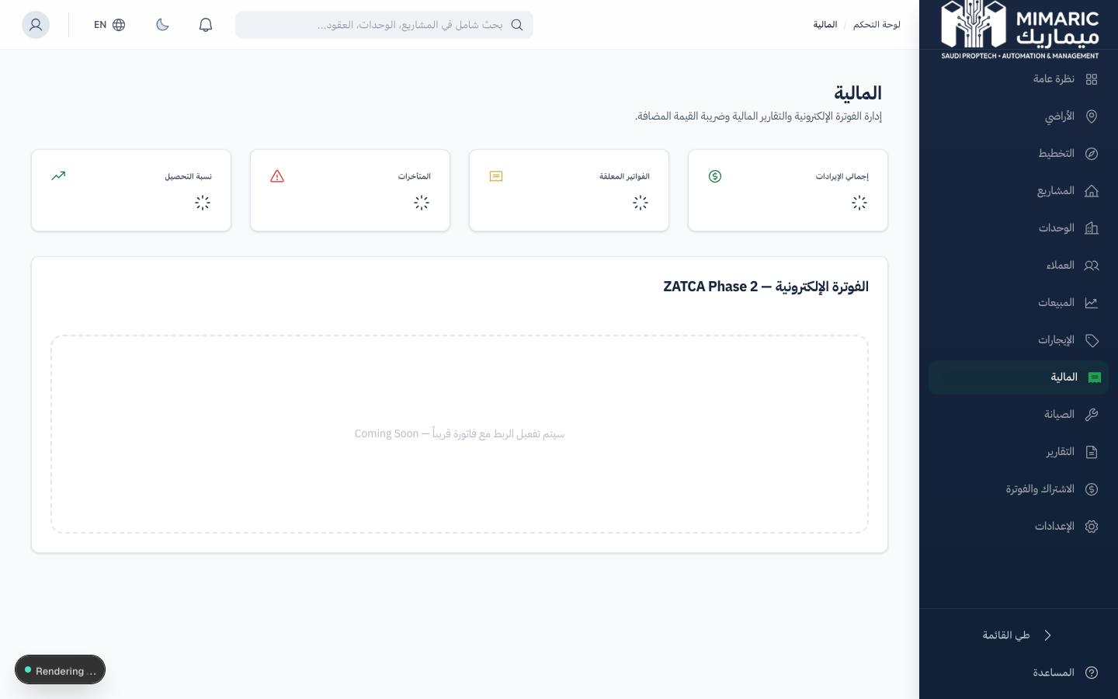
Figure: Finance module showing revenue KPIs, cost breakdown, and trend charts

Note
Finance is a read-and-report module. It aggregates data from Rentals (payments), Contracts (sale amounts), Maintenance (costs), and Projects (budgets). You don’t enter financial data here — it flows automatically from operational modules.

2. Getting Started

- Navigate to “Finance” (المالية) in the sidebar.
- The Finance dashboard loads with KPI cards and charts.
- Use the sub-navigation to access: Overview, Escrow Accounts.

Prerequisites
- Role: Finance Officer, Company Admin, or Super Admin.
- Data from other modules: leases with payments, signed contracts, maintenance work orders with cost tracking.

3. Core Tasks

3.1 Reading Revenue KPIs
The top section displays four financial KPI cards:
- Total Revenue: Sum of all paid rent installments and signed sale contract amounts.
- Pending Invoices: Sum of due (unpaid) installments that are not yet overdue.
- Overdue Amount: Sum of installments past their due date without payment.
- Collection Rate: Percentage of total due amount that has been collected (Paid ÷ Total Due).

3.2 Analyzing Maintenance Costs
The Maintenance Cost section breaks down costs by category:
- View cost breakdown across 10 categories: HVAC, Plumbing, Electrical, Structural, Fire Safety, Elevators, Cleaning, Landscaping, Pest Control, General.
- Compare estimated vs. actual costs to identify budget variances.
- Track 6-month maintenance cost trends to identify increasing cost patterns.

3.3 Viewing Unit Revenue Breakdown
The Unit Revenue section provides granular profitability data:
- View revenue aggregated by project to identify top-performing properties.
- Drill into revenue by unit type (Apartment, Villa, Office, etc.) to understand which segments generate the most revenue.
- For each unit, view: rent collected, sale revenue, maintenance costs, and net income.

3.4 Tracking Land Investments
The Land Investment section aggregates metrics from the Land Acquisition module:
- Total acquisition cost across all land parcels.
- Current portfolio value (based on per-sqm market estimates).
- ROI calculation: (Portfolio Value - Acquisition Cost) ÷ Acquisition Cost.

3.5 Managing Escrow Accounts
- Navigate to Finance > Escrow.
- View all project-level escrow accounts with current balances.
- Click any account to see the full transaction history: deposits, withdrawals, reversals.
- Deposits are auto-created when sale contracts are signed. Reversals are auto-created when contracts are voided.

Important
Escrow accounts follow Wafi regulations. Each off-plan project has a dedicated escrow account. Finance Officers can view all transactions but manual entries require appropriate authorization.

3.6 Viewing Off-Plan Revenue
For organizations with off-plan projects, the Off-Plan Revenue section shows:
- Revenue breakdown by launch wave (Wave 1, Wave 2, etc.).
- Total pipeline value: unreserved + reserved + sold inventory.
- Conversion rate from available to sold.

4. Advanced Topics

4.1 ZATCA VAT Integration
All financial calculations include 15% VAT per ZATCA requirements. VAT is auto-calculated on invoices and included in revenue figures. Phase 2 e-invoicing integration is planned for Q3 2026.

4.2 Exporting Financial Reports
Financial data can be exported in Excel or PDF format. Exports include date range filters and are available for: revenue summaries, installment schedules, cost breakdowns, and escrow statements.

4.3 P&L Per Unit and Project
For detailed profitability analysis, view P&L at the unit level (via Unit Matrix detail panel) or project level (via Project Financials tab). The Finance module provides the aggregate portfolio view.

5. Frequently Asked Questions

Q: Is the system ZATCA compliant?
Yes. The financial module calculates 15% VAT on all transactions. Invoice generation includes VAT line items. ZATCA Phase 2 e-invoicing API integration is planned for Q3 2026.
Q: How does the escrow account work?
An escrow account is created per project per Wafi regulations. When a sale contract is signed, a deposit is auto-recorded. When voided, a reversal is auto-recorded. Finance Officers can track all movements from the Escrow page.
Q: How do I view the financial summary for a unit?
Open any unit’s details in the Unit Matrix. The Financial Summary shows rent collected, sale revenue, maintenance costs, and net income — all auto-calculated.
Q: Can I enter manual financial transactions?
The Finance module is primarily a reporting tool that aggregates data from operational modules. For manual adjustments, work through the source module (Rentals for payments, Contracts for sales).
Q: How do I export financial reports?
Use the Export button on the Finance dashboard. Select format (Excel/PDF) and date range. Reports include revenue summaries, cost breakdowns, and collection analytics.

6. Related Modules

Module | Relationship | When to Use
Rentals | Feeds rent payment data | Rent payments from leases appear as revenue
Contracts | Feeds sale contract amounts | Signed sale contracts contribute to revenue
Maintenance | Feeds maintenance cost data | Work order costs appear in cost analysis
Projects | Feeds project budgets and P&L | Project-level financial data aggregated
Land Acquisition | Feeds land investment data | Acquisition costs and portfolio value
Billing | SaaS subscription costs | Your Mimaric subscription invoices

— End of Finance User Guide —

