

User Guide
Maintenance
Work Order Management with Kanban Workflow and SLA Tracking
الصيانة

Version 1.0 | March 2026
Mimaric PropTech Co. | mimaric.com

Table of Contents

1. Module Overview

The Maintenance module is Mimaric’s Computerized Maintenance Management System (CMMS). It manages work orders from request through resolution, with technician assignment, priority management, cost tracking, and SLA monitoring.
Designed for Property Managers (who create and oversee work orders), Technicians (who execute work), and Finance Officers (who track maintenance costs).

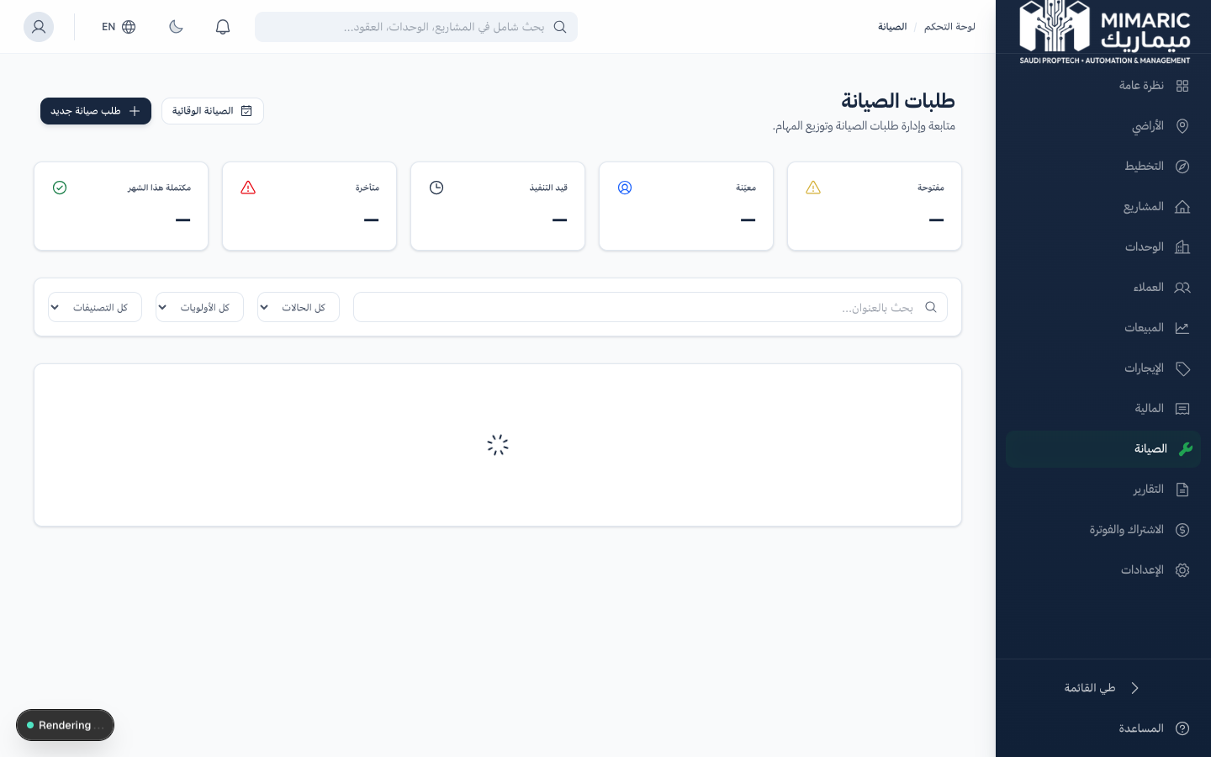
Figure: Maintenance module showing Kanban board with work orders organized by status

Work Order Lifecycle
Status | Description | Who Acts
Open | New request submitted, awaiting assignment | Property Manager assigns a technician
Assigned | Technician has been assigned | Technician reviews and begins work
In Progress | Work is actively being performed | Technician updates progress
On Hold | Work paused (waiting for parts, approval, etc.) | Technician or Manager resolves blocker
Resolved | Work completed, pending verification | Property Manager verifies resolution
Closed | Verified and archived | System archives after verification

2. Getting Started

- Navigate to “Maintenance” (الصيانة) in the sidebar.
- You’ll see the Kanban board with work orders organized by status columns.
- Toggle to Table view for a filterable list format.
- Click “New Request” to create your first work order.

3. Core Tasks

3.1 Creating a Maintenance Request
- Click “New Request” from the Maintenance page.
- Enter a descriptive title (e.g., “AC not cooling in Unit 205”).
- Select the unit where the issue is located.
- Choose the category: HVAC, Plumbing, Electrical, Structural, Fire Safety, Elevators, Cleaning, Landscaping, Pest Control, or General.
- Set priority: Low, Medium, High, or Urgent.
- Add a detailed description of the issue.
- Optionally attach photos or documents.
- Click Save. The work order is created with “Open” status.

Tip
Include specific details in the description: location within the unit, when the issue started, any error codes displayed. This helps technicians prepare before visiting.

3.2 Assigning a Technician
- Open the work order from the Kanban board or list.
- Click the “Assign” button.
- Select a technician from the dropdown (shows team members with Technician role).
- The work order status automatically changes to “Assigned.”

3.3 Tracking Work Order Progress
As work progresses, update the status:
Kanban View: Drag work order cards between status columns.
Detail View: Click the status dropdown to update.
At each status change, add a note describing what was done or what’s needed next.

3.4 Recording Costs
- Open the work order detail.
- Enter the estimated cost (before work begins).
- After completion, enter the actual cost.
- Record labor hours for workforce tracking.

Note
Maintenance costs flow automatically to the Finance module. Both estimated and actual costs are tracked, allowing budget vs. actual analysis.

3.5 Resolving and Closing Work Orders
- When work is complete, update status to “Resolved.”
- Add a resolution note describing what was done.
- The Property Manager verifies the resolution.
- After verification, update status to “Closed.” The work order is archived.

4. Advanced Topics

4.1 Priority-Based SLA Tracking
Priority levels imply response expectations:
- Urgent: Same-day response expected
- High: Response within 24 hours
- Medium: Response within 48 hours
- Low: Response within 1 week
The Kanban board highlights overdue work orders based on these thresholds.

4.2 Bulk Actions
In Table view, select multiple work orders to perform bulk actions: reassign technician, change priority, or update status.

4.3 Maintenance Statistics
The Maintenance module provides aggregate statistics: total open requests, average resolution time, cost by category, and technician workload distribution.

5. Frequently Asked Questions

Q: How do I submit a maintenance request?
From Maintenance, click ‘New Request.’ Select the unit, category (electrical, plumbing, HVAC...), priority, and describe the issue.
Q: Can tenants submit maintenance requests?
Currently, maintenance requests are created by Property Managers or Company Admins. A tenant self-service portal is planned for a future release.
Q: How do I track the cost of maintenance?
Each work order has estimated cost and actual cost fields. After resolution, enter the actual cost. These costs aggregate in the Finance module.
Q: Can I attach photos to a work order?
Yes. Use the attachment upload during creation or on the detail page. Photos help technicians understand the issue before visiting.
Q: How do I see all maintenance for a specific unit?
In the Unit Matrix, open a unit’s detail panel. The Maintenance section shows all work orders for that unit.

6. Related Modules

Module | Relationship | When to Use
Unit Matrix | Work orders reference units | Select a unit when creating a work order
Preventive Maintenance | Auto-generates work orders from plans | Scheduled maintenance creates recurring work orders
Finance | Costs feed financial reports | Work order costs appear in maintenance cost analysis
Projects | Work orders link to project properties | Maintenance tab on project detail shows work orders

— End of Maintenance User Guide —

