

User Guide
Preventive Maintenance
Scheduled Maintenance Plans to Prevent Breakdowns
الصيانة الوقائية

Version 1.0 | March 2026
Mimaric PropTech Co. | mimaric.com

Table of Contents

1. Module Overview

The Preventive Maintenance module enables proactive scheduling of recurring maintenance tasks. Instead of reacting to breakdowns, you define maintenance plans that auto-generate work orders on schedule — reducing emergency costs and extending asset life.
Designed for Property Managers who schedule maintenance and Technicians who execute recurring tasks.

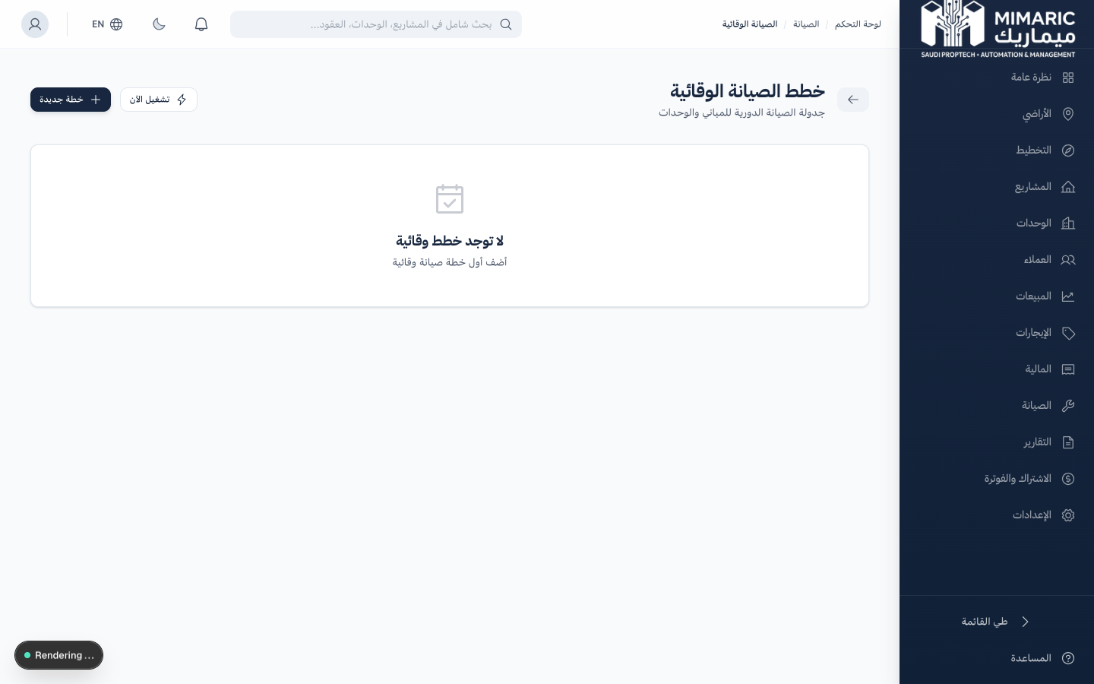
Figure: Preventive Maintenance showing scheduled plans with recurrence and next run dates

Recurrence Frequencies
Frequency | Use Case | Example
Daily | High-frequency operational tasks | Lobby cleaning, waste collection
Weekly | Regular inspections | Generator test run, fire alarm check
Monthly | Standard maintenance cycles | HVAC filter replacement, pest control
Quarterly | Seasonal maintenance | AC deep cleaning, roof inspection
Semi-Annual | Major system checks | Elevator certification, fire system test
Annual | Annual inspections and certifications | Civil defense inspection, electrical audit
One-Time | Scheduled non-recurring tasks | Initial setup, warranty inspection

2. Getting Started

- Navigate to Maintenance > Preventive Maintenance (الصيانة الوقائية).
- You’ll see a list of all preventive maintenance plans with their status and next run date.
- Click “New Plan” to create your first scheduled maintenance plan.

3. Core Tasks

3.1 Creating a Preventive Maintenance Plan
- Click “New Plan” from the Preventive Maintenance page.
- Enter the plan title (e.g., “Monthly HVAC Filter Replacement — Building A”).
- Select the category (HVAC, Plumbing, Electrical, etc.).
- Choose the recurrence type (Daily, Weekly, Monthly, Quarterly, Semi-Annual, Annual, One-Time).
- Set the recurrence interval (e.g., every 1 month, every 3 months).
- Set the next run date (when the first work order should be created).
- Optionally assign a default technician.
- Click Save. The plan is created and activated.

Tip
Create separate plans for each building or property section. This allows different schedules for different buildings and easier tracking of per-building maintenance costs.

3.2 Managing Active Plans
- View all plans in the list with status (Active/Inactive) and next run date.
- Toggle plans Active/Inactive using the status toggle.
- Edit plan details: frequency, interval, assigned technician, category.
- Delete plans that are no longer needed.

3.3 Auto-Generated Work Orders
When a plan’s run date arrives, the system automatically:
- Creates a new maintenance work order in the Maintenance module.
- Sets the work order title, category, and description from the plan template.
- Assigns the default technician (if specified in the plan).
- Calculates and sets the next run date based on the recurrence frequency.

Note
Auto-generated work orders appear in the Maintenance module with all standard work order capabilities: assignment, progress tracking, cost recording, and resolution workflow.

4. Advanced Topics

4.1 Post-Handover Auto-Setup
When a project reaches the handover stage, Mimaric can automatically create a set of standard preventive maintenance plans for the completed buildings: HVAC quarterly service, elevator semi-annual inspection, fire system annual check, and cleaning schedules.

4.2 Cost Forecasting
By reviewing historical costs of auto-generated work orders, you can forecast annual maintenance budgets per building or per property. This data is accessible through the Finance module’s maintenance cost analysis.

5. Frequently Asked Questions

Q: What is preventive maintenance?
Preventive maintenance schedules recurring work (daily, weekly, monthly, annual) to prevent breakdowns. Work orders are auto-generated per schedule.
Q: Can I pause a plan temporarily?
Yes. Toggle the plan to ‘Inactive.’ No work orders will be generated until you reactivate it. The next run date will be recalculated on reactivation.
Q: What happens if I change the frequency of an active plan?
The next run date is recalculated based on the new frequency. Existing work orders are not affected.
Q: Can auto-generated work orders be edited?
Yes. Auto-generated work orders are full work orders with all standard capabilities. You can reassign technicians, change priority, add notes, and record costs.

6. Related Modules

Module | Relationship | When to Use
Maintenance | Receives auto-generated work orders | Plans create work orders on schedule
Projects | Post-handover auto-setup | Standard plans created after project handover
Finance | Cost tracking from recurring work | Maintenance costs aggregate in financial reports
Unit Matrix | Work orders reference units | Plans can target specific buildings/units

— End of Preventive Maintenance User Guide —

