

User Guide
Documents
Centralized File Library with Versioning and Categorization
المستندات

Version 1.0 | March 2026
Mimaric PropTech Co. | mimaric.com

Table of Contents

1. Module Overview

The Documents module provides a centralized repository for all files related to your real estate operations: contracts, blueprints, feasibility studies, approval letters, invoices, receipts, insurance policies, and warranties.
Every document can be linked to a project, customer, unit, or building, and supports version tracking so you always know which version is current.

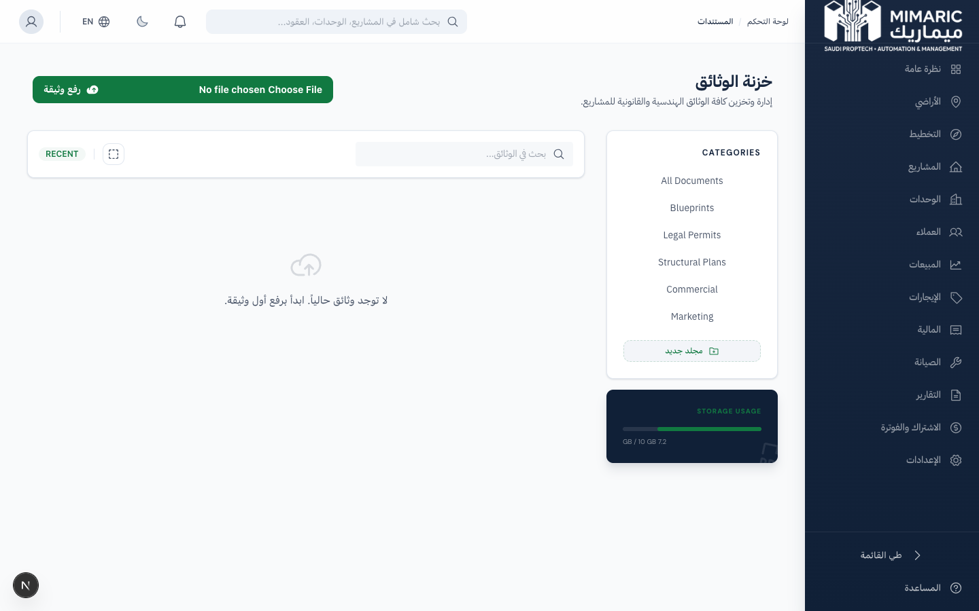
Figure: Documents library showing categorized files with search and filter options

Document Categories
Category | Description | Common File Types
Contract | Sale and lease agreements | PDF (max 16MB)
Blueprint | Architectural and engineering drawings | PDF, PNG, JPG (max 32MB)
Feasibility | Feasibility studies and market analyses | PDF, XLSX, DOCX (max 32MB)
Subdivision | Subdivision plans and plot maps | PDF, PNG (max 32MB)
Approval | Government approval letters and permits | PDF (max 32MB)
Invoice / Receipt | Financial documents | PDF, PNG (max 16MB)
Insurance / Warranty | Policies and warranty certificates | PDF (max 16MB)
Other | General documentation | PDF, images, XLSX, DOCX (max 32MB)

2. Getting Started

- Navigate to “Documents” in the sidebar (or access documents from within Project/Contract detail pages).
- You’ll see the document library with search, filters, and category tabs.
- Click “Upload Document” to add your first file.

3. Core Tasks

3.1 Uploading Documents
- Click “Upload Document” or drag files into the upload zone.
- Select the document category (Contract, Blueprint, Approval, etc.).
- Link the document to a project, customer, unit, or building.
- Add a descriptive name and optional notes.
- Click Upload. The file is securely stored and indexed.

Note
File size limits depend on the category: Contracts max 16MB, Blueprints and general documents max 32MB. Supported formats: PDF, PNG, JPG, XLSX, DOCX.

3.2 Searching and Filtering Documents
- Use the search bar to find documents by name or description.
- Filter by category using the category tabs.
- Filter by linked entity: project, customer, unit, or building.
- Sort by upload date, name, or size.

3.3 Managing Document Versions
- Open a document’s detail view.
- Click “Upload New Version.”
- Upload the updated file and add a change note.
- The new version becomes current. Previous versions remain accessible in the version history.

3.4 Downloading Documents
- Click the download icon on any document in the library.
- The file downloads in its original format.
- To download a specific version, open the version history and click download on that version.

4. Advanced Topics

4.1 Documents Within Other Modules
Documents can also be uploaded directly from other modules: Project detail page (Documents tab), Contract detail page (upload signed contracts), and Land detail page (upload title deeds and surveys). These documents automatically appear in the centralized Documents module.

4.2 Access Control
Document access follows your role-based permissions. Documents linked to projects are visible to anyone with access to that project. Personal documents linked to customers respect PII access controls.

5. Frequently Asked Questions

Q: How do I upload and manage documents?
Navigate to Documents, click ‘Upload Document,’ select category, link to a project/customer/unit, and upload. Use version management for updated files.
Q: What file types are supported?
PDF, PNG, JPG, XLSX, DOCX, and more. The maximum file size is 16MB for contracts and 32MB for blueprints and general documents.
Q: Can I link a document to multiple projects?
Currently, each document is linked to one primary entity (project, customer, unit, or building). For shared documents, upload them at the organization level without linking.
Q: Is there a storage limit?
Storage limits depend on your subscription tier. Check Billing > Plan Details for your current usage and limits.

6. Related Modules

Module | Relationship | When to Use
Projects | Store project-related documents | Upload blueprints, approvals, site photos
Contracts | Store signed agreements | Upload signed sale/lease contracts
Land Acquisition | Store land documents | Upload title deeds, surveys, feasibility reports

— End of Documents User Guide —

