

User Guide
Help Center
FAQs, Step-by-Step Guides, Support Tickets, and Permission Requests
مركز المساعدة

Version 1.0 | March 2026
Mimaric PropTech Co. | mimaric.com

Table of Contents

1. Module Overview

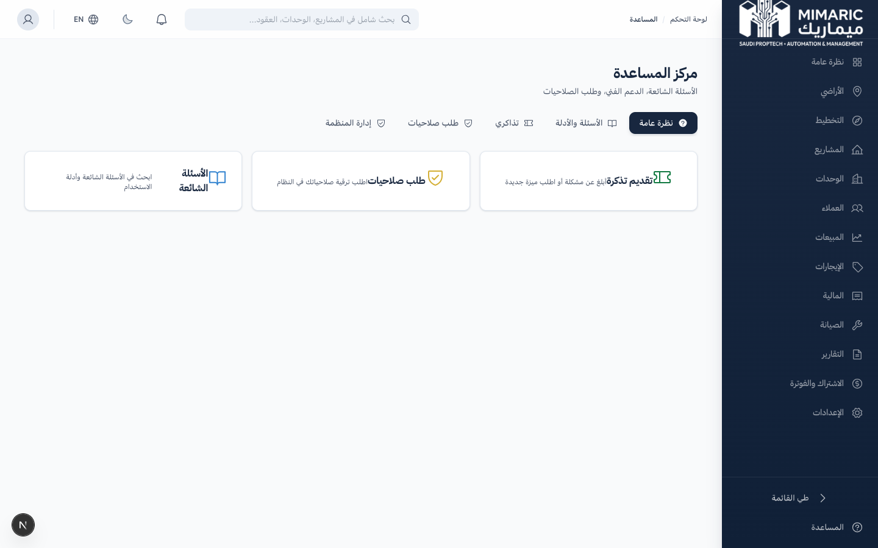
Figure: Help Center showing FAQs, step-by-step guides, and support ticket system

The Help Center is Mimaric’s in-app support hub. It provides self-service resources (FAQs and step-by-step guides), a support ticket system for issues that need human assistance, and a permission request workflow for role upgrades.

Help Center Tabs
Tab | Purpose | Who Uses It
Overview | Quick links to common help topics | All users
FAQs & Guides | 58 FAQs across 8 categories + 24 step-by-step guides | All users
My Tickets | Support ticket creation and tracking | All users
Request Permissions | Request role upgrade or additional permissions | All users
Org Management | Manage permission requests and join requests | Company Admin only

2. Getting Started

- Click “Help” (المساعدة) in the sidebar or the question mark icon.
- Browse FAQs by category or search for specific topics.
- If you can’t find an answer, create a support ticket.

3. Core Tasks

3.1 Browsing FAQs and Guides
- Go to the “FAQs & Guides” tab.
- Browse 8 FAQ categories: Getting Started, Off-Plan Development, Planning, Sales & CRM, Property Management, Finance, Security & Privacy, Technical.
- Click any question to expand the answer.
- Switch to the “Guides” sub-tab for 24 step-by-step operational guides.
- Guides are grouped by module with numbered steps.

Tip
Use the search bar to find specific topics across all FAQs and guides simultaneously. Search works in both Arabic and English.

3.2 Creating a Support Ticket
- Go to the “My Tickets” tab.
- Click “New Ticket.”
- Enter a subject line describing the issue.
- Select the category: Technical, Billing, Feature Request, Bug Report, Data Issue, or General.
- Set priority: Low, Medium, High, or Urgent.
- Write a detailed description and optionally attach files.
- Click Submit. Your ticket enters “Open” status.

3.3 Tracking Ticket Status
Tickets move through 5 statuses:
- Open → In Progress → Waiting Customer → Resolved → Closed
When support replies, you’ll see their message in the ticket thread. You can reply to provide additional information.

3.4 Requesting Additional Permissions
- Go to the “Request Permissions” tab.
- Select the role you need (e.g., Sales Manager, Finance Officer).
- Write a reason explaining why you need this role.
- Submit the request. Your Company Admin will review and approve or decline.

4. Advanced Topics

4.1 Admin: Managing Permission Requests
Company Admins see the “Org Management” tab where they can review and approve/decline permission requests and organization join requests from new users.

4.2 Bilingual Support
All 58 FAQs and 24 guides are available in both Arabic and English. Content switches automatically based on your language preference.

5. Frequently Asked Questions

Q: How do I get started with Mimaric?
After logging in, you’ll reach the main dashboard. Start by adding a project from the Projects section, then add buildings and units.
Q: How do I request additional permissions?
Go to Help > Request Permissions. Select the desired role and write your reason. An admin will review and approve or decline your request.
Q: How long do support tickets take to resolve?
Response times depend on priority: Urgent (same day), High (24 hours), Medium (48 hours), Low (1 week). Complex issues may take longer.
Q: Can I reopen a resolved ticket?
Yes. Reply to the resolved ticket with additional details, and it will be reopened for further investigation.

6. Related Modules

Module | Relationship | When to Use
Settings | Admin manages team roles | Permission requests are reviewed by admins in Settings
All Modules | FAQs and guides cover all modules | Browse guides for specific module operations

— End of Help Center User Guide —

