

User Guide
Billing
Subscription Management, Plan Comparison, and Invoice Tracking
الفواتير

Version 1.0 | March 2026
Mimaric PropTech Co. | mimaric.com

Table of Contents

1. Module Overview

The Billing module manages your Mimaric SaaS subscription. View your current plan, compare available tiers, upgrade or downgrade, view invoices, apply coupon codes, and manage payment methods.

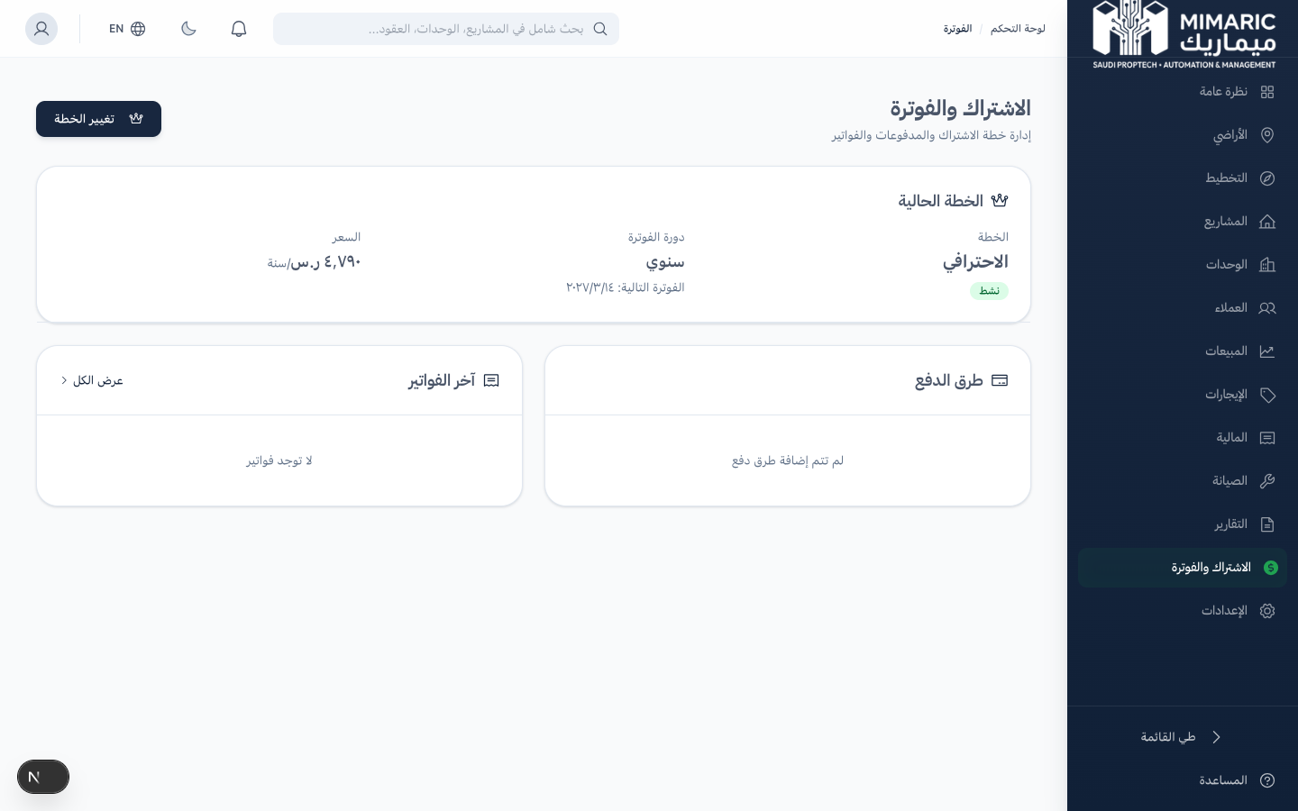
Figure: Billing dashboard showing subscription plan, usage metrics, and invoice history

Subscription Tiers
Feature | Lite | Professional | Enterprise
Target | Small portfolios | Property management cos. | Large developers
Projects | Up to 5 | Up to 25 | Unlimited
Units | Up to 100 | Up to 1,000 | Unlimited
Team Members | Up to 5 | Up to 25 | Unlimited
Planning OS | — | — | ✓
Wafi Compliance | — | — | ✓
Support | Email | Priority | Dedicated AM

2. Getting Started

- Navigate to “Billing” (الفواتير) in the sidebar.
- View your current plan, billing cycle, and next payment date.
- Click “Plans” to compare available tiers.

Note
Only Company Admins can manage billing and subscription changes. Other roles can view the current plan but cannot modify it.

3. Core Tasks

3.1 Viewing Your Current Plan
- The Billing dashboard shows: current plan name, billing cycle (monthly/annual), next payment date, and payment method.
- Usage metrics show: projects used vs. limit, units used vs. limit, team members vs. limit.

3.2 Comparing and Switching Plans
- Click “Plans” to see the plan comparison page.
- Review features, limits, and pricing for each tier.
- Toggle between Monthly and Annual billing (annual saves 15%).
- Click “Upgrade” or “Downgrade” on the desired plan.
- Confirm the change. Plan switches take effect at the start of the next billing cycle.

3.3 Viewing and Downloading Invoices
- Click “Invoices” to see all billing history.
- Each invoice shows: date, amount (including 15% VAT), plan name, and payment status.
- Click “Download” to get the invoice PDF.

3.4 Applying Coupon Codes
- Navigate to Billing and look for the “Coupon” section.
- Enter the coupon code and click Apply.
- If valid, the discount is applied to your next invoice.

4. Advanced Topics

4.1 VAT on Subscriptions
All subscription prices are subject to 15% VAT per ZATCA requirements. VAT is itemized on every invoice.

4.2 Payment Methods
Currently supported: credit/debit card (Visa, Mastercard). Mada and SADAD integration is planned for Q3 2026.

5. Frequently Asked Questions

Q: How do I manage my subscription and billing?
Navigate to Billing to view your current plan, switch plans, view invoices, and manage payment methods. Only Company Admins can modify billing.
Q: What happens if I exceed my plan limits?
You’ll receive a notification when approaching limits. You cannot create new projects/units beyond your plan limit until you upgrade.
Q: Can I cancel my subscription?
Contact support to cancel. Your data is retained for 30 days after cancellation, allowing you to re-subscribe and restore access.
Q: Is there a free trial?
Yes. New organizations get a 14-day free trial of the Professional plan, no credit card required.

6. Related Modules

Module | Relationship | When to Use
Settings | Organization profile and team management | Manage team members within plan limits
Finance | Subscription costs in financial view | Track Mimaric subscription as an operational expense

— End of Billing User Guide —

