

User Guide
Settings
Organization Profile, Team Management, Security, and Audit Logs
الإعدادات

Version 1.0 | March 2026
Mimaric PropTech Co. | mimaric.com

Table of Contents

1. Module Overview

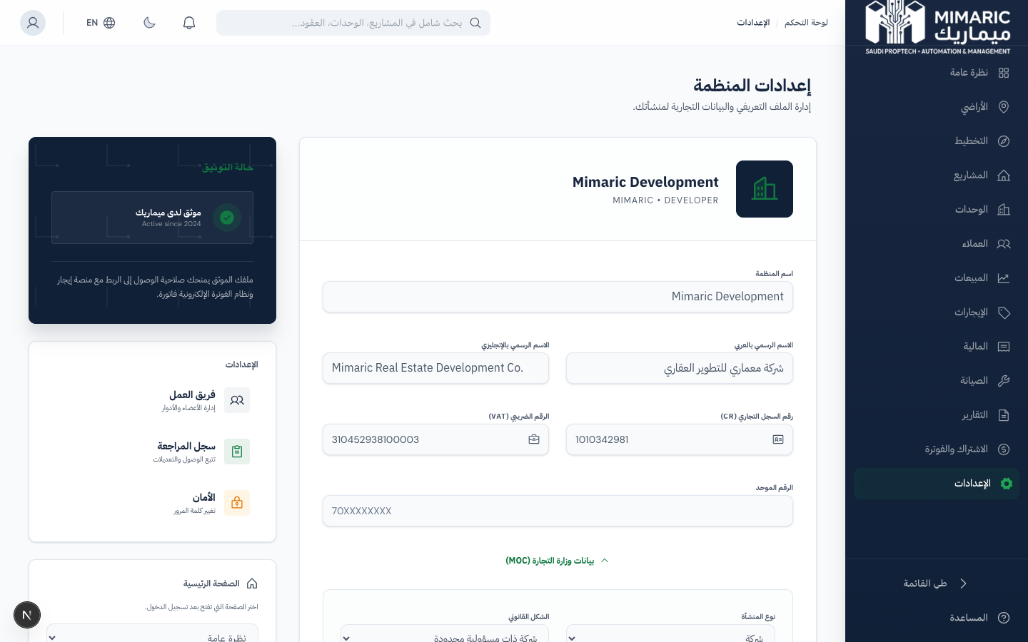
Figure: Settings showing organization profile, team management, and audit logs

The Settings module is your organization’s control center. It manages organizational identity, team membership, security policies, and provides access to the PDPL-compliant audit log for compliance monitoring.

Settings Tabs
Tab | Purpose | Required Role
Organization | Company name, logo, CR number, VAT, contact details | Company Admin
Team | Invite members, assign roles, manage active users | Company Admin
Security | Change password, configure security preferences | All users (own account)
Audit Log | View all system activity: logins, data access, PII reads | Company Admin, System Admin

2. Getting Started

- Click “Settings” (الإعدادات) in the sidebar or the gear icon.
- You’ll land on the Organization tab showing your company profile.
- Navigate between tabs: Organization, Team, Security, Audit Log.

3. Core Tasks

3.1 Editing Organization Profile
- Go to Settings > Organization.
- Edit company name (Arabic and English), Commercial Registration number, VAT number.
- Upload or update the organization logo.
- Enter business contact details: address, phone, email, website.
- Click Save Changes.

Note
The Commercial Registration number and entity type align with MOC (Ministry of Commerce) data fields for future government integration.

3.2 Managing Team Members
- Go to Settings > Team.
- View all active team members with their roles and join dates.
- To invite a new member: click “Invite Member,” enter their email, and select a role.
- To change a member’s role: click the role dropdown on their row.
- To remove a member: click the delete icon (this revokes access immediately).

Important
Removing a team member is immediate and cannot be undone. The removed user loses all access to the organization’s data. Their historical actions remain in the audit log.

3.3 Changing Your Password
- Go to Settings > Security.
- Enter your current password.
- Enter a new password (minimum 10 characters).
- The system validates: minimum length, no common passwords, no username/email in password.
- Click Update Password.

Note
Password policy follows NIST SP 800-63B guidelines (adopted by NCA): minimum 10 characters, common password blocklist, contextual rejection, and progressive rate limiting on failed attempts.

3.4 Reviewing the Audit Log
- Go to Settings > Audit Log (Company Admin only).
- View all system events: logins, data creates, updates, deletes, PII reads, exports, status changes, settings changes.
- Filter by: user, action type, date range, resource.
- Each entry shows: timestamp, user, role, action, resource, IP address, and details.

Important
The audit log is your primary PDPL Article 32 compliance tool. It provides evidence of who accessed what data, when, and from where. Retain audit logs for regulatory inspections.

4. Advanced Topics

4.1 Role Hierarchy
Mimaric has 13 user roles organized in 3 tiers:
- System Tier: System Admin, System Support — full platform access.
- Management Tier: Company Admin, Super Admin, Project Manager, Sales Manager, Property Manager, Finance Officer — organization-scoped.
- Operational Tier: Sales Agent, Technician, Engineering Consultant, Buyer, Tenant, User — task-specific access.

4.2 Onboarding Completion
Settings tracks your onboarding progress. The onboarding wizard has 4 steps: Organization Path, Business Identity, Contact Information, Team Invitations. You can resume onboarding from Settings if you skipped steps during initial setup.

4.3 Organization Discovery
Users who want to join an existing organization can discover it by searching with the 10-digit Commercial Registration (CR) number. Join requests are managed by the Company Admin in Help > Org Management.

5. Frequently Asked Questions

Q: What roles are available in the system?
Mimaric offers 13 roles: System Admin, System Support, Company Admin, Super Admin, Project Manager, Sales Manager, Sales Agent, Property Manager, Finance Officer, Technician, Engineering Consultant, Buyer, Tenant, and User.
Q: How do I manage team members?
Go to Settings > Team. Click ‘Invite Member’ to add, change role via dropdown, or click delete to remove. Only Company Admins can manage team.
Q: Can I see who accessed customer data?
Yes. The Audit Log tracks all PII reads with READ_PII action type. Filter by this action to see who viewed personal data, when, and from which IP.
Q: What happens if I forget my password?
Use the ‘Forgot Password’ link on the login page to receive a password reset email. Progressive rate limiting applies: 5 failed attempts lock for 30 seconds, 10 for 5 minutes, 20 for 15 minutes.

6. Related Modules

Module | Relationship | When to Use
Help Center | Permission requests flow through Help | Users request role upgrades via Help > Request Permissions
Billing | Subscription tied to organization | Plan limits affect team size and project counts
All Modules | Roles control access to every module | Team role assignment determines module visibility

— End of Settings User Guide —

