In the e-learning website [www.atiral.com](http://www.atiral.com), web page for selecting a course is designed in three different ways to enhance usability.

**Version A:**

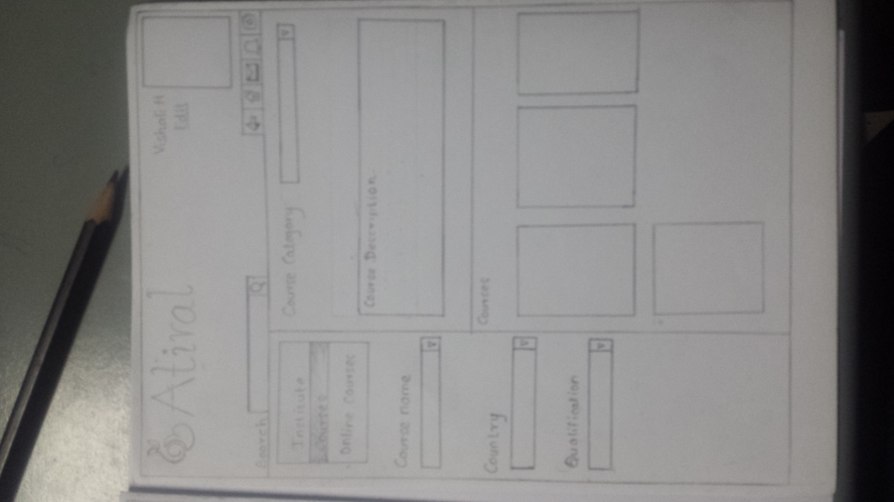

* The e-learning site has no smart search function implemented. Therefore this particular design has search function designed with smart search. And also the search field is shifted to the left side of the page which is more user friendly.
* There is no way in the website to go back to the previous page. An icon is added in the menu bar to allow user to go back to the previous page.
* User must select course category, course name, country and qualification in this particular page. But in the website, for each field the entire name has to be typed. So in this design each of these fields are designed with drop down boxes.

It is also not a must to select country, qualification to view details about a particular course. By only selecting the course category, details can be viewed. Therefore control to select to course category has been added in the centre.

* Description for each course selected will be displayed on the middle of the page which is more eye catching.
* User’s profile picture is shifted to the right hand upper corner, so that user can find it easily on the page.
* Sections called course, institute and online course has been shifted from horizontal menu bar to left side of page since it has no any drop down.

**Version B:**

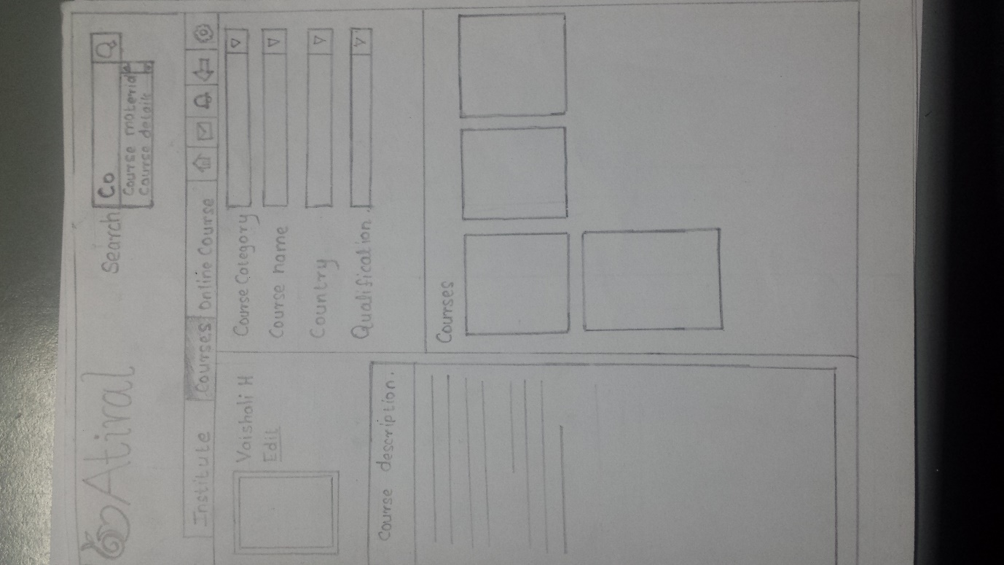

* The e-learning site has no smart search function implemented. Therefore this particular design has search function designed with smart search.
* There is no way in the website to go back to the previous page. An icon is added in the menu bar to allow user to go back to the previous page.
* User must select course category, course name, country and qualification in this particular page. But in the website, for each field the entire name has to be typed. So in this design each of these fields are designed with drop down boxes.
* Description for each course selected will be displayed on the left side of the page

**Version C:**

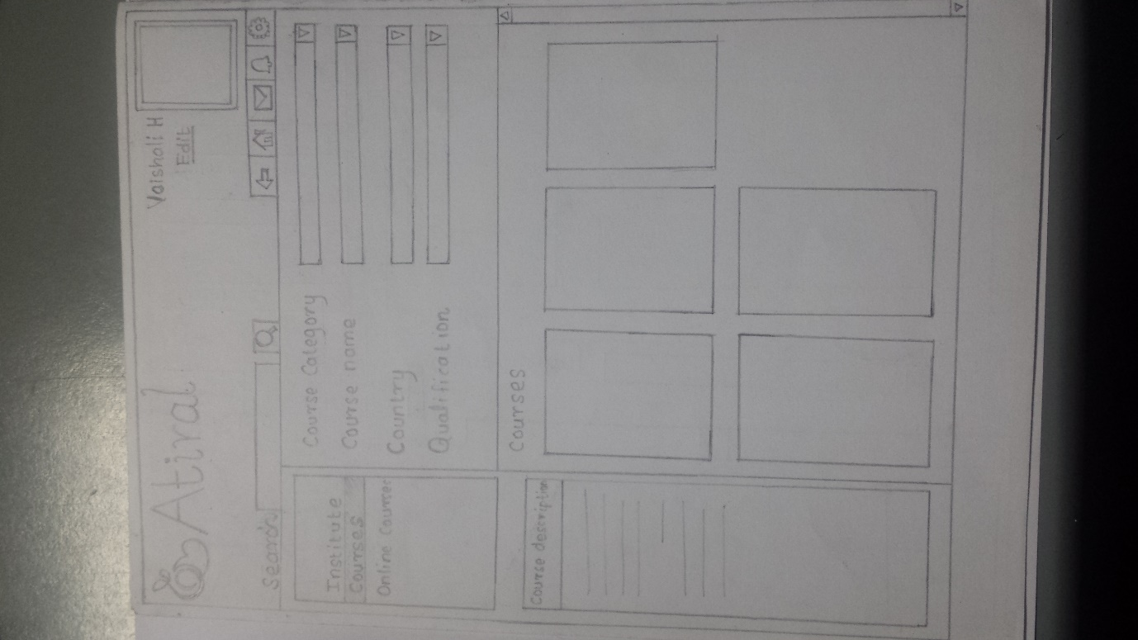

**Version C:**

* User must select course category, course name, country and qualification in this particular page. But in the website, for each field the entire name has to be typed. So in this design each of these fields are designed with drop down boxes.
* There is no way in the website to go back to the previous page. An icon is added in the menu bar to allow user to go back to the previous page.
* Description for each course selected will be displayed on the left side of the page.
* User’s profile picture is shifted to the right hand upper corner, so that user can find it easily on the page.
* Sections called course, institute and online course has been shifted from horizontal menu bar to left side of page since it has no any drop down.

Among the three designs, **Version A** is the best design which is more user friendly and satisfies the user feedback.