**Assignment-1**

**Data Set: Frailty**

1. In the below graph, X-axis represents frailty and Y-axis represents Grip Strength in kgs. A box plot is plotted to represent the relationship between Frailty and Grip Strength.

***Conclusion:***

We can conclude that the increase in Grip Strength corresponds to increase in Physical Strength of an individual.

1. Height, Weight, Age, Grip Strength, and Frailty are used to represent a Correlation Matrix to understand the patterns or relationship or dependencies between the variables.

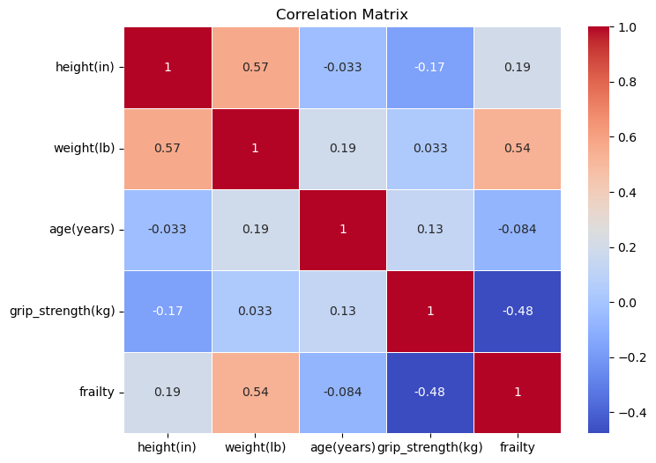

***Conclusion:***

By looking at the heat map, it is clear that the frailty and grip strength are negatively

correlated to each other and the frailty - weight and height - weight are positively correlated to each other.