Lavanya Ghanathey 16342393

***Assignment-3***

1. Setting a seed value to generate a random sample size of 25 and comparing the mean and highest glucose values of the sample and the population.

***Conclusion:***

The population mean and sample mean are nearly equal when we examine the glucose statistics.

1. Comparing the results of 98th percentile values of BMI for sample and population.

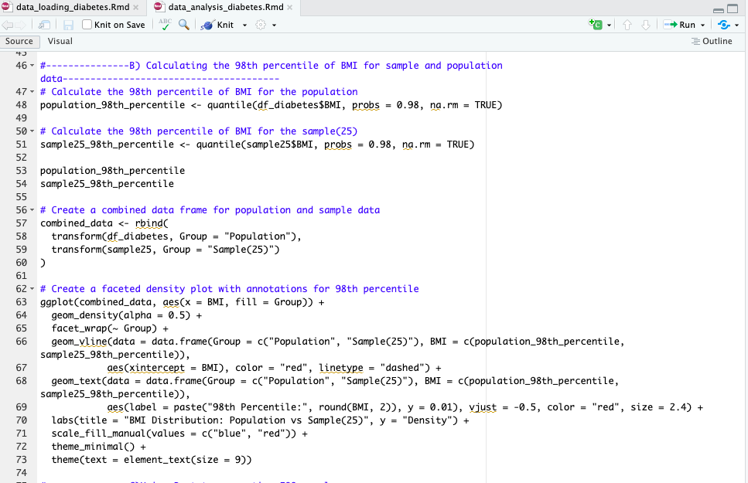

***Conclusion:***

The 98th percentile value of BMI for the population and sample size of 25 are almost similar i:e 47.53 and 45.12

1. Creating 500 samples of 150 observations each from the population and finding the average mean, standard deviation and percentile for Blood Pressure and comparing the values.

***Conclusion:***

The population values in the line plots and histograms are closely aligned with the bootstrap means, standard deviations, and percentiles. This implies that the bootstrap samples are representative of the population, allowing for accurate blood pressure statistics estimates.