**NAMA : Sonnya Ghandi**

**KELAS : Informatika Malam A**

**NIM : 201351131**

**TUGAS 1**

1. **Membuat kalimat**

**Source code :**

var word = 'JavaScript';

var second = 'is';

var third = 'awesome';

var fourth = 'and';

var fifth = 'I';

var sixth = 'love';

var seventh = 'it!';

var sentence = `${word} ${second} ${third} ${fourth} ${fifth} ${sixth} ${seventh}`

console.log(sentence);

**Output :**



1. **Mengurai kalimat (Akses karakter dalam string)**

**Source code :**

var sentence = "I am going to be React Native Developer";

var exampleFirstWord = sentence[0];

var exampleSecondWord = sentence[2] + sentence[3];

var thirdWord = sentence[5] + sentence[6] + sentence[7] + sentence[8] + sentence[9];

var fourthWord = sentence[11] + sentence[12];

var fifthWord = sentence[14] + sentence[15];

var sixthWord = sentence[17] + sentence[18] + sentence[19] + sentence[20] + sentence[21];

var seventhWord = sentence[23] + sentence[24] + sentence[25] + sentence[26] + sentence[27] + sentence[28];

var eighthWord = sentence[30] + sentence[31] + sentence[32] + sentence[33] + sentence[34] + sentence[35] + sentence[36] + sentence[37] + sentence[38];

console.log('First Word: ' + exampleFirstWord);

console.log('Second Word: ' + exampleSecondWord);

console.log('Third Word: ' + thirdWord);

console.log('Fourth Word: ' + fourthWord);

console.log('Fifth Word: ' + fifthWord);

console.log('Sixth Word: ' + sixthWord);

console.log('Seventh Word: ' + seventhWord);

console.log('Eighth Word: ' + eighthWord);

Output:

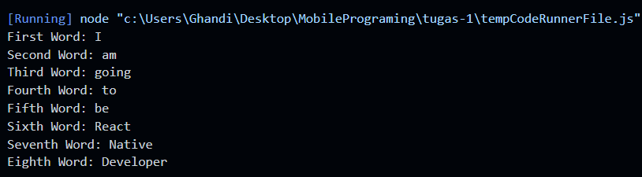

1. **Mengurai Kalimat (Substring)**

**Source code:**

var sentence2 = 'wow JavaScript is so cool';

var exampleFirstWord2 = sentence2.substring(0, 3);

var secondWord2 = sentence2.substring(4, 14);

var thirdWord2 = sentence2.substring(15, 17);

var fourthWord2 = sentence2.substring(18, 20);

var fifthWord2 = sentence2.substring(21, 25);

console.log('First Word: ' + exampleFirstWord2);

console.log('Second Word: ' + secondWord2);

console.log('Third Word: ' + thirdWord2);

console.log('Fourth Word: ' + fourthWord2);

console.log('Fifth Word: ' + fifthWord2);

**Output:**

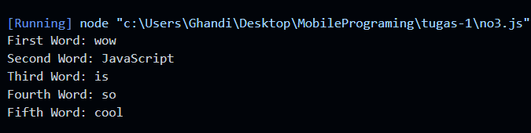

1. **Mengurai Kalimat dan Menentukan Panjang String**

**Source code:**

var sentence3 = "wow JavaScript is so cool";

var exampleFirstWord3 = sentence3.substring(0, 3);

var secondWord3 = sentence3.substring(4, 14);

var thirdWord3 = sentence3.substring(15, 17);

var fourthWord3 = sentence3.substring(18, 20);

var fifthWord3 = sentence3.substring(21, 25);

var firstWordLength = exampleFirstWord3.length;

var secondWordLength = secondWord3.length;

var thirdWordLength = thirdWord3.length;

var fourthWordLength = fourthWord3.length;

var fifthWordLength = fifthWord3.length;

console.log("First Word: " + exampleFirstWord3 + ", with length: " + firstWordLength );

console.log("Second Word: " + secondWord3 + ", with length: " + secondWordLength);

console.log("Third Word: " + thirdWord3 + ", with length: " + thirdWordLength);

console.log("Fourth Word: " + fourthWord3 + ", with length: " + fourthWordLength);

console.log("Fifth Word: " + fifthWord3 + ", with length: " + fifthWordLength);

**Output:**

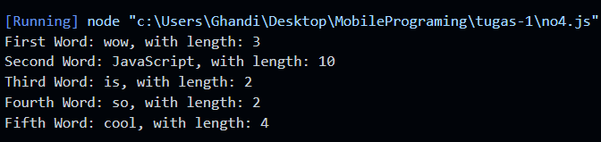

1. **If-else**

**Source code :**

var nama = 'Zack'

var peran = 'penyihir'

if (nama == '') {

console.log("Nama harus diisi!!");

} else if (peran == '') {

console.log(`Halo ${nama}, Pilih peranmu untuk memulai game!`);

} else if (peran.toLocaleLowerCase == 'penyihir') {

console.log(`Selamat datang di dunia werewolf, ${nama}`);

console.log(`Halo ${peran} ${nama}, kamu dapat melihat siapa yang jadi werewolf`);

} else if (peran.toLocaleLowerCase == 'guard') {

console.log(`Selamat datang di dunia werewolf, ${nama}`);

console.log(`Halo ${peran} ${nama}, kamu akan membantu melindungi temanmu dari serangan werewolf`);

} else if (peran.toLocaleLowerCase == 'werewolf') {

console.log(`Selamat datang di dunia werewolf, ${nama}`);

console.log(`Halo ${peran} ${nama}, kamu akan memangsa setiap malam`);

}

**Output:**

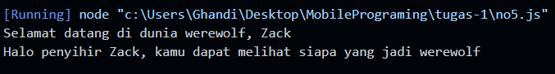

1. **Switch Case**

**Source code :**

var tanggal = 17;

var bulan = 8 ;

var tahun = 1945;

switch (bulan) {

case 1:

console.log(`${tanggal} Januari ${tahun}`);

break;

case 2:

console.log(`${tanggal} Februari ${tahun}`);

break;

case 3:

console.log(`${tanggal} Maret ${tahun}`);

break;

case 4:

console.log(`${tanggal} April ${tahun}`);

break;

case 5:

console.log(`${tanggal} Mei ${tahun}`);

break;

case 6:

console.log(`${tanggal} Juni ${tahun}`);

break;

case 7:

console.log(`${tanggal} Juli ${tahun}`);

break;

case 8:

console.log(`${tanggal} Agustus ${tahun}`);

break;

case 9:

console.log(`${tanggal} September ${tahun}`);

break;

case 10:

console.log(`${tanggal} Oktober ${tahun}`);

break;

case 11:

console.log(`${tanggal} November ${tahun}`);

break;

case 12:

console.log(`${tanggal} Desember ${tahun}`);

break;

default:

console.log("Bulan yang anda inputkan salah");

break;

}

**Output :**



1. **Looping While**

**Source code :**

var i = 2

console.log('LOOPING PERTAMA');

while (i <= 20) {

console.log(`${i} - I love coding`);

i += 2

}

console.log('LOOPING KEDUA');

while (i > 2) {

i -= 2

console.log(`${i} - I love coding`);

}

**Output :**

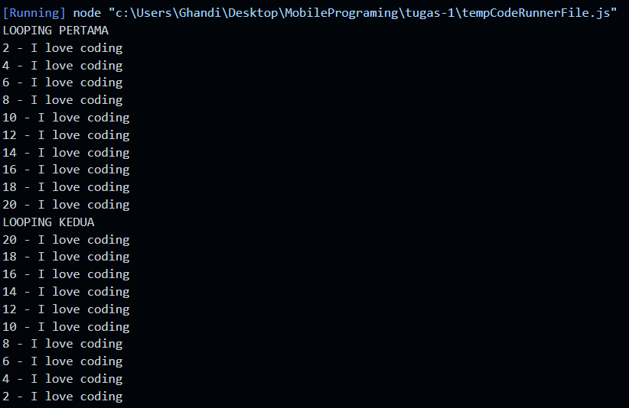

1. **Looping menggunakan for**

**Source code :**

for (let index = 1; index <= 20; index++) {

if ((index % 3 == 0) && (index % 2 != 0)) {

console.log(`${index} - I love coding`);

} else if (index % 2 != 0) {

console.log(`${index} - Teknik`);

} else if (index % 2 == 0) {

console.log(`${index} - Informatika`);

}

}

**Output :**

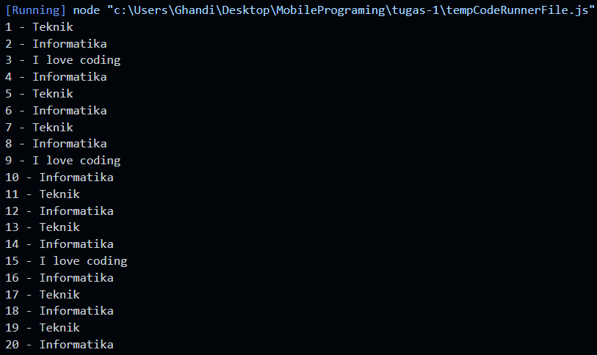

1. **Membuat Persegi Panjang #**

**Source code :**

var dimensi = 4

var persegi = "########"

while (dimensi > 0) {

console.log(persegi);

dimensi--

}

**Output:**

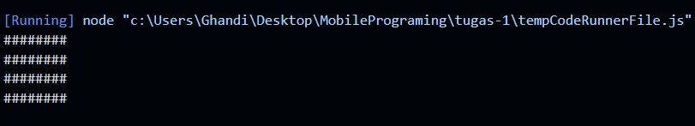

1. **Membuat Tangga**

**Source code :**

for (let line = "#"; line.length < 8; line += "#")

console.log(line);

**Output :**

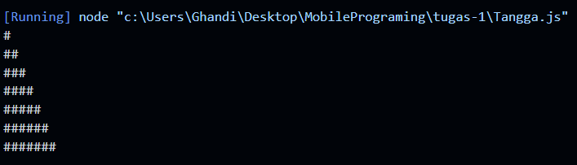

1. **Papan catur**

**Source code :**

var c = ""

var panjang = 8

var lebar = 8

for (let i = 1; i <= lebar; i++) {

if (i % 2 == 0) {

for (let j = 1; j <= panjang; j++) {

if (j % 2 == 0) {

c += "#"

} else {

c += " "

}

}

} else {

for (let j = 1; j <= panjang; j++) {

if (j % 2 == 0) {

c += " "

} else {

c += "#"

}

}

}

c += '\n'

}

console.log(c);

**Output :**

