Name = Ghanendra Tiwari
Uni roll no. = 2415000605
Class roll no. = 22
Sec = SB,
Assignment: Introduction to Web Development

1. Explain the difference between Frontend, Backend, and Full-Stack Development with suitable real-world examples.
Frontend development is the part of a website that users can see and interact with. It includes the design, buttons, images, menus, and web pages. Frontend developers mainly use HTML, CSS, and JavaScript.
Backend development is the part of a website that works behind the scenes. It manages data, user accounts, login systems, and communication with the database. Backend developers use languages like PHP, Python, Java, or Node.js.
A Full-Stack developer can work on both the frontend and the backend of a website. They can build the complete web application from start to finish.
Example:
Take the example of Amazon.
- The product images, search bar, and "Add to Cart" button are the frontend.
- Processing orders, checking stock, and saving customer information are the backend.
- A developer who creates both parts is called a full-stack developer.

2. Create a simple diagram showing how the client-server model works in web architecture.
+----------------+
| Client |
| (Web Browser) |
+----------------+
|
| Request
V
+----------------+
| Web Server |
+----------------+
|
| Response
V
+----------------+
| Client |
| Displays Page |
+----------------+

3. Describe how a browser requests and displays a web page from a web server.
When a user enters a website address in the browser, the browser sends a request to the web server. The server receives the request and finds the required web page. It then sends the HTML, CSS, JavaScript, images, and other files back to the browser. Finally, the browser reads these files and displays the webpage on the user's screen.

4. Identify and list the tools required to set up a web development environment. Explain the purpose of each.
Tool | Purpose
Visual Studio Code (VS Code) | Used to write and edit code.
Google Chrome | Used to test websites.
Live Server Extension | Automatically refreshes the webpage after changes.
Node.js | Allows JavaScript to run outside the browser.
Git | Helps track changes in the project.
GitHub | Stores and shares project files online.

5. Explain what a web server is and give examples of commonly used servers.
A web server is a computer or software that stores website files and sends them to users when they open a website in a browser.
Some common web servers are:
- Apache
- Nginx
- Microsoft IIS
- LiteSpeed
- Node.js

6. Define the roles of a Frontend Developer, Backend Developer, and Database Administrator in a project.
Frontend Developer
- Designs the user interface.
- Creates web pages using HTML, CSS, and JavaScript.
- Makes the website attractive and easy to use.
Backend Developer
- Develops the server-side part of the website.
- Handles user login, data processing, and business logic.
- Connects the website with the database.
Database Administrator (DBA)
- Manages the database.
- Stores and secures data.
- Performs database backup and maintenance.

7. Install VS Code and configure it for HTML, CSS, and JavaScript development. Take a screenshot of the setup.
Steps:
- Download and install Visual Studio Code.
- Open VS Code.
- Install the following extensions:
  - Live Server
  - HTML CSS Support
  - Prettier
  - JavaScript (ES6) Code Snippets
- Create a new folder for your project.
- Create three files:
  - index.html
  - style.css
  - script.js
- Open index.html using Live Server.
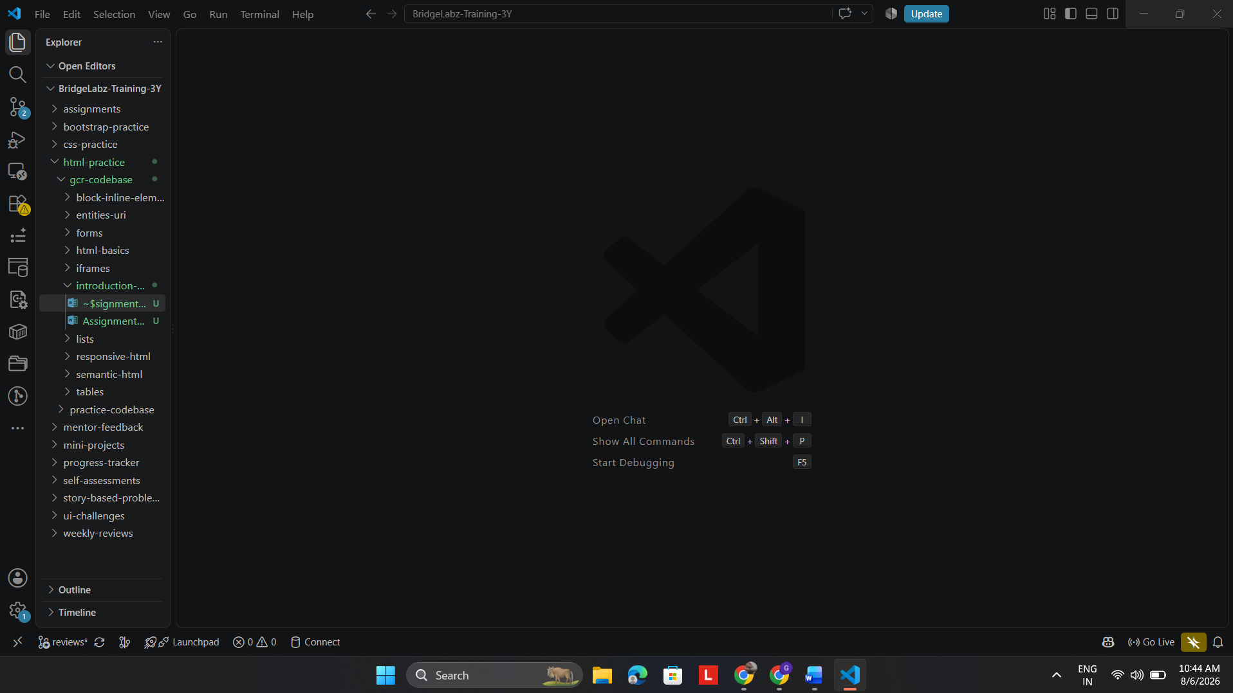
8. Explain the difference between static and dynamic websites. Provide an example of each.
A static website shows the same content to every user. It does not change unless the developer updates the files manually. Static websites are simple and fast.
A dynamic website changes its content based on the user, database, or other information. These websites are interactive and can display different content for different users.
Examples:
- Static Website: Personal Portfolio Website
- Dynamic Website: Facebook, Amazon, Instagram

9. Research and list five web browsers. Explain how rendering engines differ between them.
Five Popular Web Browsers
- Google Chrome
- Mozilla Firefox
- Microsoft Edge
- Apple Safari
- Opera
Browser | Rendering Engine
Google Chrome | Blink
Microsoft Edge | Blink
Mozilla Firefox | Gecko
Apple Safari | WebKit
Opera | Blink
Explanation:
A rendering engine is the software inside a browser that reads HTML and CSS and displays the webpage. Different browsers use different rendering engines, so the appearance and performance of a website may vary slightly. Chrome, Edge, and Opera use the Blink engine, Firefox uses Gecko, and Safari uses WebKit.

10. Draw a labeled diagram showing the basic web architecture flow — client, server, database, and APIs.
User
|
V
+---------------+
| Client Browser|
+---------------+
|
HTTP Request
|
V
+---------------+
| Web Server |
+---------------+
| |
| |
V V
+-----------+ +-----------+
| Database | | APIs |
+-----------+ +-----------+
|
V
Sends Response
|
V
+---------------+
| Client Browser|
+---------------+
Working:
The user sends a request through the browser. The request reaches the web server. The server gets the required data from the database or APIs. After processing the request, the server sends the response back to the browser. Finally, the browser displays the webpage to the user.

