PayShield Bank
Data Platform Modernisation
Milestone 2 Report
Name: [Your name]
Date: September 2026

Contents
Task 1 - Architecture & Cloud Design 3
C4 Level 2 Container Diagram 3
AWS Services 3
Why this architecture fits 4
Task 2 - Physical Data Model 5
A. Star Schema 5
B. Merchant Risk History - SCD Type 2 6
C. Data Vault 7
Task 3 - Data Engineering & Spark 8
Bronze → Silver → Gold 8
Handling data problems 8
Problem A - Double counting 8
Why is the Spark job slow? How to check 8
Should we use a broadcast join? 9
Task 4 - API Contract & Testing 10
OpenAPI Specification 10
Pydantic Model 10
Gherkin Scenarios 11
Task 5 - Deployment & Migration Strategy 12
Approach 12
Migration sequence 12
Checks 13
Task 6 - Security & DevSecOps 14
Security weaknesses in the code 14
Fixed code 14
Security controls 14
DevSecOps pipeline 14
Task 7 - Architecture Decision Record 16
Comparison 16
ADR-001: PayShield Data Platform 16

Task 1 - Architecture & Cloud Design
Cloud chosen: AWS

C4 Level 2 Container Diagram
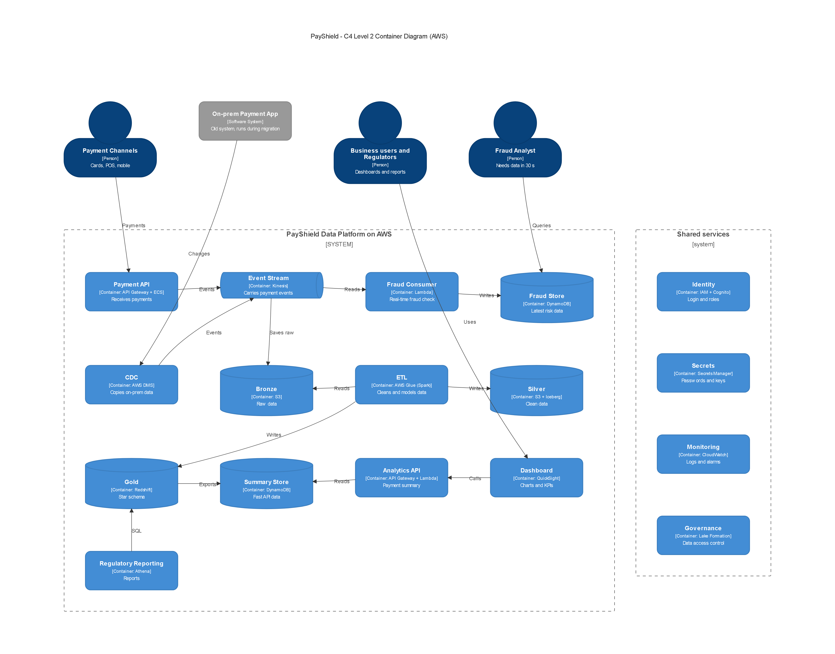

AWS Services
Capability | AWS Service
Compute | ECS Fargate, Lambda
Storage | S3
Streaming | Kinesis Data Streams
Lakehouse | Glue, Iceberg, Athena
Warehouse | Redshift
API | API Gateway
Identity | IAM, Cognito
Secrets | Secrets Manager
Monitoring | CloudWatch
Governance | Lake Formation

Why this architecture fits
- Speed: payments go into Kinesis and the fraud Lambda reads them in about 1-2 seconds, well under 30 seconds.
- Scale: Kinesis, Lambda and ECS scale automatically from 500 to 5,000 transactions/sec.
- History: S3 is cheap for 7 years. Iceberg keeps old versions, so old reports can be re-run.
- Fast API: the API reads a small summary table in DynamoDB, so it answers in under 500 ms.
- Safe migration: DMS copies data from the old system, so both can run together.

Task 2 - Physical Data Model

A. Star Schema
FACT_PAYMENT grain = one payment transaction attempt.
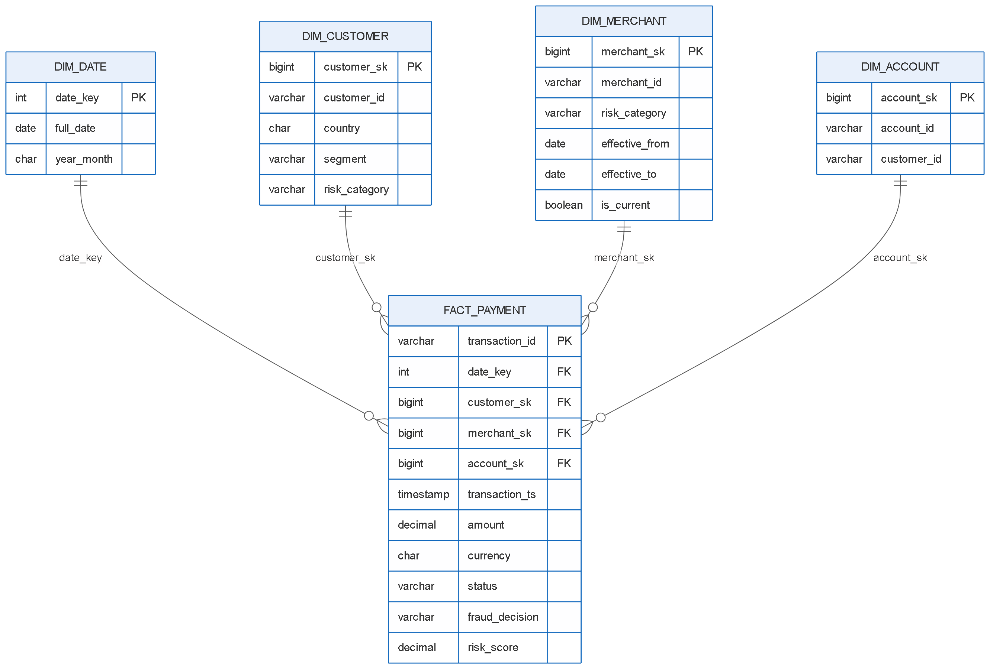
CREATE TABLE dim_date (
date_key INT PRIMARY KEY, -- 20260214
full_date DATE NOT NULL,
year_month CHAR(7) NOT NULL -- 2026-02
);

CREATE TABLE dim_customer (
customer_sk BIGINT PRIMARY KEY,
customer_id VARCHAR(20) NOT NULL,
country CHAR(2) NOT NULL,
segment VARCHAR(10) CHECK (segment IN ('Retail','Premium','SME')),
risk_category VARCHAR(6) CHECK (risk_category IN ('LOW','MEDIUM','HIGH'))
);

CREATE TABLE dim_account (
account_sk BIGINT PRIMARY KEY,
account_id VARCHAR(20) NOT NULL UNIQUE,
customer_id VARCHAR(20) NOT NULL
);

CREATE TABLE dim_merchant ( -- SCD Type 2
merchant_sk BIGINT PRIMARY KEY,
merchant_id VARCHAR(20) NOT NULL,
risk_category VARCHAR(6) NOT NULL,
risk_score DECIMAL(5,4),
effective_from DATE NOT NULL,
effective_to DATE NOT NULL DEFAULT '9999-12-31',
is_current BOOLEAN NOT NULL
);

CREATE TABLE fact_payment (
transaction_id VARCHAR(36) PRIMARY KEY,
date_key INT NOT NULL REFERENCES dim_date(date_key),
customer_sk BIGINT NOT NULL REFERENCES dim_customer(customer_sk),
merchant_sk BIGINT NOT NULL REFERENCES dim_merchant(merchant_sk),
account_sk BIGINT NOT NULL REFERENCES dim_account(account_sk),
transaction_ts TIMESTAMP NOT NULL,
amount DECIMAL(18,2) NOT NULL CHECK (amount >= 0),
currency CHAR(3) NOT NULL,
status VARCHAR(10) CHECK (status IN ('SUCCESS','FAILED','REVERSED')),
fraud_decision VARCHAR(7) CHECK (fraud_decision IN ('APPROVE','DECLINE')),
risk_score DECIMAL(5,4) CHECK (risk_score BETWEEN 0 AND 1)
);
Partitioning / indexing
- fact_payment partitioned by month of transaction_ts.
- Sort / cluster by date_key and country (most queries filter by these).
- Index on dim_merchant (merchant_id, effective_from) for fast lookups.

B. Merchant Risk History - SCD Type 2
We use SCD Type 2. When the risk changes, the old row is closed and a new row is added. History is never lost.
merchant_sk | merchant_id | risk | effective_from | effective_to
1 | M100 | LOW | 2026-01-01 | 2026-03-31
2 | M100 | HIGH | 2026-04-01 | 2026-06-30
3 | M100 | MEDIUM | 2026-07-01 | 9999-12-31

A February transaction joins on the date range, so it gets LOW (not MEDIUM):
SELECT t.transaction_id, m.merchant_sk, m.risk_category
FROM payment_transaction t
JOIN dim_merchant m
ON m.merchant_id = t.merchant_id
AND CAST(t.transaction_ts AS DATE) BETWEEN m.effective_from AND m.effective_to;

C. Data Vault
CREATE TABLE hub_customer (customer_hk CHAR(32) PRIMARY KEY, customer_id VARCHAR(20), load_ts TIMESTAMP, record_source VARCHAR(50));
CREATE TABLE hub_merchant (merchant_hk CHAR(32) PRIMARY KEY, merchant_id VARCHAR(20), load_ts TIMESTAMP, record_source VARCHAR(50));
CREATE TABLE hub_transaction (transaction_hk CHAR(32) PRIMARY KEY, transaction_id VARCHAR(36), load_ts TIMESTAMP, record_source VARCHAR(50));

CREATE TABLE link_customer_transaction (link_hk CHAR(32) PRIMARY KEY, customer_hk CHAR(32), transaction_hk CHAR(32), load_ts TIMESTAMP, record_source VARCHAR(50));
CREATE TABLE link_merchant_transaction (link_hk CHAR(32) PRIMARY KEY, merchant_hk CHAR(32), transaction_hk CHAR(32), load_ts TIMESTAMP, record_source VARCHAR(50));

CREATE TABLE sat_customer (customer_hk CHAR(32), load_ts TIMESTAMP, segment VARCHAR(10), risk_category VARCHAR(6), PRIMARY KEY (customer_hk, load_ts));
CREATE TABLE sat_merchant (merchant_hk CHAR(32), load_ts TIMESTAMP, risk_category VARCHAR(6), risk_score DECIMAL(5,4), PRIMARY KEY (merchant_hk, load_ts));
CREATE TABLE sat_transaction (transaction_hk CHAR(32), load_ts TIMESTAMP, amount DECIMAL(18,2), status VARCHAR(10), PRIMARY KEY (transaction_hk, load_ts));
Why Data Vault helps the bank
- Data is only inserted, never updated, so the full history is kept for audit.
- Every row has load_ts and record_source, so we know when and where it came from.
- Old reports can be rebuilt exactly as they were.

Task 3 - Data Engineering & Spark

Bronze → Silver → Gold
Layer | What it holds
Bronze | Raw data exactly as received. Never changed.
Silver | Cleaned data: correct types, no duplicates, bad rows removed.
Gold | Business tables: star schema and summaries for reports and the API.

Handling data problems
Problem | How we handle it
Late-arriving events | Report using event_ts (when it happened), not ingestion_ts. Wait 15 minutes for late data (watermark). Very late data is fixed by a nightly job.
Out-of-order events | Sort events by event_ts, not by arrival time.
Duplicate events | Keep only one row per event_id.
Failed records | Move bad rows to a quarantine table with the reason.
Schema changes | Allow only new optional columns. Keep raw data in Bronze.
Incremental processing | Process only new data using checkpoints and MERGE.

Out-of-order example:
SELECT transaction_id, event_type, event_ts,
ROW_NUMBER() OVER (PARTITION BY transaction_id ORDER BY event_ts) AS event_order
FROM payment_event;

Problem A - Double counting
Yes, the developer's query double counts. If a transaction has 2 settlement rows, the join repeats the payment twice, so SUM(t.amount) is doubled.
Fix: sum the settlements first, then join.
WITH s AS (
SELECT transaction_id, SUM(settlement_amount) AS settlement_amount
FROM settlement
GROUP BY transaction_id
)
SELECT t.transaction_id, t.amount AS payment_amount, s.settlement_amount
FROM payment_transaction t
LEFT JOIN s ON s.transaction_id = t.transaction_id;

Why is the Spark job slow? How to check
- Spark UI: find the slowest stage.
- Skew: if one task takes much longer than the others, one key (such as a big merchant) has too much data.
- Shuffle: joins move data across machines. A large shuffle is slow.
- Partitions: too few gives big slow tasks; too many gives overhead.
- Pre-aggregation: reduce rows (e.g. one row per transaction) before the join.
- Repartitioning: repartition big tables on the join key (transaction_id).

Should we use a broadcast join?
Yes, for MERCHANT_RISK.
- It is small (a few thousand rows), so Spark can copy it to every machine.
- The big PAYMENT_EVENT table then does not need to be shuffled, which saves time.
- The join must still use merchant_id = (plus the date range), otherwise it becomes very slow.
- It does not fix the big join (PAYMENT_EVENT + PAYMENT_TRANSACTION). That one needs repartitioning and skew handling.
from pyspark.sql.functions import broadcast
result = events.join(broadcast(merchant_risk), "merchant_id")

Task 4 - API Contract & Testing

OpenAPI Specification
openapi: 3.0.3
info:
title: PayShield Analytics API
version: 1.0.0
paths:
/analytics/payment-summary:
get:
summary: Monthly payment summary for a country
parameters:
- name: period
in: query
required: true
schema: {type: string, pattern: '^\d{4}-(0[1-9]|1[0-2])$'} # e.g. 2026-09
- name: country
in: query
required: true
schema: {type: string, pattern: '^[A-Z]{2}$'} # e.g. IN
responses:
'200': {description: Summary returned}
'400': {description: Invalid period or country}
'401': {description: Not logged in}
'403': {description: Not allowed}
'404': {description: No data found}
'500': {description: Server error}
Validation rules
- period must be YYYY-MM (month 01-12).
- country must be 2 capital letters.
- success_rate must be between 0 and 100.
- successful_transactions cannot be more than transaction_count.

Pydantic Model
from pydantic import BaseModel, Field, model_validator

class PaymentSummary(BaseModel):
period: str = Field(pattern=r"^\d{4}-(0[1-9]|1[0-2])$")
country: str = Field(pattern=r"^[A-Z]{2}$")
transaction_count: int = Field(ge=0)
successful_transactions: int = Field(ge=0)
success_rate: float = Field(ge=0, le=100)
payment_volume: float = Field(ge=0)

@model_validator(mode="after")
def check_counts(self):
if self.successful_transactions > self.transaction_count:
raise ValueError("successful_transactions cannot exceed transaction_count")
return self

Gherkin Scenarios
Feature: Payment summary API

Scenario: Return payment summary for valid country
Given valid payment data exists
When the client requests the India payment summary for 2026-09
Then the API should return HTTP 200
And success_rate should be between 0 and 100

Scenario: Invalid period
When the client requests the summary with period "2026-13"
Then the API should return HTTP 400

Scenario: Request without login
Given the client has no token
When the client requests the India payment summary
Then the API should return HTTP 401

Scenario: No data for the period
When the client requests the summary for period "2020-01"
Then the API should return HTTP 404

Task 5 - Deployment & Migration Strategy

Approach
Pattern | How we use it
Hybrid | Old on-prem system and new cloud run together.
Strangler Fig | Move one part at a time: Fraud first, then Reporting, then Finance.
Canary | Send 5% of traffic to the new system, then 25%, then 100%.
Blue-green | Keep the old version ready so we can switch back instantly.
Immutable infrastructure | Build servers from code (Terraform); replace them, don't patch them.

We do not use a big-bang cutover.

Migration sequence
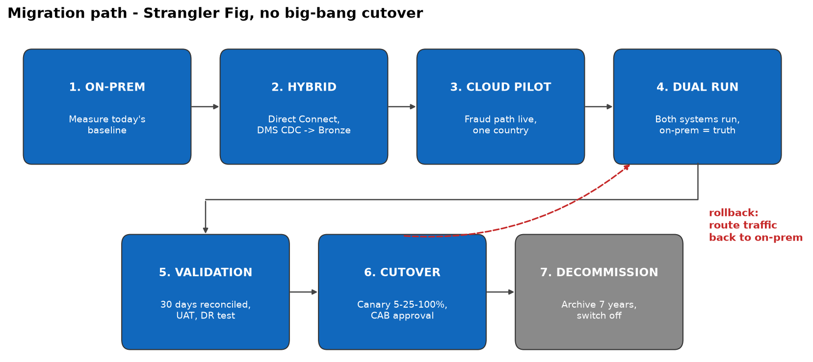
ON-PREM → HYBRID → CLOUD PILOT → DUAL RUN → VALIDATION → CUTOVER → DECOMMISSION
Phase | What happens
On-prem | Record current numbers (volumes, totals, speed).
Hybrid | Connect on-prem to AWS and copy data with DMS.
Cloud pilot | Run fraud checks in the cloud for one country.
Dual run | Both systems run; on-prem is still the main one.
Validation | Compare results and test everything.
Cutover | Move traffic to the cloud step by step.
Decommission | Archive old data and switch off on-prem.

Checks
- Cutover criteria: row counts and totals match, fraud data in ≤ 30 s, API ≤ 500 ms, no major issues for 30 days.
- Rollback criteria: totals don't match, fraud data is late, API errors are high, or a serious incident happens.
- Data reconciliation: compare daily row counts and amount totals between on-prem and cloud.
- API health checks: /health endpoint checked every minute.
- Smoke tests: after each deployment, call the API once and check the response.
- Monitoring: CloudWatch alarms for delay, errors and response time.
- Who approves cutover: CTO with the Change Advisory Board (Fraud, Finance, Compliance and Security heads).

Task 6 - Security & DevSecOps

Security weaknesses in the code
- SQL injection: user input goes straight into the SQL. Input like ' OR '1'='1 returns all customers.
- No authentication: anyone can call the API.
- No authorization: any user can see any customer.
- Returns every column: SELECT * also returns private data.
- No input validation: customer_id can be anything.

Fixed code
@app.get("/customer/{customer_id}")
def get_customer(
customer_id: str = Path(pattern=r"^C\d{4,10}$"), # input validation
user = Depends(get_current_user), # authentication
):
if not user.can_view(customer_id): # authorization
raise HTTPException(status_code=403)
query = "SELECT customer_id, country, segment FROM customer WHERE customer_id = %s"
return execute(query, (customer_id,)) # parameterized SQL

Security controls
Control | What we do
Input validation | Check the format of every input.
Parameterized SQL | Never build SQL with string formatting.
Authentication | Login with tokens (Cognito).
Authorization / RBAC | Roles such as analyst and admin decide what each user can see.
Secrets management | Passwords are kept in AWS Secrets Manager, not in code.
PII protection | Return only needed columns, encrypt data, mask personal data.
Secure logging | Never log passwords, tokens or personal data.

DevSecOps pipeline
Developer Branch → Unit Tests → SAST → Secret Scan → SCA → Docker Build → Container Scan → DAST → Approval → Production
Low and medium issues only give a warning. These block the pipeline:
Stage | Blocks the pipeline when
Unit tests | Any test fails
SAST | High or critical code issue (e.g. SQL injection)
Secret scan | Any password or key is found
SCA | Library has a high or critical vulnerability
Container scan | Image has a high or critical vulnerability
DAST | High-risk issue found in the running app
Approval | Not approved

Task 7 - Architecture Decision Record

Comparison
Approach | Strengths | Weaknesses | Suitability for PayShield
Kimball | Simple, fast for reports | Weak history, batch only | Good for Gold layer
Inmon | One integrated source of truth | Slow and costly to build | Low
Data Vault | Full history, good for audit | Many tables, hard to query | Good for history in Silver
Lakehouse / Medallion | Streaming + batch, scales, cheap storage | Needs good governance | Best fit - main platform
Data Mesh | Teams own their data | Complex, needs mature teams | Not now, maybe later

Approach | Complexity | Governance | Audit | Scalability
Kimball | Low | Central | Medium | Medium
Inmon | High | Central | Good | Medium
Data Vault | High | Central | Very good | Good
Lakehouse | Medium | Central | Good | Very good
Data Mesh | Very high | Shared by teams | Varies | Very good

ADR-001: PayShield Data Platform
Decision: Use a Lakehouse (Bronze/Silver/Gold) on AWS, with Data Vault history in Silver and a Kimball star schema in Gold.
Context: Fraud data is too slow, reports cannot be reproduced, and the old system cannot handle peak load.
Options considered: Kimball, Inmon, Data Vault, Lakehouse, Data Mesh.
Decision drivers: fraud data in 30 seconds, 5,000 transactions/sec, 7-year audit history, gradual migration.
Chosen architecture: Kinesis streaming + S3/Glue lakehouse + Redshift star schema + API Gateway.
Consequences: faster fraud checks, reproducible reports and easy scaling, but more services to manage and new skills needed.
Risks: team skills gap, cloud cost, data mismatch during migration.
Migration approach: Hybrid + Strangler Fig. Move one part at a time with a dual run (see Task 5).
Rollback approach: keep the on-prem system running until the end and switch traffic back if there is a problem.
Why not just another central warehouse? A warehouse is batch, so it cannot give fraud data in 30 seconds. It is also costly to scale and does not keep raw history for audit.

