**Simple Boost PWM based Z source Inverter**

Submitted by

**Ghanshyam Das Gupta**

**224102109**

**[ self-project]**



**Abstract: -** In this project we are going to increase the peak output voltage of single-phase boost inverter. This inverter can work both AC and DC load, but due to low frequency component in AC power it will affect the other devices which leads to device failure, to overcome from this low frequency power component we can use large capacitor and inductor bur it will increase the cost as well as power density of converter.

To overcome we use Active Power Decoupling (APD) in APD method low frequency ripples to an auxiliary network with many topologies (Buck, Boost and Buck- Boost).

**Introduction : -** The classical Inverter has many drawbacks like they have less peak output voltage where in case of single phase boosted inverter we will get more output voltage as more compare to normal single phase (VSI) but this is also leads to low frequency ripple power into AC side , SBI work on the topology of shoot through in this state both switches in a one leg will act as a short circuit and voltage across capacitor more than the nominal value and load side of inverter act as a short circuited at that time.

In the case of reduce or eliminate the low frequency ripple power we can use large capacitor and inductor in normal VSI, but in the case of SBI it will not be beneficial as power density and economic overview.

Here we use Boost type topology for APD because it requires smaller capacitance so we can choose much larger than the average DC -bus Voltage, but for the prevent from the overvoltage we use closed loop operation in APD, generally we are using two type of controller scheme 1. Proportional -integral 2. Proportional Resonant

Here we are using the PR current controller because it will provide more steady state error and better current tracking as compare to PI controller

**Analysis and Calculation:** - Now, first we do analysis in shoot through mode in this mode switches in one leg of inverter are going to short circuit and the voltage across diode less than capacitor voltage**.**

**DTs  Interval / Shoot through mode**

$$V_{L}= V_{C}$$

$$I_{C}={-I}_{L}-\frac{V_{C}}{R_{dc}}$$

$$V_{i}= 0$$

**(1-DTS) Interval / non shoot through mode**

In this mode SBI will work as a normal VSI and the inverter indicate by current source

$$V_{L}= V_{g}- V_{C}$$

$$I_{C}=I_{L}-\frac{V_{C}}{R_{dc}}-I_{i}$$

$$V_{i}= V_{C}$$

Where Vc is the voltage across Boost type APD converter, Vg is the input voltage, Ic is current across the boost type APD converter.

**Parameter:** - These are the following parameter that is used for simulate the SBI and APD topology

|  |  |
| --- | --- |
| Input Voltage | 100V |
| Modulation index | 0.5 |
| Shoot through duty ratio | 0.4 |
| Fundamental frequency | 50Hz |
| Inverter Switching Frequency | 10KHz |
| Inductor (L) | 2.75mH |
| Capacitor(c) | 100 µF |
| APD switching Frequency | 20KHz |
| APD Inductor | 1mH |
| APD Capacitor | 220µF |
| DC load (R) | 400Ω, 250W |
| Output Filter Inductor | 1mH |
| Output Filter Capacitor | 11µF |
| AC load (R) | 36Ω, 250W |

**Controller Design: -**

To prevent the auxiliary capacitor from overvoltage we use closed loop operation for control we have two types of control in the circuit PI and PR, here we are using PR controller because it has good steady state error as well as better current detection.

We are considering the frequency of moving active filter is 100Hz we are determining the 2nd order filter to filter out lower harmonics we will choose the inductor value and find the value of capacitor by given formula

$$f =\frac{1}{2π\sqrt{LC}}$$

We take Value of L is 1mH

R =10

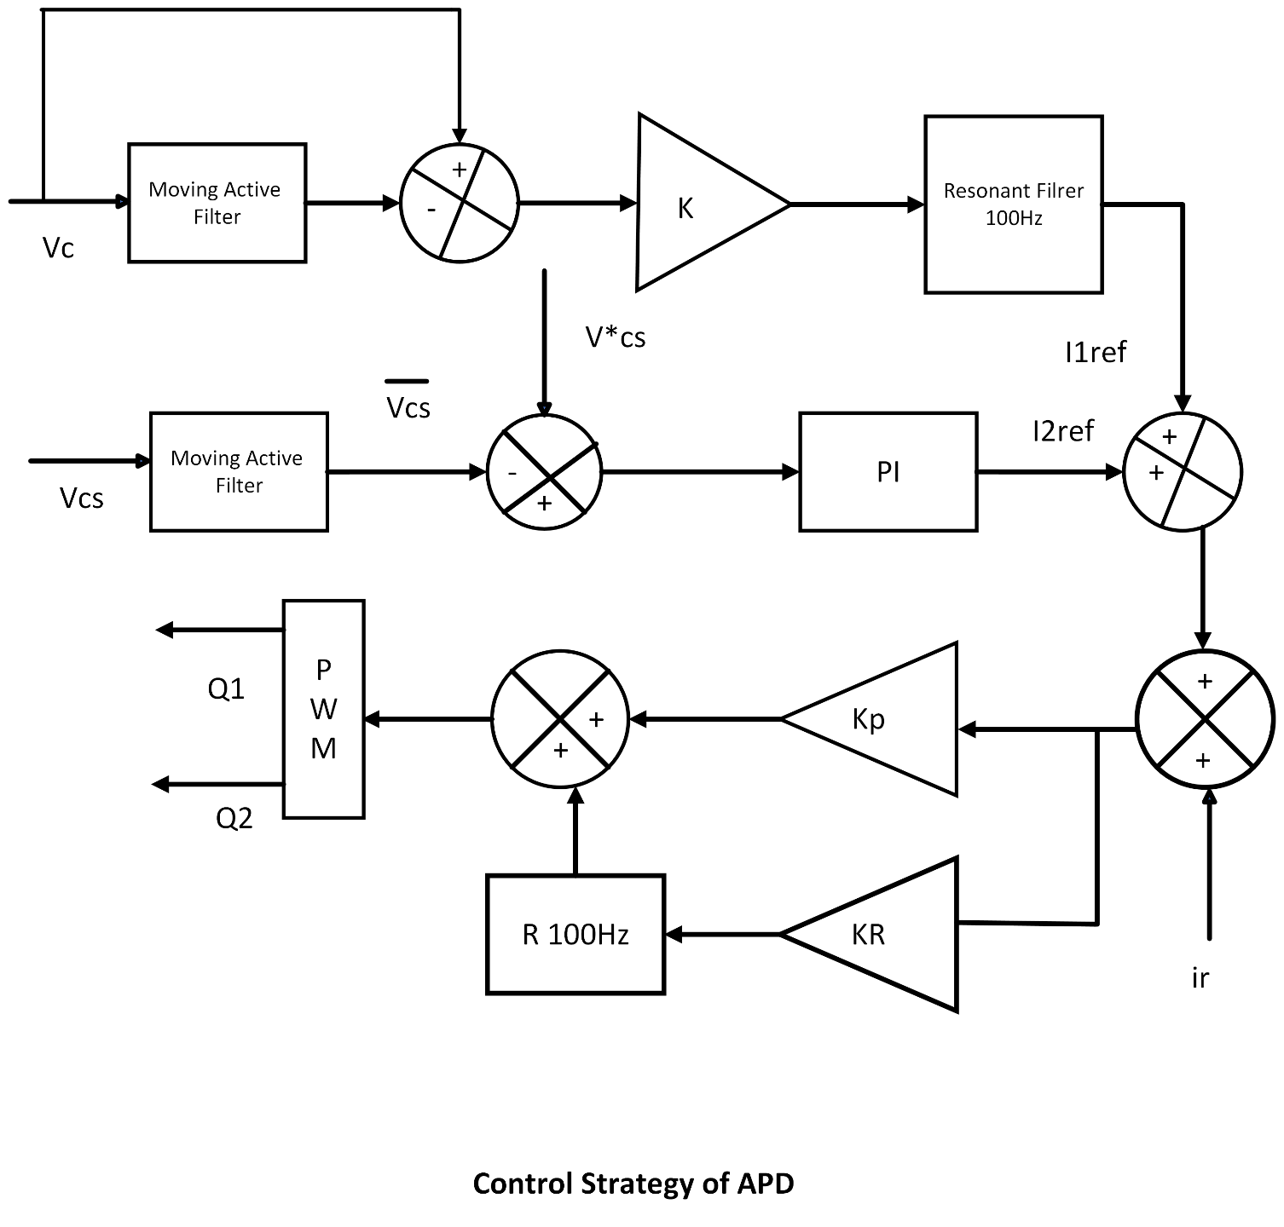

**Circuit Diagram and Waveform: -**

1. **Simulation Figure**

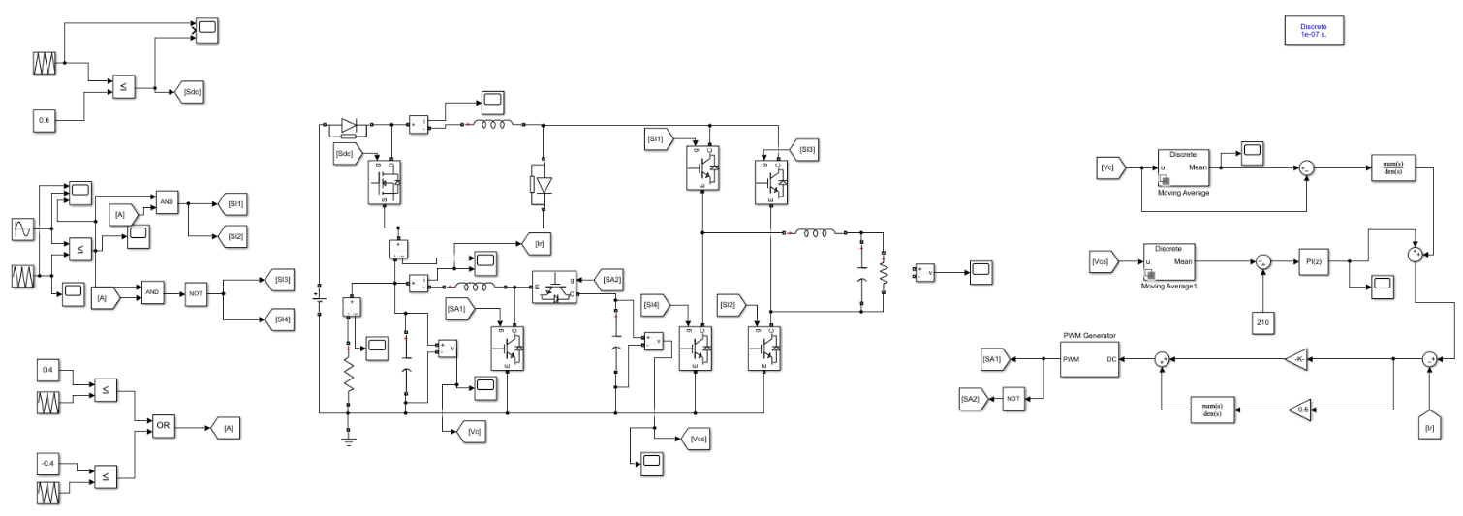

1. **Waveform**

