**Open Loop Simulation of Permanent magnet synchronous motors**

**Under Guidance**

**Dr. Ravindranath Adda**

**Assistant Professor**

Submitted by

**Ghanshyam Das Gupta**

**224102109**



**Abstract: -** In this project we are perform the open loop simulation of Permanent magnet synchronous motors and study about the closed loop operation of Permanent magnet synchronous motors using Field oriented Control (sensor less).

**Introduction: -** The smooth starting and wide speed control is of PMSM is achieve by sinusoidal pulse width modulation. As we have both AC and DC motor for water pumping.in case of DC motor Brush and commutator configuration make them hard to maintain. In case of AC motor Induction motor is widely used due to low cost and easy availability. We use PMSM for high efficiency quick acceleration and deceleration and high-power factor.

**Analysis and Calculation:** - PMSM is AC motor which works on three phase supply for generating three balanced supply we use three phase inverter for switching in three phase we are using SPWM where triangular wave consider as carrier wave (10KHz) and Reference sine wave (50Hz) with modulation index 0.8

**Specification of Permanent magnet synchronous motors**

2200W, Three Phase, 230V, Four Poles, Rs = 0.8Ω, LS = 4.6mH, Nr = 1500r/min,

Ke = 216.8Vp/Kr/min

**Closed Loop Control Method: -**

PMSM motor is AC motor so we need a control which can control Torque and Speed of the motor because in AC motor stator and rotor filed are in 90 degrees to each other

FOC control diagram

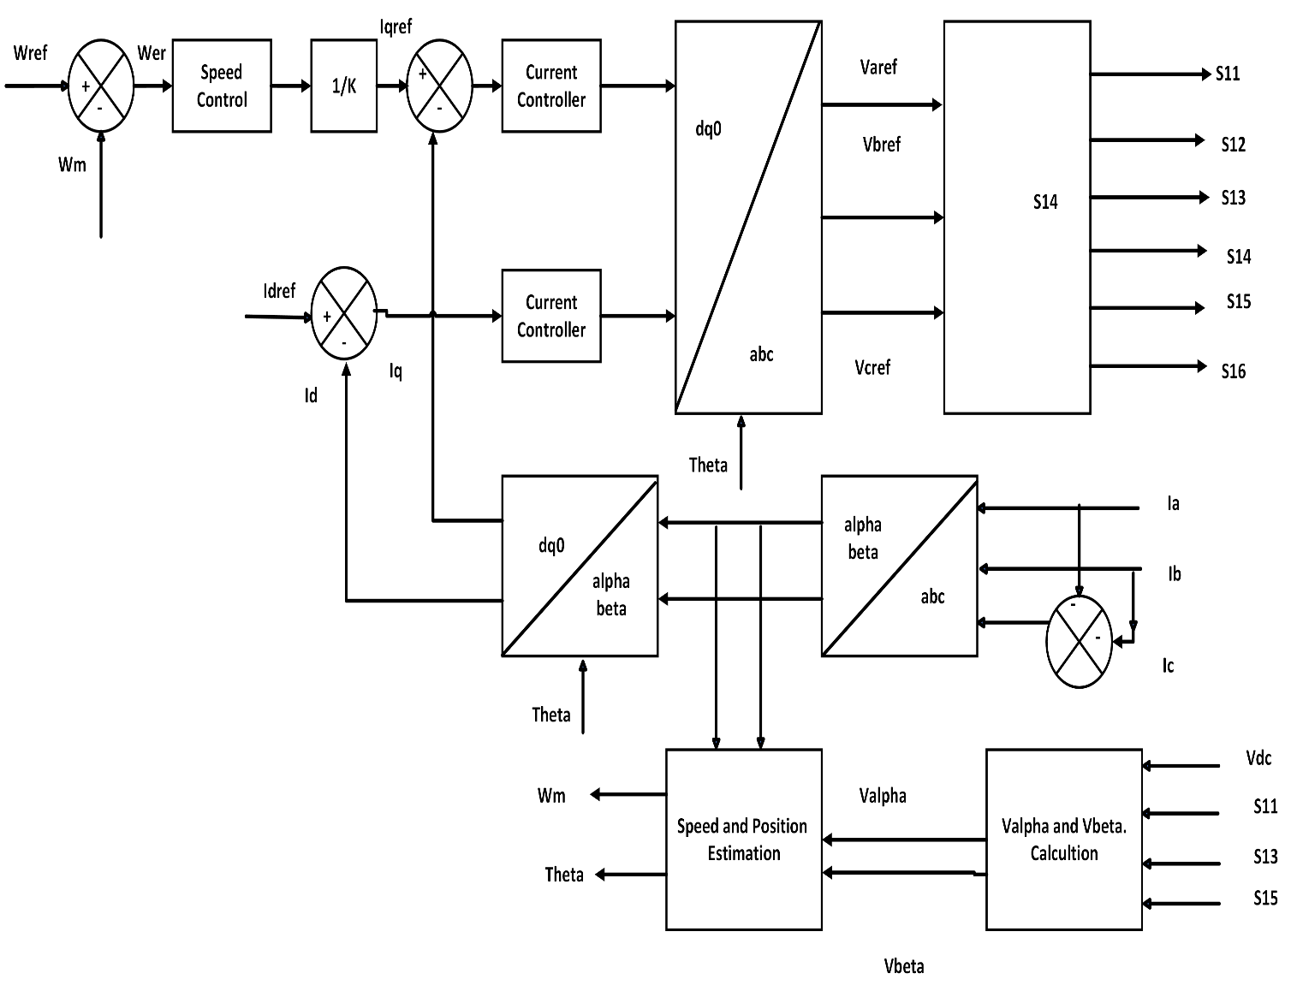

**Circuit Diagram and Waveform: -**

1. **Simulation Figure**

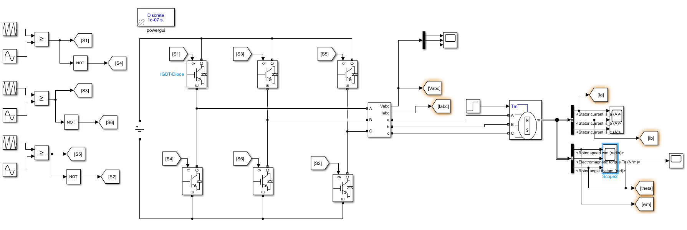

1. **Waveform**



