**Simple Boost PWM based Three phase**

**Z source Inverter**

Submitted by

**Ghanshyam Das Gupta**

**224102109**

**[ self-project]**



**Abstract:** In this project we are going to study about the Z source inverter. it is shoot through inverter here we use two inductor and capacitor at input side of inverter so it is also called impedance source inverter the use of an impedance network (consisting of two inductors and capacitors) at the input terminal of a Z-source inverter provides voltage boosting, improved voltage regulation, flexible control, and reduced harmonics in the output voltage. This makes the Z-source inverter suitable for applications where a wide range of output voltage levels and high-quality output waveforms are required. We generate shoot through mode in the ZSI inverter by using three control technique (Simple Boost PWM, Maximum Based PWM and Third Harmonic Based PWM), in this project we will work on Simple Boost PWM method

**Introduction: -** The classical VSI inverter has a very less peak output voltage and if we need more voltage, so we have to boost the voltage which will increase and size of the converter that leads to increase in cost of converter and we cannot use two switches of a same leg that will cause of damage of the converter to overcome from all these causes we use Z source inverter to improve the voltage boosting, Improve power quality and flexible control. This converter also has some limitation like using a diode at input terminal cause a discontinuous flow of input current, we use diode in series with DC voltage source at input side to boosting its output voltage with the common ground as for dc source and inverter to perform shoot through we use Simple Boost PWM based.

**Analysis and Calculation:** - Now, first we do analysis in shoot through mode in this mode switches in one leg of inverter are going to short circuit and the voltage across diode less than capacitor voltage**.**

**DTs  Interval / Shoot through mode**

$$V_{L}= V_{C}$$

$$V_{d}={2V}_{C}$$

$$V_{i}= 0$$

**(1-DTS) Interval / non shoot through mode**

In this mode SBI will work as a normal VSI and the inverter indicate by current source

$$V_{L}= V_{dc}- V_{C}$$

$$V_{d}=V_{dc}$$

$$V_{i}= {2V}_{C}-V_{dc}$$

**Output Voltage of ZSI**

$$V_{out}=M*B*V_{dc}$$

Where M is the Modulation Index of inverter $M=\frac{V_{sin}}{V_{tri}}$

B is called Boosting Factor $B=\frac{T}{{(T}_{i-T_{o})}}>1$, where T is the total time period, Ti is non-shoot time period and To is the shoot period B always should be greater than1.

Shoot Through Duty Ratio $D=\frac{T_{O}}{T_{S}}$, where To is shoot through time period and Ts is total time period.

**Formula: -**

|  |  |  |  |
| --- | --- | --- | --- |
| **Type of Switching Control** | **Shoot Through Duty Ratio Do** | **Boosting Factor B** | **Voltage Gain $$\frac{V_{o}}{V_{in}}$$** |
| Simple Boost PWM | $$1-M$$ | $$\frac{1}{2M-1}$$ | $$\frac{M}{2M-1}$$ |
| Maximum Boost PWM | $$\frac{2π-3√3M}{2π}$$ | $$\frac{π}{3\sqrt{3} M-π}$$ | $$\frac{πM}{3\sqrt{3} M-1}$$ |
| Third Harmonic Boost PWM | $$1-\frac{\sqrt{3 } M}{2}$$ | $$\frac{1}{\sqrt{3} M-1}$$ | $$\frac{M}{\sqrt{3} M-1}$$ |

**Parameter:** - These are the following parameter that is used for simulate the SBI and APD topology

|  |  |
| --- | --- |
| Input Voltage | 36V |
| Modulation index | 0.62 |
| Shoot through duty ratio | 0.351 |
| Fundamental frequency | 50Hz |
| Inverter Switching Frequency | 10KHz |
| Inductor (L1 and L2) | 3mH ,3mH |
| Capacitor (C1 and C2) | 100 µF, 100µF |
| APD switching Frequency | 20KHz |
| Filter Inductor | 5mH |
| Filter Capacitor | 10µF |
| Resistive Load | 14 Ω |

**Controller Design: -**

Here we are use generally three types of control scheme to control the output voltage of Z source Inverter.

1. **Simple Boost PWM Based:** - In the case of simple boost based PWM method we compare sinusoidal signal with triangular wave to generate PWM and for shoot through we compare triangular signal with the constant with has same value for positive and negative comparison then we generate a shoot through wave with OR gate and give to again PWM generate and passes through AND gate to generate PWM for simple boost based PWM**.**

**Block Diagram**

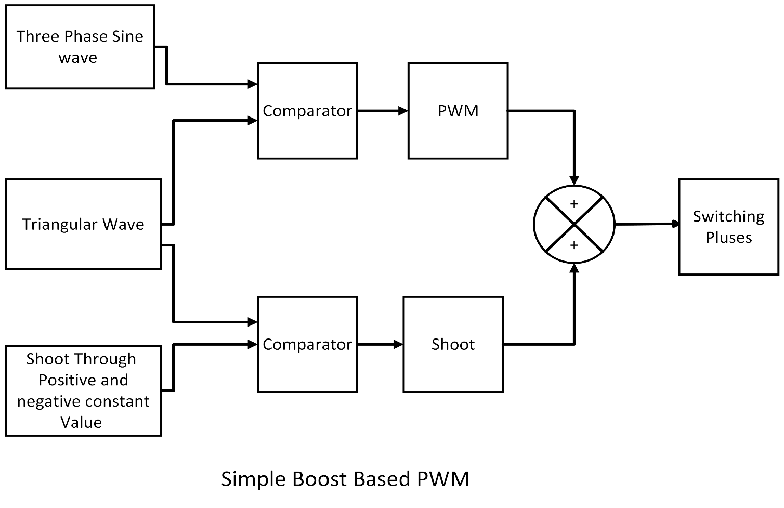

1. **Maximum Boost PWM:** - In the case of maximum boost based PWM method we compare sinusoidal signal with triangular wave to generate PWM and for shoot through we compare triangular signal with Maximum and Minimum values of sine wave then we generate a shoot through wave with OR gate and give to again PWM generate and passes through AND gate to generate PWM for simple boost based PWM**.**

**Block Diagram**

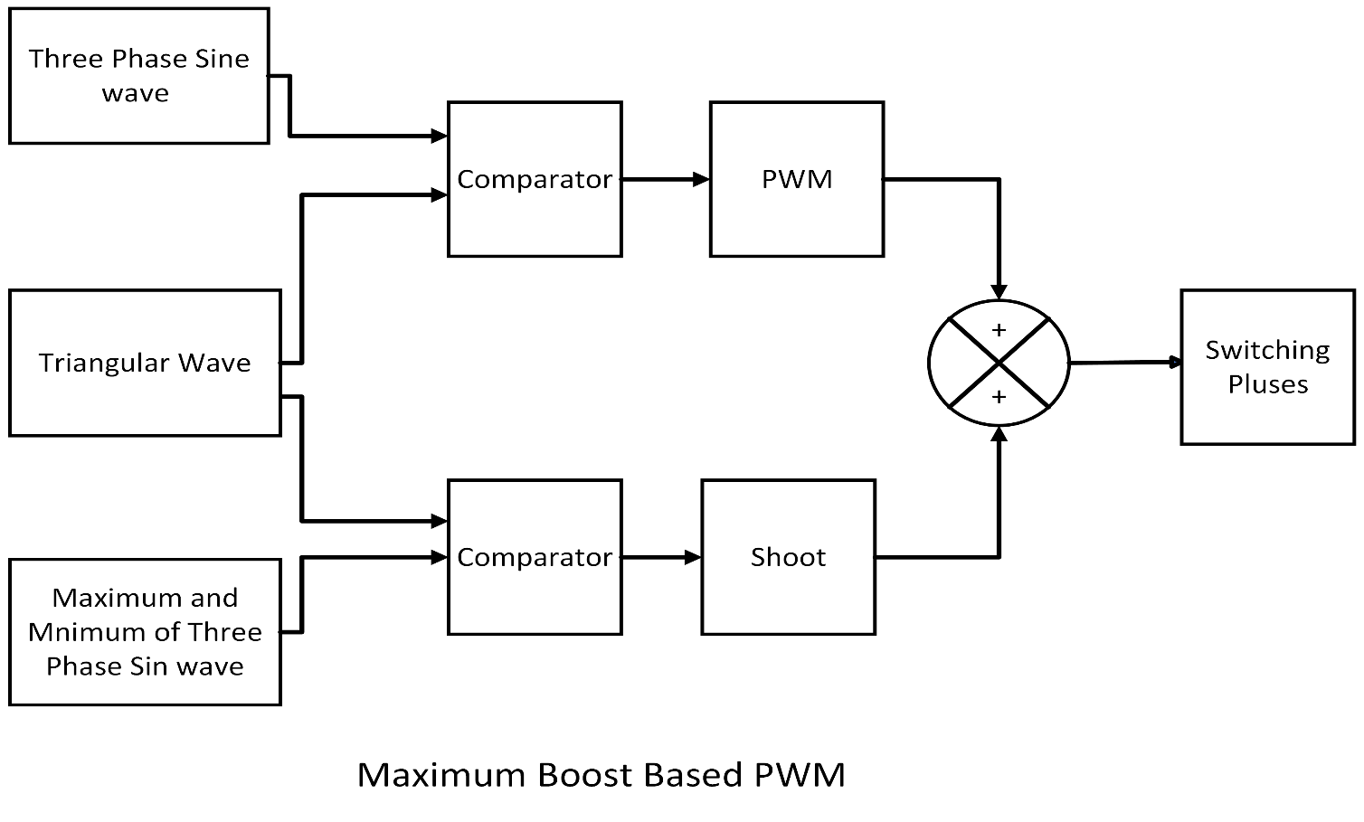

1. **Third Harmonic Boost PWM: -** In the case of Third Harmonic boost based PWM first we use sine wave of 50 Hz and 150Hz( third Harmonic) and given it to OR gate to generate sine wave contain third harmonic and compare with triangular wave to generate PWM and for shoot through we compare triangular signal with the constant with has same value for positive and negative comparison then we generate a shoot through wave with OR gate and give to again PWM generate and passes through AND gate to generate PWM for simple boost based PWM**.**

**Block Diagram**

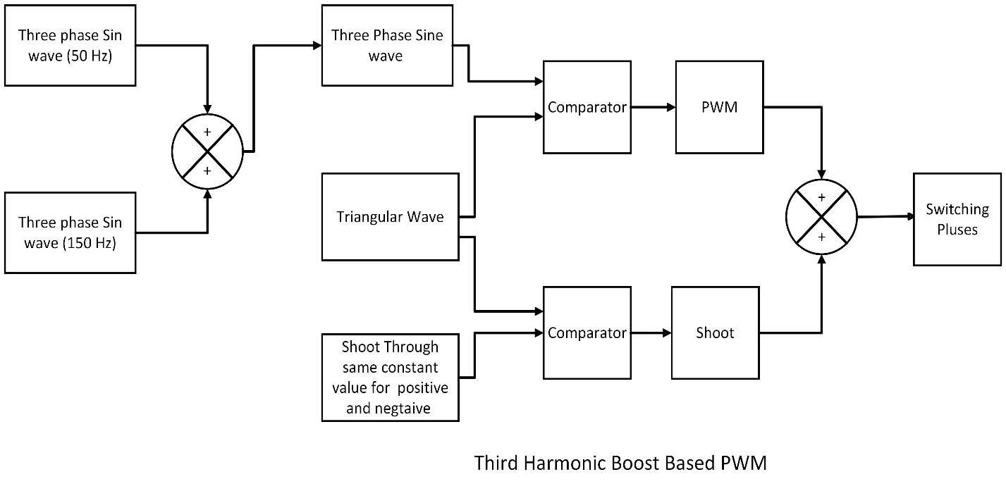

**Circuit Diagram: -**

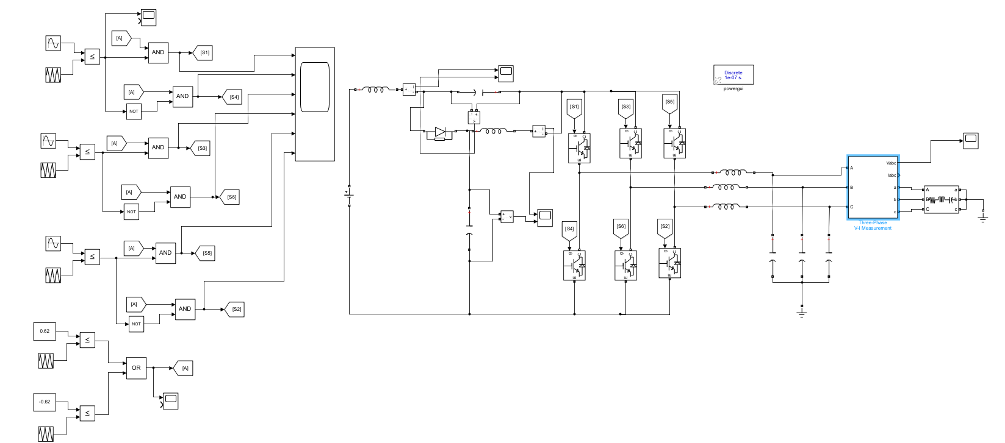

**Waveform: -**

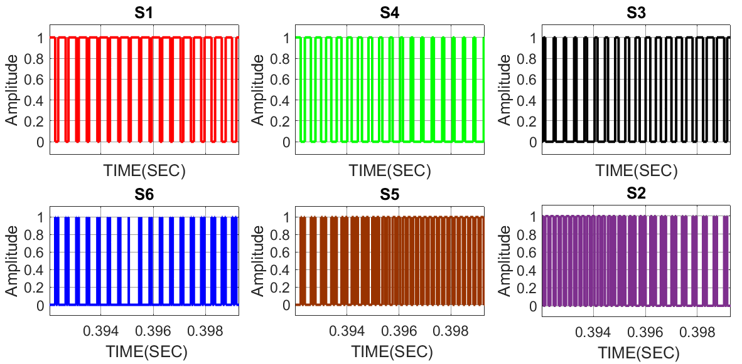

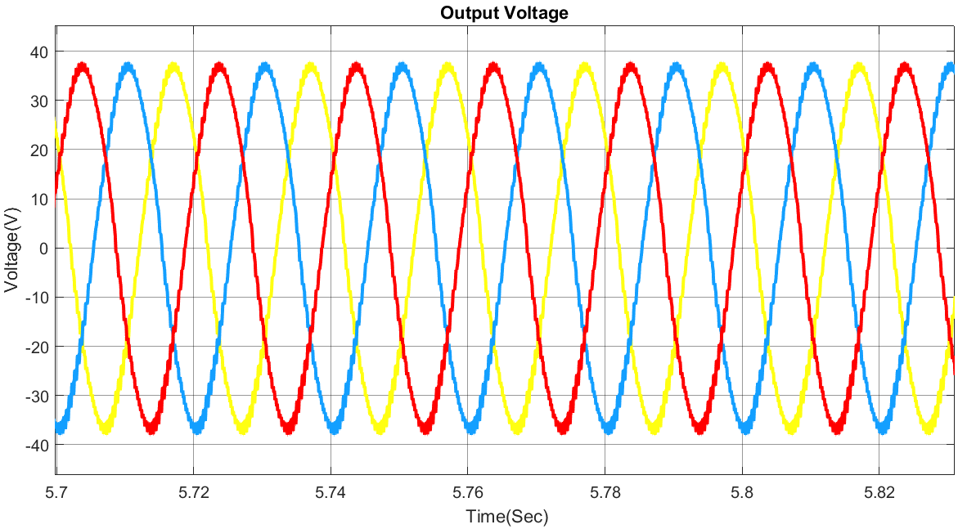

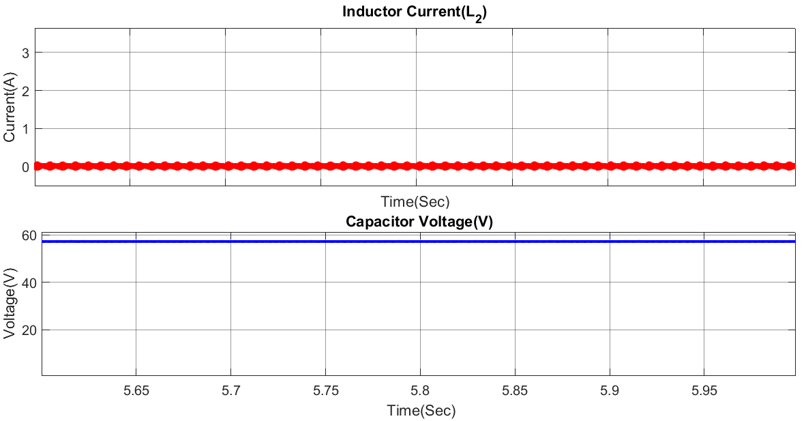

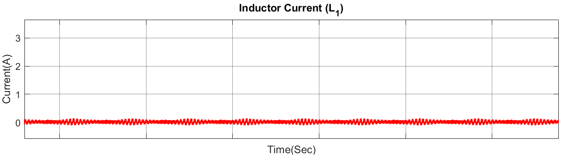

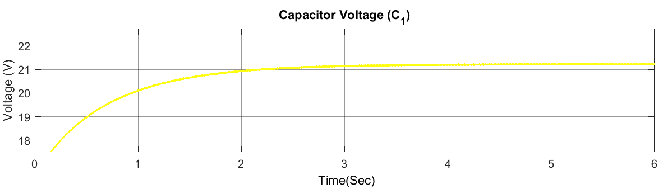

**Observation: -** As it is clearly shown that the voltage across capacitor C1 is keep increasing it will increase up to 2 times the voltage across capacitor C2 as from the calculation we know that output voltage increases up to 55V so the Voltage across C2 is also near to 55V, so the voltage across capacitor C1 increase up to approximate 100V

Voltage at 6 sec 21.45V across capacitor C1

Time taken by capacitor C1 to boost the voltage up to 100V

At 6 sec, v= 21.45

At 1 sec $V=\frac{21.45}{6}=3.575V$

To reach 100V t= 3.575*100 = 357.5 sec= approx. 7 sec