**Mbed CLI and GCC-ARM Compiler Installation**

This document is based on the instructions provided by ARM here: [https://os.mbed.com/docs/mbed-os/v5.9/tutorials/quick-start-offline.html#linux](https://os.mbed.com/docs/mbed-os/v5.9/tutorials/quick-start-offline.html" \l "linux).

**PLEASE FOLLOW THE INSTRUCTIONS OUTLINED IN THIS DOCUMENT AND NOT WHAT IS LISTED ON THE MBED WEBSITE.**

There are some key differences between what is outlined in this document and what is on the MBED website that were found to not work correctly.

**1. System requirements:**

**Ubuntu 18.04** (it may also work in previous versions). It will work in later versions. You can download Ubuntu from the following link: <https://www.ubuntu.com/download/desktop>

**2. Dependencies:**

**Python 2.7 and Pip**

* To install Python and Pip:
  + Open Ubuntu terminal. To open Ubuntu terminal press: "CONTROL+ALT+t"
  + Type on the Ubuntu terminal the following command and press ENTER:   
    *sudo apt-get install python2.7 python-pip*
  + Type the administrative password and press ENTER
  + When you are asked "Do you want to continue?" type: *y* and then press ENTER
  + Wait until the installation is finished

**ARM Cortex-M Device with the Mbed Bootloader Installed**

* Check if device has the Mbed bootloader installed:
  + Plug device into a free USB port on your PC, ensuring that it is plugged into the ‘OpenSDA’ port on the device.

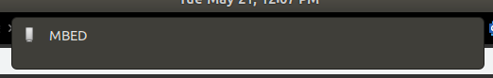

* + If the device is labeled ‘MBED’, no action is needed. If not, the Mbed bootloader will have to be installed on the device. See Appendix for details.

**3. GCC-ARM Compiler**

The latest GCC-ARM Compiler can be downloaded from the following link:

<https://developer.arm.com/tools-and-software/open-source-software/developer-tools/gnu-toolchain/gnu-rm/downloads>

* Once downloaded:
  + Open File Explorer and navigate to ‘Downloads’ folder.
  + Right click on downloaded file and select “Extract Here” option. Wait for extraction to complete, it may take a minute.
  + Open Ubuntu terminal. To open Ubuntu terminal press: "CONTROL+ALT+t"
  + Type on the Ubuntu terminal the following command and press ENTER:

*sudo mv /home/<USER>/Downloads/<FOLDER_NAME>/<FOLDER_NAME> /opt/*

Where <USER> is your user account name, and <FOLDER_NAME> is the name of the extracted GCC-ARM compiler folder. For example:

*sudo mv /home/kyle/Downloads/gcc-arm-none-eabi-8-2018-q4-major-linux/gcc-arm-none-eabi-8-2018-q4-major /opt/*

**4. Mbed CLI**

* To install and configure the Mbed CLI:
  + Open Ubuntu terminal. To open Ubuntu terminal press: "CONTROL+ALT+t"
  + Type on the Ubuntu terminal the following command and press ENTER:   
    *sudo pip install mbed-cli*
  + If prompted, type the administrative password and press ENTER
  + Set Mbed compiler path.

*mbed config -G GCC_ARM_PATH /opt/<FOLDER_NAME>/bin*

*Where FOLDER_NAME is the same as Step 3. For Example:*

*mbed config -G GCC_ARM_PATH /opt/gcc-arm-none-eabi-8-2018-q4-major/bin*

**5. Example**

* + Open Ubuntu terminal. To open Ubuntu terminal press: "CONTROL+ALT+t"
  + Type on the Ubuntu terminal the following commands:

*mbed import https://github.com/ARMmbed/mbed-os-example-blinky*

*cd mbed-os-example-blinky*

* + Once “Blinky” has been downloaded, compile and flash. Make sure that your Mbed supported device is plugged in to a USB port for this step. Use the command *‘mbed detect’* to ensure the device is plugged in.

mbed compile --target NUCLEO_F401RE --toolchain GCC_ARM --flash

Where target device in this example is a NUCLEO_F401RE. Change the device depending on what the target is.

* + If the process was successful, the LED on your board should now be blinking!

**Install Cadmium**

<INSERT CADMIUM INSTRUCTIONS HERE>

<https://github.com/SimulationEverywhere/cadmium>

**Download and Configure Boost**

Download the latest version of boost from the following link:

[https://www.boost.org/users/download/#live](https://www.boost.org/users/download/" \l "live)

If there are issues resort back to boost version 1.70.0:

<https://dl.bintray.com/boostorg/release/1.70.0/source/>

* + Right click on downloaded file and select “Extract Here” option. Wait for extraction to complete, it may take a minute.
  + Open Ubuntu terminal. To open Ubuntu terminal press: "CONTROL+ALT+t"
  + Type on the Ubuntu terminal the following command and press ENTER:

*sudo mv ~/Downloads/<FOLDER_NAME>/ ~*

Where <FOLDER_NAME> is the name of the extracted Boost folder. For example:

*sudo mv ~/Downloads/boost_1_70_0/ ~*

Note: You may store these files in any directory. For simplicity these instructions use the home directory.

**Appendix**

**Installing Mbed Bootloader onto a Target Device**

Doing this in Linux is not straight forward, and not supported by ARM. I would suggest finding a Windows machine and following the steps described on the Mbed website. In Windows the process is trivial, and shouldn’t take more than a few minutes.

Here is the link to the instructions for the FRDM-KL25Z:

<https://os.mbed.com/handbook/Firmware-FRDM-KL25Z>

… But searching for ‘Mbed Firmware <Insert Board here>’ should give instructions for other common boards.

**Debugging with ‘Screen’ on Ubuntu**

You can listen on the serial port for UART communication from the device using the ‘screen’ program.

* + Open Ubuntu terminal. To open Ubuntu terminal press: "CONTROL+ALT+t"
  + Type on the Ubuntu terminal the following command and press ENTER:

*sudo apt-get install screen*

*mbed detect*

* + Mbed should tell you what port to listen to the device on, most likely it will be *dev/ttyACM0*

*screen /dev/ttyACM0*

**Upgrade Nucleo Board Firmware**

Using an older firmware can cause some minor issues. One known issue is that the board can only be flashed once without a power cycle (unplugging, and plugging it back in). This can be fixed by using the Stlink update utility.

Download here: <https://www.st.com/en/development-tools/stsw-link007.html>

Extract the folder, and run the .jar file:

*java – jar en.stsw-link007/stsw-link007/AllPlatforms/STLinkUpgrade.jar*

*An application should open up, and look like the following image:*

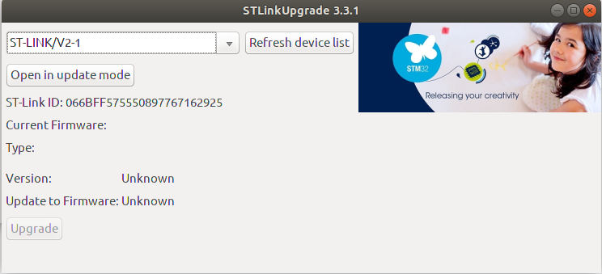

Press the “open in update mode” button, then press the “Upgrade” button and wait for it to finish. If the plugged in Nucleo board doesn’t show up, press the “Refresh device list” button.