CS 590BD Big Data Analytics and Applications

Lab 1 - June 17, 2014

|  |  |  |
| --- | --- | --- |
|  | **Gharib Gharibi**  **16170368** |  |

**Task 1.**

**1.1 TI SensorTag with Android sensor app**

We were able to pair the TI SensorTag with our Android device successfully. The BLE SensorTag app identified the sensor and was able to capture the motion. However, we were not able to use the app1-SensorTag to capture the device’s motion due to callback registration failure (see log output).

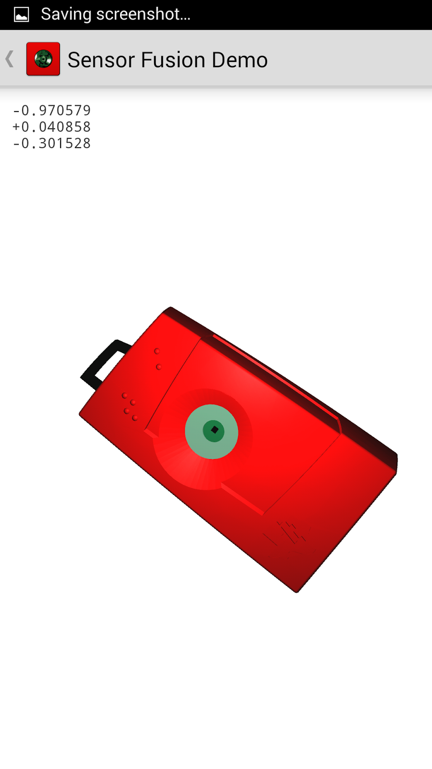

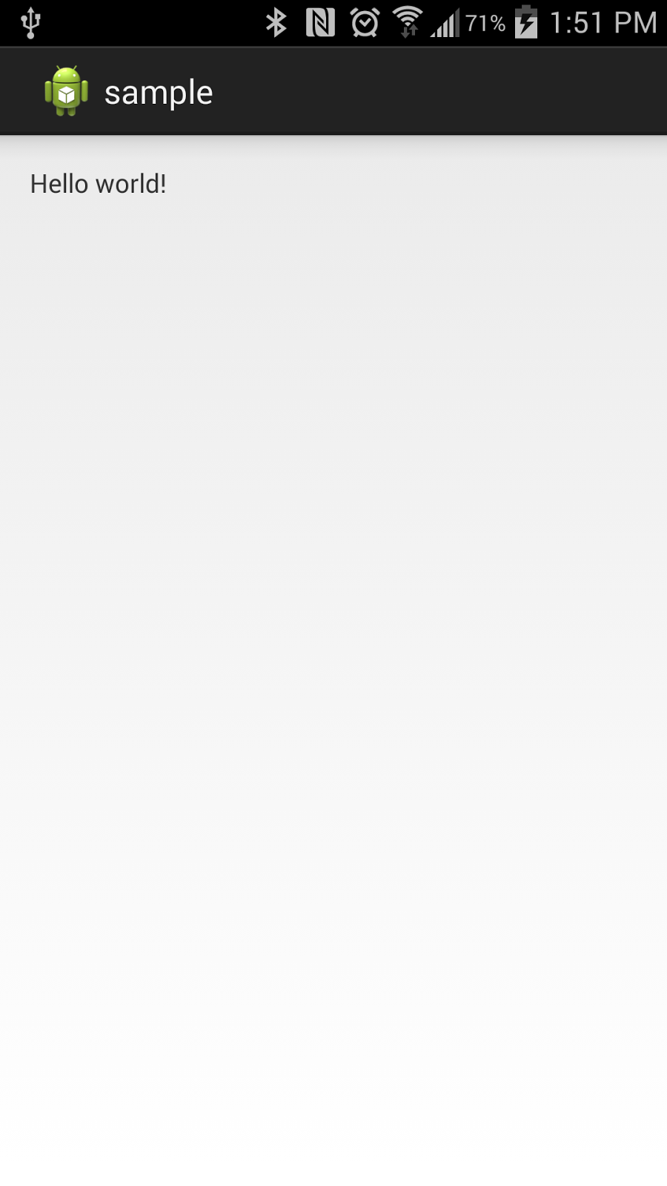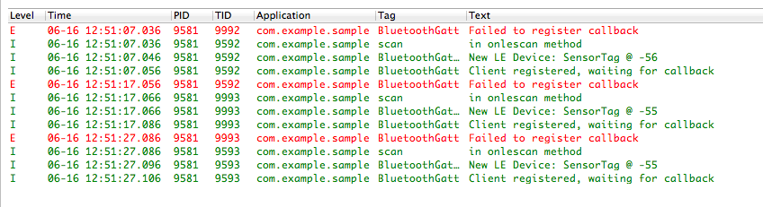

**1.2 Mobile sensor with Android sensor app**

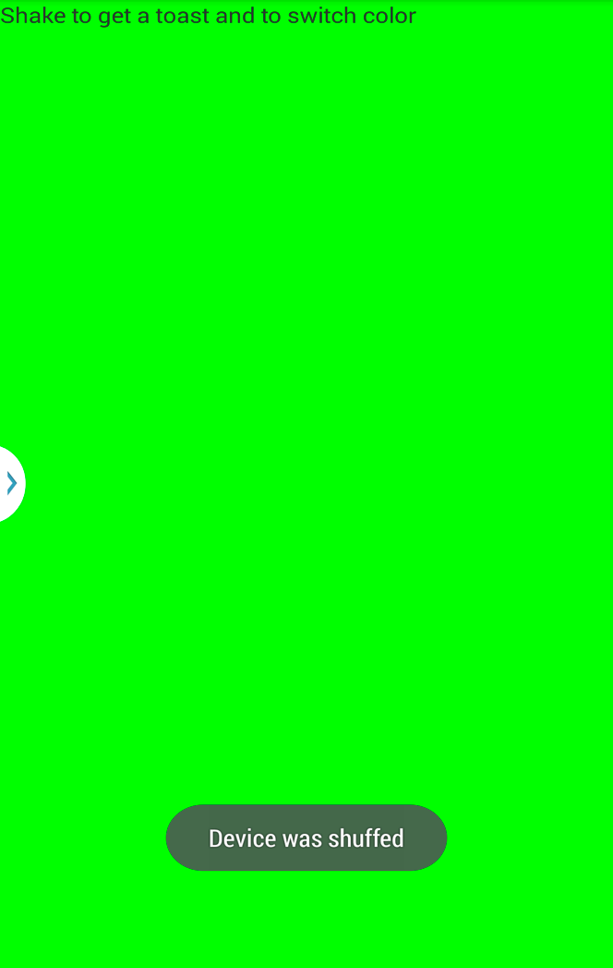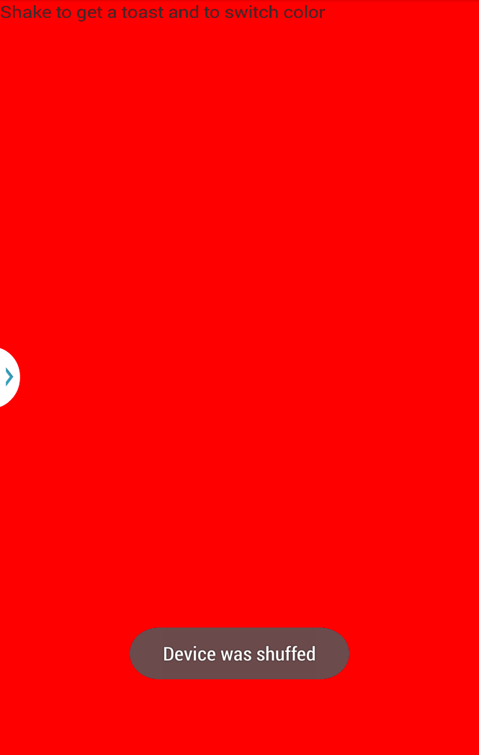The sensor app (app2-AndroidMotionSensor) detected the Android mobile device’s movement using the device’s accelerometer and changed the screen color accordingly.

**1.3 GPS feature with Android smartphone**

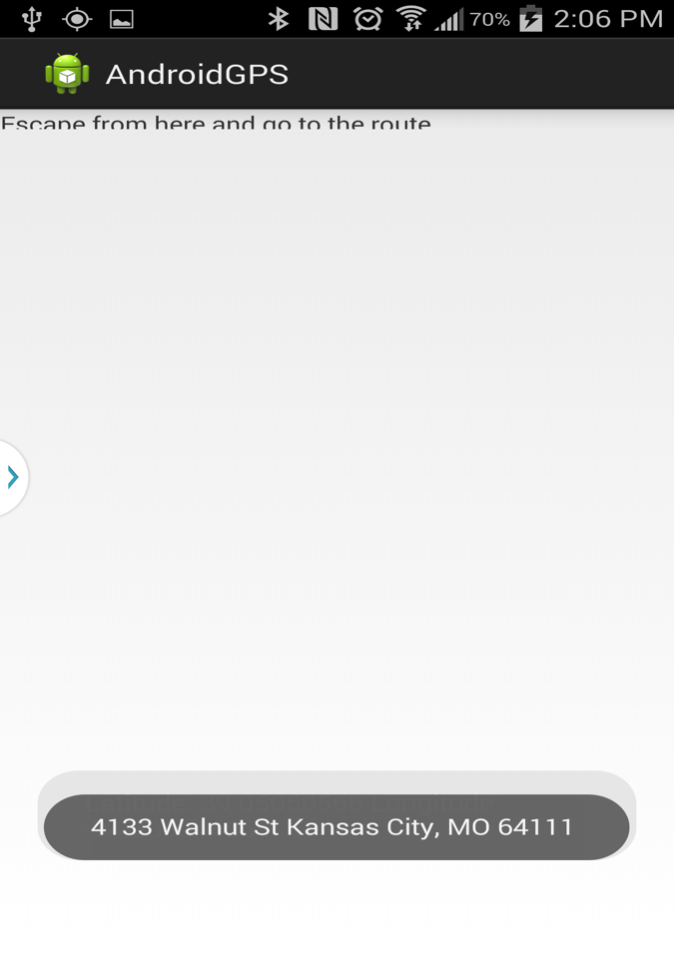Using app3-AndroidGPS the mobile device was able to display the GPS coordinates that were identified by the GPS sensor.

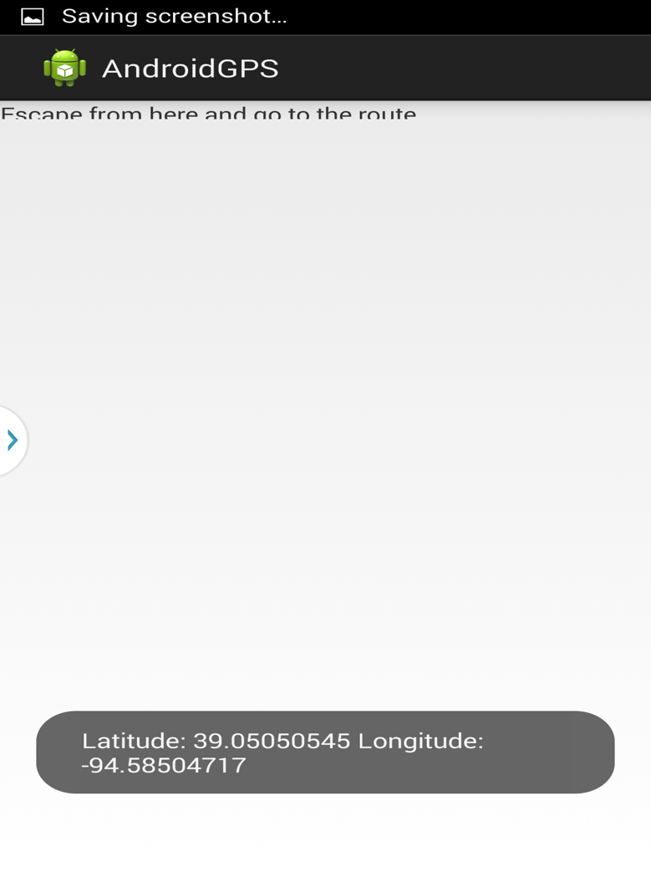

**1.4 Wiigee app with Android smartphone**

The app4-AndroidWiigee successfully recognized gestures with a high probability using the the mobile device’s accelerometer.

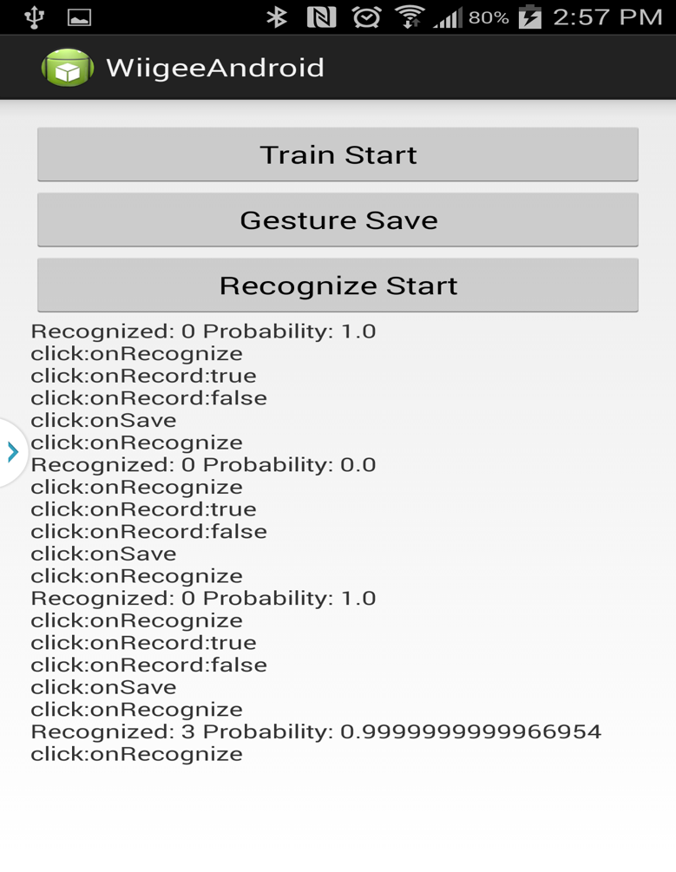

**1.5 TI Chronos watch with Java app**

Both the Chronos Control Center and the PunchMeterGame recognized the movements successfully using the Chronos watch’s accelerometer.

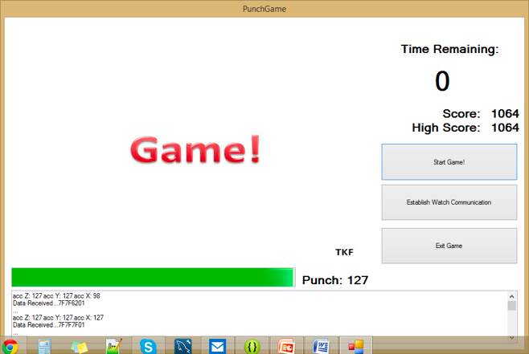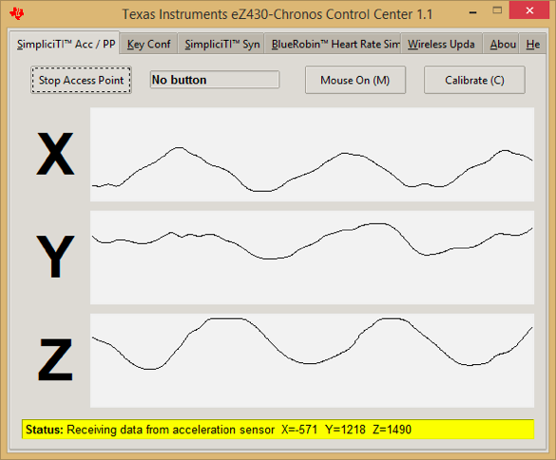

**Task 2. Cloudera**

**2.1 Accessing UMKC Cloudera server as an individual group (Group4)**

* To Access the Cloudera Manager as an individual student account, we can use the direct server address (<http://134.193.136.127:7180>) with the associated port number. If you are accessing the Internet from outside UMKC LAN, then you have to connect to the server using UMKC VPN. Then, each student has to enter his UMKC SSO for both username and password. *It’s highly recommended that each student change his password after his first login.* To change the password click on the student SSO at the top-left corner in the browser and select “Change Password” (See figure1).

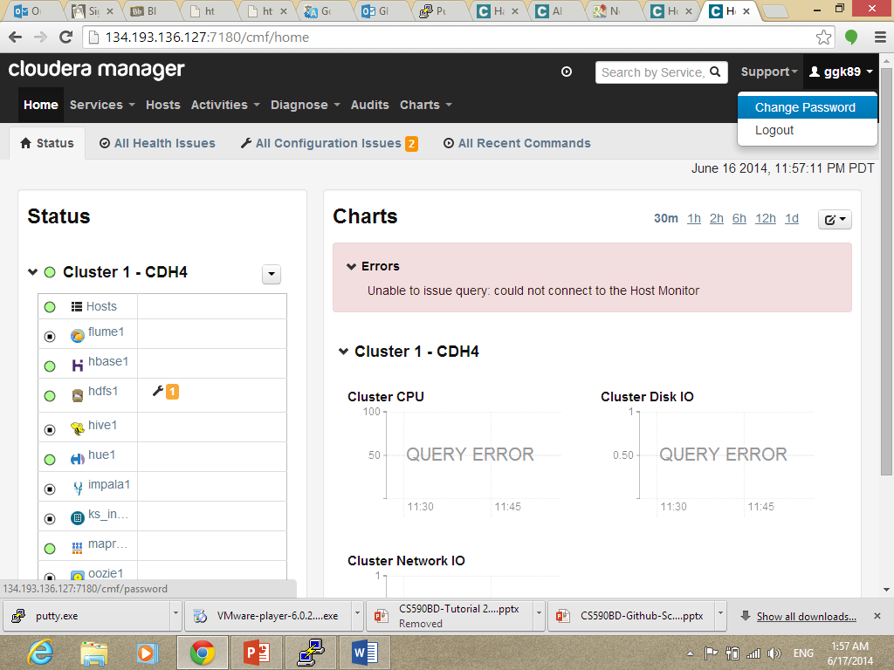

Figure 1. Clodera Manager homepage

* In order to be able to access the Cloudera remote machine terminal, we need to install the PuTTY tool, which is both the Telnet and SSH client. You can download it form the following link

<http://www.chiark.greenend.org.uk/~sgtatham/putty/download.html>

We use the same Cloudera IP address with port 22. The user name and password are the group name (Group4). We highly recommend changing the group password; but do not forget to tell you teammates about the new password. To change the password, use the command “passwd” in the terminal, and enter the current password and then the new password and re-enter it again (see figure2).

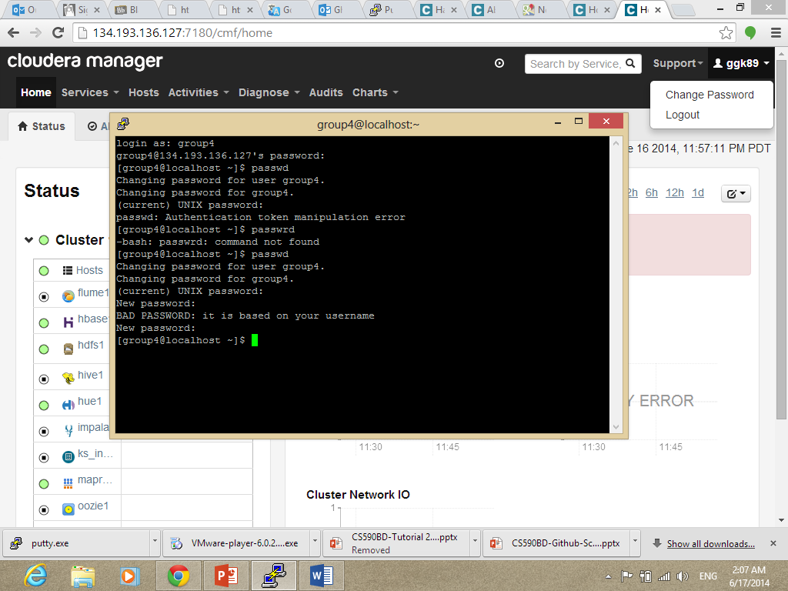

Figure 2. Cloudera remote terminal and changing password

**Subtask 2.2**

To setup our own Cloudera server, we will use VMWare to install Cloudera image on our local machine. We can get the VMWare player from the following website:

<http://www.vmware.com/products/player>

After downloading the VMware player, you can download the Cloudera image (either to run it on VMWare, KVM, or VirtualBox) form the following website;

<http://www.cloudera.com/content/support/en/downloads/download-components/download-products.html?productID=F6mO278Rvo>

Make sure to enable the “Virtualization Technology” in the BIOS configuration.

After downloading botht the VMWare player and Cloudera image you can now open the VMWare and run Cloudera image, I will ask for username and password, use “Cloudera”.

**Subtask2.3**

In order to transfer files to Cloudera, we need a remote file transfer tool such as Filezilla or WinSCP (which is used in our lab). WinSCP is one of the best tools to transfer files from Windows to Linux . To download WinSCP visit the following webpage:

<http://winscp.net/eng/download.php>

Running the tool will open the following screen:

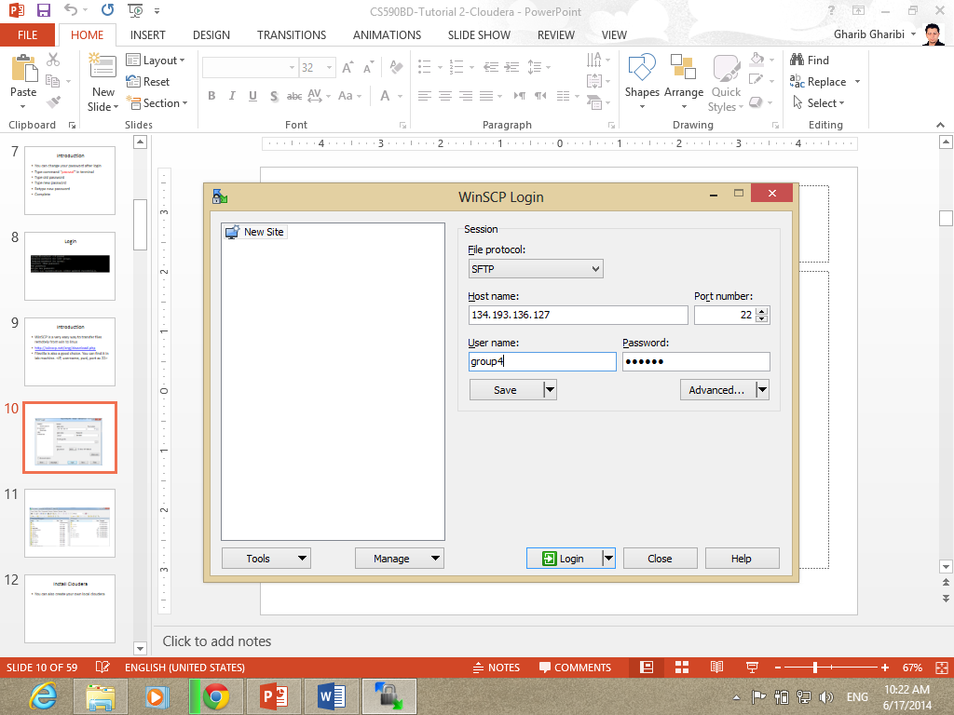

Figure 3. WinSCP startup screen

Make sure to use the correct server IP and port 22. The Username and Password are both the group name (group4, in our group). Then press Login button.

After that, we will see the main software screen (see figure 4)

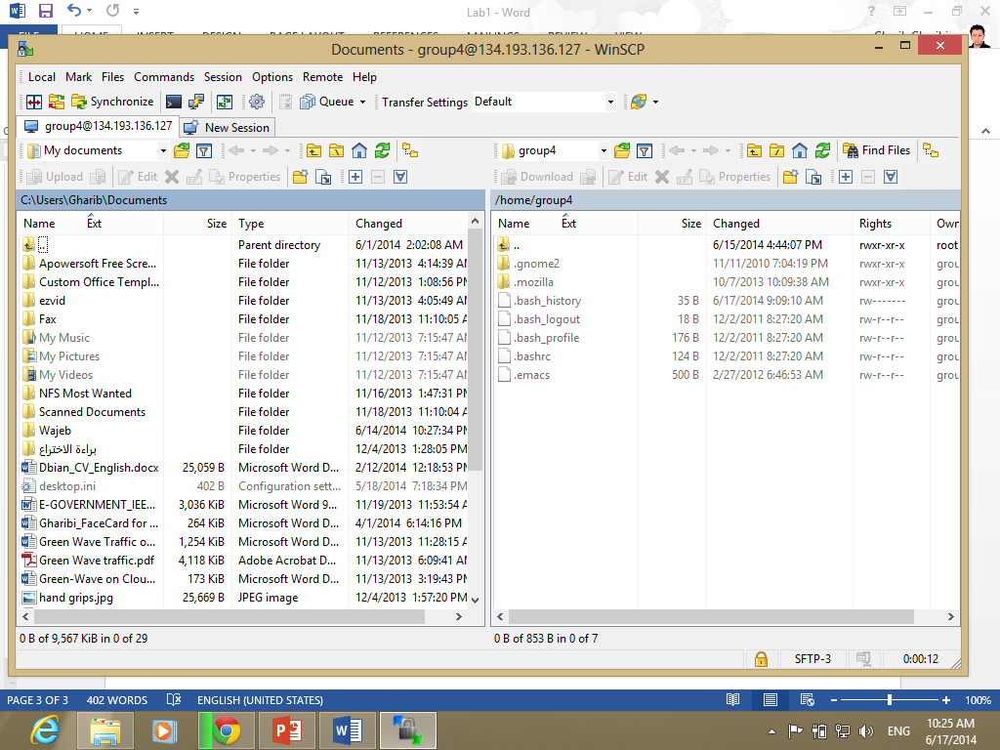

Figure 4. Main WinSCP screen

The left side of the screen is our local machine; the right side of the screen is the remote server. To transfer files between the two ends, we can easily drag and drop files in the folders we need!

**Subtask 2.4**

To run the Word Count example, we need to download it first from the following website:

<https://portal.futuregrid.org/manual/hadoop-wordcount>

After installing the Zipped file on our local machine, we unzipped it and transferred it to the Cloudera server using WinSCP (Figure 5)

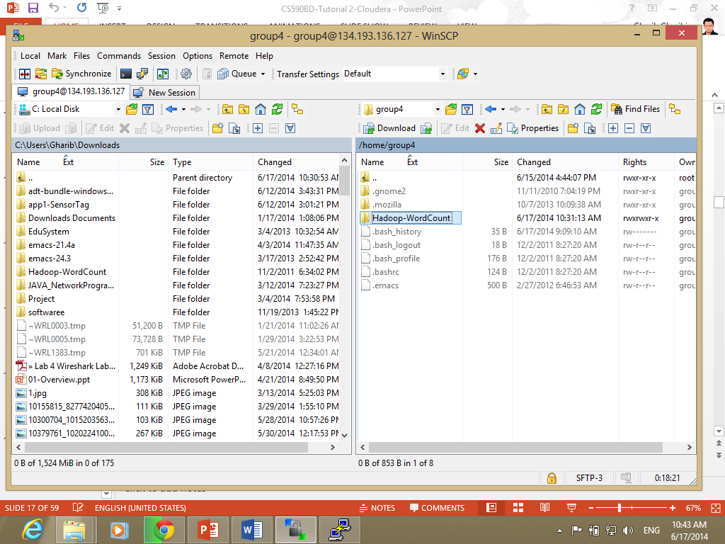

Figure 5. Transferring WordCount from local machine to Cloudera using WinSCP

Then, we used PuTTY tool to connect to our remote server.

1. Upload the input file into Hadoop HDFS;

hadoop fs -put input input

2. Run the WordCount jar;

hadoop jar wordcount.jar WordCount input output

3. See the results;

hadoop fs -cat output/*

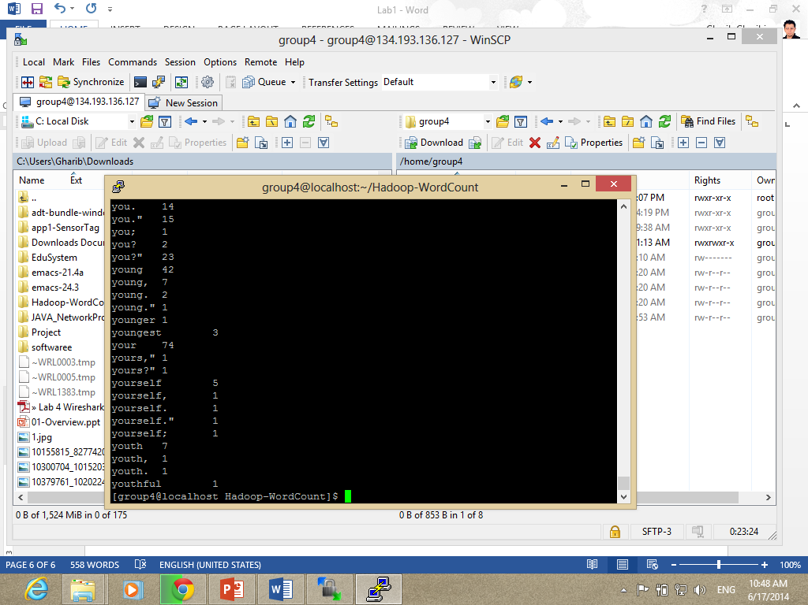

Figure 6. WordCount results

**Subtask 2.5**

Creating a Hadoop file is a straight forward process of Eclipse.

First, we have to import our project “WordCOunt” into Eclipse. After installing the project as Eclipse project, we can right click it and Export it as a Jar file. Select “WordCount” as the main class.

Now we have the Jar file, we need to upload our jar file to the Cloudera Server. We transfer it using WinSCP tool. Then, using PuTTY, we can run the jar file using the following command:

hadoop jar WordCountExercise.jar

To check out the result, use the following command:

hadoop fs –cat out2/*

**Subtask 2.6**

To build a java based restful service, we went through the following steps:

* Download OEPE Juno, from the following website:

<http://www.oracle.com/technetwork/developer-tools/eclipse/downloads/oepe-1211-1357594.html>

* After installing the OEPE Juno Plug-in, we have to install it in the eclipse itself. Open Eclipse, Go to Help menu and select “Install new Software”. Browse for the plug-in and add it.

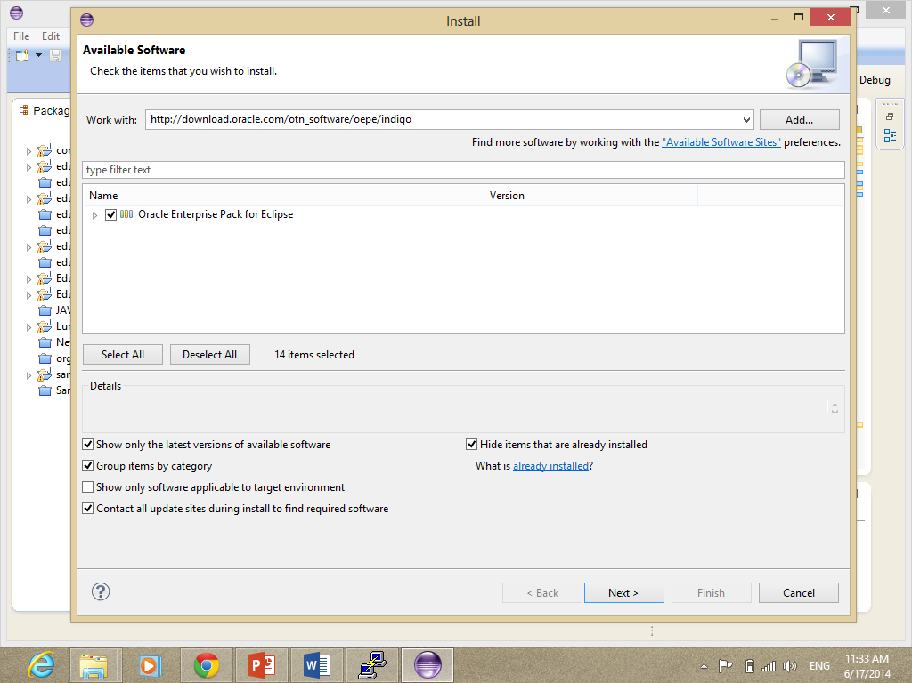

Figure 7. Installin the OEPE into Eclipse

* Restart Eclipse and Open it again. Open it in the Java EE perspective (Window > Open perspective> Java EE). Then, right click (Servers > add new server). Select Glowfish server as shown in the next figure:

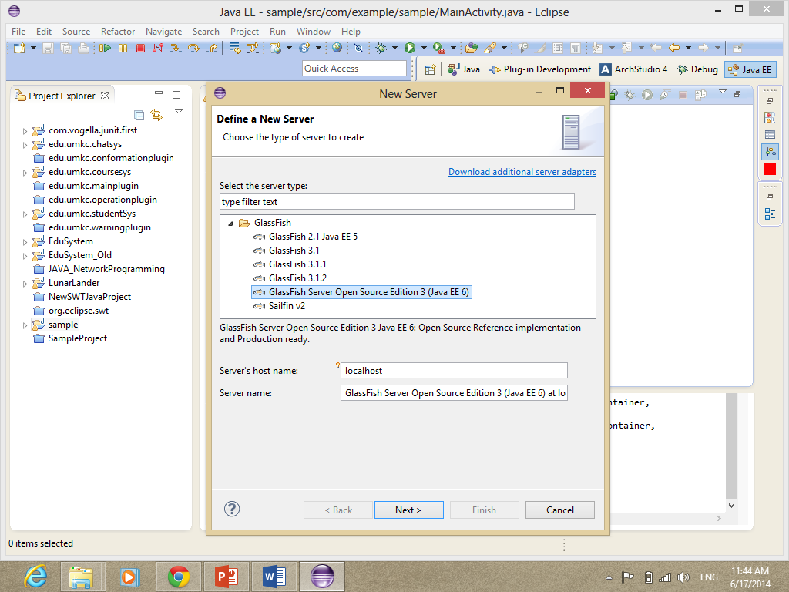

* Then Select you JRE and the folder where you want to install the server. Click Install Server and wait for installation. After installation is finished, enter your username and password. Click Finish.

To run the server, right click the server tap and select Run. Then, go to file menu > New> Dynamic Webpage Project. Then, click Finish. After that, you will see the “Hello World” message!

* To create a rest project, we need to enable Java API (JAX-RS). Right click project name> Properties> facet> Check “JAX-SR”> click Further Configuration required> OK> OK.
* Right click project> new> Restful Web Service from pattern. Fill out the information needed with the pathway.
* Download Glassfish from the following website:

<http://glassfish.java.net/downloads/v3-final.html>

* Start the GlassFish server. Use <http://134.193.136.147:4848>. If authentication required use “admin” for bith username and password.
* Save the file from eclipse as War file

**Task 3**

**1. GitHub**

To use GitHub, follow the following steps:

* Create a new account at GitHub website <https://github.com/>
* Download GitHub software for Windows
* Create a remote Repo at the GitHub website
* Clone the remote Repo into your local machine
* Modify your file at local machine
* After modification, Commit your changes, publish them and Sync with the remote Repo
* Create new Organization and add your team members

**2. ScrumDo**

* Access ScrumDO from [http://www.scrumdo.com](http://www.scrumdo.com/)
* Sign up for a new Free Account
* Create a new Story
* Create Iterations
* Update and keep trace of the progress
* Create Team members and manage them

…THE END…