**Big Data Analytics**

**Lab2**

**Gharib Gharibi (16170368)**

For lab2, I used the provided CC2541 SensorTag as a peripheral to collect data and Nexus 7 tablet with Android 4.4 to run the application and save the collected data from the sensor. It’s well known that CC2541 SensorTag comes with sex different services (sensors), Temperature, Humidity, Accelerometer, Gyroscope, Pressure, and Magnetometer.

In our data collection process, we focused on the first four types of services (Temperature, Humidity, Accelerometer, and Gyroscope). Moreover, we included the time in our collected data.

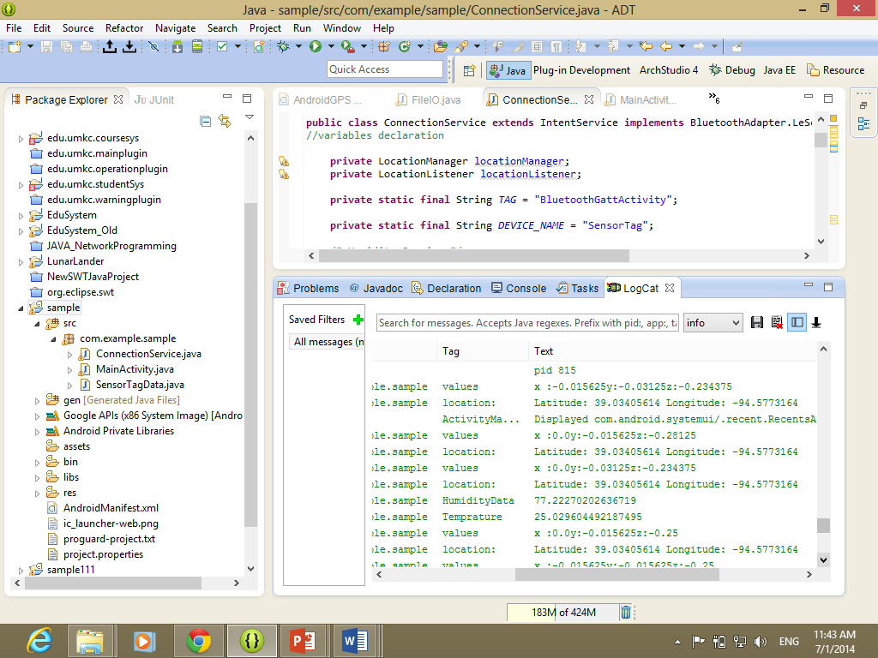

Figure 1. Data collection on the local machine shown in the LogCat

After collecting and recording the data, we used “ASTRO file Manager” to retrieve the data file from our Nexus7 local sdcard storage.

Then, a table in Hbase is created:

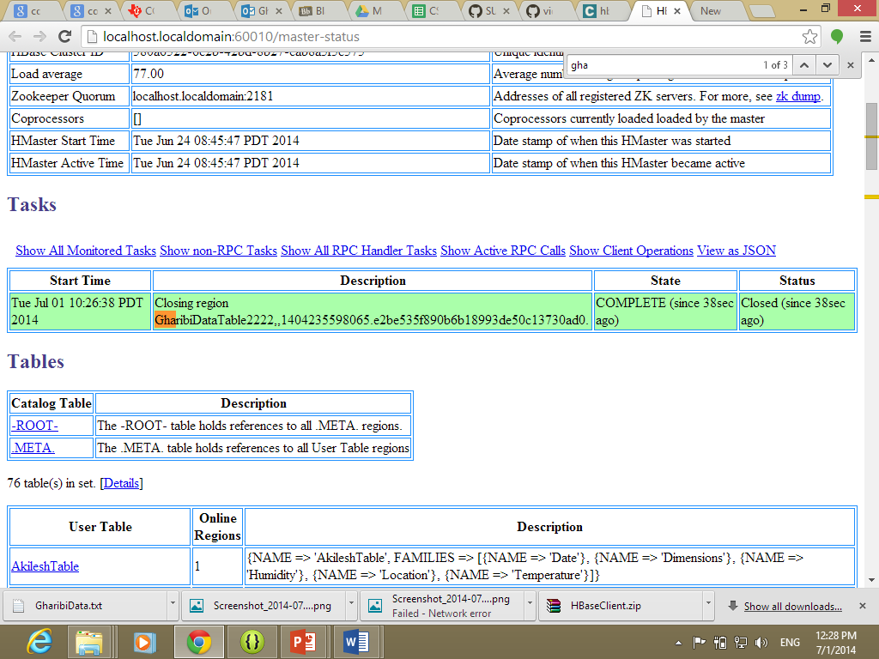

In the same way, we used the provided Java application to Insert, Retrieve and delete the table. Our function was not running because of the column families names! We learned that the column family are case sensitive!

