Name: Syed Ghassan Faheem

Teacher: Dr. Usman Sadiq

Roll # L15-4375

T.A: Hammad-ul-Qudous

Section: B

DIGITAL IMAGE PROCESSING

PROJECT-1

Question # 1:-

P1.1. Take Fourier transform of the image by fft2 and shift by fftshift. After shifting, frequencies are swapped also as shown in the image:

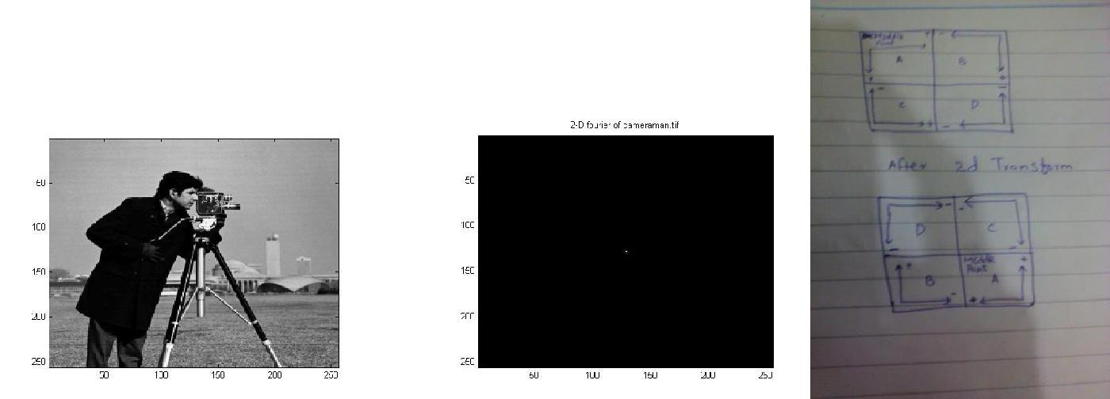

P1.2. Take the 2d fourier of image. Three points were there. Point in the center is original and other point are noise. Removing the other points removes noise.

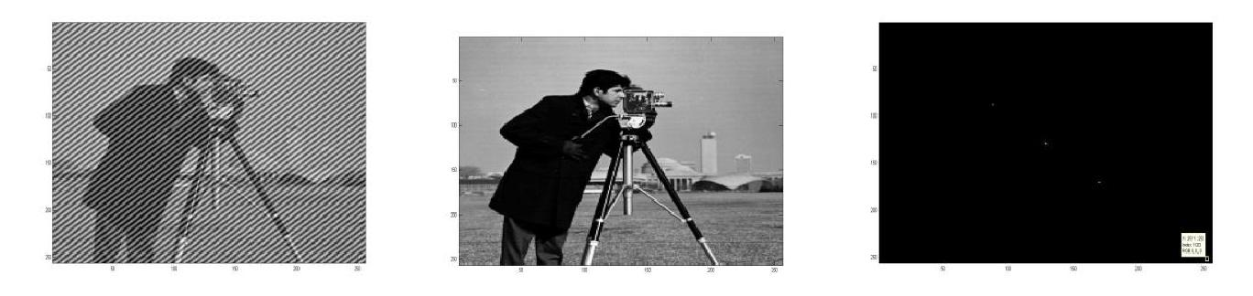

P1.3. Just applied the filter given in the handout by imfilter. And it did averaging.

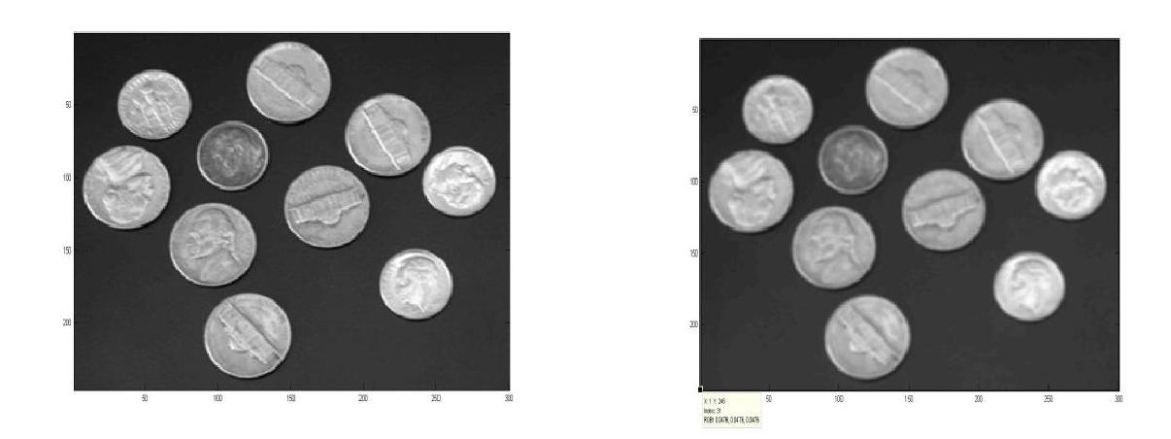

P1.4. Take 2d transform of the image. After that find threshold. Created an image of pixels having above threshold. Set pixels to 0. Take inverse and image shown.

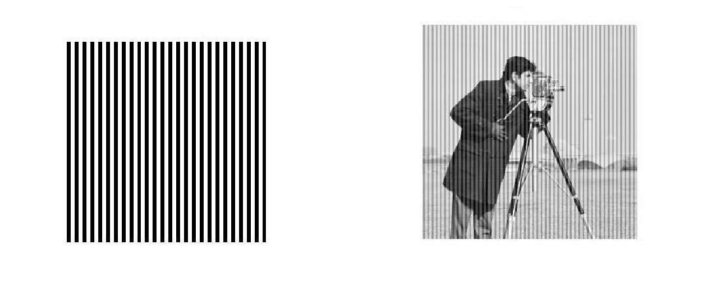

Question 2:-

P2.1. Read image by imread and draw histogram by imhist.

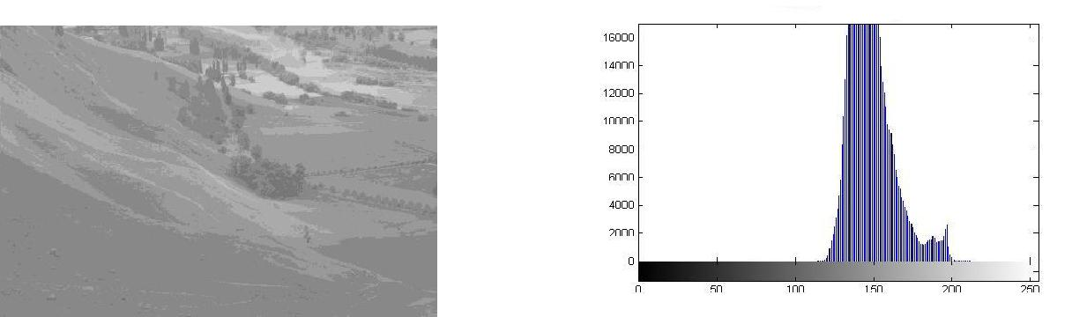

P2.2. Calculate probabilities,by dividing the number of pixels in every gray level by total number of pixels. This will give probability distribution function.

P2.3. To equalize histogram using the probabilities. Calculate the cumulative distribution function then multiply 255. Round it, make another matrix .

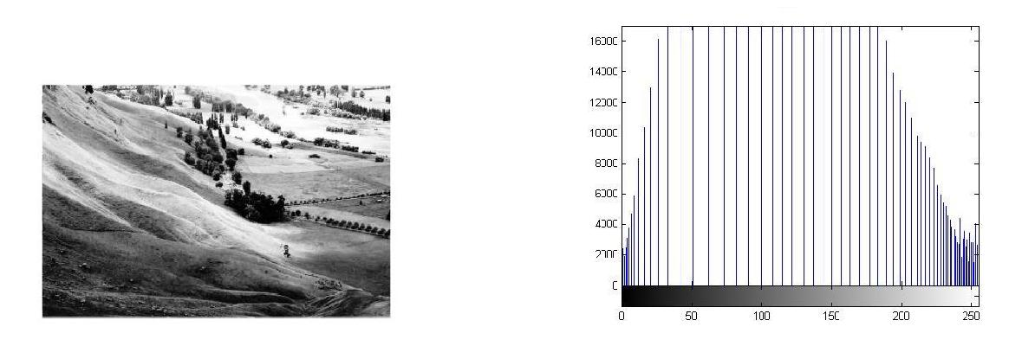

P2.4. Plot the probabilities, take differential of probabilities by gradient and it is the inverse of probabilities. Multiply probabilities and derivative and plot it.

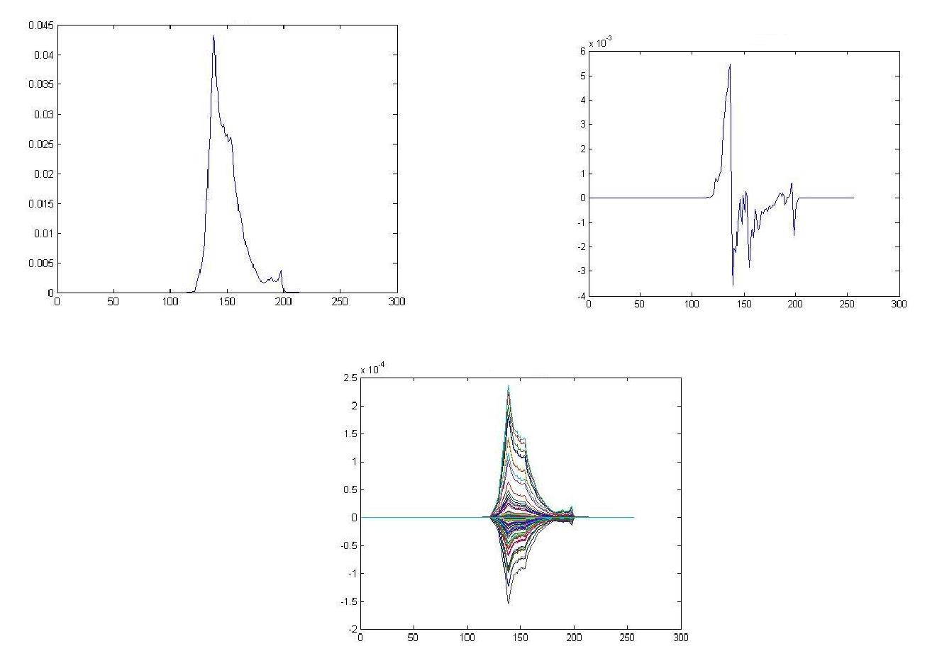

P2.5. Equalizing the histogram of one more image randomly.

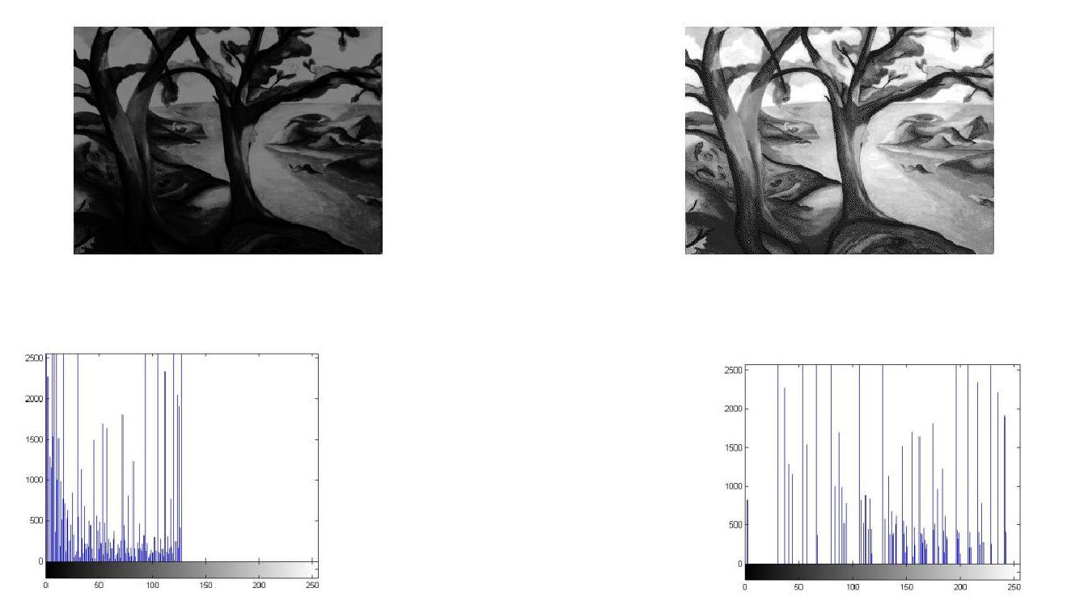

Question 3:-

P3.1. **:** Create noisy image of 256*256 of 0.2 variance and 0 mean by randn. Normalize the cameraman image by the to convert range into 0-1. Add noise. Create another image. Averaging both images. See that variance is less than original images.

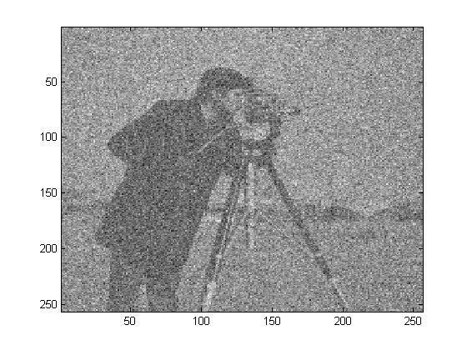

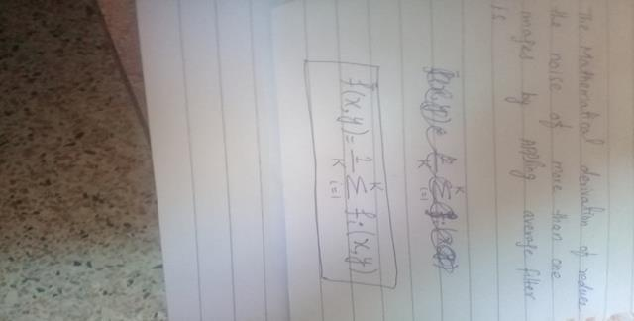p3.1(a)

P3.1(b)**.** Implement standard deviation by calculated mean by adding all pixel values and then dividing it by total numbers of pixels then subtracted mean from each pixel value and then squared and then took summation then divided it with total number of pixels and then took under root to calculate standard deviation.

P3.2**.** Yes filter is averaging filter. Applied this filter by imfilter command and it is reducing noise.

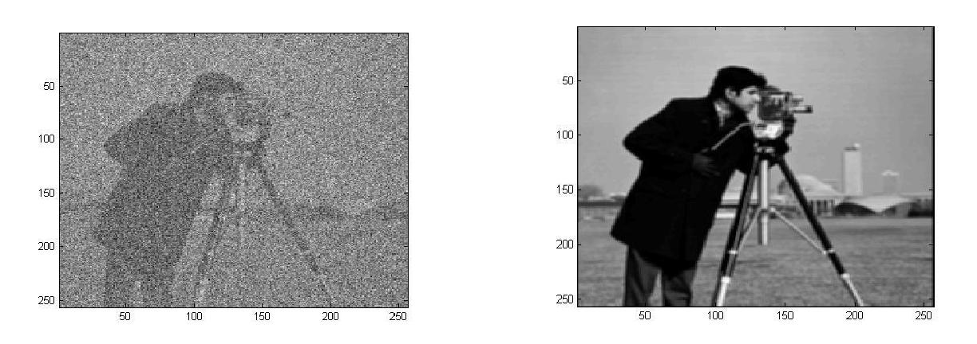

P3.2(a).

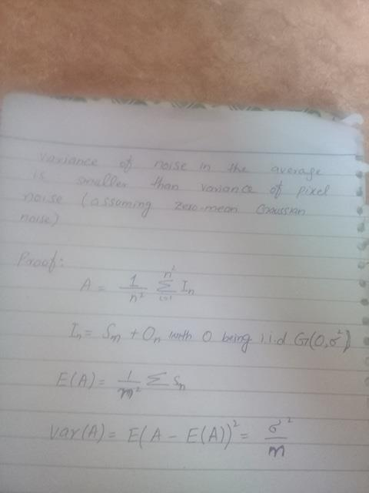

P3.3. Took 2-D Fourier’s of noise less image, noise and filter using the command fft.

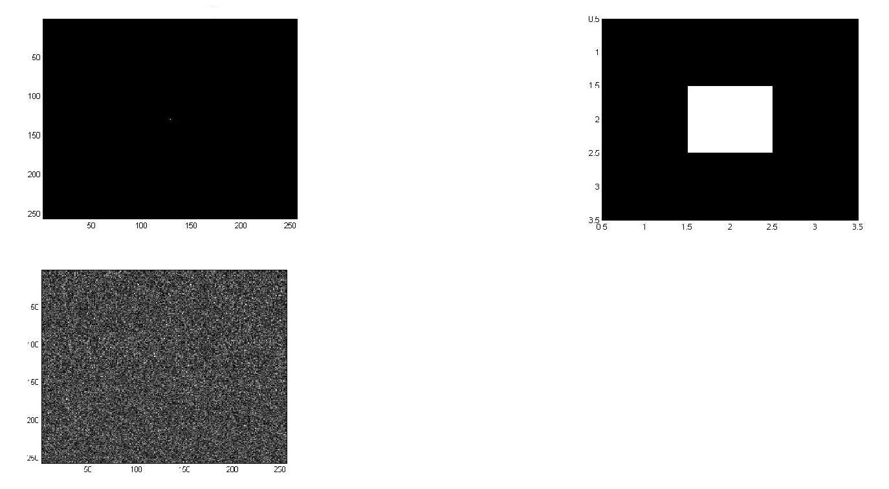

yes, averaging is the low pass filter. Noise reduces by averaging with the neighboring pixels. So by averaging the pixel with low noise pixel reduces the noise of that pixel and other all pixels in the image.