EECE 2140: COMPUTING FUNDAMENTALS FOR ENGINEERS
Spring 2025

OPTIMIZING WORKFORCE ALLOCATION AND SERVICE EFFICIENCY THROUGH DISCRETE-EVENT SIMULATION

- Course Number and Name: EECE2140 Computing Fundamentals for Engineers

Semester and Year: Spring 2025

Project Title: Optimizing Workforce Allocation and Service Efficiency Through Discrete-Event Simulation

Names of Group Members:  Gabriel Atun  Ghassan Alsarmi | Instructor Comments:
Date of Report Submitted:  Apr-14-2025 | Instructor Comments:
Names of Group Members:  Gabriel Atun  Ghassan Alsarmi | Instructor Comments:
Names of Group Members:  Gabriel Atun  Ghassan Alsarmi | Grade:

ABSTRACT
This project aimed to reduce customer wait times and daily labor costs at Equator Coffees, a busy café located in Snell Library, by simulating how different staffing schedules affect service performance. The objective was to develop a realistic model of the café’s operations during a typical day, especially during class breaks when lines tend to get long. We used Python to build a simulation that models customer arrivals and service times using common queuing theory tools like Poisson and exponential distributions.
To inform the model, we collected real data on staffing levels and wait times during both peak and non-peak hours. The simulation allowed us to test different staff configurations and see how changes in employee schedules could improve performance without increasing cost. Running the model 1,000 times for each scenario, we found that simply reallocating employees—by adding more during peak hours and fewer during slow periods—reduced average wait times by nearly 8% without raising labor costs. In one case, we also showed how a more aggressive staffing strategy could save over $21,000 annually while keeping wait times nearly the same.
Python was used to develop every part of the simulation, from data input to final output. We used built-in structures like lists to store time blocks and dictionaries to track block-level staffing and peak classifications. The numpy library allowed us to simulate randomness using random.poisson() for customer arrivals and random.exponential() for service times. Conditional statements and loops helped simulate multiple days and calculate average outcomes. We also included input validation and built-in labor cost calculations, making the code flexible, interactive, and easy to adapt for future versions or real-time decision support.
OBJECTIVE AND INTRODUCTION

Understanding queue behavior and service system performance is a key challenge in many real-world environments. In this project, the focus was on Equator Coffees in Snell Library, a café that regularly experiences long lines during peak periods specially when students have class breaks. Rather than using traditional spreadsheets or manual calculations, a Python-based simulation was developed to model customer arrivals, wait times, and staffing configurations over the course of a typical day. We want to develop a simulation model in Python that replicates a typical day in the Café and see if we can relocate the staff in order to reduce costs and to tackle the problem of long wait times during peak hours.

Python was chosen for its flexibility and powerful support for random number generation, loop structures, and data manipulation. The model used probabilistic arrival and service rates to replicate real customer flow, with simulation results providing insight into how staffing changes affect performance. This coding-driven approach enabled iterative testing of different scenarios and offered a hands-on application of core Python concepts like loops, conditionals, functions, and statistical sampling. Through this, the project demonstrated how programming can be used to solve operational challenges through modeling and simulation.

THEORY AND EXPERIMENTAL METHODS

(Data Collection and Simulation Inputs) This project is based on a real-world study of customer flow and staffing efficiency at Equator Coffees, conducted as part of an Industrial Engineering course. Over one week, data was collected in 20-minute intervals using standardized Google Sheets to capture arrivals, employee count, and wait times during both peak and non-peak hours.
The data revealed a strong relationship between staffing levels and average wait times:
Employees | Samples Available | Average Wait Times
2 | 4 | 8.461
3 | 16 | 7.461
4 | 16 | 4.957
Table 1. Employee Impact on Average Wait Times During Peak Times

Employees | Samples Available | Average Wait Times
2 | 32 | 1.283
3 | 68 | 0.832
4 | 8 | 0.605
Table 2. Employee Impact on Average Wait Times During Non-Peak Times
These values were used to define the mean of the exponential wait time distribution and the average wait times in general used to justify our simulation.

To build a simulation that could realistically model a day in the café, we wrote all of our code in Python. We structured the project into clear sections so that anyone reading or modifying it could easily follow the logic — starting from the setup of time blocks, through user input, arrival rates, simulation logic, and ending with final results. This organization helped us stay focused and test individual parts of the model as we built it out.
We used lists, dictionaries and sets as our main data structures because they allowed us to keep things both simple and flexible. For example, the list of time intervals gave us a clean way to track each 20-minute block of the day. We added employee data and peak classification to each block using a dictionary, which let us store everything we needed in one place — like this:
{
"start": "09:20",
"end": "09:40",
"is_peak": True,
"employees": 4
} We also used a set to identify which blocks were considered peak. Since sets let us check membership very quickly, we could just write: if i in peak_block_indices without having to loop through anything — a small detail, but one that helped keep the simulation efficient.
To model customer behavior, we used a Poisson distribution to simulate the number of arrivals per time block, and an exponential distribution to represent wait times. These are both standard tools in queuing theory and helped us capture the randomness of customer flow:
arrivals = np.random.poisson(lam)
wait_time = np.random.exponential(scale=base_mean)

One part of the project that worked particularly well was our use of a lookup dictionary for average wait times. Instead of writing out dozens of if-statements to handle every possible case, we stored the values from our real-world data in a clean, nested dictionary. That allowed us to instantly access the correct wait time for any combination of staffing level and peak status:

wait_time_lookup = {
"peak": {2: 8.000, 3: 7.461, 4: 4.957},
"non_peak": {2: 1.2828, 3: 0.8316, 4: 0.6052}
}
We also added input validation to make sure users couldn’t enter anything other than 2, 3, or 4 employees per block. This made the program more robust and prevented it from crashing due to invalid entries.
One of our main goals was to make the code not just functional, but easy to adapt. If someone wanted to change the number of time blocks, shift the peak hours, or adjust the arrival rates, they could do it in just one or two places. That flexibility makes the model scalable for future versions or different café layouts.
Overall, our coding decisions — from the structure of the code to the data types we used — helped us build a working simulation that was clean, understandable, and useful. It gave us a deeper appreciation of how thoughtful programming and simple data structures can be combined to model real systems and support operational decision-making.

RESULTS (40 points)

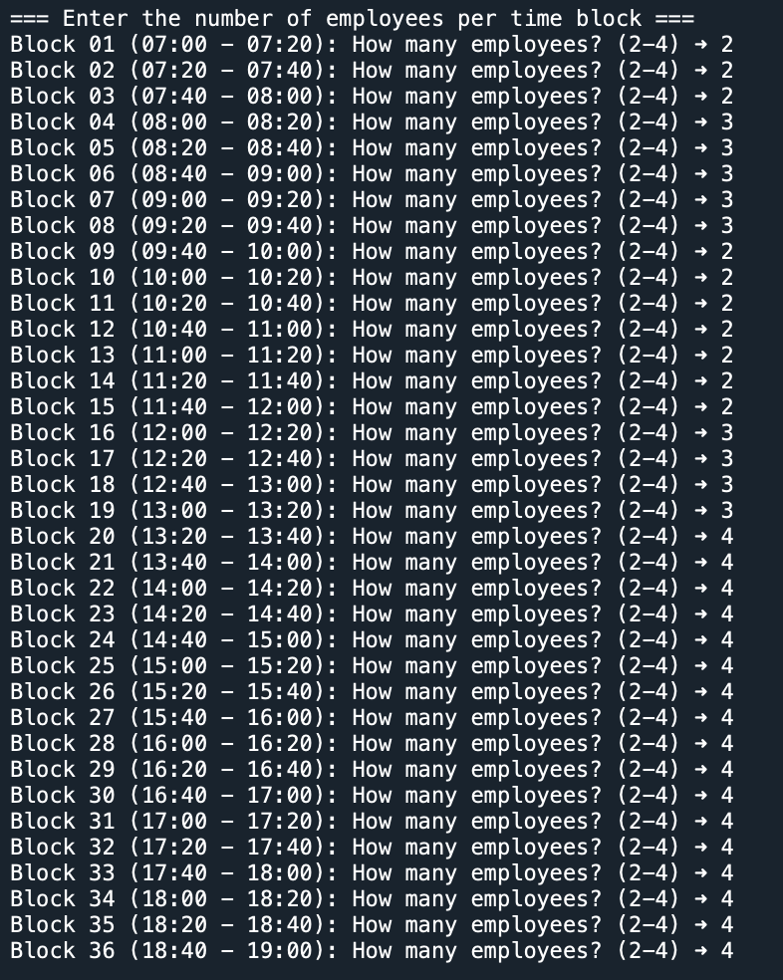
Figure 1: (User Input) Full-Day Staffing Input Across 36 Time Blocks

The first part of our simulation asks the user to enter how many employees are working during each 20-minute time block throughout the day. We wanted to keep it flexible so we could test different staffing schedules without having to rewrite any part of the code.
As shown in the image above, the program goes block by block — from 7:00 AM to 7:00 PM — and prompts the user to type in a number between 2 and 4. This number represents how many people are working at that time. We chose this range based on what’s realistic for a café of this size: 2 employees during slower hours, and up to 4 during busier periods.
This step is important because it gives us control over how labor is distributed across the day. It also makes it easy to simulate different scenarios — like “What if we added an extra person during peak hours?” — without needing to dig into the simulation code itself.
Once all the employee numbers are entered, the simulation uses that schedule to calculate labor costs and estimate average wait times based on the staffing levels and whether it’s a peak or non-peak period.

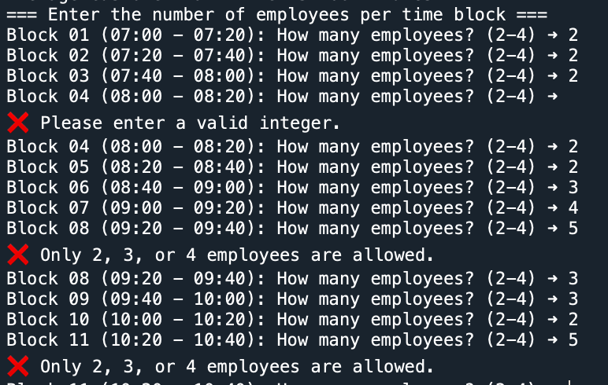
Figure 2: Error Handling for Invalid Staffing Inputs

To make sure the simulation runs smoothly, we added simple error handling for the user inputs. If someone enters something that isn’t a number (like a letter or symbol), the program shows a clear message: "Please enter a valid integer."
Also, if the user types a number outside the allowed range (anything other than 2, 3, or 4 employees), the program responds with: "Only 2, 3, or 4 employees are allowed." Then it gives the user another chance to enter a correct value. This helped make the simulation more user-friendly and avoided crashes due to bad inputs. It also ensured that we only simulate staffing levels that match real conditions in the café.
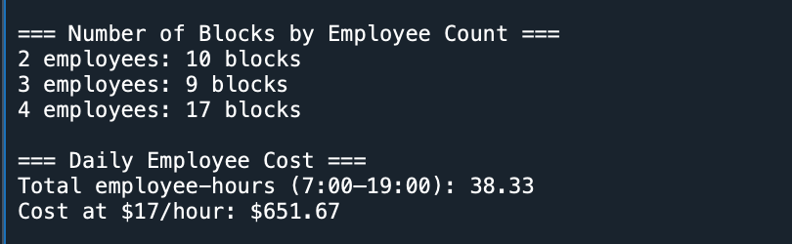
Figure 3: Simulation over 1000 times: Output with summary of employee Distribution and Labor Cost

After collecting all the staffing inputs, the simulation gives us a quick summary of how employees are distributed throughout the day.
(Results and Insights from the Simulation) Our simulation allowed us to test how different staffing schedules affect customer wait times and daily labor costs at Equator Coffees, without having to change anything in the real café. By adjusting the number of employees in each 20-minute block, we could compare multiple staffing scenarios and see how those changes impacted performance.
Baseline Simulation (Figure 1) In the current staffing schedule used at the café—9 blocks with 2 employees, 20 blocks with 3 employees, and 7 blocks with 4 employees—the simulation predicted:
- Average wait time: 3.152 minutes
- Daily labor cost: $600.67
- Total employee-hours: 35.33
This is our reference point for comparing other setups.
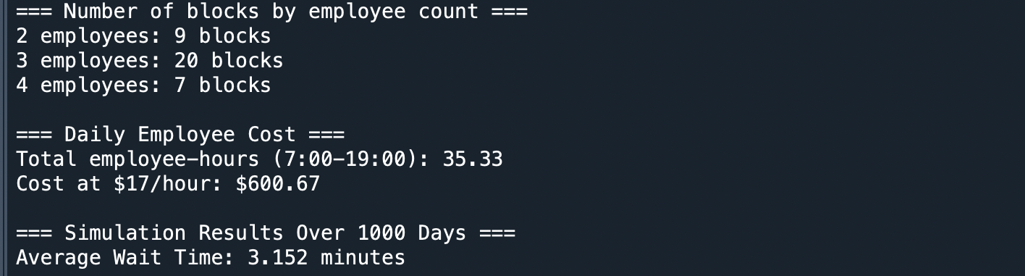
Figure 4: Baseline Simulation Results with Current Staffing Schedule
Optimized Redistribution (Figure 5) Next, we tested a more strategic schedule: reducing the number of 3-employee blocks (which were often used inefficiently), and instead placing more 4-employee blocks during known peak periods. With the same number of total employee-hours (and cost), this small shift led to:
- Average wait time: 2.907 minutes (down from 3.152)
- Cost and hours: same as baseline
This showed us that we don’t necessarily need more employees—we just need them at the right times.
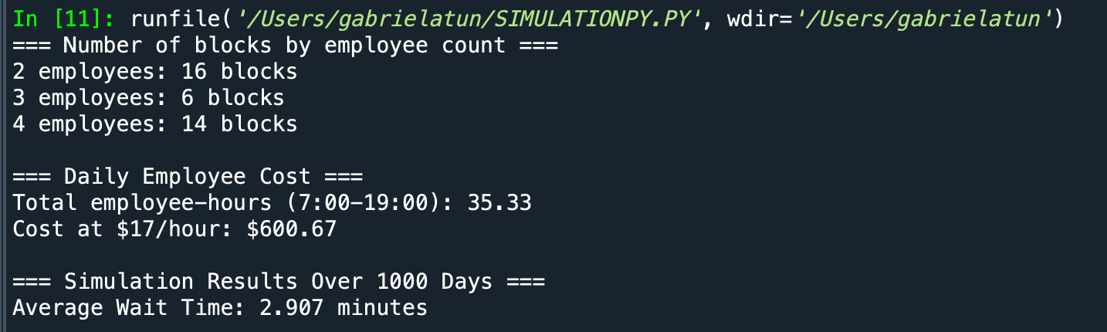
Figure 5: Simulation Results with Optimized Employee Redistribution

Peak-Time Focused Staffing (Figure 6) As a final test, we simulated a staffing setup where:
- All peak blocks had 4 employees
- All non-peak blocks had just 2
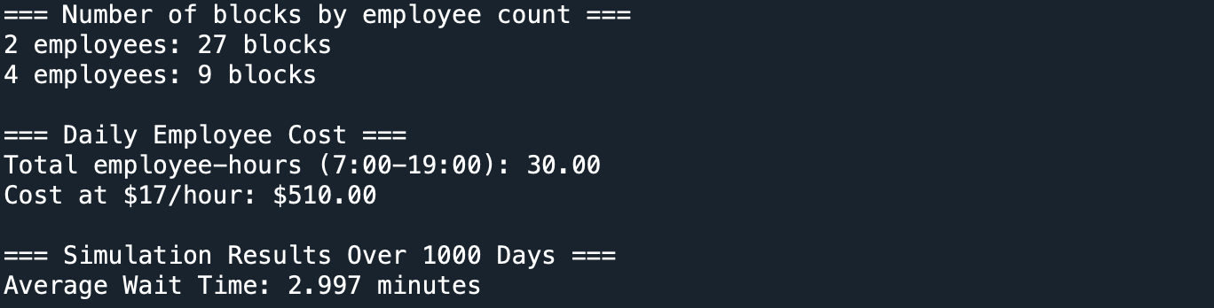
Figure 6: Simulation Results with Peak-Time Focused Staffing
This brought the total labor cost down to $510.00 while still keeping the average wait time low at 2.997 minutes. That’s a daily savings of $90.67, which adds up to over $21,000 per year, without significantly impacting waiting times and just re distributing the employees in a more efficient way.
CONCLUSIONS
This project successfully met its main objective: to simulate a full day of operations at Equator Coffees and explore how staffing adjustments could reduce customer wait times and labor costs. By combining real-world data with a Python-based simulation model, we were able to test different staffing scenarios without disrupting the café’s daily routine.
Using Python gave us the flexibility to structure the simulation in a way that was both functional and adaptable. With tools like loops, functions, and NumPy’s random number generation, we modeled arrival patterns using a Poisson distribution and customer service times using an exponential distribution — both widely used in queuing theory. This approach allowed us to realistically approximate customer flow and service behavior.
The results clearly showed that smarter staff allocation can make a measurable difference. For example, simply redistributing employees — without increasing total labor hours or cost — lowered average wait times by nearly 8%. And by aligning staff more precisely with demand (more employees during peak hours, fewer during slower periods), we achieved additional cost savings of over $21,000 per year, while maintaining nearly the same wait time performance.
From a technical perspective, the project also demonstrated how basic Python structures like lists, dictionaries, and sets can be combined to build a clean, modular simulation model. The simulation was easy to modify, run repeatedly, and understand — which made it a powerful tool not just for analysis, but also for communicating findings.
In the end, this project showed how data, coding, and simulation modeling techniques can be used to support operational decisions and improve service quality in real environments.

LIMITATION AND FUTURE WORK
While the simulation gave us helpful insights into how staffing affects wait times and costs, there are still a few limitations, both in the logic of the model and the way the code was built.
One of the main simplifications is that we assume fixed arrival rates and average wait times for each staffing level. In reality, customer flow is more irregular and depends on many factors, like time of day, order type, and even how busy the café looks. Our model also doesn't include queue buildup or delays from customers arriving faster than they can be served, which would happen in a real environment during rush periods.
From a technical standpoint, the simulation is written as a simple procedural script. While that made it easier to build and test, it limits flexibility. For future versions, we could make the code more modular by using object-oriented programming, or allow users to import schedules from a file like a CSV instead of entering them manually each time. This would make it easier to test different scenarios or even run large batches of simulations automatically.
We also use NumPy's random number generation, which is appropriate for modeling randomness in arrivals and service times, but we didn’t implement random seeds or controls for reproducibility. Adding that would make the results easier to validate and compare.
Lastly, while the simulation works well in the terminal, a graphical interface or dashboard could help café managers test different schedules without having to interact with code. And tools like Pandas or Matplotlib could be added to analyze and visualize performance more clearly.
In the end, the simulation achieved what we set out to do, but there’s a lot of room to grow. With just a few improvements, it could become a much more powerful tool for decision-making in real operations.

REFERENCES

[1] Gross, D., Shortle, J. F., Thompson, J. M., and Harris, C. M., Fundamentals of Queueing Theory, 4th ed., Hoboken, N.J.: Wiley-Interscience, 2008.

