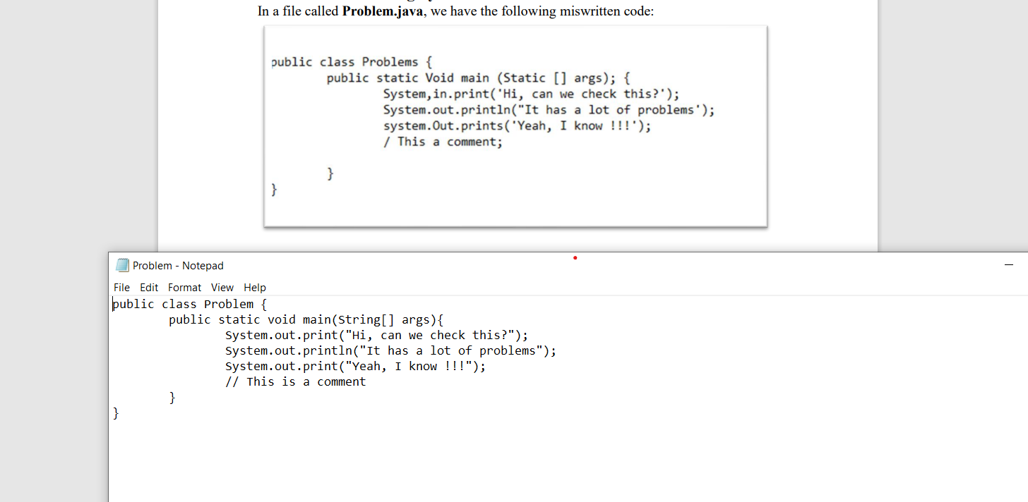

So the main problems were

The name of public class must be same

String not static

Double slashes for adding a comment

No semi colon beside args