Constraint Encoding and Penalty Weight Determine Quantum-Inspired Solver Performance on a Real Crop-Allocation QUBO
Anonymous Submission | NGIA-QC 2026 — Double-blind review
Abstract—When many farmers independently choose the same profitable crop, the combined harvest depresses its price. We write this for 174 real parcels (1,464 ha) in Jenin, Palestine as a 1,914-variable QUBO with market-clearing prices, and benchmark two constraint encodings against two solvers over 20 seeds at a matched wall-clock budget. Encoding, not solver, decides usability: under one-hot encoding discrete simulated bifurcation leaves 130 of 174 parcels invalid and earns 67% less than annealing, while domain-wall encoding raises its profit by 138% and makes the two solvers indistinguishable. We then sweep the domain-wall ordering penalty, a weight that published comparisons fix without reporting, and find it inverts the apparent conclusion: annealing loses 22% at the conventional weight and gains 18% at twice that value. A myopic greedy plan loses $10.5M by flooding the market. Both learned components are reported as negative results.
Index Terms—quantum-inspired optimisation, simulated bifurcation, QUBO, domain-wall encoding, constraint encoding, crop planning
INTRODUCTION
Crop planning is an allocation problem constrained by a market signal no individual farmer can observe. A farmer plants on last season's prices without knowing what the neighbours intend; when many independently converge on the same profitable crop, the combined harvest depresses its price. Every decision is individually rational and the aggregate outcome is a collective loss, a coordination failure that bites hardest where output cannot be held back until prices recover. Producer prices in Palestine move sharply year to year: across 2010–2023 the largest single-year change in the FAOSTAT series [1] ranges from 14% for wheat to 60% for oranges, and the two crops in our set that store well, wheat and olives, sit at the bottom of that range at 14% and 23%. Recent crop-planning models therefore treat market absorption as a binding constraint rather than assuming prices are exogenous to the plan [2, 3].
Allocating P parcels among C crops admits C^P candidate assignments and does not decompose: because revenue depends on aggregate production, the best crop for one parcel depends on the choices made for all the others. Problems of this form map onto quadratic unconstrained binary optimisation (QUBO) [4, 5], the input format shared by quantum annealers and by a growing family of quantum-inspired classical solvers. Among the latter, simulated bifurcation (SB) [6] integrates the classical Hamiltonian dynamics of nonlinear oscillators. All variables update simultaneously, so SB parallelises where sequential methods such as simulated annealing [7] cannot, and it has cut time-to-solution substantially against annealing hardware on large benchmarks [8].
Passing a discrete allocation problem to any such solver first requires an encoding: a representation of each parcel's crop choice in binary variables, together with a mechanism enforcing that exactly one crop is selected. One-hot encoding imposes this through a quadratic penalty over all pairs of binaries within a parcel. Domain-wall encoding [9] instead constrains a chain of binaries to be non-increasing, replacing the dense per-parcel penalty with a local penalty between adjacent binaries. Encoding is ordinarily treated as an implementation detail, subordinate to the choice of solver. On the instance studied here it is not: it decides whether the quantum-inspired solver returns a usable plan at all.
A second decision is buried one level deeper. The domain-wall ordering penalty carries a weight that published comparisons fix once and do not report. We show that this weight determines not only the size of the encoding effect but its sign for one of the two solvers, so a single-weight study can reach the opposite conclusion from a swept one.
Our contributions are threefold. First, a 2×2 encoding-by-solver benchmark on a real 1,914-variable agricultural QUBO, over 20 seeds at a verified wall-clock budget, in which domain-wall encoding raises discrete simulated bifurcation's profit by 138% and renders the two solvers statistically indistinguishable. Second, a sweep of the domain-wall ordering penalty across five weights showing that the conventional value sits in a region where annealing appears to lose 22%, while at twice that weight domain-wall improves both solvers; the apparent conclusion inverts with an unreported hyperparameter. Third, an evaluation of every learned component against a trivial baseline, in which an LSTM price forecaster fails to beat persistence and a Random Forest suitability model is shown to carry almost no parcel-level discriminating power, both reported rather than omitted.
LITERATURE REVIEW
:lit
AI-Based Crop Recommendation and Price Forecasting
Random Forest, an ensemble of bagged decision trees, remains a strong baseline for tabular agricultural data because it absorbs nonlinear, heterogeneous features without extensive preprocessing [10]. Dey et al. [11] reached classification accuracy above 99% for crop recommendation with XGBoost on soil and climatic features, but their pipeline stops at suitability: with no forecasting or allocation stage, a crop flagged suitable may still be a poor choice if the market is saturated. Saha et al. [12] combined satellite land mapping, machine-learning crop and yield prediction above 95% accuracy, and irrigation control; their LSTM forecasts vegetation area rather than prices, so it cannot signal oversupply before it occurs.
Because the allocation objective is driven by prices, the quality of the price input matters as much as the optimiser; Li et al. [2] address this by feeding neural-network forecasts into theirs. Long Short-Term Memory networks [13] are widely applied to agricultural price series for the same purpose. Their benefit is sensitive to record length, and a governorate-level history offers only a few decades of annual observations per crop. Whether a learned forecaster improves on a naive baseline at this data scale is an empirical question rather than a given, and we treat it as one.
Optimisation: Classical and Quantum-Inspired
Crop allocation was traditionally posed as linear programming, but recent work treats it as a nonlinear problem integrating prediction and market effects. Li et al. [2] combined simulated annealing with a genetic algorithm across 34 plots in northern China, constraining production by regional market-absorption capacity and farm water supply, and beat standalone GA, SA, PSO and ACO by 5–10 percentage points of profit increment. Hou et al. [3] paired particle swarm optimisation with simulated annealing and Monte Carlo simulation, lowering prices when production exceeds demand, and raised expected profit by 12.6% over a baseline PSO.
Quantum-inspired approaches offer a different route. Zeng et al. [8] benchmarked quantum-annealing-inspired algorithms against a D-Wave annealer on Max-Cut instances of up to 20,000 nodes: ballistic SB cut time-to-solution nearly fifty-fold on small and Chimera-structured graphs, and discrete SB was fastest on large ones. On dense QUBO instances, Kim et al. [14] found a hybrid quantum-annealing solver roughly 6,561× faster than the best classical solver. Within agriculture, Verma et al. [15] paired a quantum convolutional network with QAOA and reported speed-ups of up to 3.5×.
Encoding has been studied separately from solvers. Chen et al. [16] compared domain-wall against one-hot on D-Wave annealing hardware across three problems and found domain-wall superior on every metric, with none favouring one-hot. Berwald et al. [17] proved domain-wall optimal in binaries per discrete variable, showed its dynamics freeze later on hardware, and conjectured that the advantage extends to gate-model and quantum-inspired algorithms.
Two gaps follow. First, none of the agricultural studies formulates allocation as a QUBO with market-clearing prices for Ising-type solvers. Second, the encoding comparisons were run on annealing hardware and abstract problems, within a single solver class, at one ordering-penalty weight. Whether the conjecture of Berwald et al. holds for a quantum-inspired solver on a real allocation problem, and whether the comparison is stable in the penalty weight, have not been tested. Table lit summarises the studies reviewed.
TABLE I. Summary of reviewed studies across crop recommendation, forecasting, and optimisation
p3.0cmp3.9cmp6.6cm Study | Focus area | Method | Limitation relative to this study
Breiman [10] | Ensemble learning, general | Random Forest (foundational) | Not agricultural; the method used here for suitability
Hochreiter \ | Schmidhuber [13] | Sequence modelling, general | LSTM (foundational) | Not agricultural; the method used here for forecasting
Dey et al. [11] | Crop recommendation | XGBoost on soil/climate features | Suitability only; no forecasting or allocation
Saha et al. [12] | Land suitability, irrigation | ML + LSTM (vegetation), satellite data | LSTM forecasts vegetation area, not prices
Li et al. [2] | Dynamic multi-plot crop planning | Hybrid SA–GA + neural-network forecasts | Classical; no QUBO or encoding analysis
Hou et al. [3] | Crop planning under uncertainty | Hybrid PSO–SA + Monte Carlo | No learned forecasts; classical
Zeng et al. [8] | Quantum-inspired optimisation | SB and simulated CIM vs. D-Wave annealer | Abstract benchmarks; solvers, not encodings
Kim et al. [14] | Large-scale dense QUBO | Hybrid quantum annealing vs. classical | Benchmark instances; solvers, not encodings
Verma et al. [15] | Quantum computing in precision agriculture | QCNN + QAOA | No market-clearing prices; no encoding analysis
Chancellor [9] | Encoding discrete variables | Domain-wall encoding | Theoretical; not evaluated on a real problem
Chen et al. [16] | Encoding comparison, experimental | Domain-wall vs. one-hot on D-Wave hardware | Annealing hardware; one solver class, one penalty weight
Berwald et al. [17] | Encoding theory and dynamics | Variable-count optimality; freezing behaviour | Conjectures the extension without testing it

METHODOLOGY
:method
Study Area and Data
All inputs are public. Parcels are OpenStreetMap land-use polygons [18]: of 941 polygons in the Jenin window, 625 have centroids outside the West Bank, and the remainder are filtered to 0.1–100 ha, leaving 174 parcels covering 1,464 ha in the Palestinian-administered class of the UN OCHA Oslo layer [19]. Climate is NASA POWER [20] for 2015–2024 (Fig. map): 465 mm rainfall per year, 20.7^°C and 68.7% relative humidity. Jenin resolves as a single grid cell, so climate is identical across parcels and all parcel-level variation comes from soil and land use. Soil properties are SoilGrids 250 m estimates [21].
Producer prices are FAOSTAT [1] means for 2019–2023; we exclude 2024, when perishable prices rose 1.24–5.76× over 2023 while wheat (0.95×) and olives (1.10×) did not, consistent with a wartime supply shock rather than demand. Yields are FAOSTAT means for 2014–2022, rescaled to the PCBS open-field level for the northern West Bank [22]. Irrigation requirements follow FAO-56 [23]. Production cost is an assumption: a share of baseline gross revenue typical of the system type, held fixed when prices are perturbed. Table crops lists the parameters.
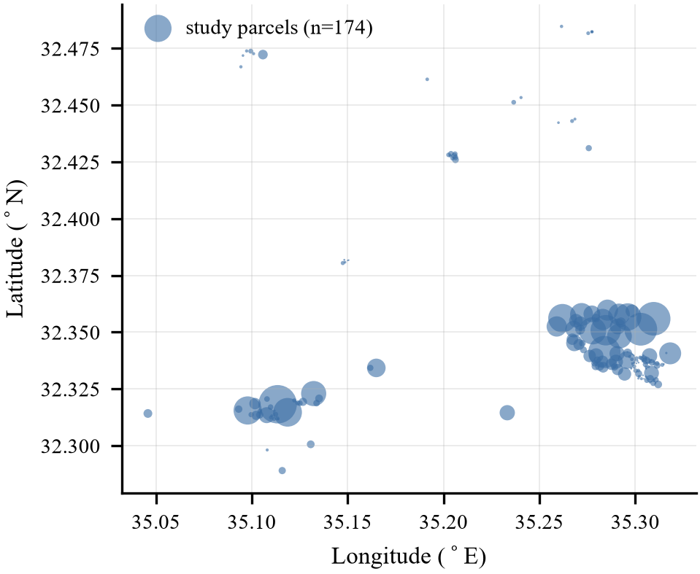
Fig. 1. The 174 study parcels; marker area is proportional to parcel size. Median parcel is 1.69 ha and mean 8.41 ha, so the instance is dominated by smallholdings with a few large blocks.
TABLE II. Crop parameters
Crop | Yield (t/ha) | Price ($/t) | Water (m³/ha) | Cost share
wheat | 2.41 | 568 | 500 | 0.65
potatoes | 13.27 | 488 | 4000 | 0.55
tomatoes | 51.74 | 628 | 6000 | 0.55
cucumbers | 18.49 | 614 | 4500 | 0.55
onions | 9.56 | 526 | 3500 | 0.55
eggplants | 19.04 | 459 | 6000 | 0.55
maize | 5.79 | 572 | 5000 | 0.65
olives | 1.43 | 1752 | 1500 | 0.40
grapes | 9.38 | 987 | 3000 | 0.40
oranges | 19.38 | 601 | 7000 | 0.40

Suitability Model
A Random Forest of 300 trees [10] is trained on 2,900 rows over 29 classes: 1,900 real observations covering 19 crops from a public dataset [24], plus 1,000 rows for the ten study crops generated from FAO EcoCrop envelopes [25]. Real and synthetic rows are scored separately and never pooled. Suitability is
sij=RFj() φ(ℓi,j),
where RFj is the predicted probability of crop j and φ is a land-use factor from the OSM class ℓi. Each crop is scored under its own water regime: the model receives rainfall plus that crop's irrigation allotment, since the optimiser purchases irrigation for these crops and scoring them on rainfall alone penalises them for water the plan already buys. Phosphorus and potassium have no parcel-level source and are sampled over published ranges across 200 Monte-Carlo draws. A parcel–crop pair counts as unsuitable if it falls in the bottom 20% of that crop's suitability across parcels.
QUBO Formulation
Let xij\0,1\ indicate that parcel i grows crop j (j=0 is fallow), with production qij=aiyj and total Qj=. The allocation maximises
(pjQj-βjQj²)-,jcjaixij -λ,jwjaixij,
where βj=pj/(2Dj) gives a linear inverse-demand curve whose marginal revenue falls to zero at Qj=Dj. No crop-level demand data exist for Jenin, so market size is an assumption, Dj=0.6 A yj with A the study area. Irrigation is charged at λ \/m³ (λ=0.15 unless swept); pricing water rather than capping it avoids the large slack penalties a cap requires, which in an earlier formulation drowned the profit signal. Two penalties remain, each of weight M=0.5$ against the objective normalised by its largest linear coefficient: one crop per parcel, and unsuitable pairs. Reported profit excludes the internal water charge, so water use is reported alongside it throughout.
Encodings, Solvers and Protocol
One-hot uses C=11 binaries per parcel with penalty M(-1)², giving 1,914 variables. The penalty couples every pair of binaries within a parcel, and invalid assignments remain reachable. Domain-wall [9] uses C-1=10 binaries per parcel constrained to be non-increasing, xij=dij-di,j+1, giving 1,740 variables. It replaces the dense per-parcel penalty with a chain of nearest-neighbour ordering terms of weight Mwall; non-monotone chains remain reachable and are penalised, not forbidden. The suitability penalty is retained in both.
Simulated annealing (SA) [7] flips single bits with incremental O(n) energy updates and geometric cooling. The incremental update matters for fairness: a naive O(n²) implementation would turn a wall-clock comparison into a measure of implementation quality. Discrete simulated bifurcation (dSB) [6] evolves positions and momenta
y=-(a0-p(t))x-c0(J sgn(x)+h), x=a0y,
with inelastic walls at |x|=1, linear pump p(t) and time step 0.25. Greedy assigns each parcel its highest-margin suitable crop, ignoring market coupling.
A solver's bit string is decoded to an assignment before evaluation: within each one-hot block the highest bit is taken, and in domain-wall the position of the descent is read. Blocks outside the encoding's valid subspace therefore still yield a feasible plan, and reported profits are of these decoded plans. “Invalid” counts parcels whose block lies outside that subspace: for one-hot, not exactly one bit set; for domain-wall, a non-monotone chain.
Following benchmarking practice for stochastic solvers [26], all configurations receive the same wall-clock budget of 2.5 s per run. Step and sweep counts are calibrated to that budget, the arms are then run, and the achieved median across the 20 seeds is checked against it; an arm more than 12% off is recalibrated from its own achieved median and re-run. This is necessary rather than cautious: the same 1,000-step dSB run measured 3.10 s, 2.50 s and 1.11 s on one host within a single session, and an earlier protocol that calibrated once gave one encoding 3.2× the compute of the other. Results are not written unless all four arms land within 15% of the budget. Differences are tested with two-sided Mann–Whitney U tests, the seeds being independent.
RESULTS
:results
Learned Components
In 5-fold stratified cross-validation the Random Forest reaches 0.9958±0.0021 accuracy on the real rows against a majority-class baseline of 0.0526, and 0.8940±0.0297 on the synthetic rows, which measures fidelity to the EcoCrop envelopes rather than predictive skill. Feature importances are rainfall 0.275, humidity 0.174, K 0.150, P 0.134, temperature 0.092, N 0.091 and pH 0.083.
These figures overstate what the model contributes here. Within Jenin, soil pH spans only 7.45–7.80 and available nitrogen 87–138 kg/ha across the 174 parcels, a range narrower than almost any split the forest learned on a global training set. In consequence the 90 distinct soil profiles present in the data collapse to between 2 and 12 distinct suitability values per crop. Parcel-level suitability is therefore close to a per-crop constant modulated by a three-valued land-use factor, and the model should not be read as discriminating between individual parcels.
The optimiser requires a price for each crop. To decide whether that price should be forecast or taken from recent history, we compared an LSTM [13] of 24 hidden units and 3,481 parameters against four naive baselines under walk-forward validation, with the split made before normalisation (Table lstm).
TABLE III. Price forecasts, 50 test windows, 2024 excluded
Model | RMSE ($/t) | MAPE (%)
Persistence | 130.1 | 16.3
AR(1) | 150.5 | 18.3
Mean of last 3 | 170.1 | 19.7
Linear trend | 186.0 | 20.9
LSTM (pooled, augmented) | 252.2 | 26.7

The LSTM ranks last. With 142 training windows drawn from 13–27 annual observations per crop, 3,481 parameters are not constrained. The optimisation therefore uses 2019–2023 mean prices. Including 2024 in the test window reverses the ranking (LSTM 624.2 against 639.6 for persistence), but the wartime shock raises persistence error 4.9-fold and LSTM error only 2.5-fold, so a window containing 2024 rewards robustness to a discontinuity rather than forecasting skill.
Encoding Versus Solver
TABLE IV. Encoding by solver, 20 seeds, 2.5 s per run
Enc. | Solver | Profit (M$) | Invalid | Water (Mm³) | Budget (M$)
one-hot | SA | 6.18±0.23 | 0.0 | 6.34 | 1.69±0.20
one-hot | dSB | 2.04±0.42 | 130.3 | 2.31 | 1.27±0.29
dom.-wall | SA | 4.80±0.53 | 5.0 | 7.17 | 1.75±0.18
dom.-wall | dSB | 4.87±0.48 | 3.5 | 7.01 | 1.68±0.18
Greedy |  | -10.47 | — | 8.97 | 1.37

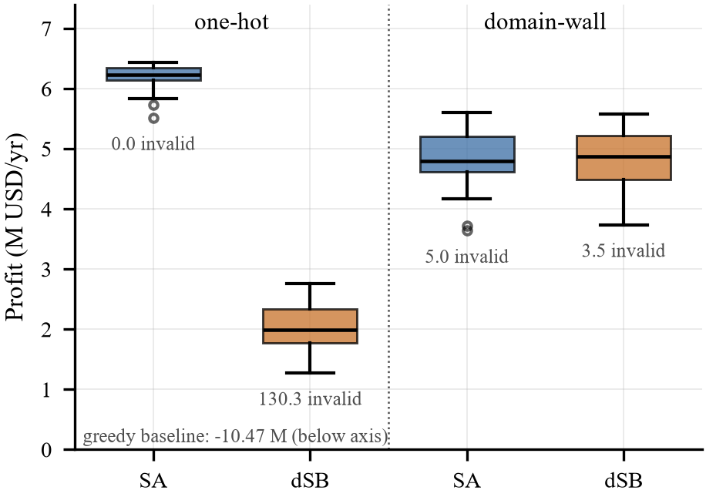
Fig. 2. Profit over 20 seeds, with the mean number of parcels whose binary block lies outside the encoding's valid subspace.
Table bench and Fig. encoding give the results at Mwall=1. Under one-hot encoding dSB leaves 130 of 174 parcels invalid and earns 67% less than SA (p<10⁻⁷): its continuous dynamics bifurcate variables independently, and the dense per-parcel penalty does not reliably leave exactly one positive. Domain-wall encoding raises dSB profit by 138% (p<10⁻⁷), after which the two solvers do not differ (-1.5%, p=0.78). At this penalty weight domain-wall lowers SA profit by 22% (p<10⁻⁷). Section mwall shows that this last result is an artefact of the weight.
The greedy plan loses \10.47M. Assigning every parcel its best-margin crop concentrates production far beyond Dj; even when unsaleable surplus is discarded rather than sold at the negative prices a linear demand curve implies beyond 2Dj, it still loses \7.51M. This is the coordination failure the formulation exists to avoid.
The Ordering-Penalty Weight
:mwall
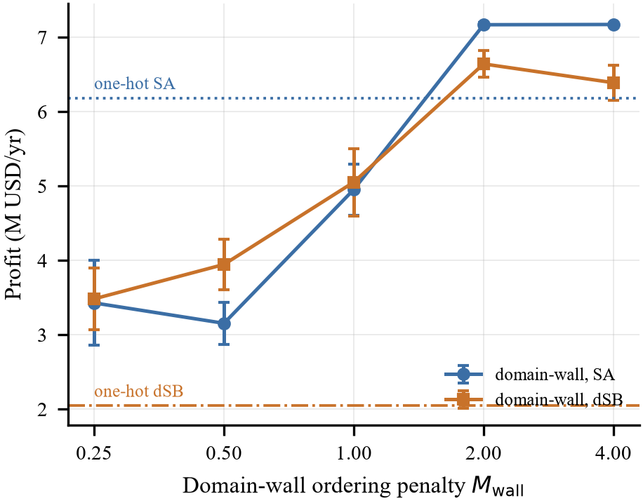
Fig. 0. Profit against the domain-wall ordering penalty, 20 seeds per point, with the one-hot references as horizontal lines. The sign of the annealing effect changes between Mwall=1 and 2.
The ordering penalty is a free weight, and published comparisons fix it without reporting a sweep. Fig. mwall shows its effect over Mwall\0.25,0.5,1,2,4\, 20 seeds per point, against the one-hot references of \6.05M (SA) and \2.04M (dSB) from the same experiment.
Profit rises monotonically with the weight for both solvers until it saturates near Mwall=2. Invalid parcels fall with it, from 23.0 (SA) and 20.3 (dSB) at the weakest weight through 5.0 and 3.4 at Mwall=1 to 0.1 and 0.0 at Mwall=2, where the seed variance also collapses to ±0.03M: a strong chain penalty does not merely permit valid solutions, it makes the landscape tractable. Domain-wall exceeds one-hot for dSB at every weight tested, by 67% at the weakest and 226% at the strongest. For SA the comparison changes sign: a 45% deficit at Mwall=0.25, 17% at the conventional value of 1, and an 18% advantage at 2 and above.
Two conclusions follow. The domain-wall advantage reported on annealing hardware [16] does extend to a quantum-inspired solver on a real allocation problem, confirming the conjecture of Berwald et al. [17], and at an adequate weight it extends to annealing as well. But the conclusion a single-weight study reaches depends on which weight it picked: at the value used in Section results-B the same experiment reports that domain-wall harms annealing. The weight belongs in the experimental protocol, not in the defaults.
Water and the Budget-Feasible Plan
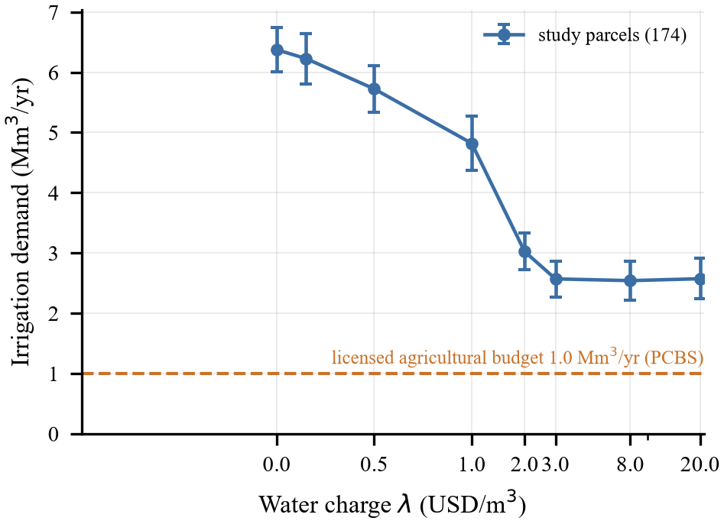
Fig. 3. Irrigation demand against the water charge λ (SA, one-hot, 50 seeds; bars are one standard deviation). Note the symmetric-log axis.
PCBS reports 1.0 Mm³/yr of agricultural abstraction from licensed Palestinian wells in Jenin governorate, against 5.0 Mm³ domestic and 6.0 Mm³ total [27]. Every plan in Table bench uses 2.3–9.0 Mm³, so the licensed allocation binds hard.
Sweeping the water charge (Fig. water) traces a demand curve that falls monotonically from 6.37±0.37 Mm³ at λ=0 to 2.57±0.30 Mm³ at \3/m³, then flattens: demand never falls below 2.54 Mm³ at any charge up to \20/m³, still 2.5 times the licensed budget. Pricing cannot reach this constraint. Above λ1 the formulation is also numerically degenerate, because once the water term dominates the normalising coefficient the profit differences fall below the fixed penalty weights, so only small λ is interpretable.
The budget is therefore imposed directly, by fallowing parcels in ascending order of margin per cubic metre until the plan fits, applied identically to every arm including greedy. The resulting budget-feasible profits are the last column of Table bench. They fall into a narrow \1.27–1.75M band, cultivating only 9–47 of the 174 parcels, and the encoding difference for SA becomes insignificant (+3.2%, p=0.31) while for dSB it persists (+32.7%, p<10⁻⁴). Under the licensed allocation the problem is small enough that encoding and solver choice largely stop mattering. Greedy reaches \1.37M under the same constraint: forced to leave most land fallow, it can no longer flood the market, so the water limit incidentally performs the coordination that the optimiser performs deliberately.
Price Robustness
The optimum is degenerate: inverse demand equalises marginal revenue across crops, so many parcel-level plans reach similar profit and two runs differing only in seed agree on 11.5% of parcels. We therefore compare crop mix by area, as 1- total variation distance, against a seed-control floor of 94.6% (50 seeds each).
Every moderate scenario sits at that floor and is therefore indistinguishable from solver noise: 94.7% for the LSTM price vector, 93.7% for persistence, 95.0% for a uniform ±15% shift and 93.3% for +30%. Only a 30% price fall shifts the crop mix materially, to 87.7% for a uniform fall and 82.4% for perishables alone, moving land toward grapes, olives, oranges and fallow as profit drops to \1.72M and \2.61M. The asymmetry is economically sensible: a uniform rise scales revenues together and barely changes relative margins, whereas a fall pushes marginal crops below cost and forces reallocation toward low-cost perennials.
LIMITATIONS
:limits
Market size Dj is an assumption and the linear demand curve carries no meaning beyond Qj=2Dj. Climate is a single grid cell; the suitability model has almost no parcel-level resolution, for the reasons in Section results-A; phosphorus and potassium are sampled, not measured; SoilGrids values are model estimates; and yields are national series rescaled to regional open-field levels. The PCBS figure covers licensed wells only, excluding springs, purchased supply, wastewater reuse and unlicensed abstraction, so it is a lower bound and the budget-feasible plans are conservative. Reported profits are of decoded plans, so a solver leaving many blocks outside the valid subspace is scored after an implicit argmax repair. Wall-clock matching is enforced to 15%, not exactly, on a host that showed threefold timing variation. At 1,914 variables with ten 174-node cliques the instance exceeds the largest fully connected problem directly embeddable on current annealing hardware (K150 on Pegasus [28]), so this compares classical against quantum-inspired solvers, not quantum hardware.
CONCLUSION
:concl
On a real 1,914-variable crop-allocation QUBO, constraint encoding decided whether a quantum-inspired solver was usable at all, and the weight of the domain-wall ordering penalty decided the sign of the effect for annealing. The domain-wall advantage therefore does extend from annealing hardware to quantum-inspired solvers, as Berwald et al. [17] conjectured, but any single-weight comparison risks reporting its opposite. Held to the licensed agricultural water available in Jenin, every configuration converges to $1.3–1.8M on a sixth of the land, and the choice of encoding and solver largely ceases to matter: the computational question and the agricultural one bind at different scales. Future work should tune the ordering penalty per solver rather than globally, measure freezing behaviour to test the mechanism proposed by Berwald et al., and obtain parcel-level soil and crop-level demand data adequate to the allocation question.
REFERENCES
[1] Food and Agriculture Organization of the United Nations, “FAOSTAT producer prices and crops and livestock products,” 2026, https://www.fao.org/faostat/, accessed 2026.
[2] C. Li, Z. Su, Y. Nie, Z. Ye, J. Li, J. Wang, Z. Yang, X. Li, W. Zeng, and Y. Chen, “Scientific planning of dynamic crops in complex agricultural landscapes based on adaptive optimization hybrid SA-GA method,” Scientific Reports, vol. 15, p. 28992, 2025.
[3] D. Hou, J. Li, Y. Wang, S. Guo, X. Wang, and X. Wang, “Research on agricultural development issues based on comprehensive optimization strategy,” Scientific Reports, vol. 16, p. 12505, 2026.
[4] A. Lucas, “Ising formulations of many NP problems,” Frontiers in Physics, vol. 2, p. 5, 2014.
[5] F. Glover, G. Kochenberger, and Y. Du, “Quantum bridge analytics I: a tutorial on formulating and using QUBO models,” 4OR, vol. 17, pp. 335–371, 2019.
[6] H. Goto, K. Endo, M. Suzuki, Y. Sakai, T. Kanao, Y. Hamakawa, R. Hidaka, M. Yamasaki, and K. Tatsumura, “High-performance combinatorial optimization based on classical mechanics,” Science Advances, vol. 7, no. 6, p. eabe7953, 2021.
[7] S. Kirkpatrick, C. D. Gelatt, and M. P. Vecchi, “Optimization by simulated annealing,” Science, vol. 220, no. 4598, pp. 671–680, 1983.
[8] Q.-G. Zeng, X.-P. Cui, B. Liu, Y. Wang, P. Mosharev, and M.-H. Yung, “Performance of quantum annealing inspired algorithms for combinatorial optimization problems,” Communications Physics, vol. 7, p. 249, 2024.
[9] N. Chancellor, “Domain wall encoding of discrete variables for quantum annealing and QAOA,” Quantum Science and Technology, vol. 4, no. 4, p. 045004, 2019.
[10] L. Breiman, “Random forests,” Machine Learning, vol. 45, no. 1, pp. 5–32, 2001.
[11] B. Dey, J. Ferdous, and R. Ahmed, “Machine learning based recommendation of agricultural and horticultural crop farming in India under the regime of NPK, soil pH and three climatic variables,” Heliyon, vol. 10, no. 3, p. e25112, 2024.
[12] G. Saha, F. Shahrin, F. H. Khan, M. M. Meshkat, and A. A. M. Azad, “Smart IoT-driven precision agriculture: Land mapping, crop prediction, and irrigation system,” PLOS ONE, vol. 20, no. 3, p. e0319268, 2025.
[13] S. Hochreiter and J. Schmidhuber, “Long short-term memory,” Neural Computation, vol. 9, no. 8, pp. 1735–1780, 1997.
[14] S. Kim, S.-W. Ahn, I.-S. Suh, A. W. Dowling, E. Lee, and T. Luo, “Quantum annealing for combinatorial optimization: a benchmarking study,” npj Quantum Information, vol. 11, p. 77, 2025.
[15] D. S. Verma, M. Dafadar, J. K. Mishra, A. Kumar, and M. K. Priydarshi, “Quantum-enhanced computational models for multi-variable optimization in precision agriculture,” Atlantis Press, 2025, https://www.atlantis-press.com/article/126013752.
[16] J. Chen, T. Stollenwerk, and N. Chancellor, “Performance of domain-wall encoding for quantum annealing,” IEEE Transactions on Quantum Engineering, vol. 2, pp. 1–14, 2021, https://arxiv.org/abs/2102.12224.
[17] J. Berwald, N. Chancellor, and R. Dridi, “Understanding domain-wall encoding theoretically and experimentally,” Philosophical Transactions of the Royal Society A, vol. 380, 2022, https://arxiv.org/abs/2108.12004.
[18] OpenStreetMap Contributors, “OpenStreetMap land-use data, Palestine extract,” 2026, via Geofabrik, https://download.geofabrik.de/, accessed 2026.
[19] UN OCHA occupied Palestinian territory, “State of Palestine – Oslo agreement in the West Bank,” Humanitarian Data Exchange, 2024, https://data.humdata.org/dataset/state-of-palestine-other-0-0-0-0-0, accessed 2026.
[20] NASA Langley Research Center, “NASA POWER: Prediction of worldwide energy resources,” 2025, https://power.larc.nasa.gov/, accessed 2026.
[21] L. Poggio, L. M. de Sousa, N. H. Batjes, G. B. M. Heuvelink, B. Kempen, E. Ribeiro, and D. Rossiter, “SoilGrids 2.0: producing soil information for the globe with quantified spatial uncertainty,” SOIL, vol. 7, pp. 217–240, 2021.
[22] Palestinian Central Bureau of Statistics, “Agricultural statistics and producer price surveys,” 2023, Ramallah, Palestine.
[23] R. G. Allen, L. S. Pereira, D. Raes, and M. Smith, “Crop evapotranspiration: guidelines for computing crop water requirements,” FAO Irrigation and Drainage Paper 56, 1998.
[24] A. Ingle, “Crop Recommendation Dataset,” 2020, https://www.kaggle.com/datasets/atharvaingle/crop-recommendation-dataset.
[25] Food and Agriculture Organization, “EcoCrop: a global crop environmental requirements database,” FAO Land and Water Division, 2021, https://gaez.fao.org/pages/ecocrop.
[26] V. Beiranvand, W. Hare, and Y. Lucet, “Best practices for comparing optimization algorithms,” Optimization and Engineering, vol. 18, no. 4, pp. 815–848, 2017.
[27] Palestinian Central Bureau of Statistics, “Palestinian water wells and annual pumping quantity by governorate and type of use, 2018,” 2019, source: Palestinian Water Authority. https://www.pcbs.gov.ps/Portals/_Rainbow/Documents/water-E5-2018.html.
[28] D-Wave Quantum Inc., “Minor-embedding: Best practices — D-Wave quantum computing documentation,” 2025, https://docs.dwavequantum.com/, accessed 2026. thebibliography.
Note: this Word file is a readable export of main.tex for review and comment. The submission artefact is main.pdf, which is the authoritative IEEE two-column version.

