Crop Allocation as a QUBO: Constraint Encoding, Solver Choice, and the Agricultural Cost of Occupation
Anonymous Submission | NGIA-QC 2026 — Double-blind review
Abstract—When many farmers independently choose the same profitable crop, the combined harvest depresses its price. We formulate the resulting allocation problem as a 1,914-variable QUBO over 174 real parcels (1,464 ha) in Jenin, Palestine, with a Random Forest scoring suitability and irrigation priced rather than capped. How a discrete choice is encoded in binary variables is usually treated as an implementation detail. Here it decides the outcome. In a 2×2 benchmark over 20 seeds at a matched wall-clock budget, domain-wall encoding raises discrete simulated bifurcation's profit by 152% and brings it level with simulated annealing, yet costs annealing 8.5%. The encoding advantage therefore depends on the solver's move set, which single-solver studies cannot reveal. A myopic baseline loses money by flooding the market, and restricting cultivation to Areas A/B under occupation costs $0.23–1.22M/yr within a fixed water budget.
Index Terms—quantum-inspired optimisation, simulated bifurcation, QUBO, domain-wall encoding, crop planning, random forest
INTRODUCTION
Crop planning is an allocation problem constrained by a market signal no individual farmer can observe. A farmer plants on last season's prices, without knowing what the neighbours intend; when many independently converge on the same profitable crop, the combined harvest depresses its price. Each decision is individually rational and the aggregate outcome is a collective loss, a coordination failure that bites hardest for perishables, which cannot be stored until prices recover. The northern West Bank has lived through this repeatedly, including a cucumber glut in 2021 and a collapse in tomato prices in 2025 [ref. pending]. Recent crop-planning models therefore treat market absorption as a binding constraint rather than assuming prices are exogenous to the plan [1, 2].
Allocation in Jenin governorate is shaped by two further constraints, both consequences of occupation. Under the Oslo interim framework the occupied West Bank is divided into Areas A and B, administered by the Palestinian Authority, and Area C, which remains under full Israeli military and administrative control. Agricultural development in Area C requires permits that are rarely granted, and more than 70% of the communities located there have no connection to the water network [3]. In 2024 the International Court of Justice found Israel's continued presence in the occupied Palestinian territory unlawful, including its use of the territory's natural resources [4]. Within our study window, 32.5% of the mapped agricultural parcel area lies in Area C, and irrigation across the remainder draws on an agricultural water budget of roughly 6.0 Mm³/yr [ref. pending]. Measuring what these restrictions cost parcel by parcel, rather than through national accounts [5], means solving the allocation problem once under each land regime. The computational question that follows is a prerequisite, not an aside.
Allocating P parcels among C crops admits C^P candidate assignments, and the problem does not decompose: because revenue depends on aggregate production, the best crop for one parcel depends on the choices made for all the others. Problems of this form map onto quadratic unconstrained binary optimisation (QUBO) [6, 7], the input format shared by quantum annealers and by a growing family of quantum-inspired classical solvers. Among the latter, simulated bifurcation (SB) [8] integrates the classical Hamiltonian dynamics of nonlinear oscillators. All variables update simultaneously, so SB parallelises where sequential methods such as simulated annealing [9] cannot, and it has matched annealing hardware on large benchmarks [10].
Passing a discrete allocation problem to any such solver first requires an encoding: a representation of each parcel's crop choice in binary variables, together with a mechanism enforcing that exactly one crop is selected. The conventional choice, one-hot encoding, imposes this through a quadratic penalty and leaves invalid assignments reachable. Domain-wall encoding [11] instead constrains a chain of binaries so that the requirement holds by construction. Encoding is ordinarily treated as an implementation detail, subordinate to the choice of solver. On the instance studied here, it is not.
We study 174 real parcels (1,464 ha) in Jenin as a 1,914-variable QUBO with market-clearing prices and priced irrigation water. Our contributions are fourfold. First, a 2×2 encoding-by-solver benchmark over 20 seeds at a matched wall-clock budget, in which domain-wall encoding raises discrete simulated bifurcation's profit by 152% and brings it level with simulated annealing, while lowering annealing's own profit by 8.5%; single-solver studies cannot observe that interaction. Second, a QUBO formulation in which prices fall with aggregate production and irrigation is priced rather than capped, so that sweeping the charge recovers the water shadow price. Third, a bounded parcel-level estimate of the agricultural cost of restricting Palestinian cultivation to Areas A/B under a fixed water budget. Fourth, because the objective is driven by prices, a test of whether a learned forecaster beats recent-mean prices as the optimiser's input; an LSTM does not outperform persistence at this data scale, and we report that negative result rather than bury it.
LITERATURE REVIEW
AI-Based Crop Recommendation and Price Forecasting
Random Forest, an ensemble of bagged decision trees, remains a strong baseline for tabular agricultural data because it absorbs nonlinear, heterogeneous features (soil nutrients, pH, temperature, rainfall) without extensive preprocessing [12]. Dey et al. [13] reached classification accuracy above 99% for crop recommendation with XGBoost on soil and climatic features, but their pipeline stops at suitability: with no forecasting or allocation stage, a crop flagged suitable may still be a poor choice if the market is saturated. Saha et al. [14] went further, combining satellite land mapping, machine-learning crop recommendation and yield prediction above 95% accuracy, and irrigation control; their LSTM forecasts vegetation area rather than prices, so it cannot signal oversupply before it occurs.
Because the allocation objective is driven by prices, the quality of the price input matters as much as the optimiser; Li et al. [1] address this by feeding neural-network forecasts into theirs. Long Short-Term Memory networks [15] are widely applied to agricultural price series for the same purpose. Their benefit is sensitive to record length, and a governorate-level history offers only a few decades of annual observations per crop. Whether a learned forecaster improves on a naive baseline at this data scale is an empirical question rather than a given, and we treat it as one, evaluating our LSTM against persistence, autoregressive, moving-average and trend models before any forecast reaches the optimiser.
Optimization Approaches: From Classical Methods to Quantum-Inspired Algorithms
Crop allocation was traditionally posed as linear programming, but recent work treats it as a nonlinear problem integrating prediction and market effects. Li et al. [1] combined simulated annealing with a genetic algorithm (H-SAGA) across 34 plots in northern China, feeding neural-network price forecasts into the optimizer and constraining production by regional market-absorption capacity and farm water supply; H-SAGA beat standalone GA, SA, PSO and ACO by 5–10 percentage points of profit increment. Hou et al. [2] paired particle swarm optimization with simulated annealing and Monte Carlo simulation (PSO–SA–MCS), lowering prices when production exceeds demand, and raised expected profit by 12.6% over a baseline PSO at a runtime complexity of O(N²). Integrating forecasting, market saturation and resource limits into a single allocation model is thus well established with classical metaheuristics.
Quantum and quantum-inspired approaches offer a different route. Simulated bifurcation [8] derives from a quantum-mechanical model but simulates classical Hamiltonian dynamics, so it runs on conventional hardware. Zeng et al. [10] benchmarked quantum-annealing-inspired algorithms, SB among them, against a D-Wave annealer on Max-Cut instances of up to 20,000 nodes: ballistic SB cut time-to-solution nearly fifty-fold on small and Chimera-structured graphs, and discrete SB was fastest on large ones. On dense QUBO instances, Kim et al. [16] found a hybrid quantum-annealing solver roughly 6,561× faster than the best classical solver, with marginally higher accuracy. Within agriculture, Verma et al. [17] proposed HQOMLF, pairing a quantum convolutional neural network for prediction with the Quantum Approximate Optimization Algorithm for resource allocation, and reported speed-ups of up to 3.5×.
Two gaps remain. First, none of these agricultural studies formulates allocation as a QUBO with market-clearing prices for Ising-type solvers: Li et al. and Hou et al. use classical metaheuristics, and Verma et al. apply QAOA without a market model. Second, the benchmarking literature compares solvers, yet results on a real problem also depend on how constraints are encoded. One-hot encoding enforces one crop per parcel through a penalty, leaving invalid assignments reachable; Chancellor's domain-wall encoding [11] makes them unreachable by construction. Chen et al. [18] compared the two on D-Wave annealing hardware across three problems and found domain-wall superior on every metric, with none favouring one-hot. Berwald et al. [19] showed that domain-wall dynamics freeze later, and conjectured that the advantage extends to gate-model and quantum-inspired algorithms. That conjecture has not been tested on a quantum-inspired solver, nor on a real allocation problem. We test it here and find that it holds only conditionally: large for simulated bifurcation, but reversed in sign for simulated annealing. Table lit summarizes the studies reviewed.
TABLE I. Summary of reviewed studies across crop recommendation, forecasting, and optimization
p3.0cmp3.9cmp6.6cm Study | Focus area | Method | Limitation relative to this study
Breiman [12] | Ensemble learning, general | Random Forest (foundational) | Not agricultural; the method applied here to crop suitability
Hochreiter \ | Schmidhuber [15] | Sequence modeling, general | LSTM (foundational) | Not agricultural; the method applied here to price forecasting
Dey et al. [13] | Crop recommendation | XGBoost on soil/climate features | Suitability only; no forecasting or allocation stage
Saha et al. [14] | Land suitability, irrigation | ML + LSTM (vegetation), satellite data | LSTM forecasts vegetation area, not prices; no allocation stage
Li et al. [1] | Dynamic multi-plot crop planning | Hybrid SA–GA + neural-network price forecasts | Classical metaheuristic; no QUBO or encoding analysis; no land restrictions
Hou et al. [2] | Crop planning under uncertainty | Hybrid PSO–SA + Monte Carlo | No learned forecasts; classical metaheuristic
Zeng et al. [10] | Quantum-inspired optimization | SB and simulated CIM vs. D-Wave annealer | Abstract Max-Cut benchmarks; compares solvers, not encodings
Kim et al. [16] | Large-scale dense QUBO | Hybrid quantum annealing vs. classical solvers | Benchmark instances; compares solvers, not encodings
Verma et al. [17] | Quantum computing in precision agriculture | QCNN + QAOA (HQOMLF) | No market-clearing prices; no encoding analysis; no SB comparison
Chancellor [11] | Encoding discrete variables | Domain-wall encoding | Theoretical; not evaluated on a real-world allocation problem
Chen et al. [18] | Encoding comparison, experimental | Domain-wall vs. one-hot on D-Wave hardware | Annealing hardware, abstract problems; one solver class, so the interaction is unobservable
Berwald et al. [19] | Encoding theory and dynamics | Variable-count optimality; freezing behaviour | Conjectures the extension to quantum-inspired solvers, untested

Integrated crop planning combining prediction, market saturation and resource limits is thus established with classical metaheuristics [1, 2], and quantum-inspired solvers perform strongly on abstract benchmarks [10, 16]. What remains unexamined is where the two meet: agricultural allocation as a QUBO with market-clearing prices, and the effect of encoding on the solvers that consume it. We address that gap on 174 real parcels in Jenin, under the land and water restrictions specific to the occupied West Bank.
%% ============================================================ %% METHODOLOGY – REMOVED FOR TALA TO WRITE. %% Reference text: METHODOLOGYREMOVED.tex %% Requirements: METHODOLOGYBRIEF.md %% ============================================================
METHODOLOGY
[This section is to be written. It must cover: study area and data sources; the Random Forest suitability model; the QUBO formulation; and the two encodings and two solvers compared, including the matched wall-clock protocol. See METHODOLOGY.md for every number the Results section depends on.]
RESULTS
Suitability and Price Forecasting
In 5-fold stratified cross-validation the Random Forest reaches 0.9945±0.0037 accuracy on real data against a majority-class baseline of 0.0455, and 0.8514±0.0291 on synthetic EcoCrop rows, which measures fidelity to the envelopes rather than predictive skill. Feature importances are rainfall 0.251, humidity 0.192, K 0.166, P 0.139, N 0.098, temperature 0.082 and pH 0.072, so the unmeasured P and K together carry 30.5%. Under Jenin's inputs the model gives oranges zero probability on every parcel, and oranges are consequently never assigned.
The optimiser requires a price for each crop. To decide whether that price should be forecast or taken from recent history, we compared an LSTM [15] of 24 hidden units and 3,481 parameters against four naive baselines (Table lstm). The LSTM was trained on pooled log-price windows with augmentation applied to training data only, under walk-forward validation with the split made before normalisation.
TABLE II. Price forecasts, 50 test windows, 2024 excluded
Model | RMSE ($/t) | MAPE (%)
Persistence | 130.1 | 16.3
AR(1) | 150.5 | 18.3
Mean of last 3 | 170.1 | 19.7
Linear trend | 186.0 | 20.9
LSTM (pooled, augmented) | 252.2 | 26.7

The LSTM ranks last. With 142 training windows drawn from 13–27 annual observations per crop, 3,481 parameters are not constrained, and augmentation adds no information the series does not already contain. The optimisation therefore uses 2019–2023 mean prices. Including 2024 in the test window reverses the ranking (LSTM RMSE 624.2 against 639.6 for persistence), but the wartime shock raises persistence error 4.9-fold and LSTM error only 2.5-fold, so a window containing 2024 rewards robustness to a discontinuity rather than forecasting skill.
Encoding Versus Solver
TABLE III. Encoding by solver, 20 seeds, 2.5 s per run
Enc. | Solver | Profit (M$) | Invalid | Unsuit. | Water (Mm³)
one-hot | SA | 5.42±0.26 | 0.0 | 0.5 | 5.48
one-hot | dSB | 1.98±0.42 | 129.1 | 10.7 | 2.20
dom.-wall | SA | 4.97±0.39 | 13.0 | 0.3 | 6.25
dom.-wall | dSB | 5.00±0.30 | 2.9 | 0.0 | 5.97
Greedy |  | -1.58 | — | 0 | 5.98

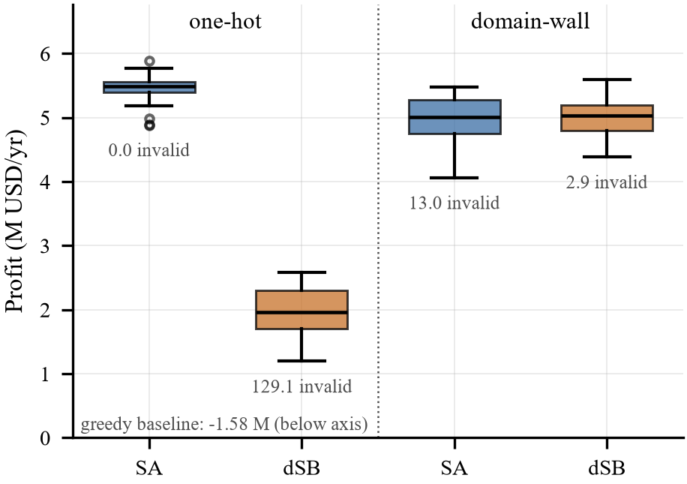
Fig. 1. Profit over 20 seeds, with the mean number of parcels holding an invalid assignment.
Table bench and Fig. encoding give the results, where “Invalid” counts parcels whose binary block is not a valid assignment. Under one-hot encoding dSB leaves 129 of 174 parcels invalid and earns 63% less than SA (p<10⁻⁷): its continuous dynamics bifurcate variables independently, and the dense per-parcel penalty does not reliably leave exactly one positive. Domain-wall encoding raises dSB profit by 152% (p<10⁻⁷), after which the two solvers do not differ (dSB +0.6%, p=0.93).
The encoding effect is not symmetric. Domain-wall lowers SA profit by 8.5% (p<10⁻⁴) and leaves SA with 13 invalid parcels, because the ordering penalty is not sized to SA's single-bit moves. This is a metric on which one-hot performs better, which Chen et al. [18] did not observe on annealing hardware. The encoding advantage appears to depend on the solver's move set, so the conjecture of Berwald et al. [19] holds for bifurcation dynamics but not for single-bit annealing. The best configuration overall remains classical SA with one-hot encoding. Our finding is that encoding choice decides whether the quantum-inspired solver is usable at all, not that it outperforms annealing.
The greedy plan loses \1.58M. Assigning every parcel its best-margin crop concentrates production in a few crops far beyond Dj. Even when unsaleable surplus is discarded rather than sold at the negative prices a linear demand curve implies beyond 2Dj, it still loses \1.55M. This is the glut mechanism that motivates the study.
Water Shadow Price and the Cost of Land Restriction
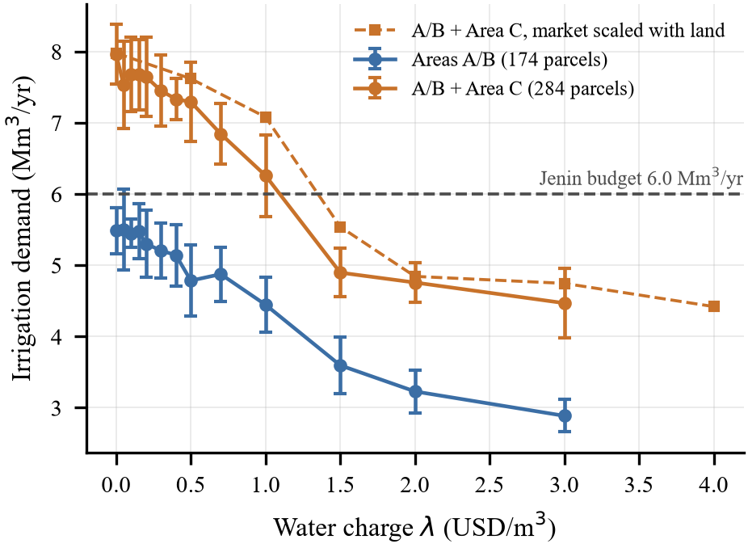
Fig. 2. Irrigation demand against the water charge λ (SA, one-hot, 10 seeds; bars are one standard deviation).
Sweeping λ traces the demand for irrigation water (Fig. water). Restricted to Areas A/B, demand peaks at 5.50 Mm³/yr, so the 6.0 Mm³ budget never binds and its shadow price is zero. Across the full land base at the same market size, demand reaches 7.96 Mm³ and the budget binds at \1.09/m³, or \1.35/m³ if the market grows with land. Water scarcity in Jenin is a consequence of land restriction, not an independent limit.
TABLE IV. Cost of restricting cultivation, within the 6.0 Mm³ water budget
Land regime | Area (ha) | Profit (M$/yr) | Loss
Full land base, market fixed | 2,169 | 5.59 | —
Full land base, market ×1.48 | 2,169 | 6.58 | —
Restricted to Areas A/B | 1,464 | 5.36 | 0.23–1.22

Table areac compares land regimes at identical prices, yields, suitability thresholds and water budget. Confining cultivation to Areas A/B withholds 706 ha and costs \0.23M/yr at the present market size, or \1.22M/yr if unrestricted access brought proportionate market access. The range is wide because, with water binding and a fixed market, extra land mostly adds supply that cannot be sold at a profit: the value of land access depends on market access, and occupation restricts both. On SoilGrids estimates, Area C and A/B parcels are similar in pH (7.69 vs. 7.71), clay (46.2 vs. 46.4%) and cation exchange capacity (34.2 vs. 36.0 cmol/kg), and Area C carries higher soil organic carbon (28.3 vs. 20.7 g/kg). Nothing in these estimates suggests the withheld land is poorer.
Price Robustness
The optimum is degenerate: inverse demand equalises marginal revenue across crops, so many parcel-level plans reach similar profit, and two baseline runs differing only in seed agree on just 18.4% of parcels. Parcel-level agreement is therefore uninformative, and we compare crop mix by area instead, as 1- total variation distance, against a seed-control floor (10 seeds each).
TABLE V. Crop-mix similarity to the baseline plan
Scenario | Profit (M$/yr) | Mix similarity
Seed control | 5.12 | 93.0%
LSTM prices / persistence | 4.96 / 4.93 | 93.0 / 93.7%
Uniform -15% / +15% | 3.20 / 7.41 | 90.6 / 93.2%
Uniform +30% / perish. +30% | 9.80 / 8.86 | 91.6 / 92.1%
Uniform -30% / perish. -30% | 1.45 / 2.38 | 84.6 / 84.4%

Every moderate scenario, the LSTM and persistence price vectors included, lies within 2.4 points of the seed-control floor. Only a 30% price fall shifts the crop mix beyond that, moving land toward grapes, olives, wheat and fallow.
LIMITATIONS
Market size Dj is an assumption, which is why we report the cost of land restriction as a range rather than a point estimate. The linear demand curve carries no meaning beyond Qj=2Dj. Climate comes from a single grid cell; phosphorus and potassium are sampled, not measured; available nitrogen and irrigation requirements are approximations; SoilGrids values are model estimates, not field measurements. Yields are national series rescaled to regional open-field levels, with tree crops assumed at steady bearing. We did not tune the domain-wall ordering penalty, so the 8.5% annealing penalty is an upper bound on that encoding's true cost. OpenStreetMap under- represents unmapped smallholdings. At 1,914 variables with ten 174-node cliques, the instance also exceeds the largest fully connected problem directly embeddable on current annealing hardware (K150 on Pegasus [20]), though hybrid solvers [16] could accept it.
CONCLUSION
On a real 1,914-variable crop-allocation QUBO, encoding choice decided whether a quantum-inspired solver was usable. Domain-wall encoding raised discrete simulated bifurcation's profit by 152% and brought it level with simulated annealing, while costing annealing 8.5%. The domain-wall advantage reported on annealing hardware [18] therefore does not transfer unconditionally to quantum-inspired solvers: it depends on the solver's move set, and we identify a case in which one-hot is the better encoding. A myopic greedy plan lost money by flooding the market, which is the failure that market-aware allocation exists to prevent. For Jenin, irrigation water does not bind on the land Palestinian farmers are currently permitted to use, and confining cultivation to Areas A/B costs $0.23–1.22M/yr within the water budget, depending on market access. Future work should tune the domain-wall ordering penalty, measure freezing behaviour in both solvers to test the mechanism proposed by Berwald et al. [19], obtain crop-level demand data, and extend the model to multi-season rotations.
REFERENCES
[1] C. Li, Z. Su, Y. Nie, Z. Ye, J. Li, J. Wang, Z. Yang, X. Li, W. Zeng, and Y. Chen, “Scientific planning of dynamic crops in complex agricultural landscapes based on adaptive optimization hybrid SA-GA method,” Scientific Reports, vol. 15, p. 28992, 2025.
[2] D. Hou, J. Li, Y. Wang, S. Guo, X. Wang, and X. Wang, “Research on agricultural development issues based on comprehensive optimization strategy,” Scientific Reports, vol. 16, p. 12505, 2026.
[3] UN OCHA occupied Palestinian territory, “Area C of the West Bank: Key humanitarian concerns,” Fact Sheet, 2014, https://www.ochaopt.org/.
[4] International Court of Justice, “Legal consequences arising from the policies and practices of israel in the occupied Palestinian territory, including East Jerusalem,” Advisory Opinion of 19 July 2024, General List No. 186, 2024, https://www.icj-cij.org/case/186.
[5] World Bank, “Area C and the future of the Palestinian economy,” World Bank, Washington DC, Tech. Rep. AUS2922, 2014.
[6] A. Lucas, “Ising formulations of many NP problems,” Frontiers in Physics, vol. 2, p. 5, 2014.
[7] F. Glover, G. Kochenberger, and Y. Du, “Quantum bridge analytics I: a tutorial on formulating and using QUBO models,” 4OR, vol. 17, pp. 335–371, 2019.
[8] H. Goto, K. Endo, M. Suzuki, Y. Sakai, T. Kanao, Y. Hamakawa, R. Hidaka, M. Yamasaki, and K. Tatsumura, “High-performance combinatorial optimization based on classical mechanics,” Science Advances, vol. 7, no. 6, p. eabe7953, 2021.
[9] S. Kirkpatrick, C. D. Gelatt, and M. P. Vecchi, “Optimization by simulated annealing,” Science, vol. 220, no. 4598, pp. 671–680, 1983.
[10] Q.-G. Zeng, X.-P. Cui, B. Liu, Y. Wang, P. Mosharev, and M.-H. Yung, “Performance of quantum annealing inspired algorithms for combinatorial optimization problems,” Communications Physics, vol. 7, p. 249, 2024.
[11] N. Chancellor, “Domain wall encoding of discrete variables for quantum annealing and QAOA,” Quantum Science and Technology, vol. 4, no. 4, p. 045004, 2019.
[12] L. Breiman, “Random forests,” Machine Learning, vol. 45, no. 1, pp. 5–32, 2001.
[13] B. Dey, J. Ferdous, and R. Ahmed, “Machine learning based recommendation of agricultural and horticultural crop farming in India under the regime of NPK, soil pH and three climatic variables,” Heliyon, vol. 10, no. 3, p. e25112, 2024.
[14] G. Saha, F. Shahrin, F. H. Khan, M. M. Meshkat, and A. A. M. Azad, “Smart IoT-driven precision agriculture: Land mapping, crop prediction, and irrigation system,” PLOS ONE, vol. 20, no. 3, p. e0319268, 2025.
[15] S. Hochreiter and J. Schmidhuber, “Long short-term memory,” Neural Computation, vol. 9, no. 8, pp. 1735–1780, 1997.
[16] S. Kim, S.-W. Ahn, I.-S. Suh, A. W. Dowling, E. Lee, and T. Luo, “Quantum annealing for combinatorial optimization: a benchmarking study,” npj Quantum Information, vol. 11, p. 77, 2025.
[17] D. S. Verma, M. Dafadar, J. K. Mishra, A. Kumar, and M. K. Priydarshi, “Quantum-enhanced computational models for multi-variable optimization in precision agriculture,” Atlantis Press, 2025, https://www.atlantis-press.com/article/126013752.
[18] J. Chen, T. Stollenwerk, and N. Chancellor, “Performance of domain-wall encoding for quantum annealing,” IEEE Transactions on Quantum Engineering, vol. 2, pp. 1–14, 2021, https://arxiv.org/abs/2102.12224.
[19] J. Berwald, N. Chancellor, and R. Dridi, “Understanding domain-wall encoding theoretically and experimentally,” Philosophical Transactions of the Royal Society A, vol. 380, 2022, https://arxiv.org/abs/2108.12004.
[20] D-Wave Quantum Inc., “Minor-embedding: Best practices — D-Wave quantum computing documentation,” 2025, https://docs.dwavequantum.com/, accessed 2026. thebibliography.
Note: Word export of main_no_methodology.tex for review and comment. The authoritative version is main_no_methodology.pdf (IEEE two-column).

