

**Faculty of Engineering & Technology**

**Electrical & Computer Engineering Department**

**ENCS 313**

**Linux lab**

**Python Report**

________________________________________________________

**Prepared by:**

Momen Abdelhafez 1181893

Ghaydaa Khateeb 1180681

**Instructor:** Dr. Moawiah Assali

**Assistant:** Eng. Isra Elayyan

**Section :** 4

**BIRZEIT**

**January 22, 2021**

# 

# ***1 ) Abstract:***

**The aim of this project is to be more familiar with python programming by building a python program for design and implement a software that executes several commands automatically and to produce a well-defined report (log).**

**A software like this can be used in Automation testing to run some scenarios at various environments to check if a specific behavior break**

**Contents**

***1 ) Abstract:*** 2

***2) Introduction :*** 4

**3) CODE ILLUSTRATION AND COMMENTS:** 5

**Command Implementation:** 5

1- **Grep class** 5

**2-** **Categorize class :** 6

**3-** **Mv_last class :** 7

**4-** **All files function and parser function :** 8

**5-** **Main function :** 8

**6- loggin function :** 9

**7- Dealing with max log files function :** 10

**8- csv output function :** 11

***4 ) Conclusion and Future Work :*** 13

# ***2) Introduction :***

**Python is a general-purpose interpreted, interactive, object-oriented, and high-level programming language. It was created by Guido van Rossum during 1985- 1990.**

**Repetitive tasks are ripe for automation. It is common for developers and system administrators to automate routine tasks like health checks and file backups with shell scripts. However, as those tasks become more complex, shell scripts may become harder to maintain.**

**Fortunately, we can use Python instead of shell scripts for automation. Python provides methods to run shell commands, giving us the same functionality of those shells scripts. Learning how to run shell commands in Python opens the door for us to automate computer tasks in a structured and scalable way.**

**In this report, we will look at the various ways to execute shell commands in Python, and the ideal situation to use each method.**

# **3) CODE ILLUSTRATION AND COMMENTS:**

**In this section, we will be considering our code in details, every case we have tried to study will be mentioned, and all the concepts implemented will be explained.**

## **Command Implementation:**

**We implement the commands as classes in case of factory design pattern concept .**

1. **Grep class** :

**allF : all files in the gived directory and its sub directories .**

**here checkExistance function for check if the file exist in the list of all files .**

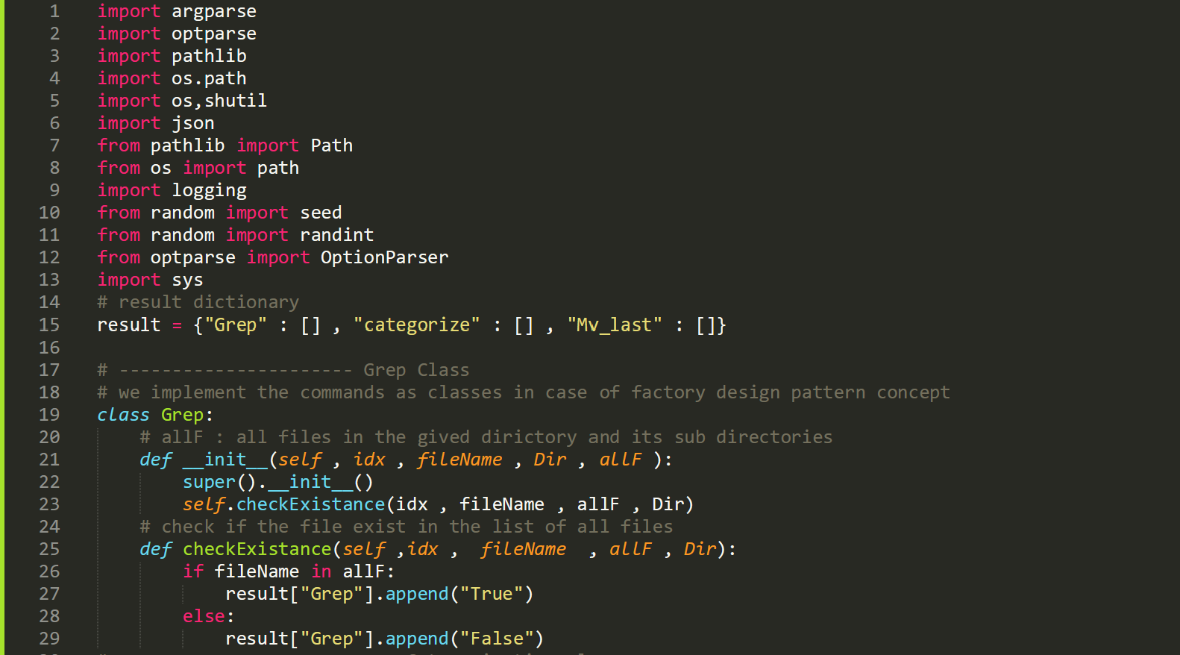

### **Categorize class :**

**We build Categorize class for split files in the given directory into 2 types**

**▪ An inner directory with files less than <threshold_size>**

**▪ An inner directory with files more than <threshold_size>**

**Note : the value that we need by the command categorize “Threshold_size” is 10KB .**

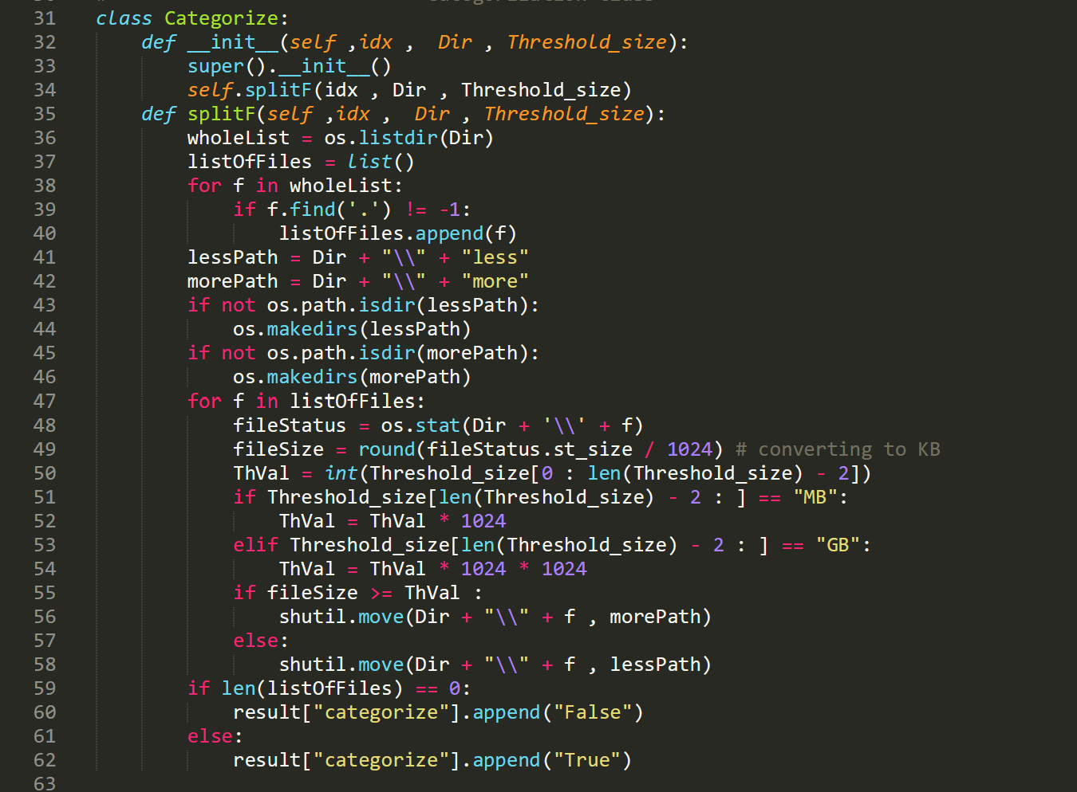

### **Mv_last class :**

**We build this class to move the most recent files to a specified directory**

**We assume that the most recent may be the most resent modified or created or updated and so on**

**If you want to specify such folder add a \ after its name**

**For example if you want to move the most recent file in the folder linuxlab**

**Make the source directory as the following C:\ . . .\linuxlab\**

**And the same with destination .**

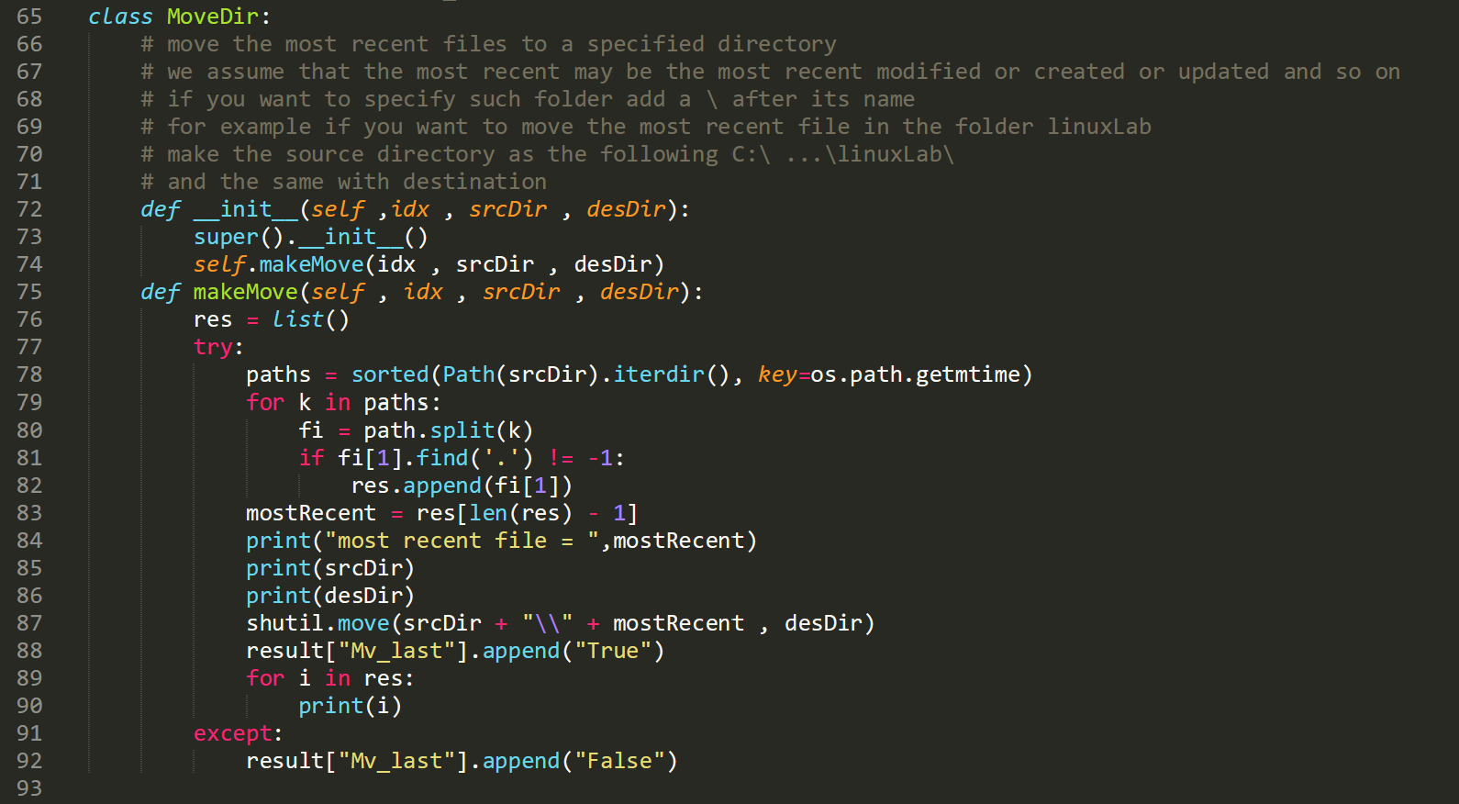

### **All files function and parser function :**

**allFiles function : is a recurcive function to find all files in the directory and its sub directory .**

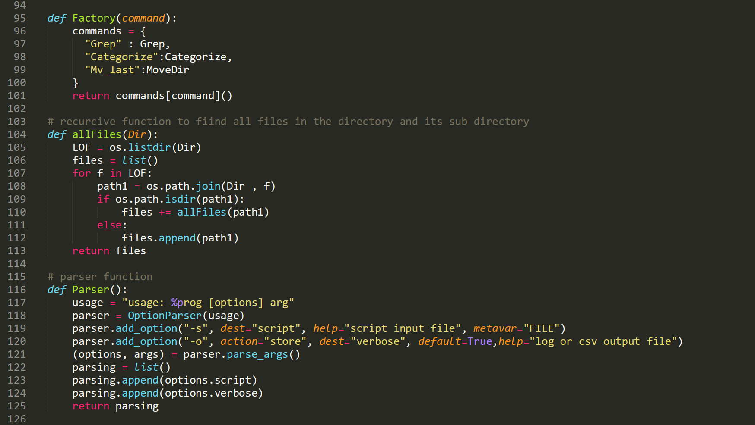

### **Main function :**

**This function reads predefined scripts based on the upper commands and parse/execute them.**

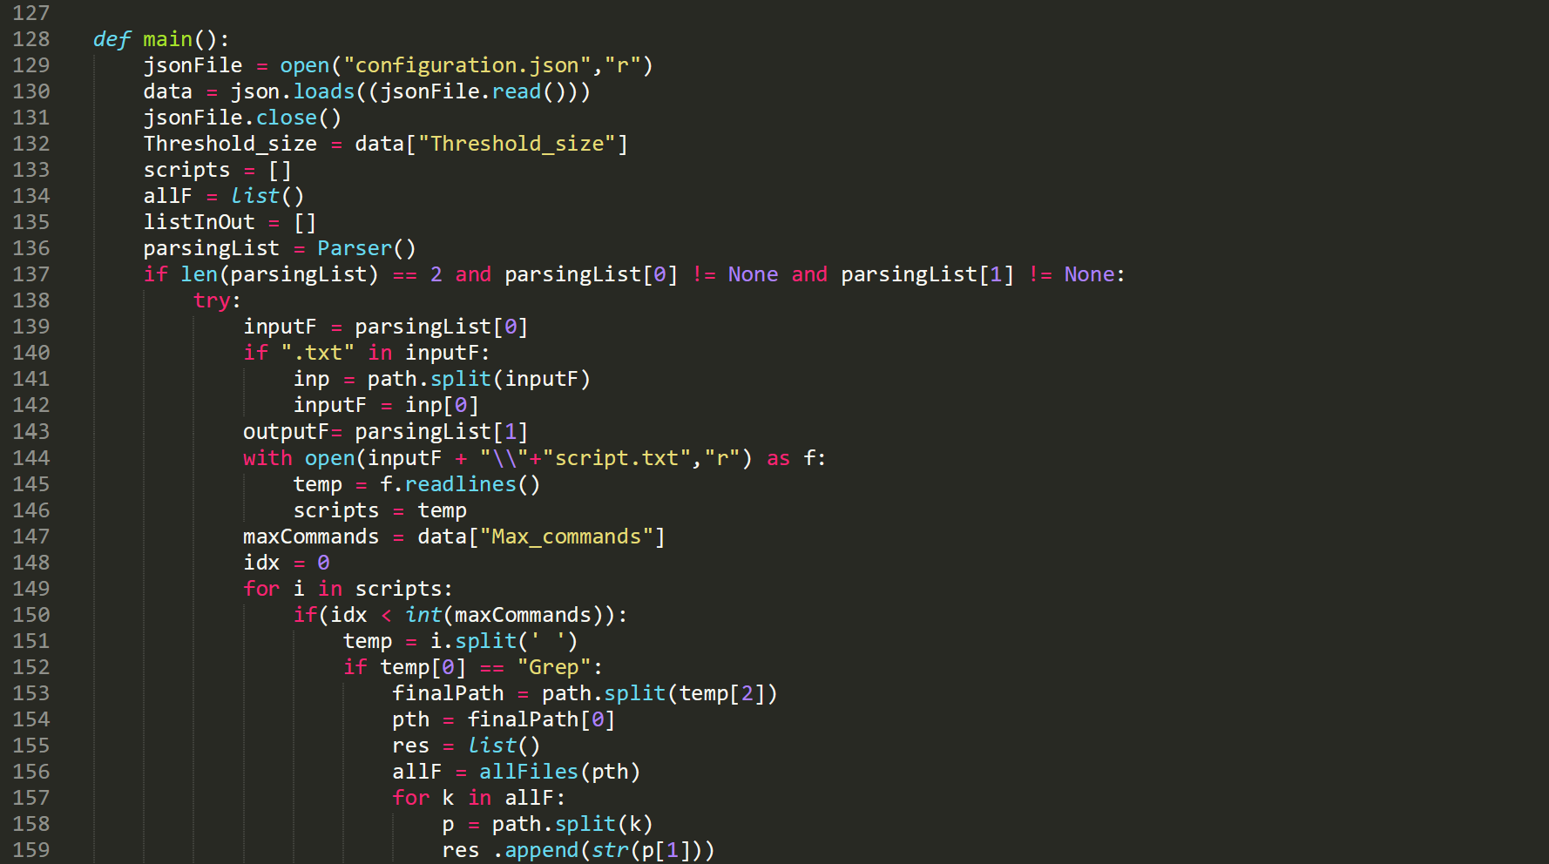

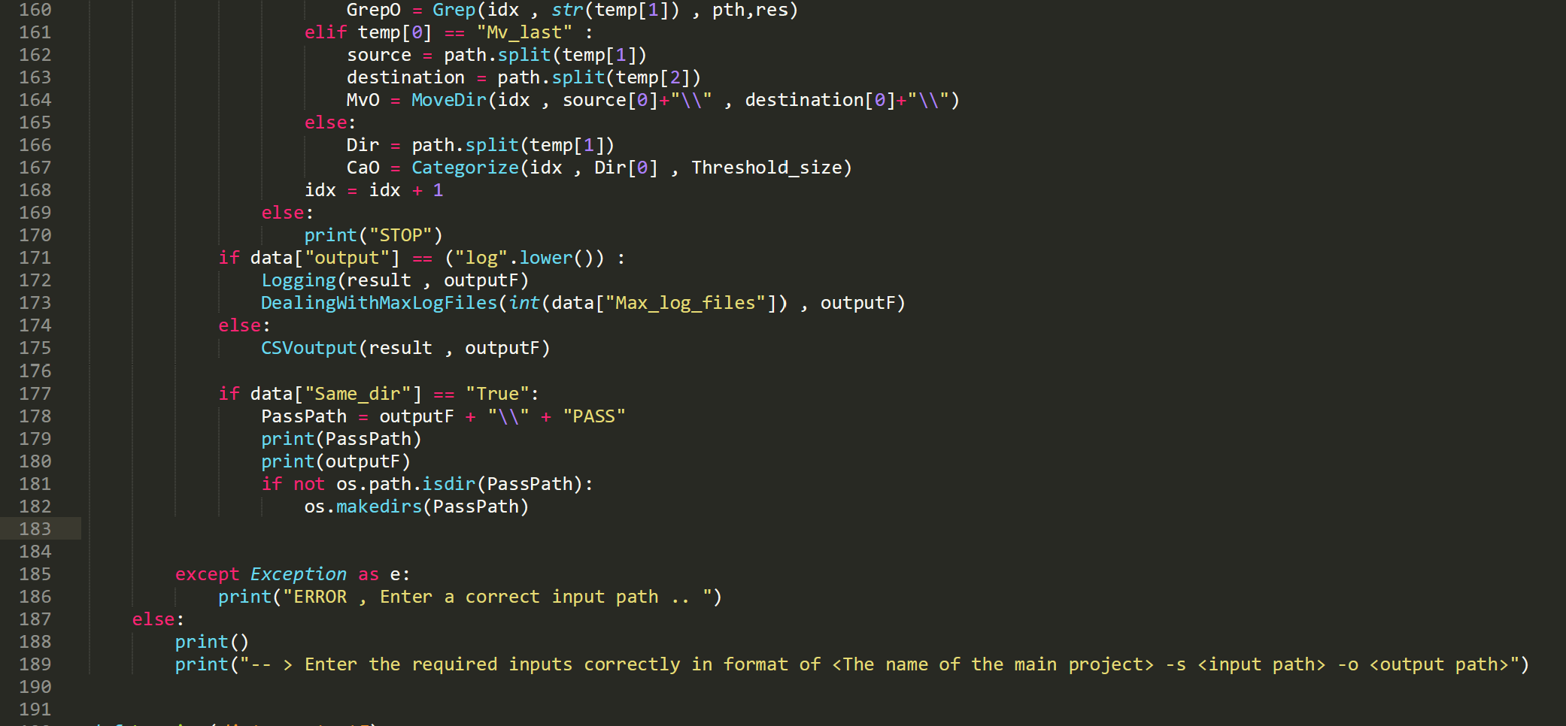

### 

### **6- loggin function :**

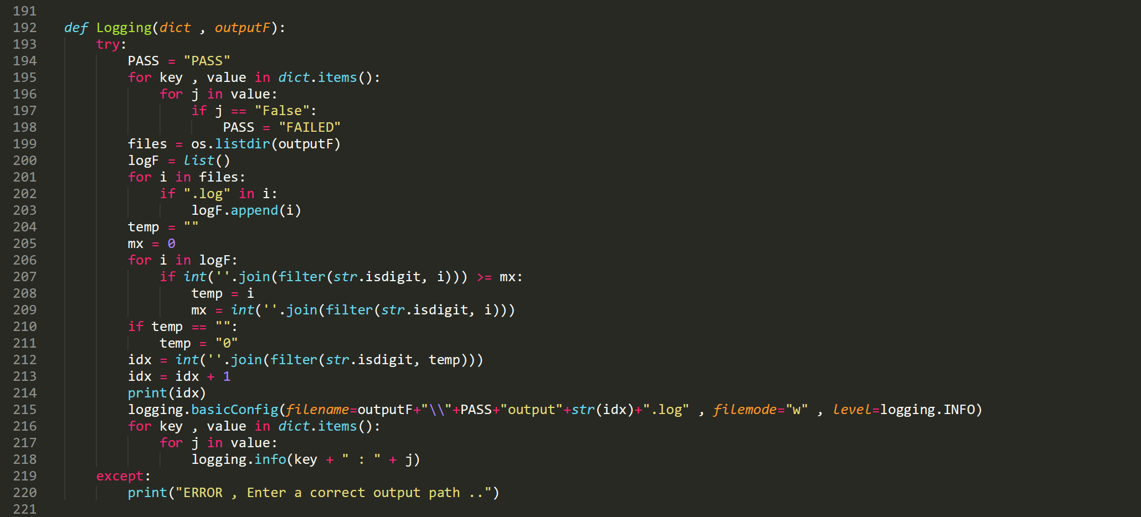

### **7- Dealing with max log files function :**

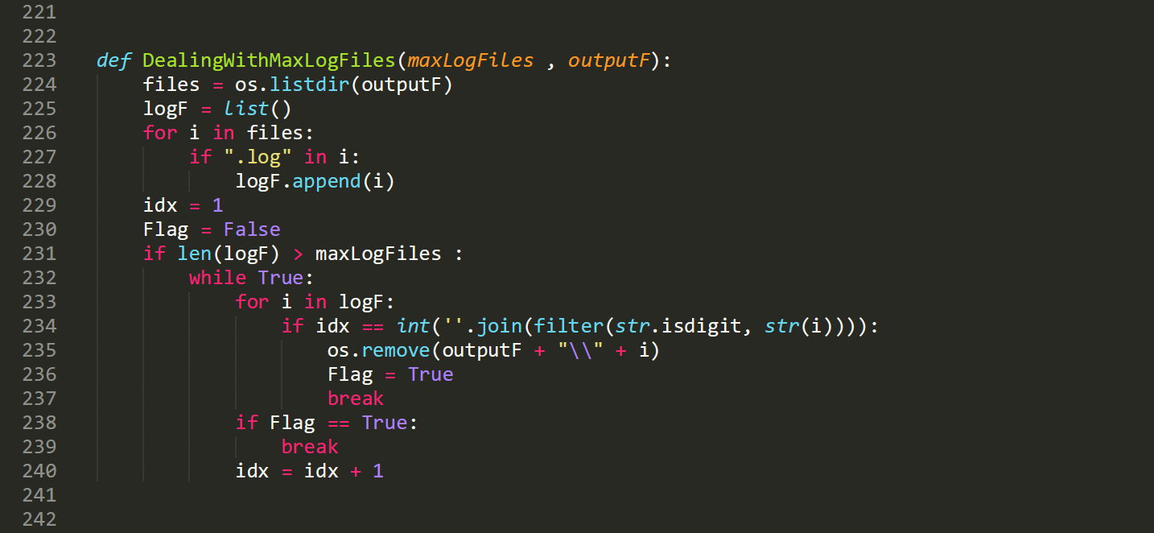

### **8- csv output function :**

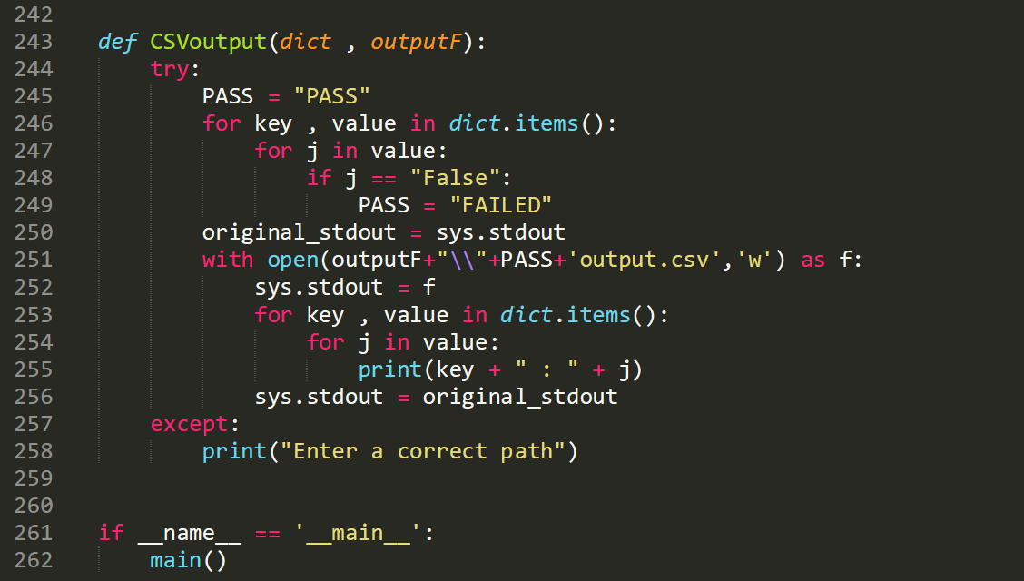

# ***4 ) Conclusion and Future Work :***

**In this project ,** **we have learned a lot about python programming also we have succeeded to design and implement a software that executes several commands automatically.**

**working at the project and building the program have motivated us to be familiar with python programing language .**

**Our future plan , this project encourage us to dive more and more in python programming because simply it’s the language of the future , and it can be used for a wide range of fields like AI , Machine learning , web development , and so on .**