**Mobile Application Development For Android, iPhone(Using Hybrid Platform)**

**Requirement Document**

Application will be latest apk version for existing app of Netyatra Link: <https://play.google.com/store/apps/details?id=com.deucen.netyatraa>

Slider Options as per below:

Change title: My Other Apps 🡺 Our Other Apps

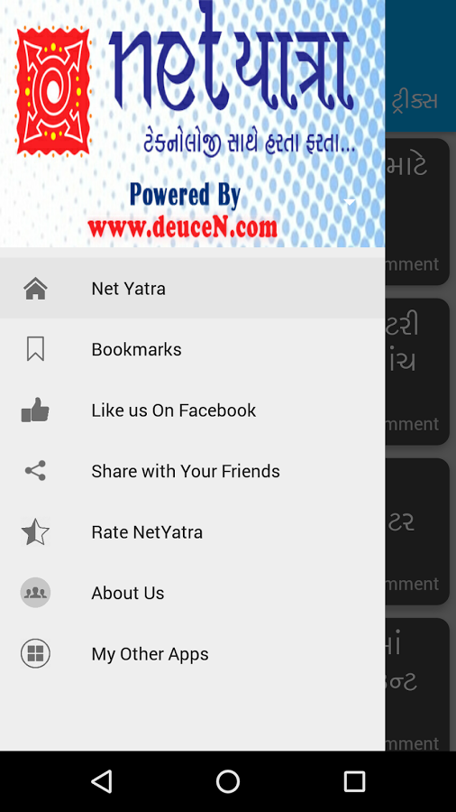

**Slider Menu 1: Net Yatra (Functionalities)**

* This option will open main application page, which will pull all posts from netyatra.in blog as per below

Top side, it will list all available Categories of Blog.

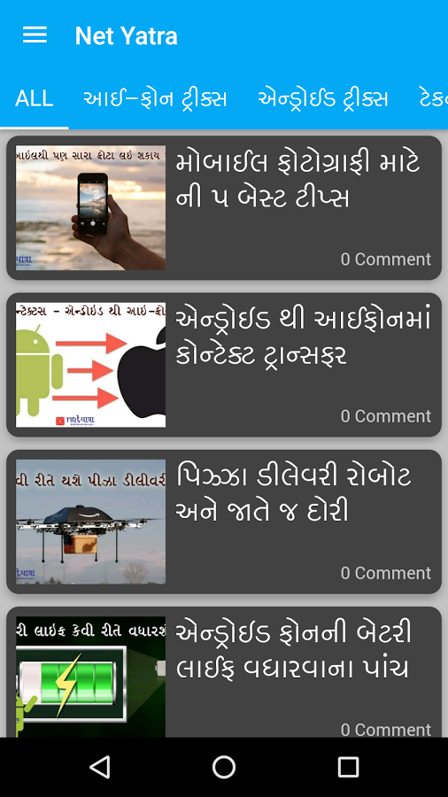

* Upon click on Any category from Top. It will bring all posts belongs to that category on downside area.
* Remove “0 comment” option – it is not required.
* Just thumbnail image and post Title with big font is enough
* In place of “0 comment” mention “Read Full Article”

**Inside Main Article:**

When user clicks on any article title and goes inside main article, it looks like existing page only. Which has below options like existing:

1. Share button at bottom
2. Facebook like and tweet button
3. When share, it should come up with customized text and link as per existing app
4. Each post will have facility to bookmark the posts
5. User can bookmark any post or remove from bookmark as per wish. Bookmark icon should show if post is bookmarked or not
6. Copy of any post should be disabled, user cannot copy content in clipboard

* **Other slider menus are same like existing app**
* Notification: There should be provision to send notification for any post. User should get push notification on his mobile with custom text and when click on that, user should divert to that post in application. Post id should go along with notification, so same post will open when user click on notification
* Existing app users also should get notifications. I have all GCM ID in a table
* Stats: Application should provide traffic and analytics of application. Proper analytical reporting