THE UNIVERSITY OF AZAD JAMMU AND KASHMIR, MUZAFFARABAD
DEPARTMENT OF SOFTWARE ENGINEERING

Name: | Ghazanfar Rasheed
Roll No: | 2025-SET-14
Course: | Software Configuration Management Technologies
Submitted To: | Engr. Ghulam Rabbani Butt
Lab Preview: | Week 01
Session: | 2025-29
Semester: | 2nd

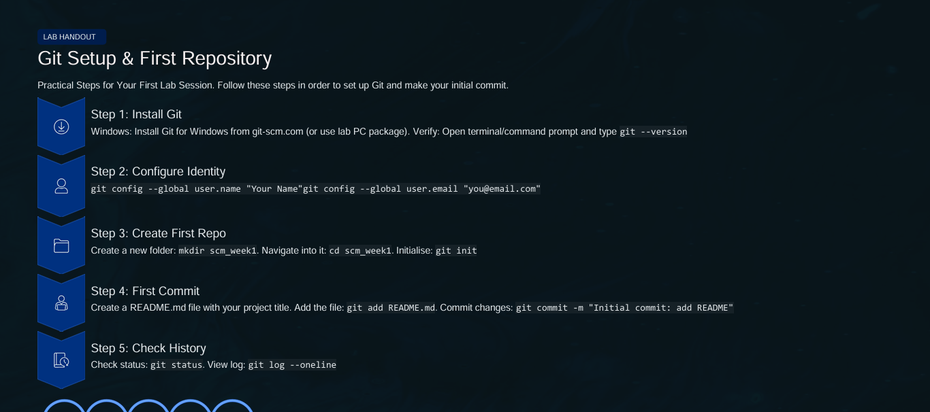
Solution:




