THE UNIVERSITY OF AZAD JAMMU AND KASHMIR, MUZAFFARABAD
DEPARTMENT OF SOFTWARE ENGINEERING

Name: | Ghazanfar Rasheed
Roll No: | 2025-SET-14
Course: | Object Oriented Programming
Submitted To: | Engr. Muhammad Awais
Title: | Lab Task # 03
Session: | 2025-29
Semester: | 2nd

LAB 03 – THEORY (Encapsulation in C++)

Introduction to Encapsulation
Encapsulation is one of the main pillars of Object-Oriented Programming (OOP). It is the process of combining data (variables) and functions (methods) into a single unit called a class.
It also restricts direct access to some of the object’s components, which helps in protecting the data.

Definition
Encapsulation is the technique of binding data and functions together in a class and hiding the internal details from outside access.

Key Features
- Data members are declared private
- Access is provided through public methods
- Data is protected from unauthorized access
- Improves program security and reliability

Why We Use Encapsulation
- To protect data from accidental changes
- To control how data is accessed and modified
- To apply validation in one place
- To make code easier to maintain

How to Achieve Encapsulation
- Declare class variables as private
- Create public setter functions to assign values
- Create public getter functions to access values
- Apply validation inside setters

Real-Life Examples
- ATM Machine → You use buttons, not internal system
- Car → You use steering and pedals, not engine directly
- Medicine Capsule → Inside content is hidden

Advantages
- Data security
- Better control over data
- Cleaner and organized code
- Easy maintenance and debugging

Example (Concept Explanation)
In the Product class:
- name, price, quantity are private
- Setters validate input
- Getters provide controlled access
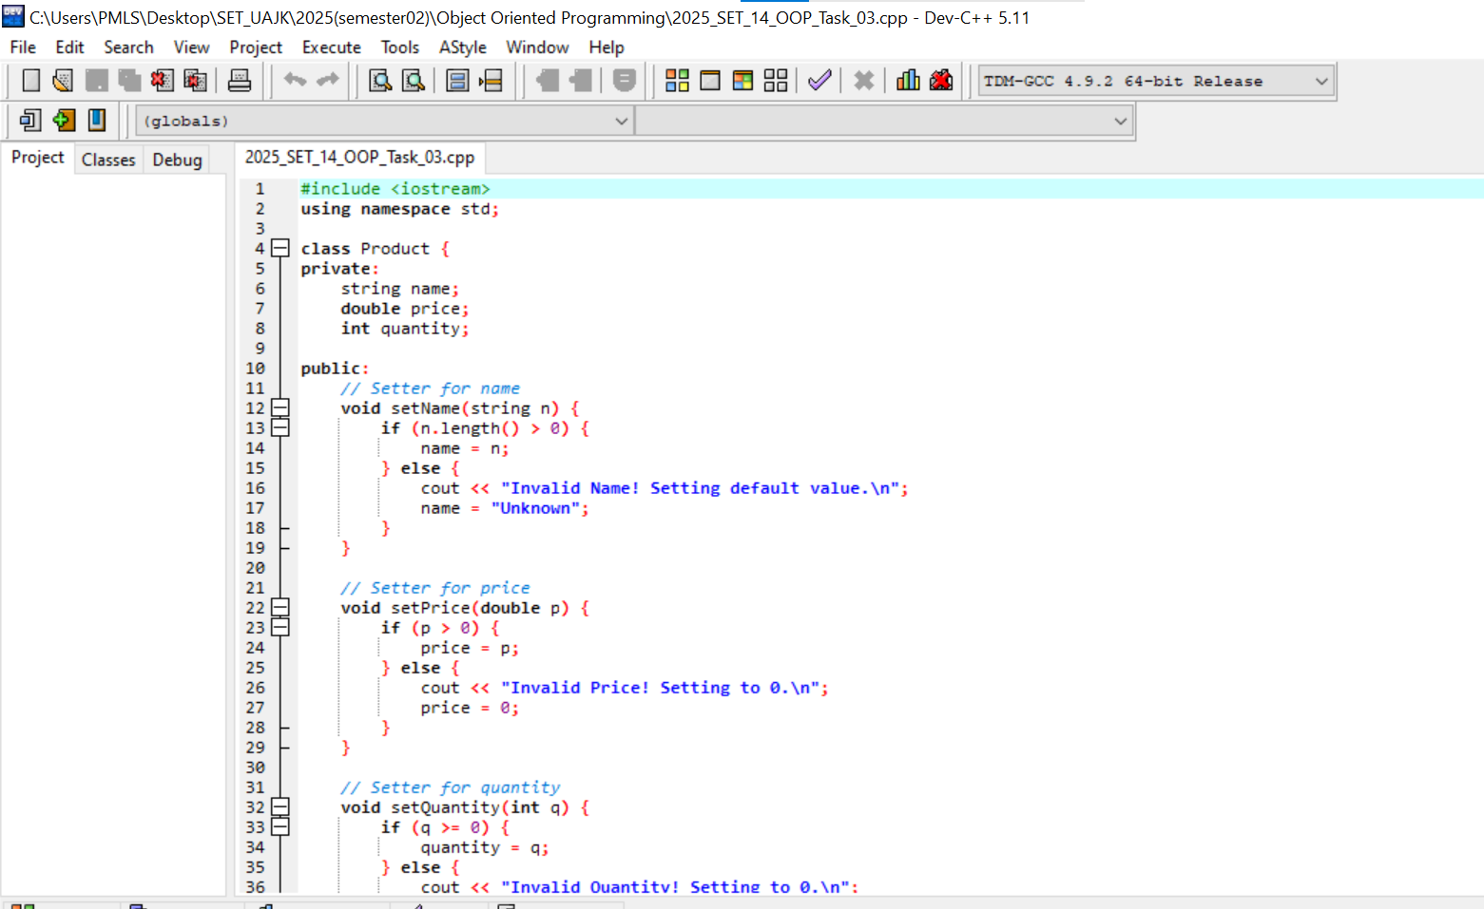
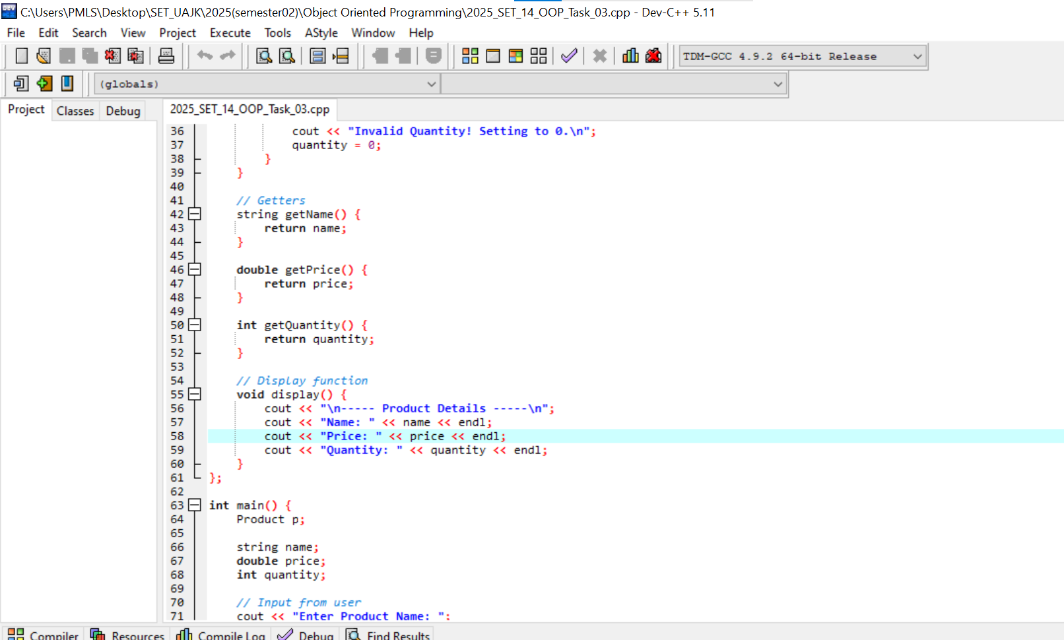
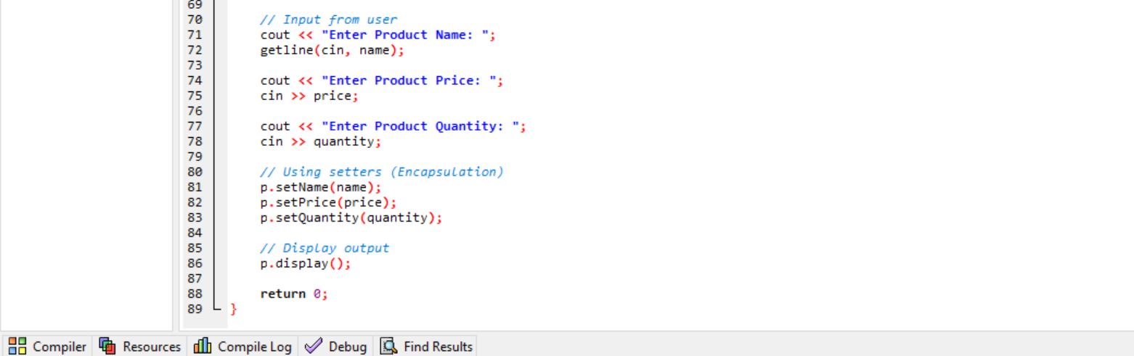
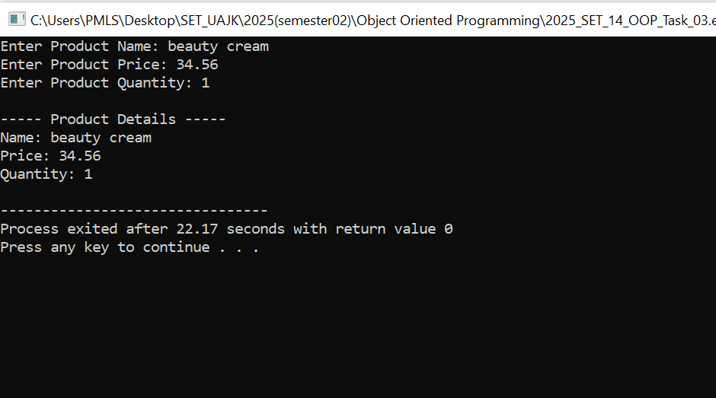

Conclusion
Encapsulation helps in building secure and well-structured programs by hiding internal details and controlling access through methods.
************************************************************************************************************************************************************

