THE UNIVERSITY OF AZAD JAMMU AND KASHMIR, MUZAFFARABAD
DEPARTMENT OF SOFTWARE ENGINEERING

Name: | Ghazanfar Rasheed
Roll No: | 2025-SET-14
Course: | Object Oriented Programming
Submitted To: | Engr. Muhammad Awais
Title: | Lab Task # 05
Session: | 2025-29
Semester: | 2nd

LAB REPORT: OBJECT ORIENTED PROGRAMMING (CONSTRUCTORS & INHERITANCE)

Task 1: Online Shopping System (Constructor)

Objective
The objective of this task is to understand the concept of constructors, inheritance, and constructor chaining in C++. It demonstrates how a derived class initializes properties of a base class using constructors.

Theory
Object-Oriented Programming (OOP) is a programming paradigm that uses classes and objects to design software. One of the fundamental concepts of OOP is inheritance, which allows one class (derived class) to acquire properties and behaviors of another class (base class).
In this task, a base class named Product is created which contains common attributes such as:
- Product Name
- Price
A derived class named Electronics extends the Product class and adds an additional attribute:
- Warranty Years

Constructor
A constructor is a special member function of a class that is automatically called when an object is created. It is mainly used to initialize object data members.

Constructor Chaining
Constructor chaining is the process where a derived class constructor calls the constructor of its base class. This ensures that the base class properties are initialized before the derived class properties.
In C++, constructor chaining is achieved using the initializer list:
Electronics(string n, double p, int w) : Product(n, p)

Working of the Program
- The user enters product details at runtime (name, price, warranty).
- When an object of Electronics is created:
  - First, the Product constructor is called.
  - Then, the Electronics constructor is executed.
- Finally, all values are displayed using member functions.

Output Explanation
- Constructor call messages ->Product details entered by user -> Warranty information

Screenshot Output:

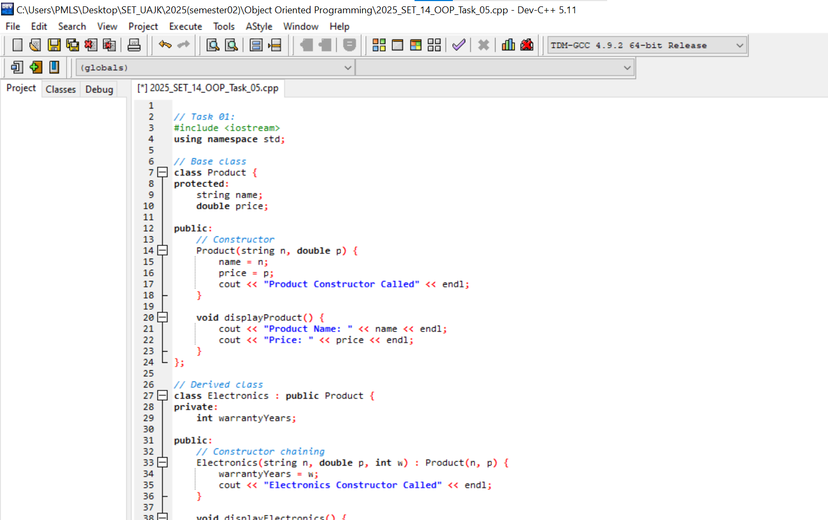

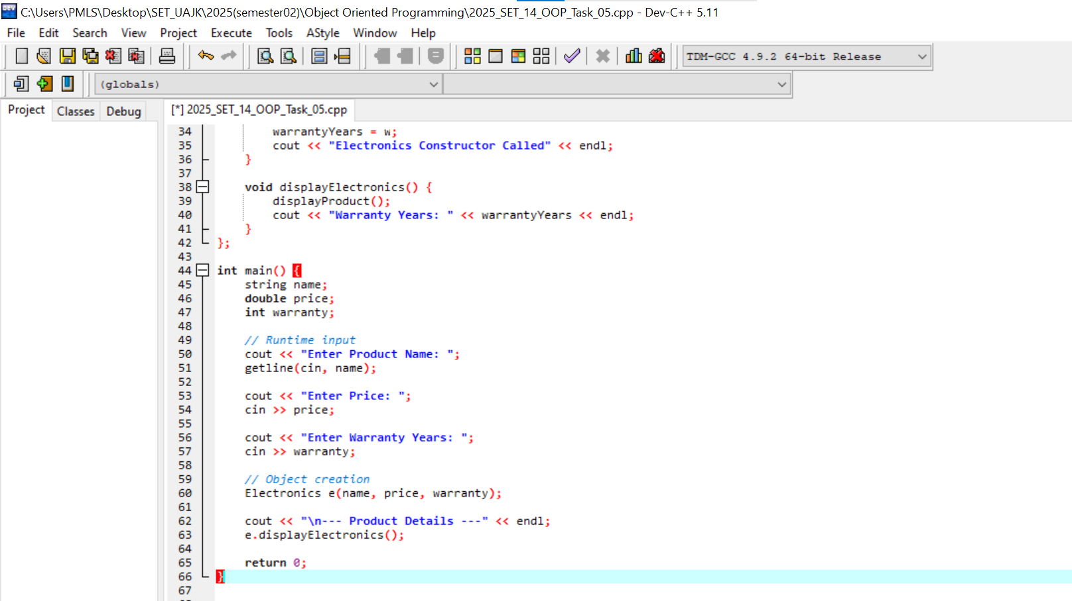

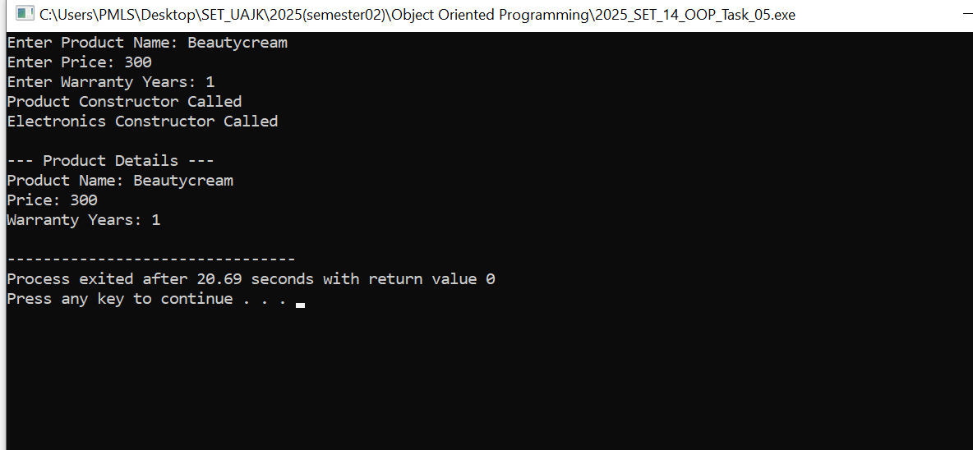

Task 2: Ride Booking System (Multi-Level Inheritance)

Objective
The objective of this task is to understand multi-level inheritance and the order of constructor execution in C++.

Theory
Multi-level inheritance is a type of inheritance where a class is derived from another derived class. It forms a chain of inheritance.
In this task, three classes are created:
- Vehicle (Base Class)
  - Contains basic information like brand
- Car (Derived from Vehicle)
  - Adds number of seats
- ElectricCar (Derived from Car)
  - Adds battery capacity

Constructor in Multi-Level Inheritance
Each class has its own constructor. When an object of the most derived class (ElectricCar) is created, constructors are executed in a specific order.

Execution Order
When an object of ElectricCar is created, constructors are called in the following order:
Vehicle → Car → ElectricCar
This happens because:
- Base class must be initialized first
- Then intermediate class
- Finally derived class

Constructor Passing
Values are passed from the derived class to base class constructors using initializer lists:
ElectricCar(string b, int s, int bc) : Car(b, s)
Car(string b, int s) : Vehicle(b)

Working of the Program
- The user inputs:
  - Car brand
  - Number of seats
  - Battery capacity
- When object is created:
  - Vehicle constructor runs first
  - Then Car constructor
  - Then ElectricCar constructor
- Each constructor prints a message to show execution order.

Output Explanation
The output clearly shows:
- Order of constructor calls
- Values passed through each level
- Final initialized data

Screenshot Output





