THE UNIVERSITY OF AZAD JAMMU AND KASHMIR, MUZAFFARABAD
DEPARTMENT OF SOFTWARE ENGINEERING

Name: | Ghazanfar Rasheed
Roll No: | 2025-SET-14
Course: | Object Oriented Programming
Submitted To: | Engr. Muhammad Awais
Title: | Lab Task # 04
Session: | 2025-29
Semester: | 2nd

LAB 04 – THEORY (Constructors in C++)

Introduction to Constructors
A constructor is a special function in a class that is automatically called when an object is created. It is mainly used to initialize the object’s data members.

Definition
A constructor is a member function of a class that has the same name as the class and does not have any return type.

Key Features
- Same name as class
- No return type (not even void)
- Automatically executed when object is created
- Used to initialize values

Why Use Constructors
- Avoid forgetting to initialize variables
- Make code cleaner and safer
- Automatically assign values at object creation
- Reduce errors in the program

Types of Constructors

1. Default Constructor
- Takes no parameters
- Assigns default values

Example:
Employee() {
id = 0;
name = "Not Assigned";
}

2. Parameterized Constructor
- Takes arguments
- Initializes object with user-defined values
Example:
BankAccount(string accNo, string holder, double bal) {
accountNumber = accNo;
}

3. Constructor Overloading
- Multiple constructors in the same class
- Different parameters
Example:
- No parameter
- One parameter
- Two parameters

When to Use Constructors
- When values must be initialized at object creation
- When creating multiple objects
- When writing clean and efficient code

Constructor vs Setter
Constructor | Setter
Automatically called | Called manually
Used for initialization | Used for updating values
Runs once | Can run multiple times

Advantages
- Saves time
- Reduces errors
- Ensures object is always valid
- Improves code readability

Example (Concept Explanation)
- Employee → Default constructor
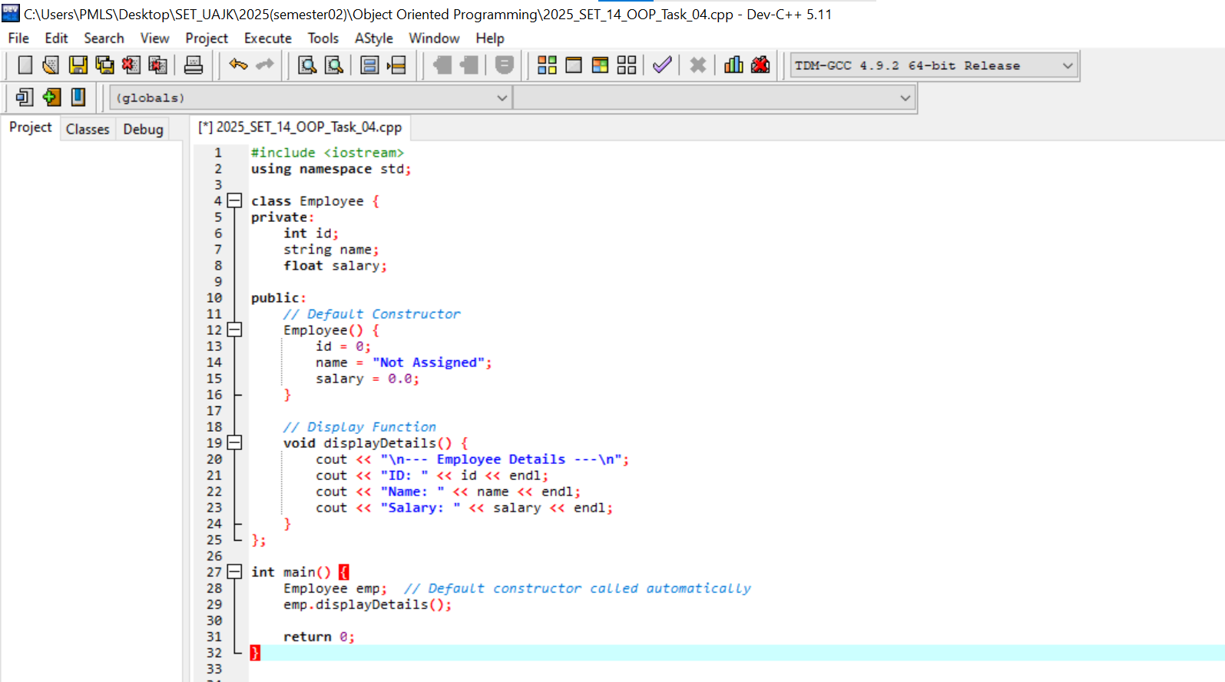
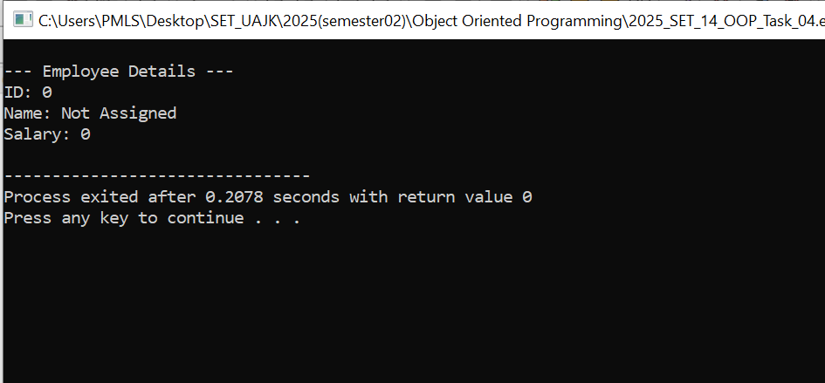

- BankAccount → Parameterized constructor
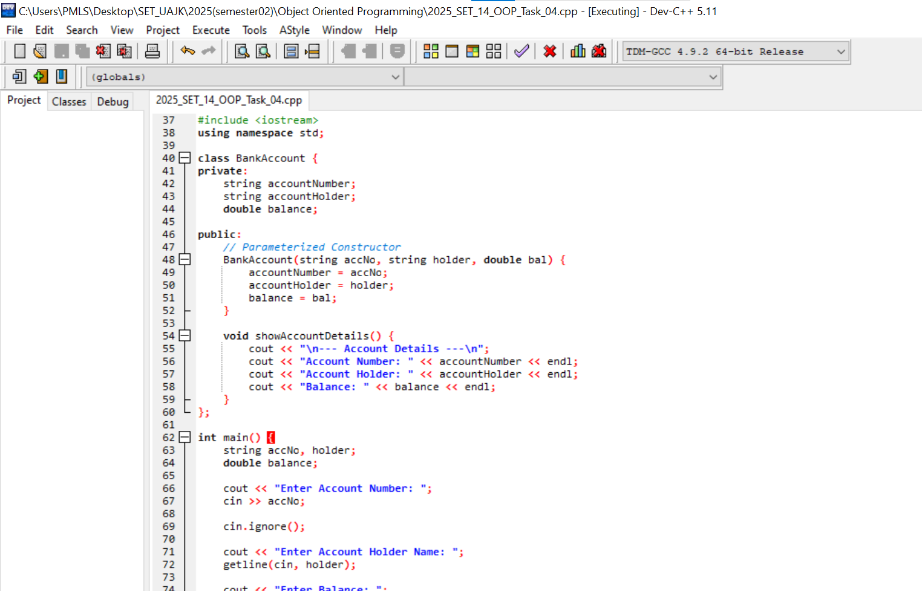

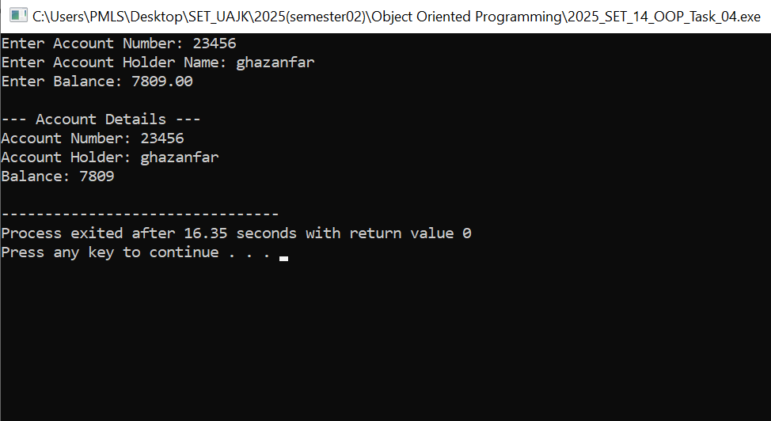
- Rectangle → Constructor overloading
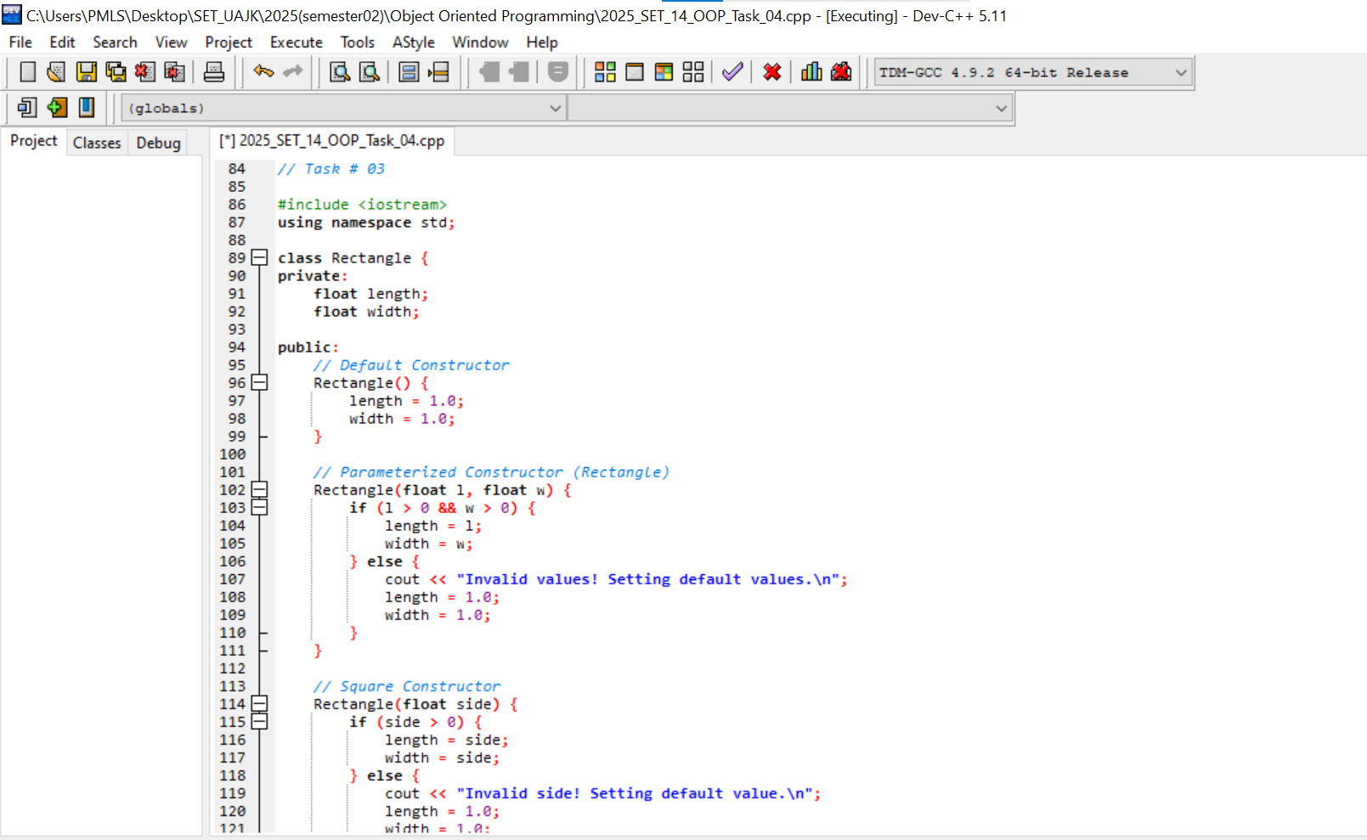
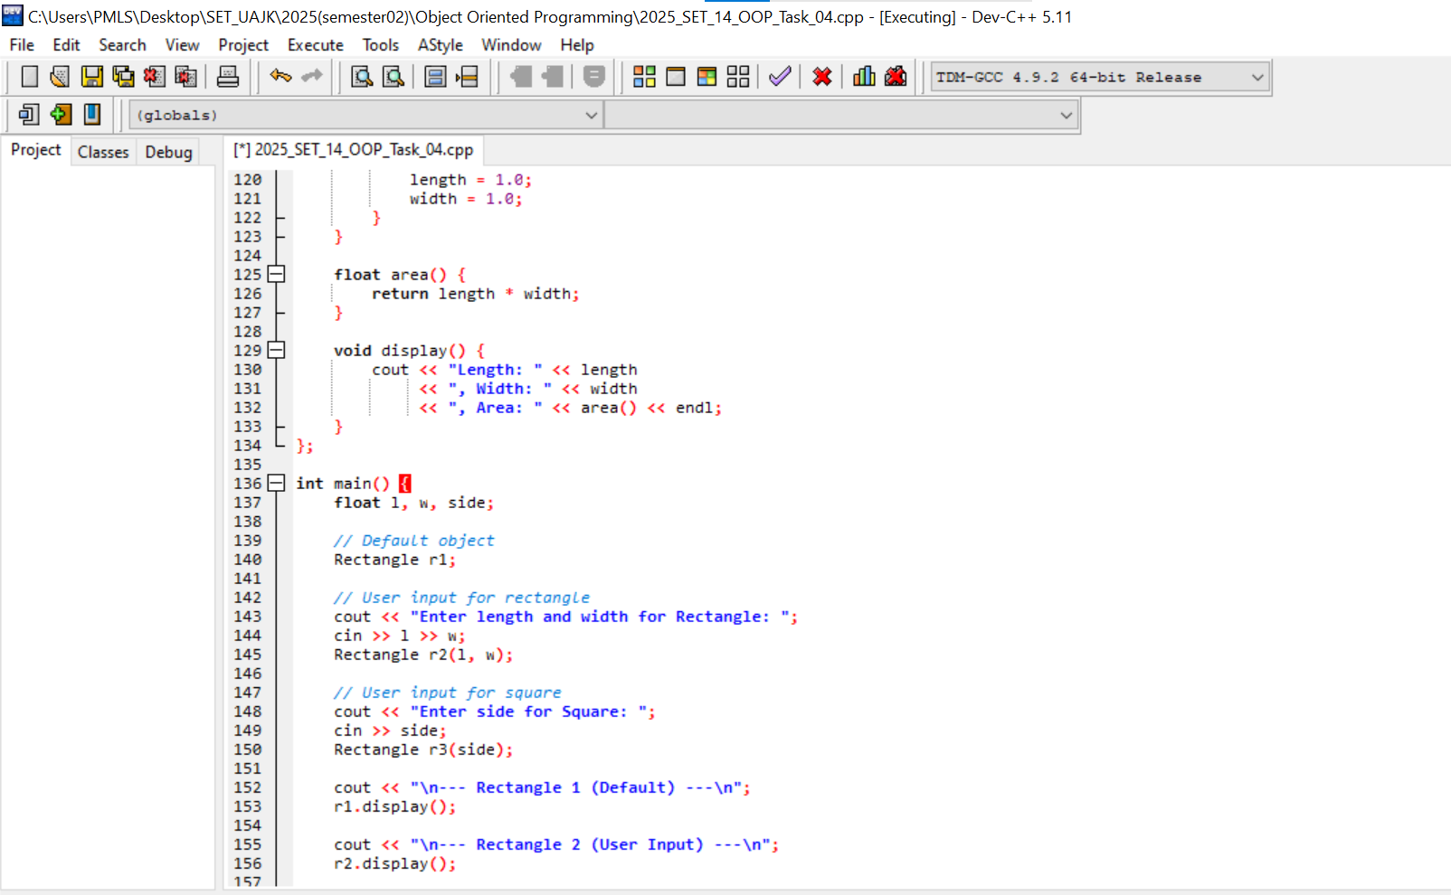
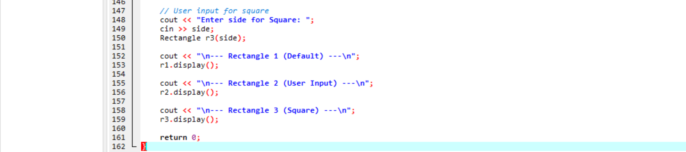
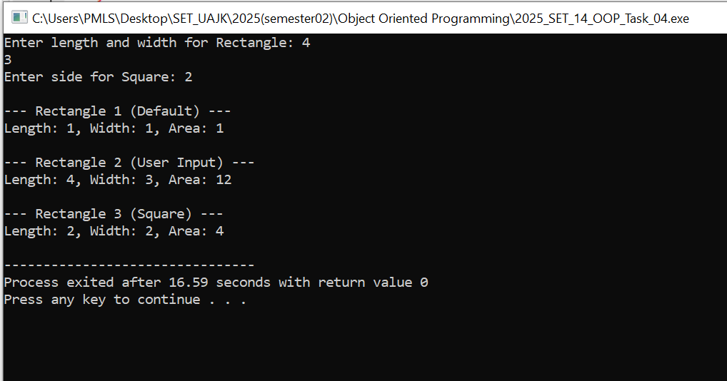

Conclusion
Constructors are essential in OOP because they ensure that objects are properly initialized and help in writing clean, efficient, and error-free programs.
************************************************************************************************************************************************************

