THE UNIVERSITY OF AZAD JAMMU AND KASHMIR, MUZAFFARABAD
DEPARTMENT OF SOFTWARE ENGINEERING

Name: | Ghazanfar Rasheed
Roll No: | 2025-SET-14
Course: | Object Oriented Programming
Submitted To: | Engr. Muhammad Awais
Title: | Lab Task # 02
Session: | 2025-29
Semester: | 2nd

Object-Oriented Programming (OOP)
Object-Oriented Programming (OOP) is a programming approach that organizes programs using objects and classes. In OOP, a program is divided into small units called objects. Each object contains data (variables) and functions (methods) that operate on the data.
OOP helps programmers create programs that are easy to understand, reusable, and maintainable. It is widely used in modern software development because it models real-world entities like students, cars, and employees.
For example, a Car can be considered a class, and different cars like Toyota or Audi can be considered objects of that class.

Objectives of Object-Oriented Programming
The main objectives of OOP are:
- To represent real-world problems in programming.
- To organize large programs into smaller and manageable parts.
- To improve code reusability.
- To make programs easier to maintain and modify.
- To provide data security through data hiding.

Class
A class is a user-defined data type in C++. It acts as a blueprint or template for creating objects. A class contains data members (variables) and member functions (methods).
Data members store information, while member functions perform operations on that data.
Example concept:
A Student class can contain attributes like name, roll number, and marks.

Object
An object is an instance of a class. It represents a real-world entity and allows access to the class members.
For example:
- Class → Student
- Object → student1, student2
Objects are used to call the functions and access the variables defined in the class.

Member Variables
Member variables are the attributes of a class. They store the data related to the object.
For example, in a Student class:
- name
- roll number
- marks
These variables store information about each student.

Member Functions
Member functions are the functions that belong to a class. They define the behavior of the class and perform operations on the data.
In C++, member functions can be defined in two ways:

1. Inside the Class
The function is written directly inside the class definition.

2. Outside the Class
The function is declared inside the class and defined outside using the scope resolution operator (::).

Scope Resolution Operator (::)
The scope resolution operator (::) is used to define a member function outside the class. It tells the compiler that the function belongs to a particular class.
Example concept:
ClassName::functionName()
This helps keep programs organized and improves readability.

Problem Description (Tasks)
In this lab, different classes were created to understand the basic concepts of object-oriented programming.

Task 1 – Student Record System
A class named Student was created with attributes:
- name
- rollNumber
- marks
Two member functions were implemented:
- getData() to take input from the user
- displayData() to display the student information
The functions were defined inside the class.
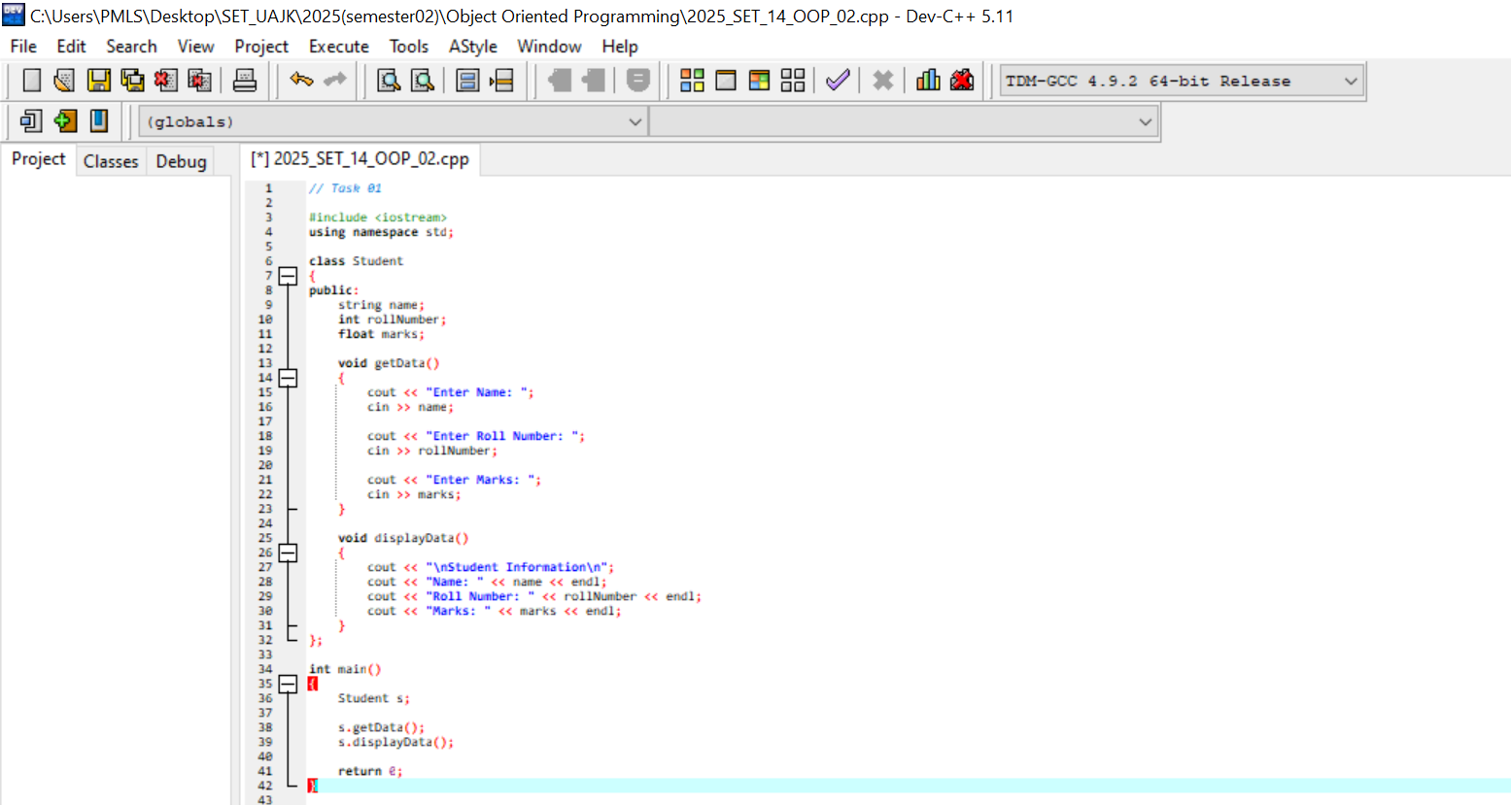

Task 2 – Rectangle
A class named Rectangle was created with attributes:
- length
- width
Three member functions were used:
- setDimensions() to input values
- area() to calculate area
- perimeter() to calculate perimeter
The functions were defined outside the class using the scope resolution operator.
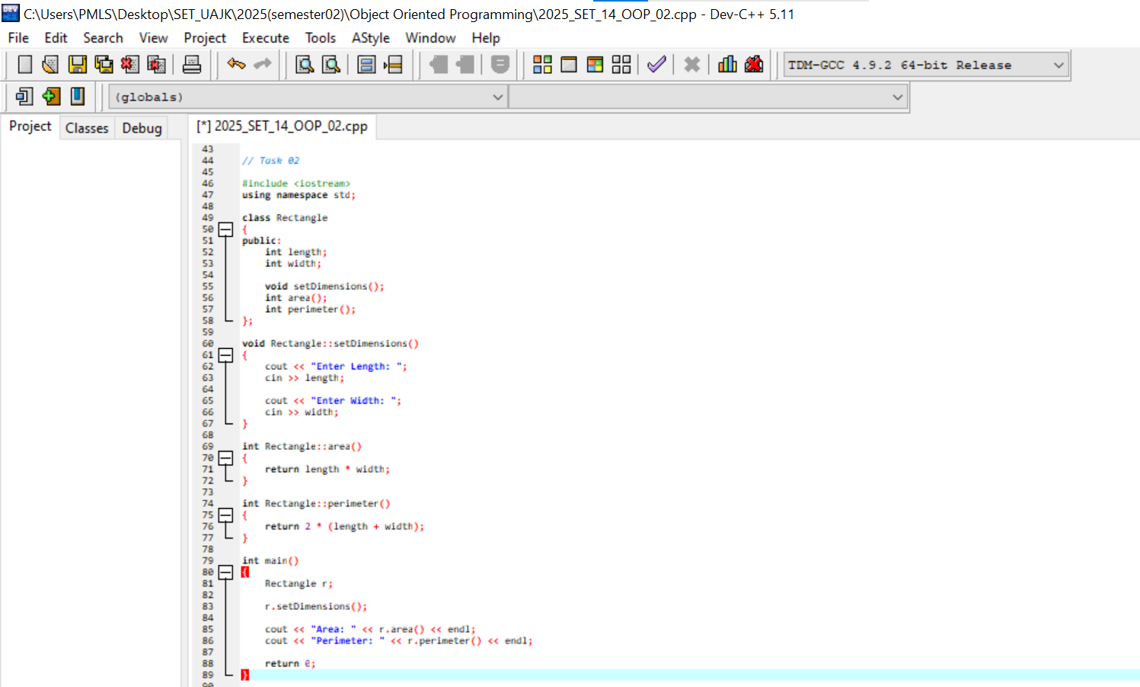

Task 3 – Voting Eligibility
A class named Voter was created with attributes:
- name
- age
A function isEligible() was used to check whether a person is eligible to vote or not. If the age is greater than 18, the function returns true, otherwise it returns false.
The decision message is displayed in the main function.
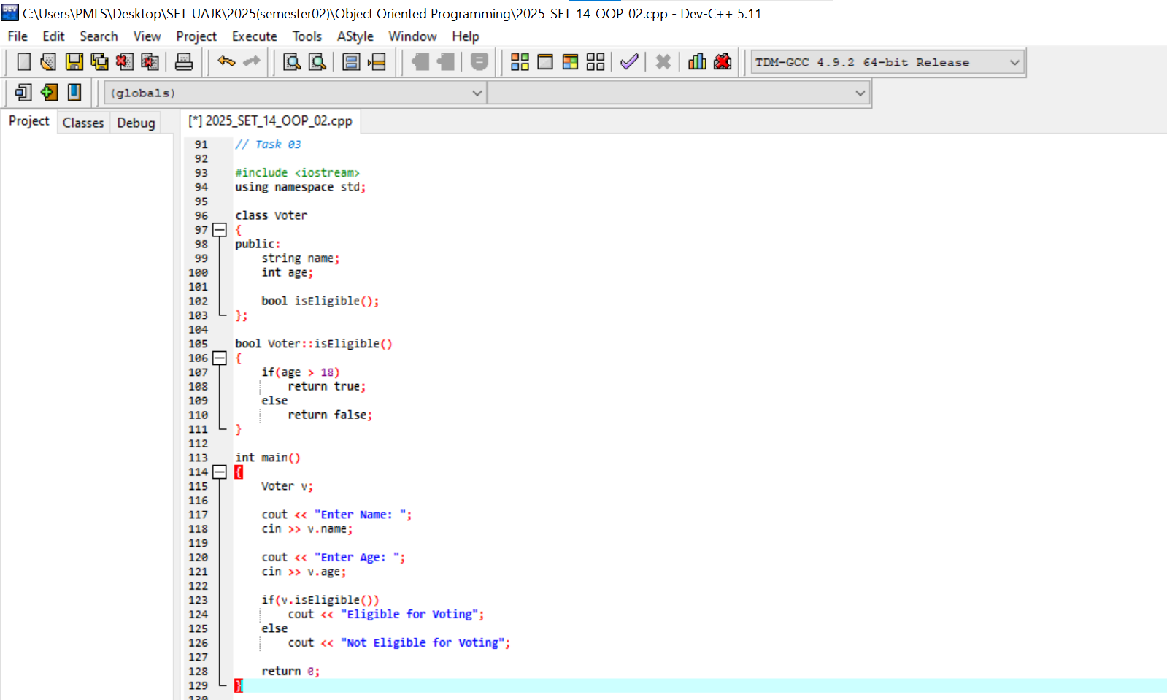

Task 4 – Temperature Converter
A class named Temperature was created to convert temperature from Celsius to Fahrenheit.
Formula used:
F = (C × 9/5) + 32
The class contains:
- a variable to store Celsius value
- a function to convert temperature
- a function to display the result
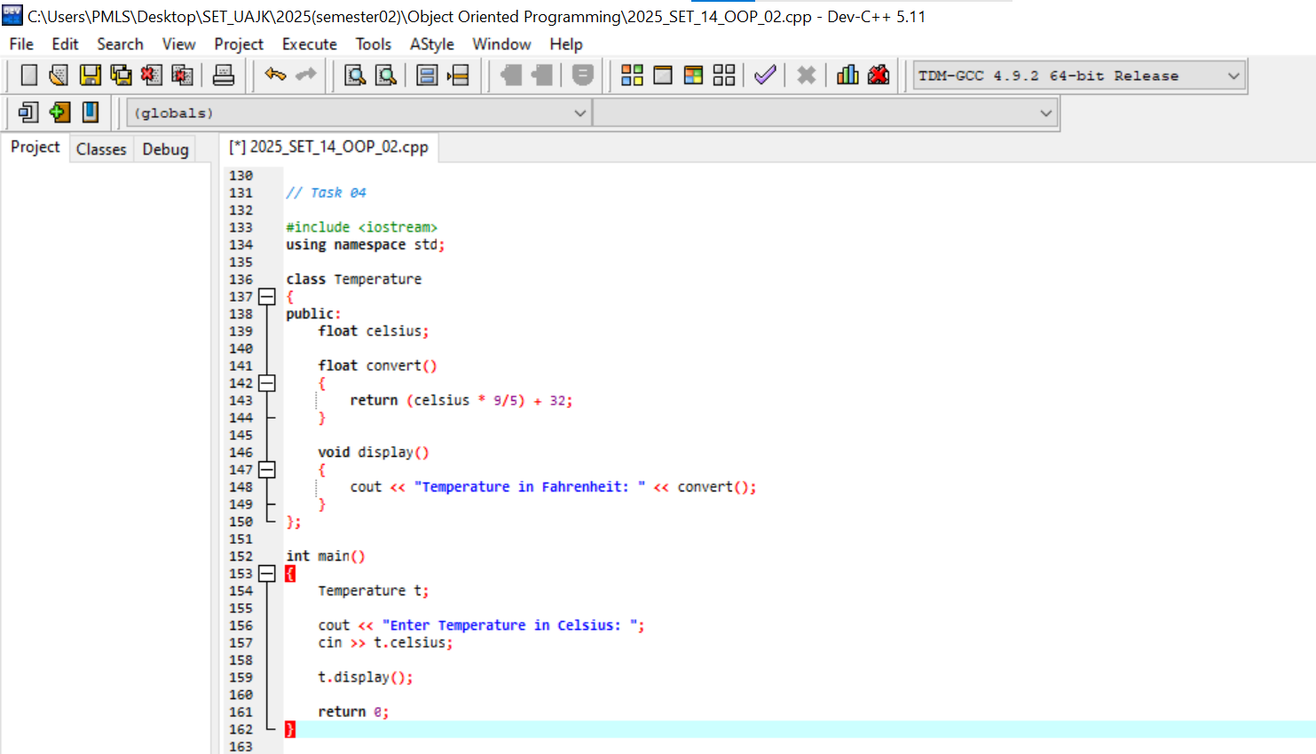

Task 5 – Calculator
A class named Calculator was created with two numbers:
- num1
- num2
The class contains functions for basic mathematical operations:
- add()
- subtract()
- multiply()
- divide()
The user selects an operation using a menu, and the program displays the result.
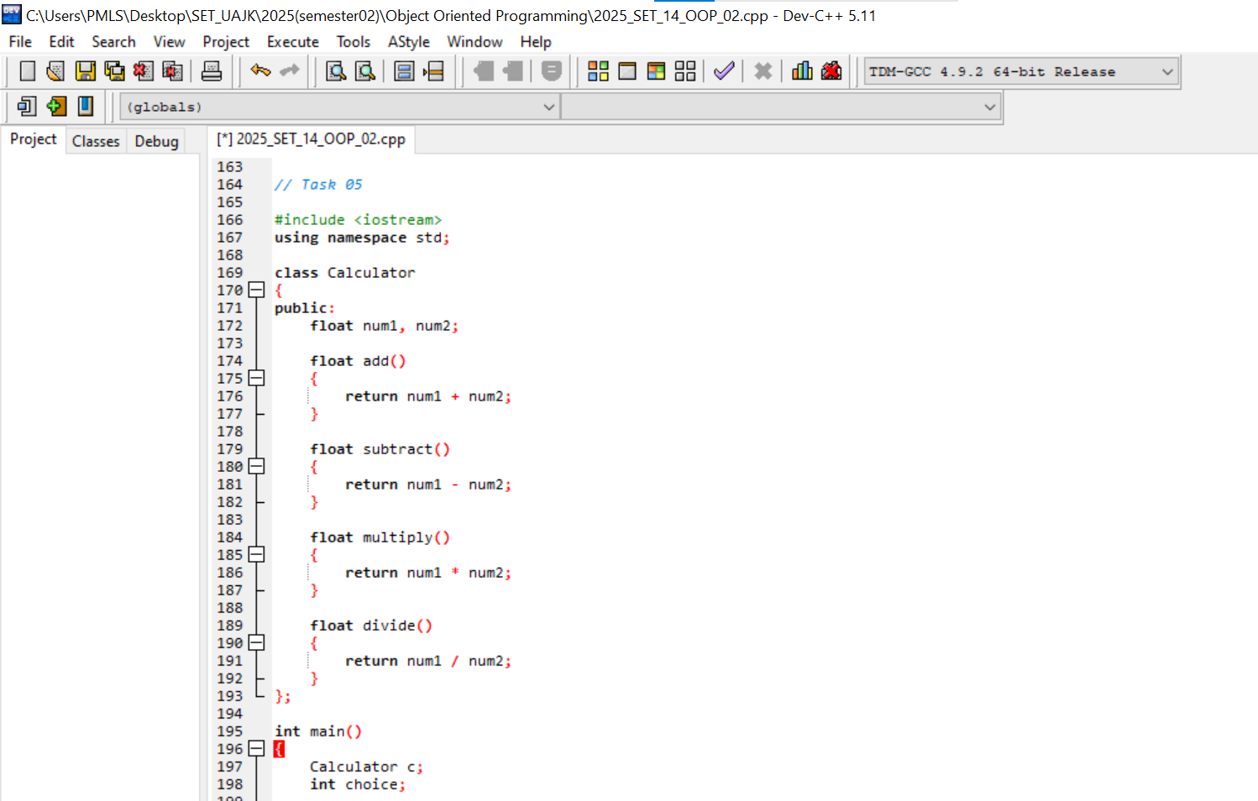


Conclusion
In this lab, the basic concepts of Object-Oriented Programming in C++ were implemented. Different classes and objects were created to solve real-world problems. The use of member variables and member functions helped organize the code effectively.
The lab also demonstrated how functions can be defined inside and outside the class, and how objects interact with class members. These concepts form the foundation of object-oriented programming and are essential for building large and structured software systems.

