THE UNIVERSITY OF AZAD JAMMU AND KASHMIR, MUZAFFARABAD
DEPARTMENT OF SOFTWARE ENGINEERING

Name: | Ghazanfar Rasheed
Roll No: | 2025-SET-14
Course: | Programming Fundamentals
Submitted To: | Engr. Zeeshan Rashid
Lab Task no: | 01
Session: | 2025-29
Semester: | 1st

Lab task 01
Question:01:-
Installation of Dev C++
Step 01
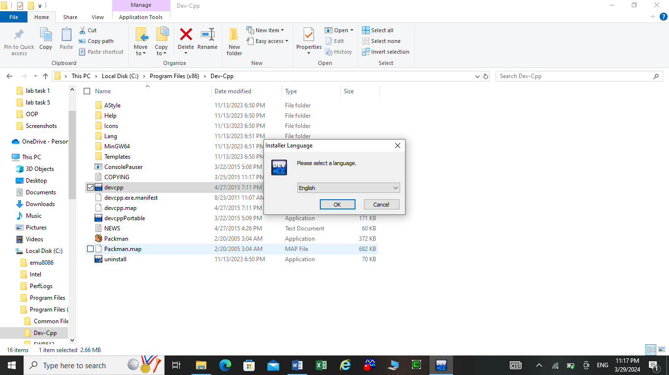
Step 02

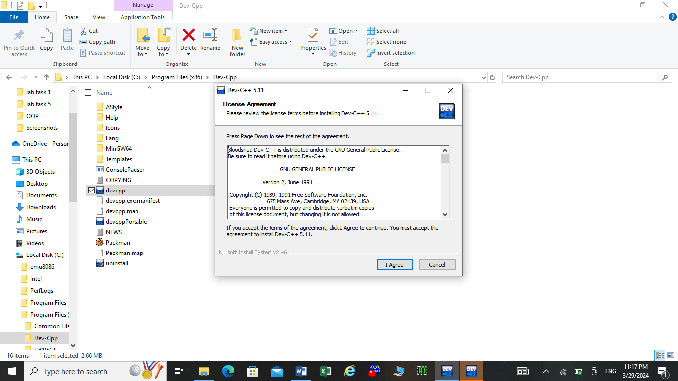
Step 03
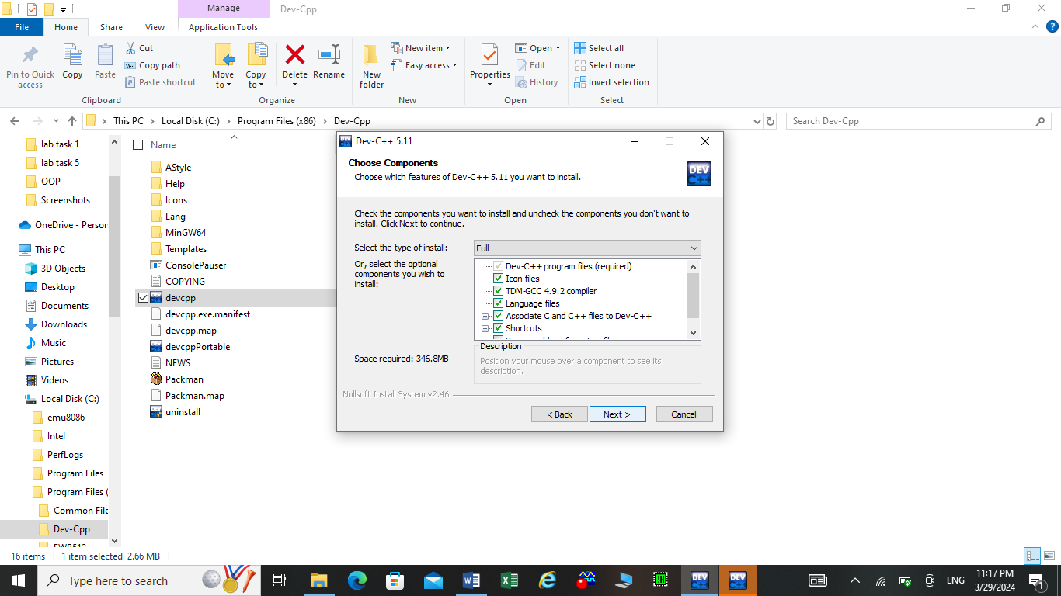
Step 04
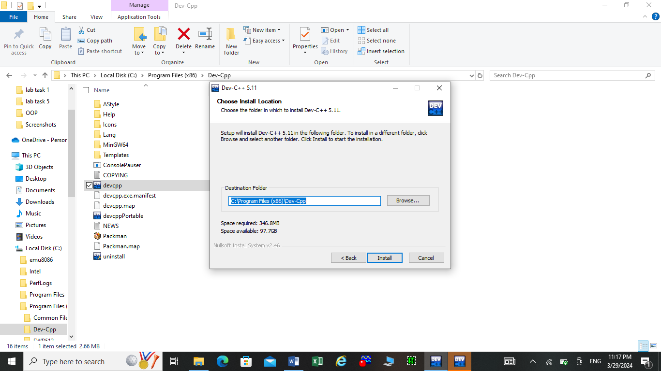

Step 05
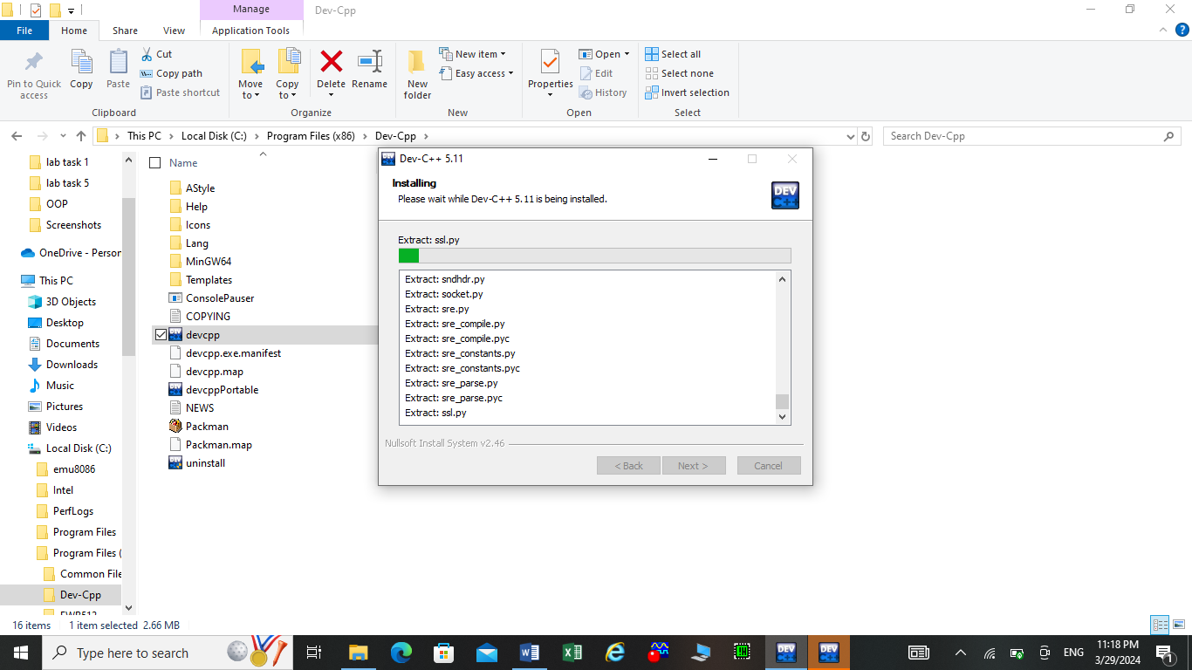
Step 06
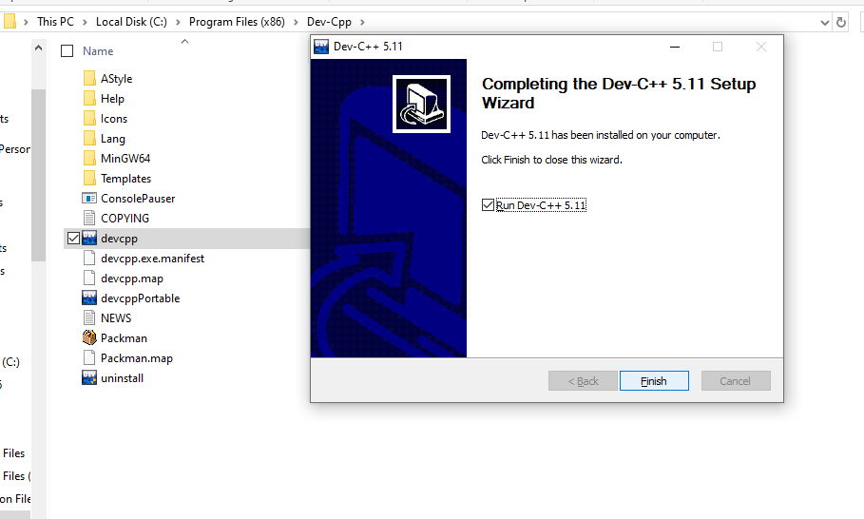

Step 07
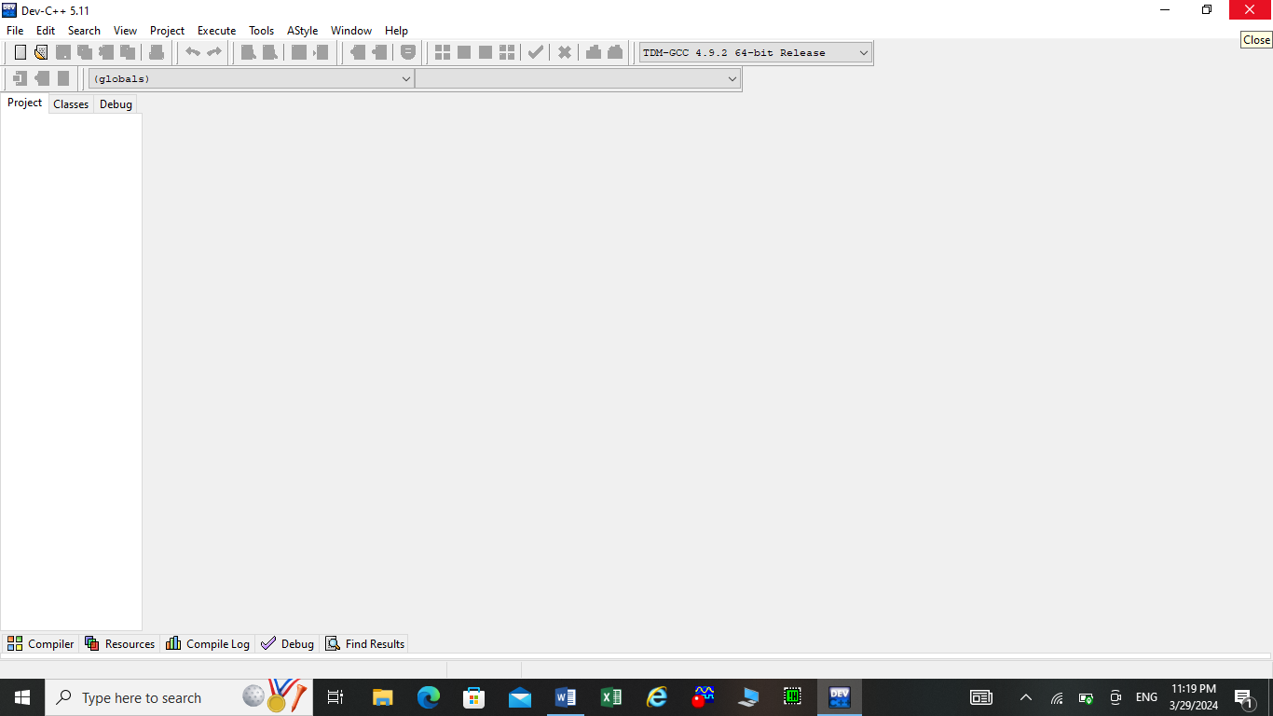

Question 02:-
Write a C++ program to print the following lines (line by line): Name, Roll Number, Department, Address, Hobby, F.sc Marks, Matric Marks and Qualification.
Code:
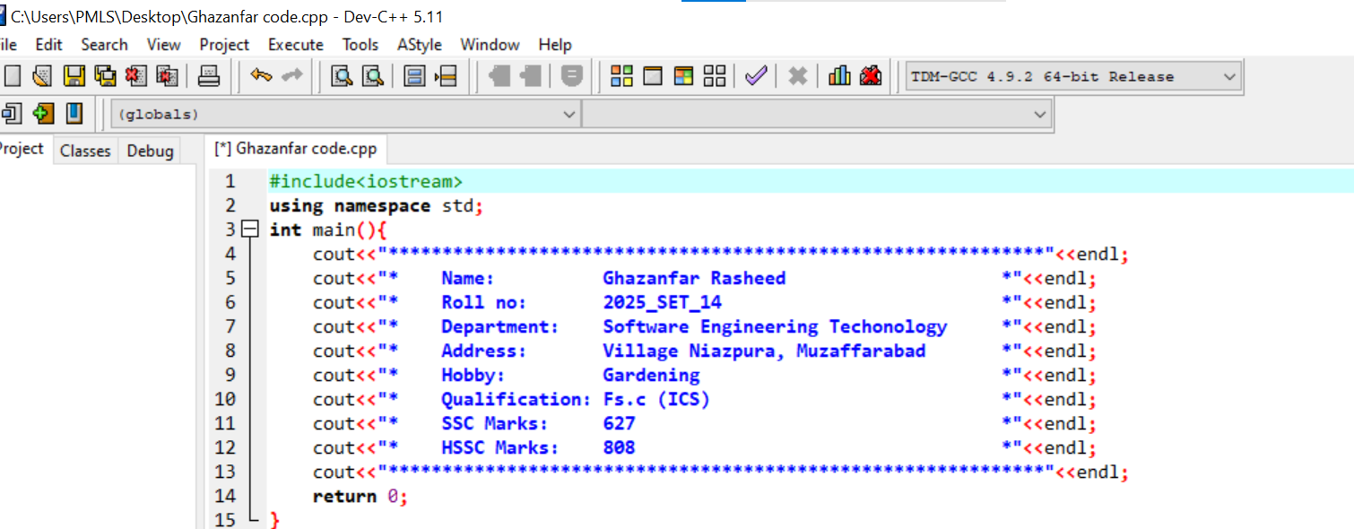

Output:
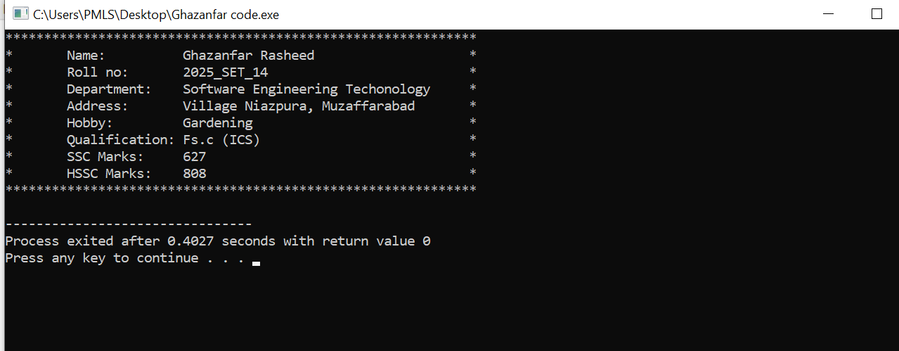
Question 03:-
Build calculator that perform basic operations:
- Addition
- Subtraction
- Multiplication
- Division
Code:
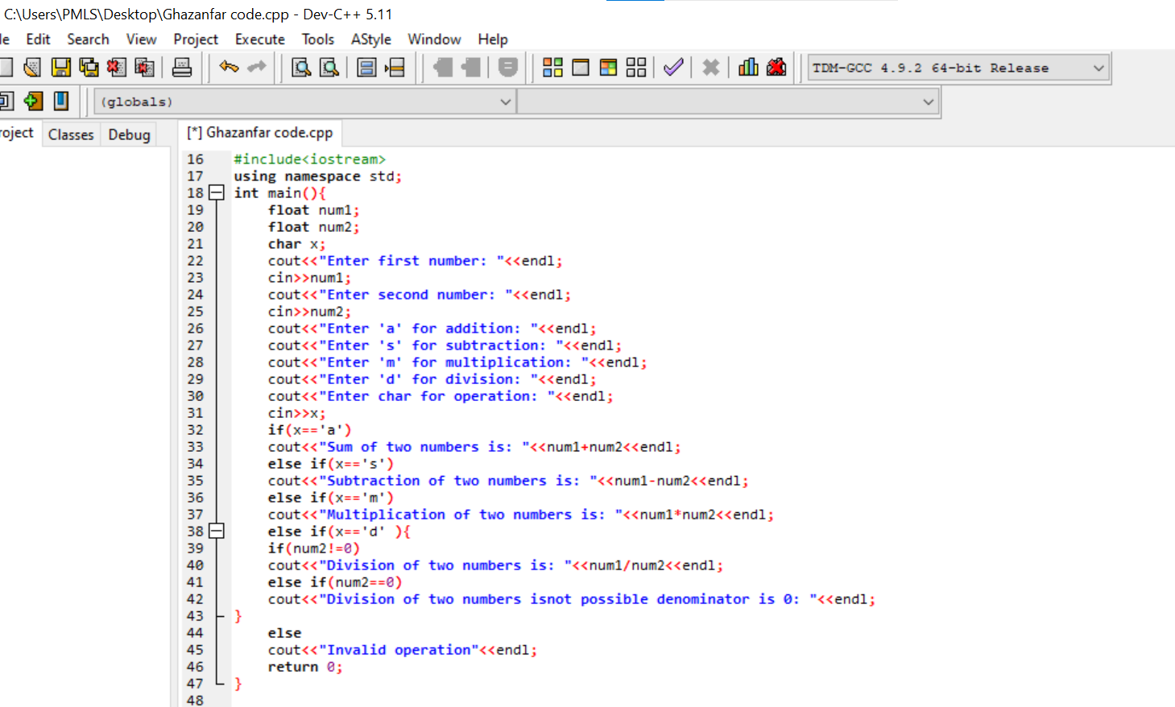

Output:
Addition:
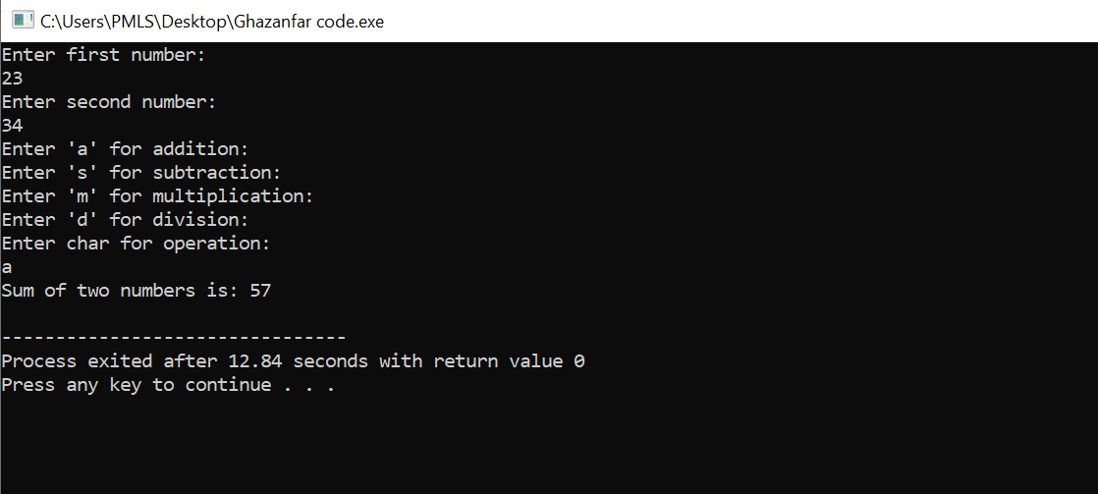
Subtraction:
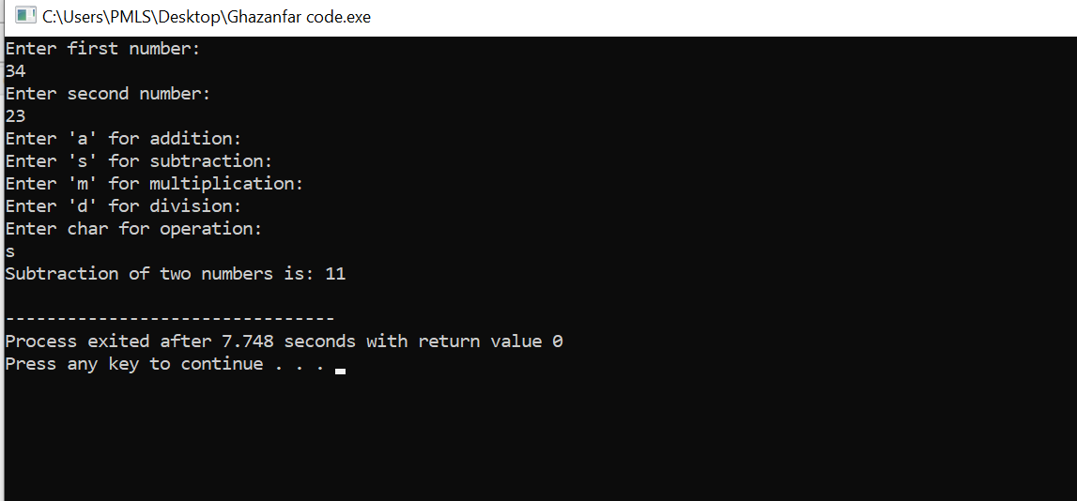
Multiplication:
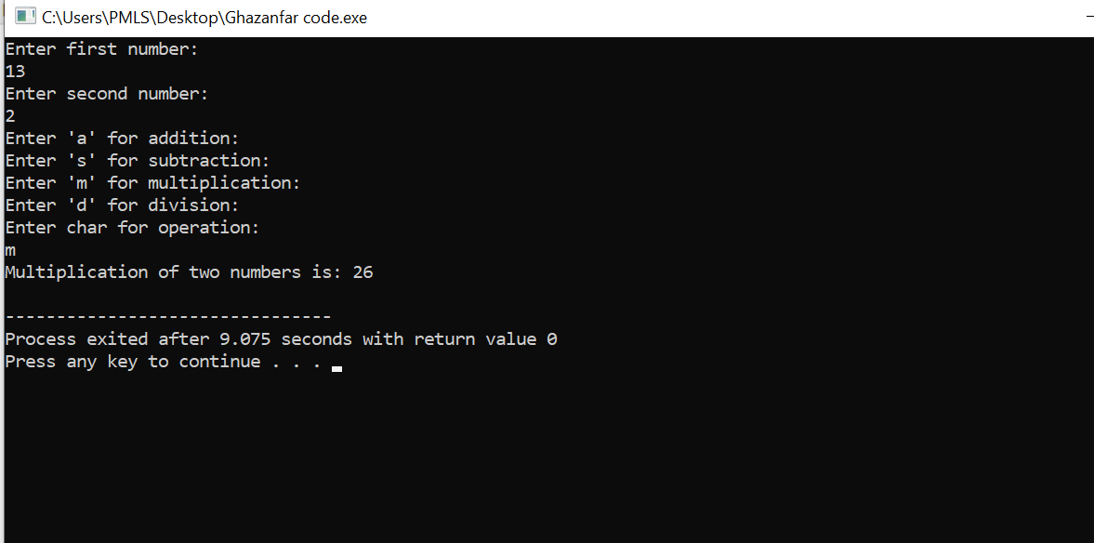
Division:
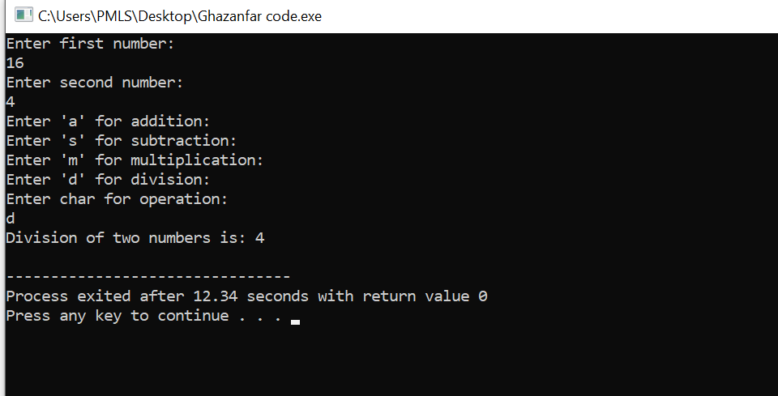
Division when denominator is zero:
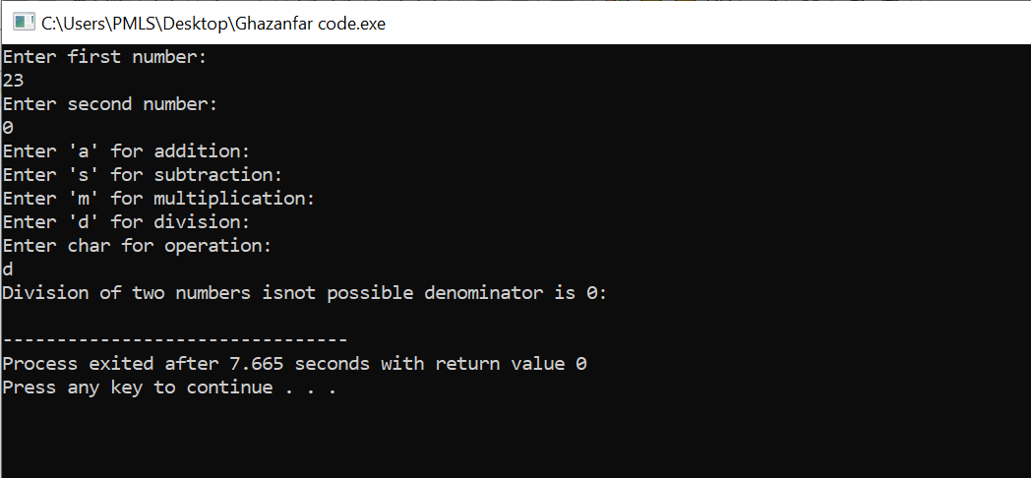
Output when invalid operator entered:



