THE UNIVERSITY OF AZAD JAMMU AND KASHMIR, MUZAFFARABAD
DEPARTMENT OF SOFTWARE ENGINEERING

Name: | Ghazanfar Rasheed
Roll No: | 2025-SET-14
Course: | Programming Fundamentals
Submitted To: | Engr. Zeeshan Rashid
Lab Task no: | 02
Session: | 2025-29
Semester: | 1st

Lab task 02
Question:01:-
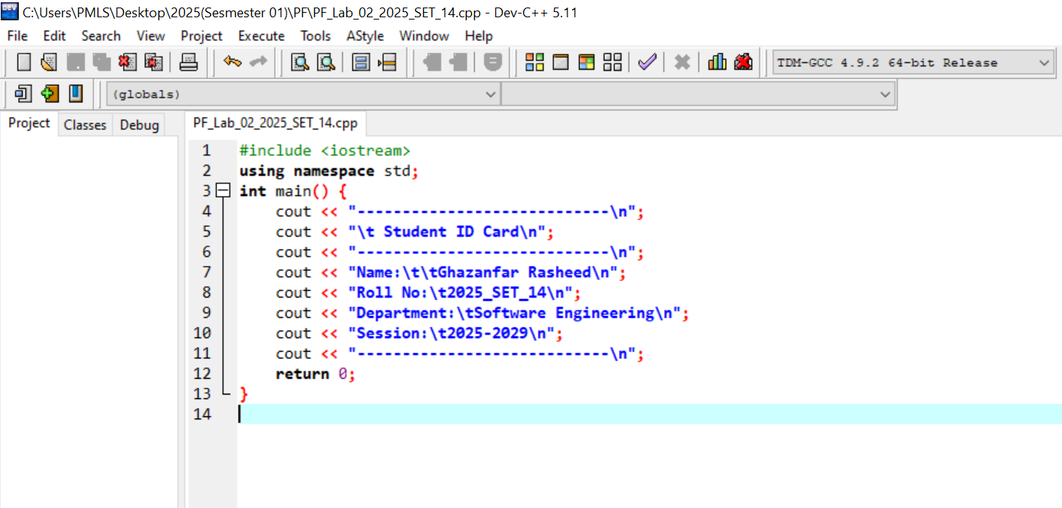
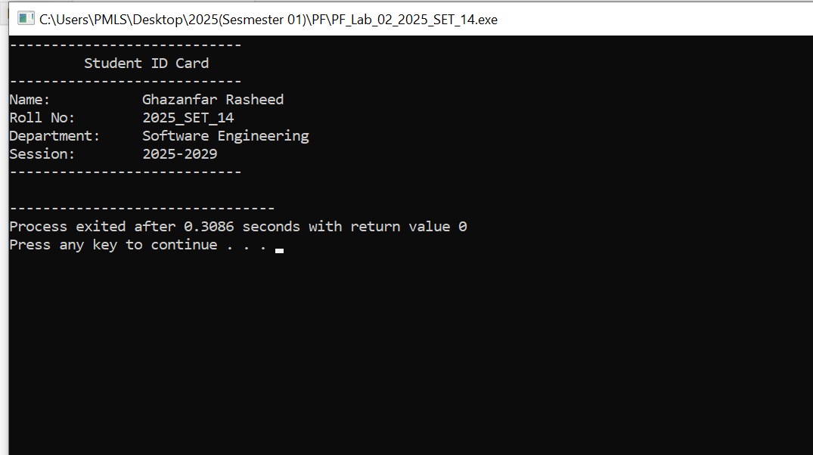
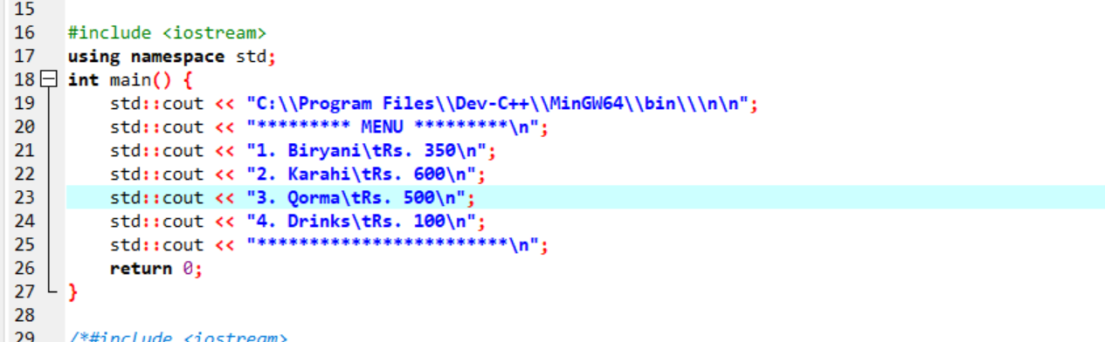
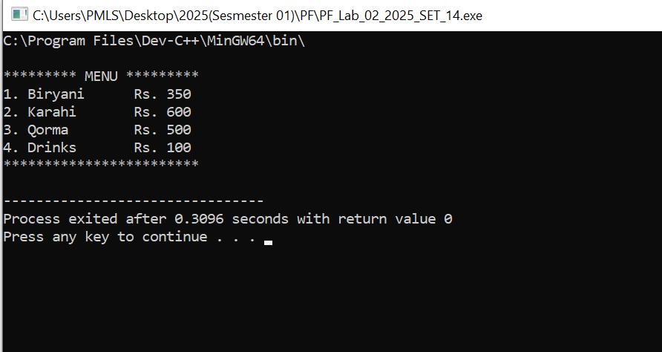
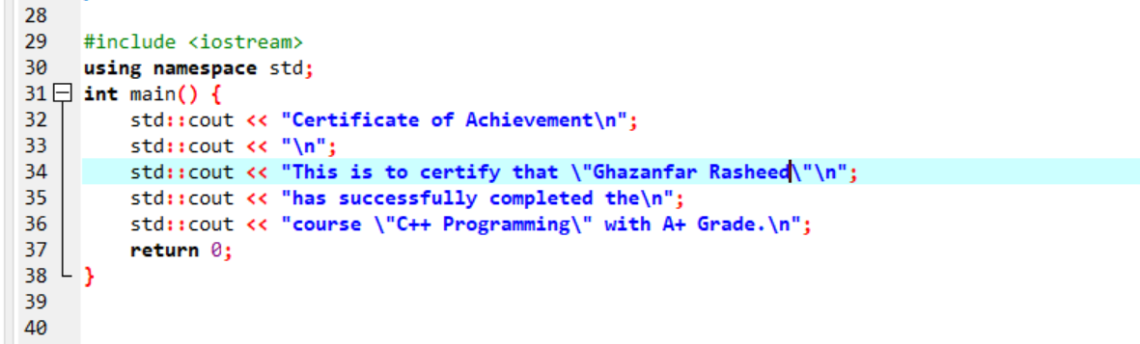
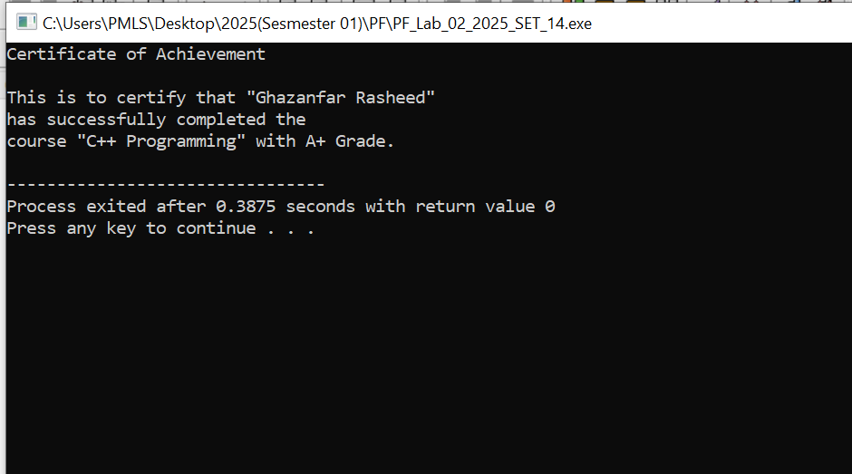
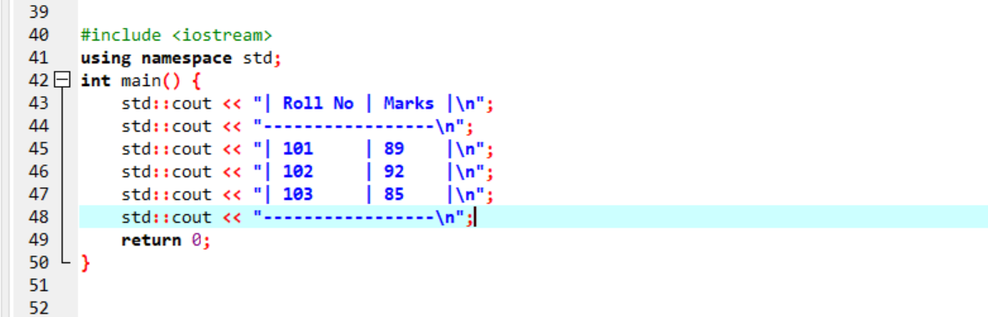
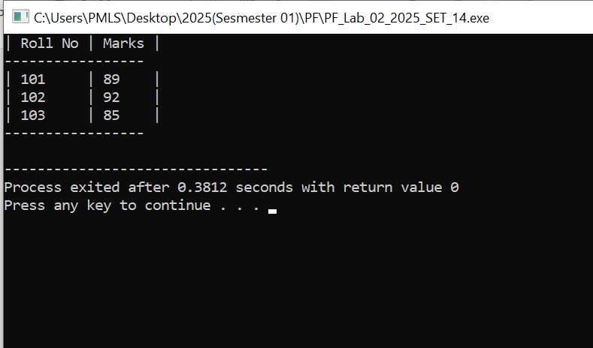
Question 02:-



