THE UNIVERSITY OF AZAD JAMMU AND KASHMIR, MUZAFFARABAD
DEPARTMENT OF SOFTWARE ENGINEERING

Name: | Ghazanfar Rasheed
Roll No: | 2025-SET-14
Course: | Programming Fundamentals
Submitted To: | Engr. Zeeshan Rashid
Lab Task no: | 03
Session: | 2025-29
Semester: | 1st

Evaluate following expressions:
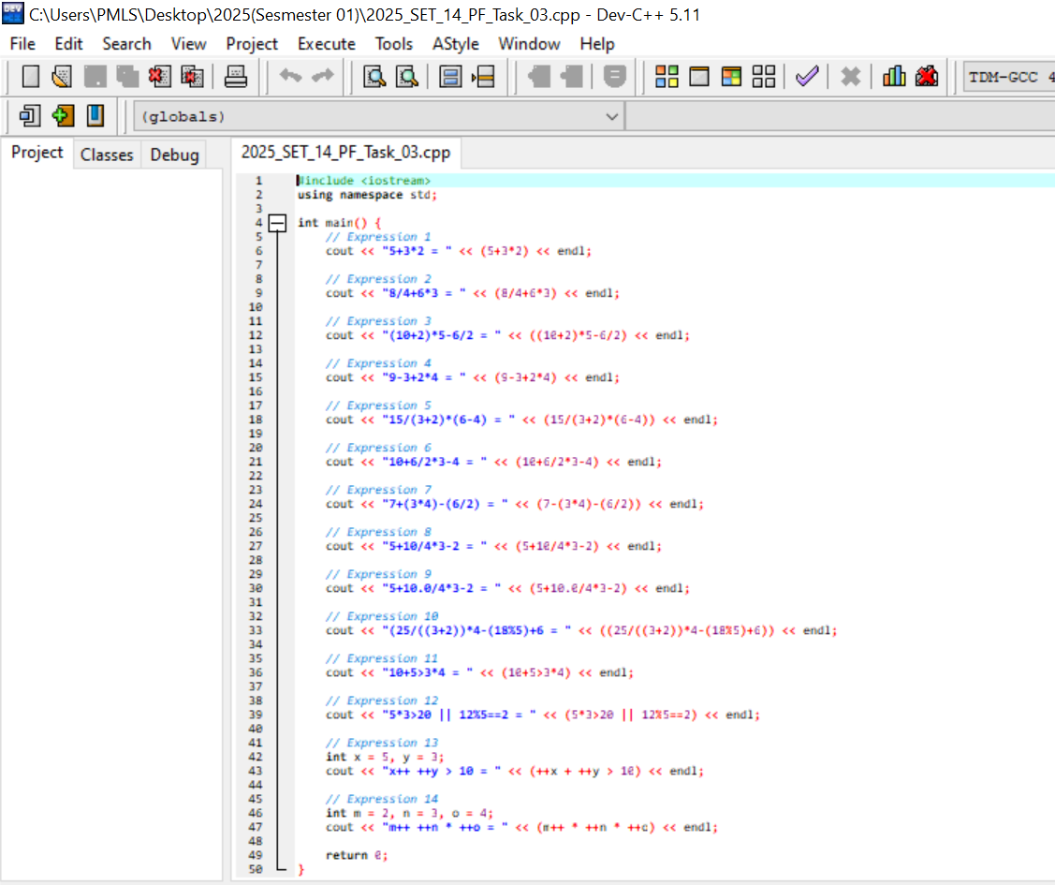
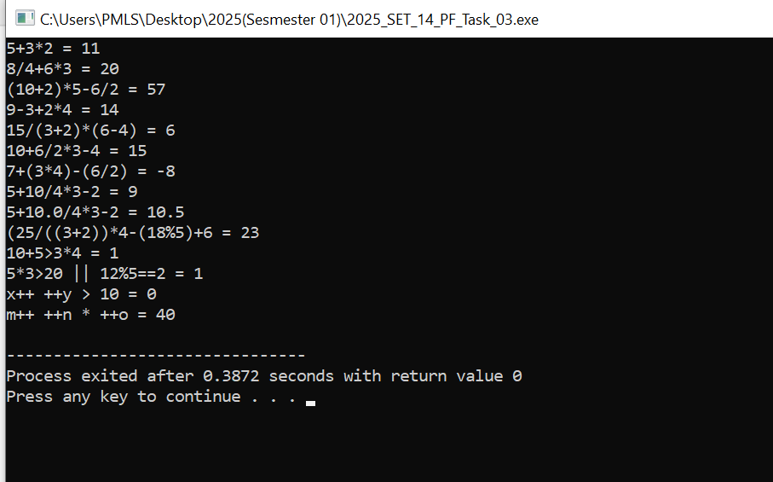

Task 1 : Determine Even or Odd Numbers
Write a program that checks if an integer inputted by user is even or odd using the ternary operator.
Format the output to display:
"The number X is even" if the number is even. "The number X is odd" if the number is odd.
Input Example:
Enter an integer : 5
Enter an integer : 12
Output Format Example:
The number 5 is odd
The number 12 is even
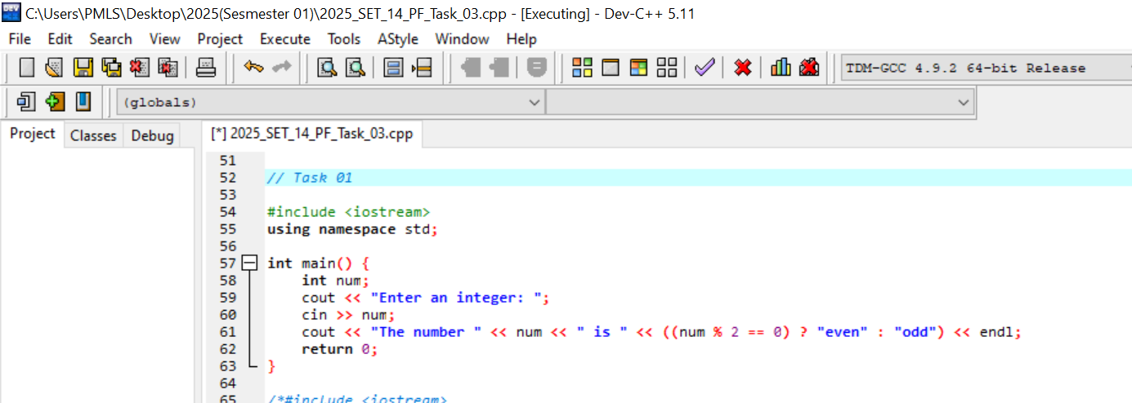
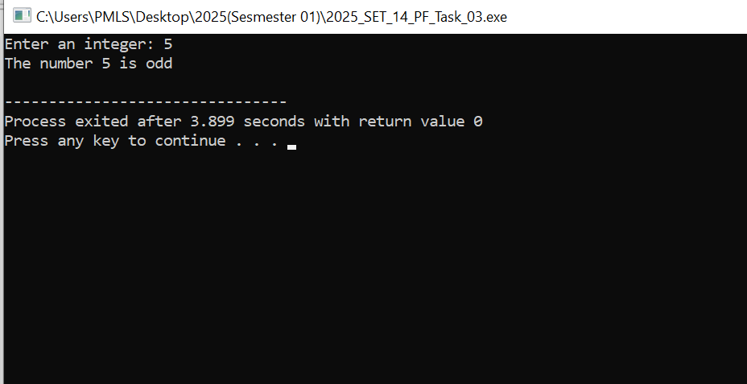
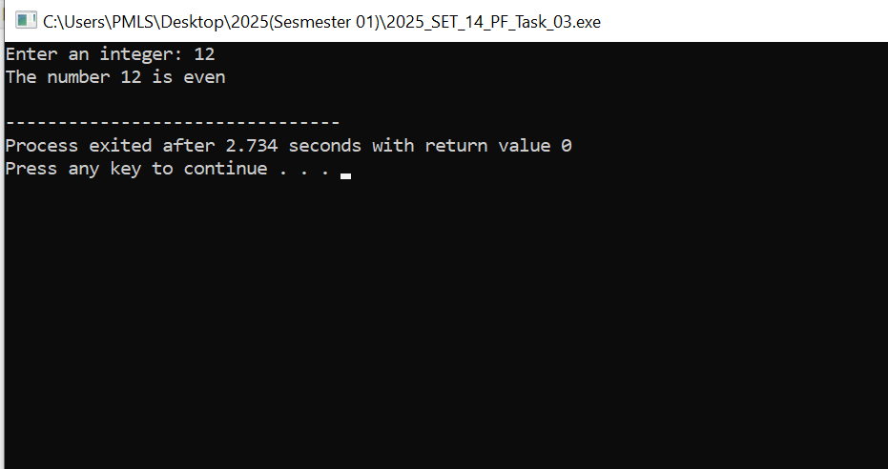

Task 2 : Age Group Classification
Write a program that classifies a person’s age into different categories:
"Child" if the age is less than 13.
"Teenager" if the age is between 13 and 19.
"Adult" if the age is 20 or greater.
Use the ternary operator to classify the age and display the output.
Input Example:
10
15
25
Output Format Example:
Age 10 falls under the category: Child
Age 15 falls under the category: Teenager
Age 25 falls under the category: Adult
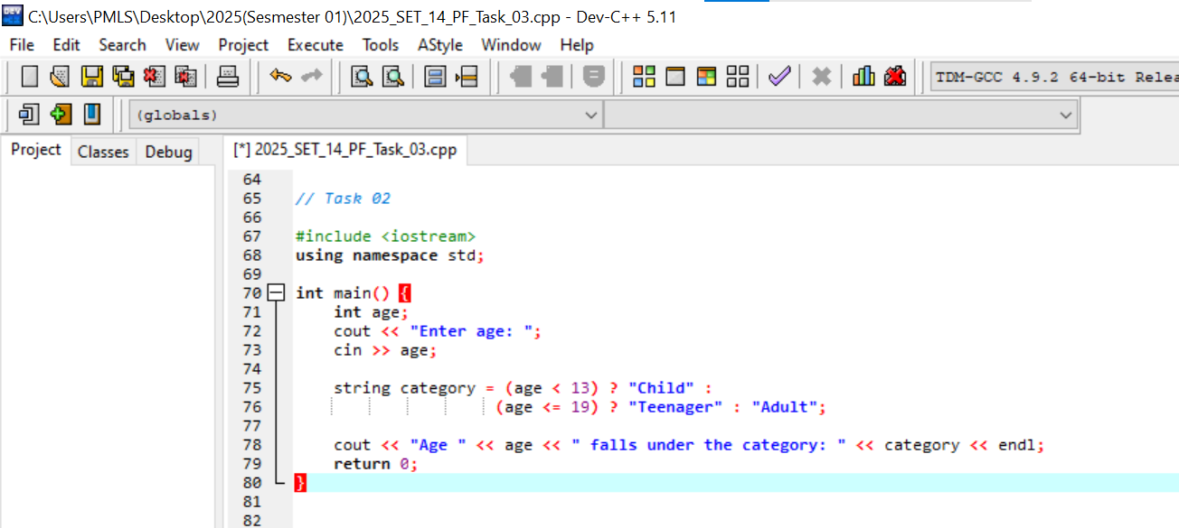
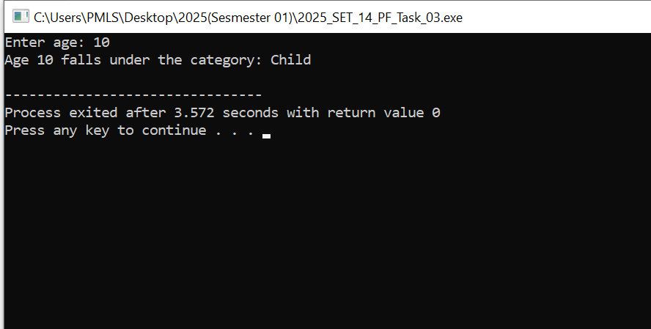
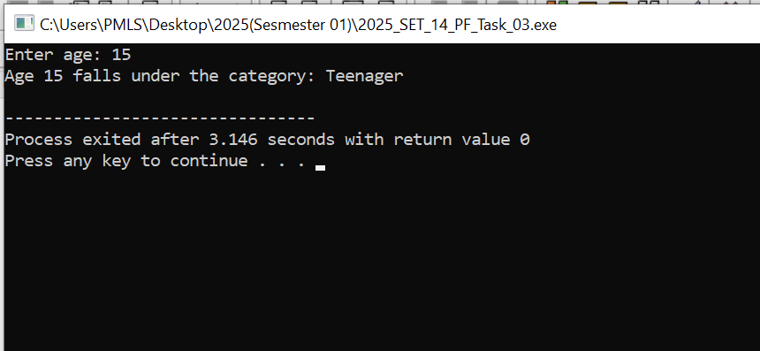
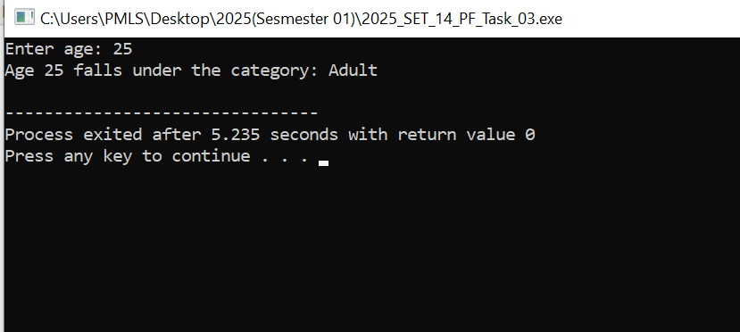

Task 3 : Banking App
Write a program that checks a customer's bank account balance and determines both their account type and special offer eligibility.
The program should work as follows:
Account Type Determination:
- If the account balance is less than $100, the account is considered a Low Balance account.
- If the account balance is between $100 and $500 (inclusive), it is considered a Standard Account.
- If the account balance is greater than $500, it is considered a Premium Account.
Special Offer Eligibility:
The customer is eligible for a special offer if their account balance is greater than $200 and they are also a loyal customer.The loyalty status is provided as a Boolean value (1 for loyal, 0 for not loyal).
Output Format:
Print the Account Type based on the account balance.
Print whether the customer is eligible for a special offer based on their balance and loyalty status.
You are required to use the ternary operator to implement all the decision-making logic in your program. You should not use if-else statements. Additionally, use logical operators (AND, OR, NOT) where needed to combine multiple conditions.




