THE UNIVERSITY OF AZAD JAMMU AND KASHMIR, MUZAFFARABAD
DEPARTMENT OF SOFTWARE ENGINEERING

Name: | Ghazanfar Rasheed
Roll No: | 2025-SET-14
Course: | Programming Fundamentals
Submitted To: | Engr. Zeeshan Rashid
Lab Task no: | 04
Session: | 2025-29
Semester: | 1st

Topic: Arithmetic Operators, Relational Operators

Scenario:

Q. No.1:
a. You are developing a small café billing calculator.
A customer orders:
• 2 Burgers (price: 350 each)
• 1 Drink (price: 120)
• 1 Fries Pack (price: 150)
Task:
Using only arithmetic operators, calculate:
1. Total bill
2. 7% sales tax
3. Final amount after adding tax
4. Average cost per item
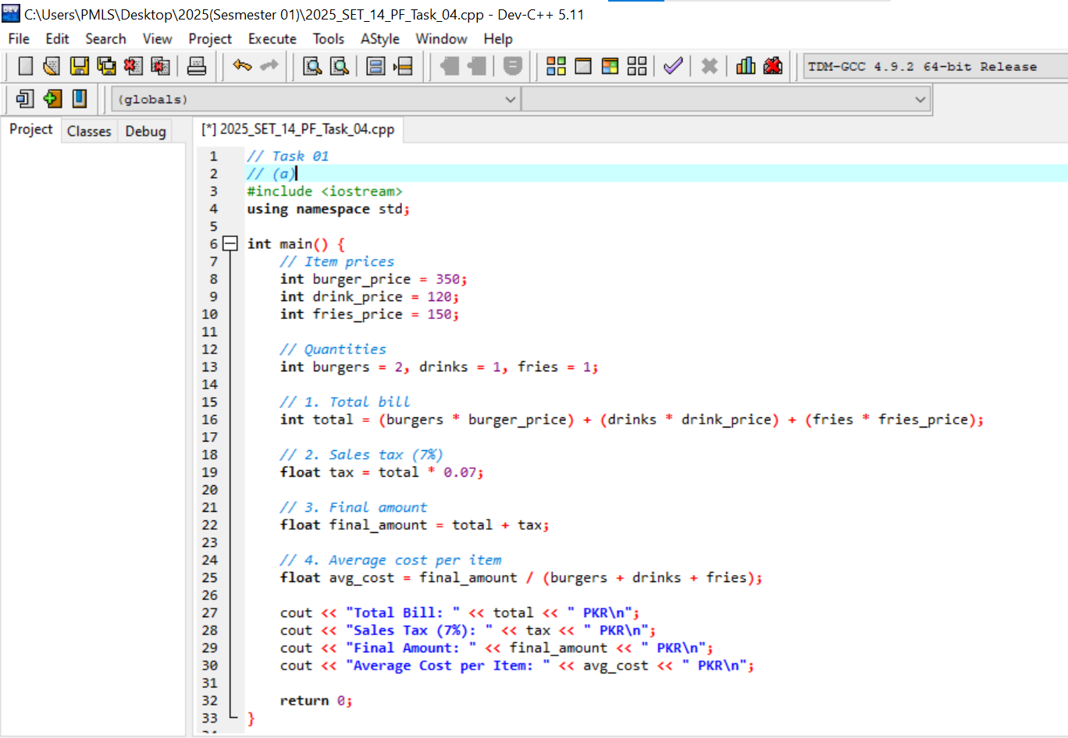
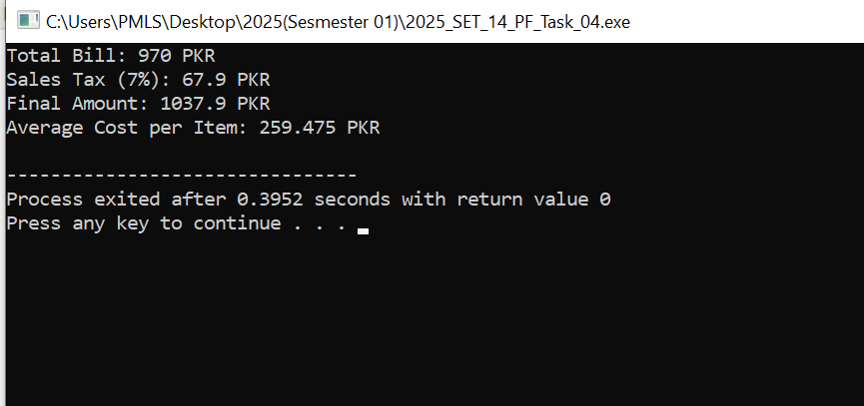
b. A train ticket costs 1200 PKR.
Due to policy changes:
• 25% discount is applied
• Then 8% service charges are added back
• Finally, Rs. 50 online booking fee is added
Task:
Compute the final ticket cost using only arithmetic operators.
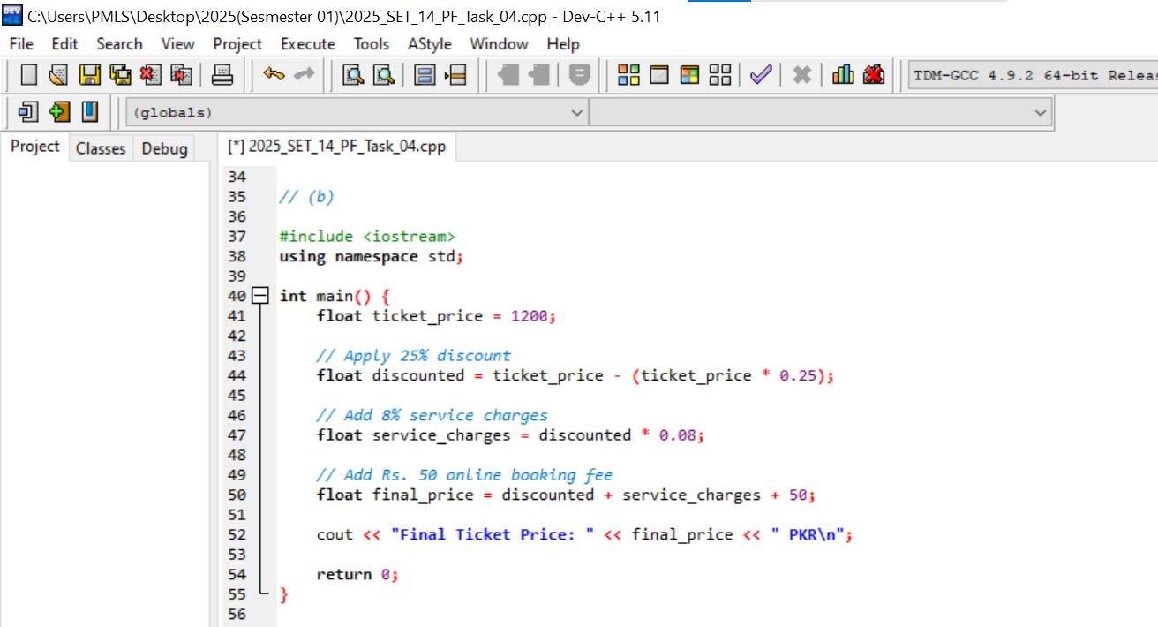
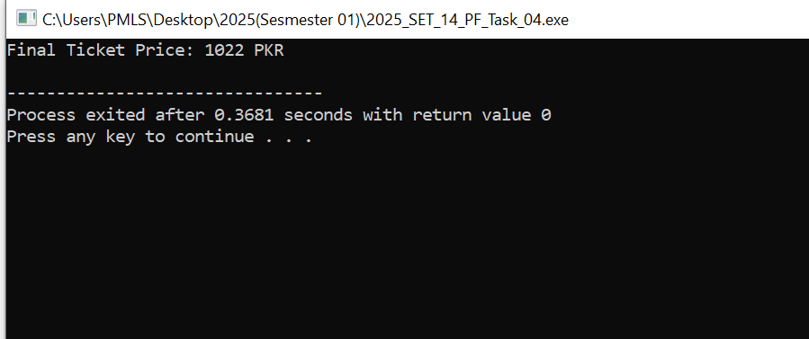
Q. No.2:
a. A warehouse has:
• Required stock = 500 units
• Current stock = 420 units
Task:
Using only relational operators, evaluate these comparisons:
1. Is stock sufficient?
2. Is stock less than 50% of required level?
3. Is stock exactly equal to required stock?
4. Is the shortage greater than 50 units?
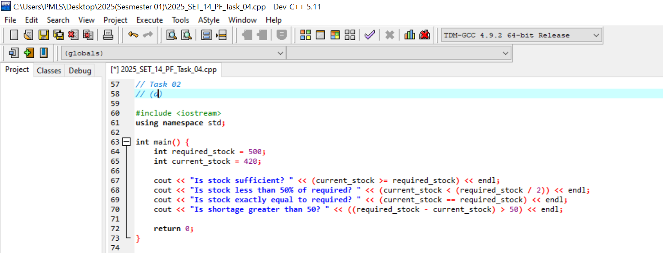
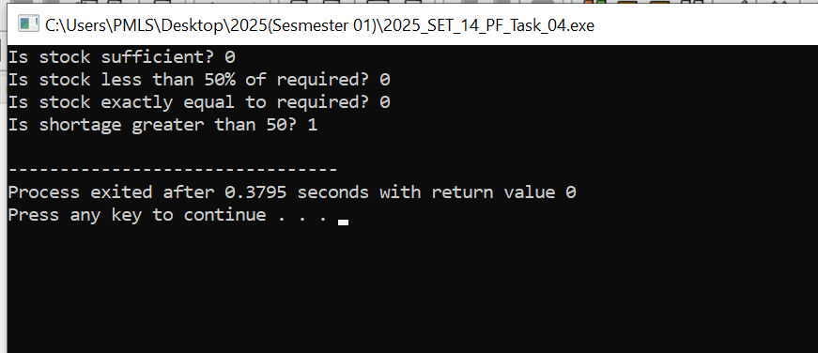
b.
A student must have 75% attendance.
He attended 48 classes out of 60.
Task:
Using relational operators, determine:
• Was the requirement met?
• Did he attend more than 50 classes?
• Did he attend less than 60% of total classes?




