THE UNIVERSITY OF AZAD JAMMU AND KASHMIR, MUZAFFARABAD
DEPARTMENT OF SOFTWARE ENGINEERING

Name: | Ghazanfar Rasheed
Roll No: | 2025-SET-14
Course: | Programming Fundamentals
Submitted To: | Engr. Zeeshan Rashid
Lab Task no: | 05
Session: | 2025-29
Semester: | 1st

Topic: Logical Operators, Assignment Operators

Scenario:
Q. No.1: a.
Student Attendance Requirement
A university requires that:
• A student is allowed in exam only if attendance >= 75 AND feePaid == true.
Write a program that prints:
• "Eligible" when both conditions are true
• "Not Eligible" otherwise WITHOUT using if / else / switch / loop / function
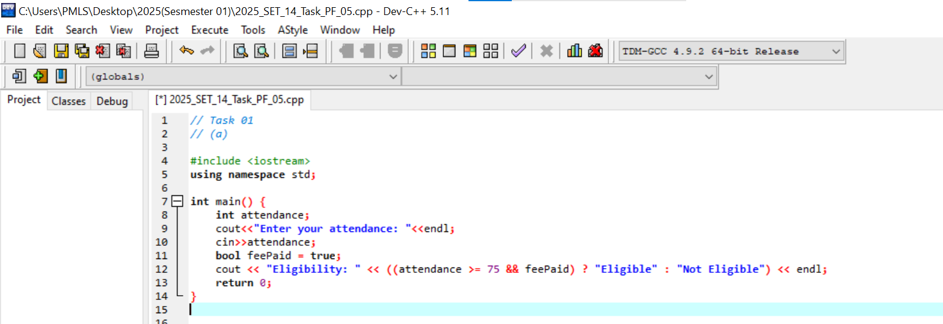
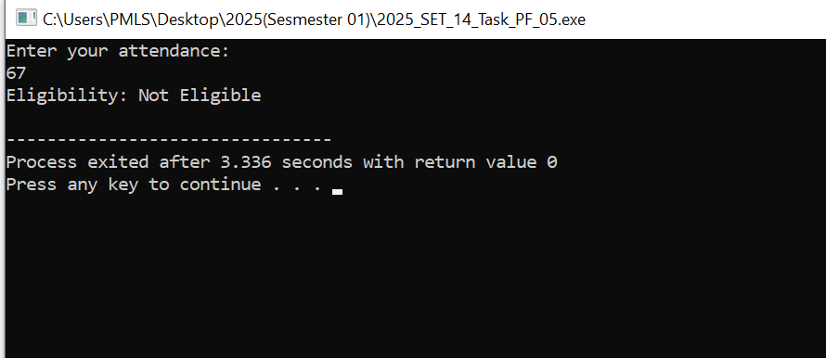

b. Discount Eligibility
A store offers:
• 20% discount if purchaseAmount > 5000 OR customer has membershipCard
Print "Discount Applied" or "No Discount"
→ WITHOUT if / else / loop.
Use logical operators + expressions.
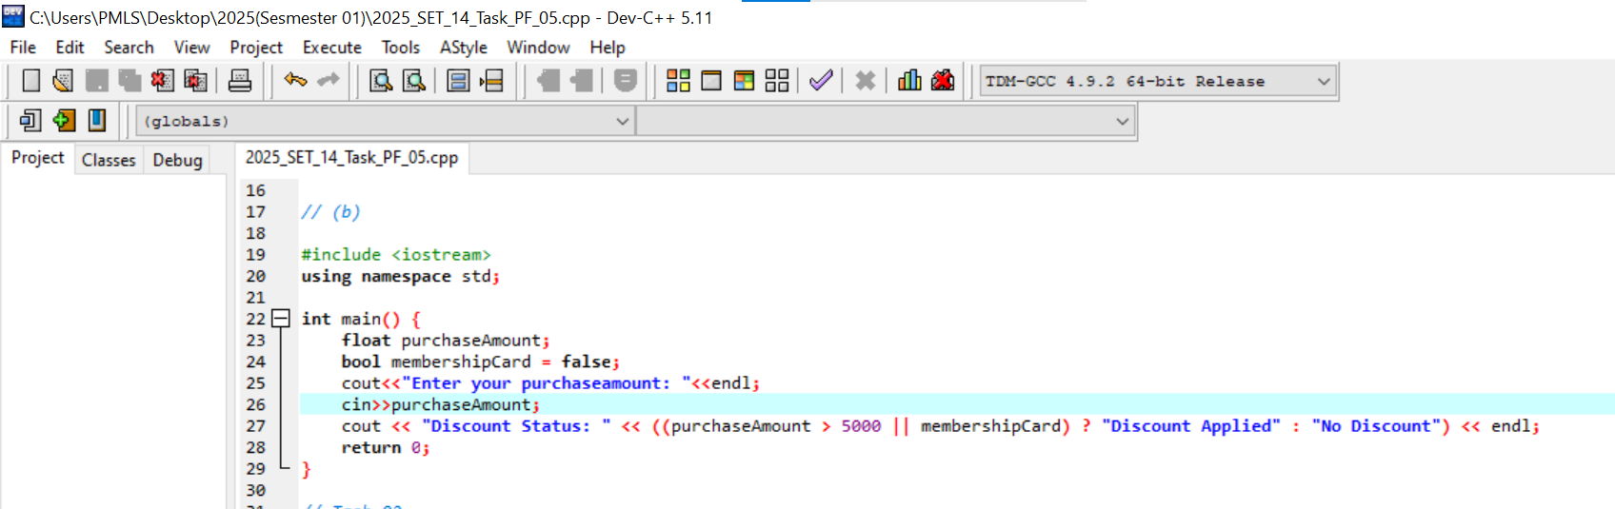
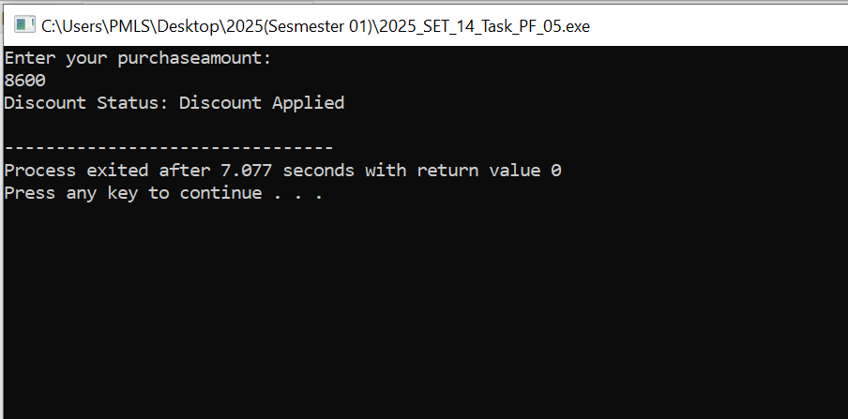
Q. No.2:
a. Mobile Recharge Bonus
Mobile company offers:
• Every recharge gets a 10% bonus automatically
Use assignment operator to update balance:
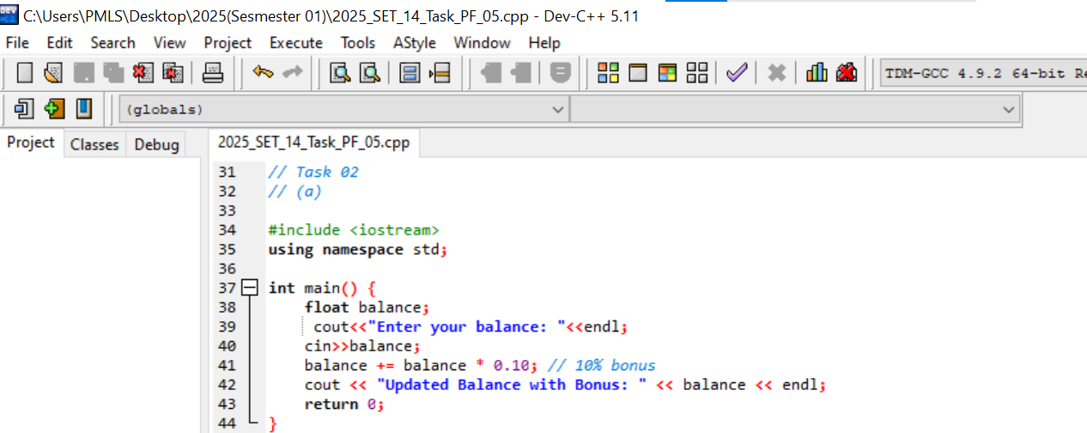
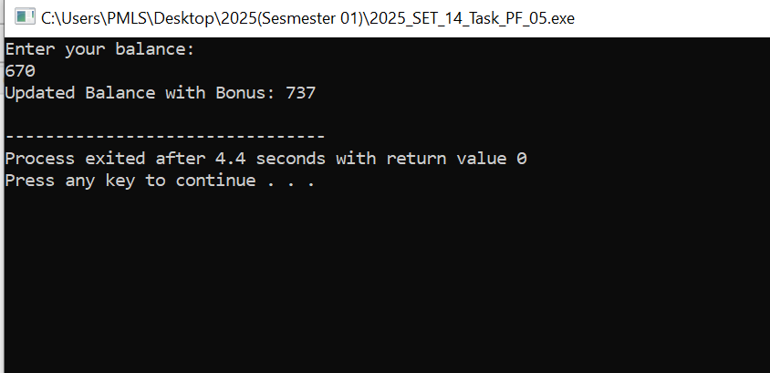
b.
A teacher adds:
• 5 marks grace in assignment
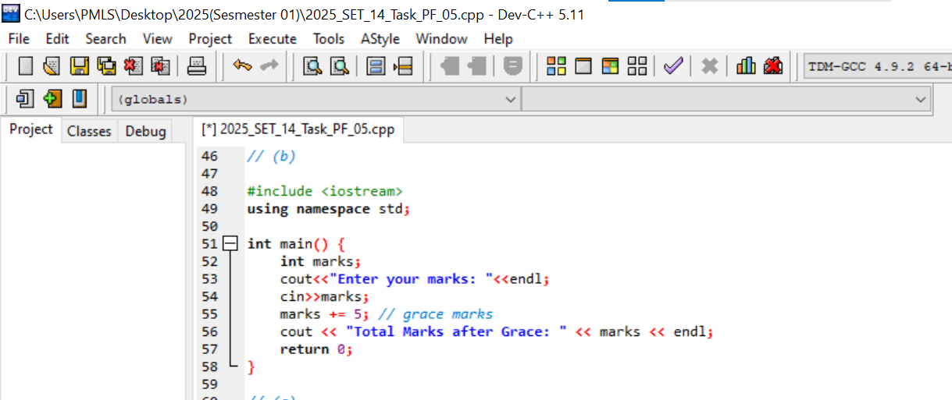
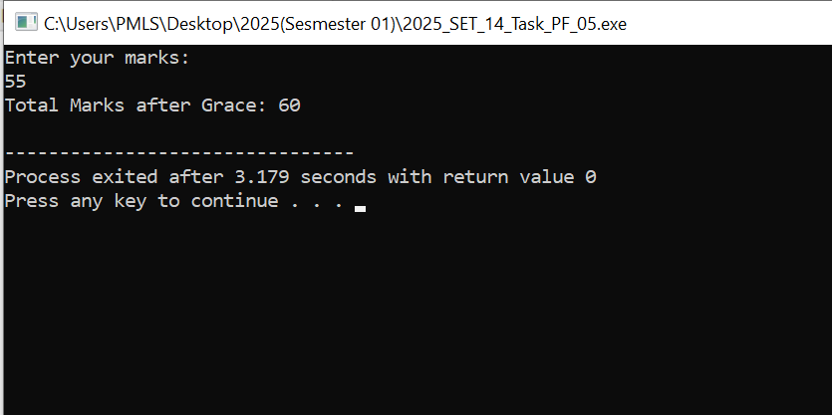
c.
Car consumes 2 liters fuel per trip.
Update fuel level.
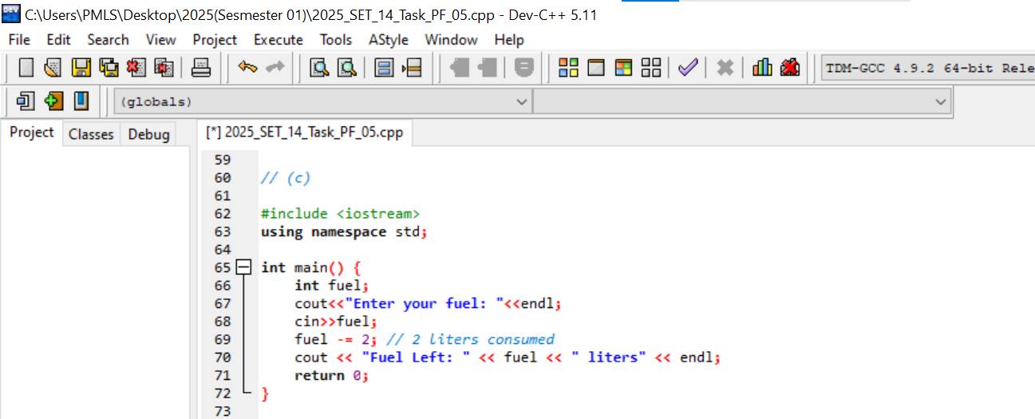
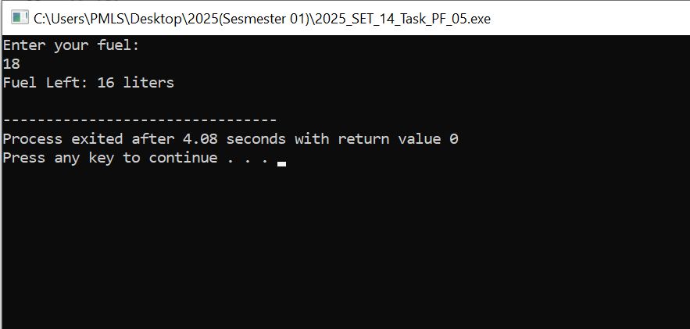

d.
A smart AC should turn ON only if:
• Temperature is greater than 30°C, AND
• Window is closed Write an expression that prints:
• "AC ON" when both are true
• "AC OFF" otherwise
Use only logical operators + ternary operator




