THE UNIVERSITY OF AZAD JAMMU AND KASHMIR, MUZAFFARABAD
DEPARTMENT OF SOFTWARE ENGINEERING

Name: | Ghazanfar Rasheed
Roll No: | 2025-SET-14
Course: | Programming Fundamentals
Submitted To: | Engr. Zeeshan Rashid
Lab Task no: | 06 & 07
Session: | 2025-29
Semester: | 1st

Question # 01:
A temperature monitoring system is installed in a chemical laboratory. Extremely high temperature more than 45°C may damage equipment and cause safety hazards. The system continuously reads the temperature. The program should read the current temperature from the user and print an alert message only when the temperature crosses the safe limit.
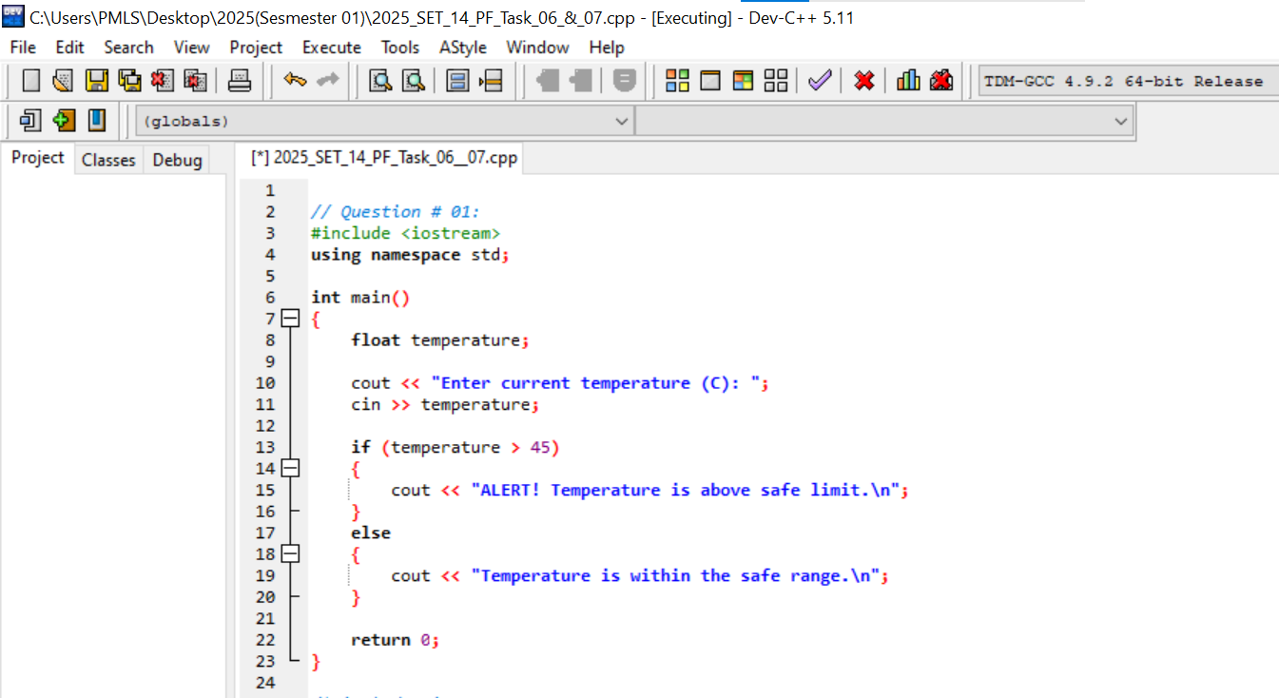
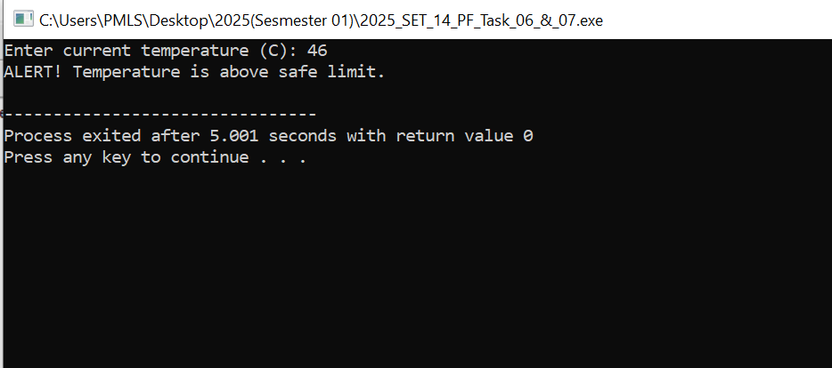

Question # 02:
A building management system is responsible for calculating the electricity bill of every apartment at the end of the month. The service department follows a two-tier pricing policy. Families that consume a small amount of electricity are charged at a normal rate ($5 per unit), while families that use more electricity than the allowed monthly usage are charged at a higher rate for all of their usage ($10 with sales tax 29%). In addition to energy charges, every apartment is required to pay a monthly maintenance fee (39$), regardless of how much electricity is used.
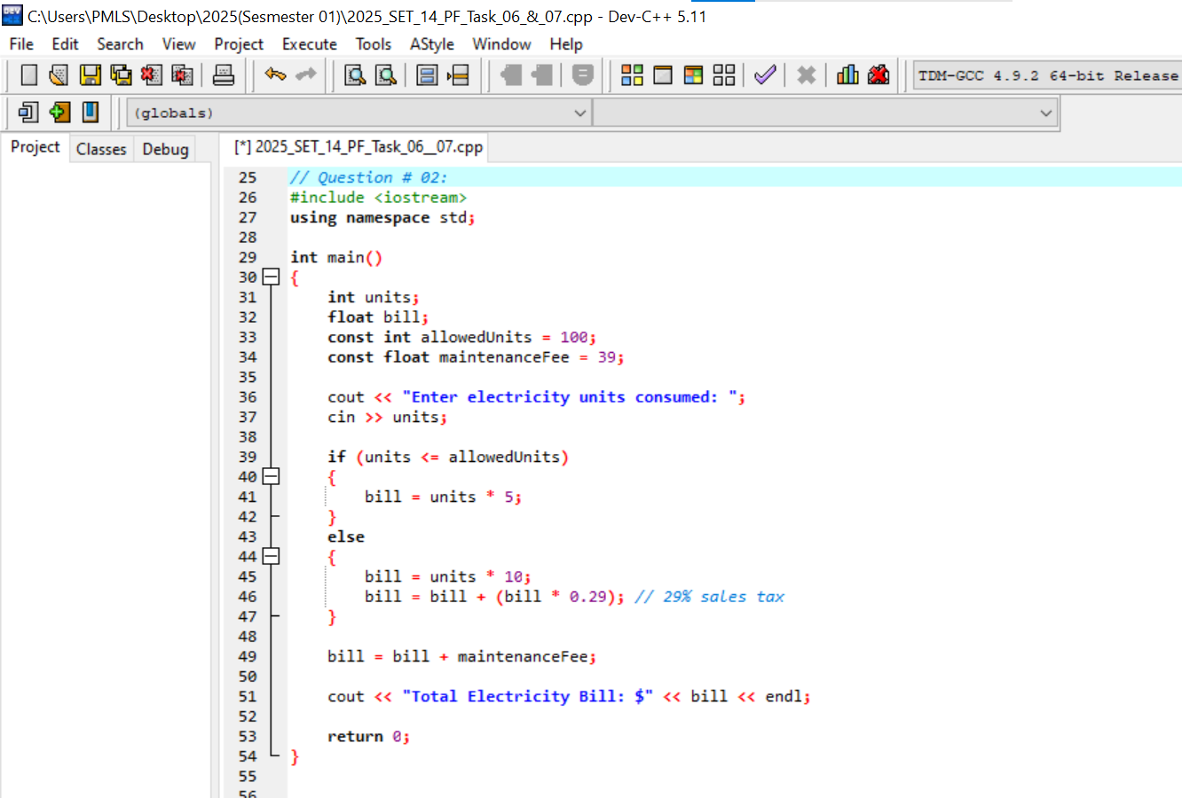
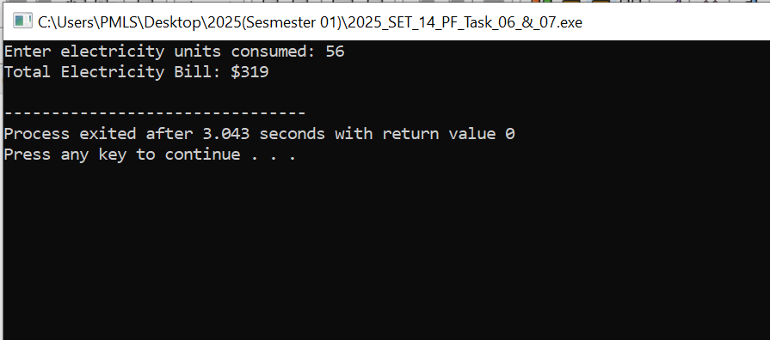
Question # 03:
A multinational company manages employee salaries using an automated payroll engine.
The payroll rules depend not only on how much an employee earns, but also on how long the employee has been working in the organization.
Management announced:
• Only employees who have served the company for a minimum number of years are considered for additional payment.
• Among those eligible employees, the amount of increase in salary is not the same for everyone.
• Employees who have served longer receive a higher additional amount.
• Employees with very short service periods receive no increase.
The payroll system must:
• First analyze whether the employee qualifies for any additional payment.
• Then decide the amount of increment based on the service duration category.
• Finally, calculate the new salary and print it.
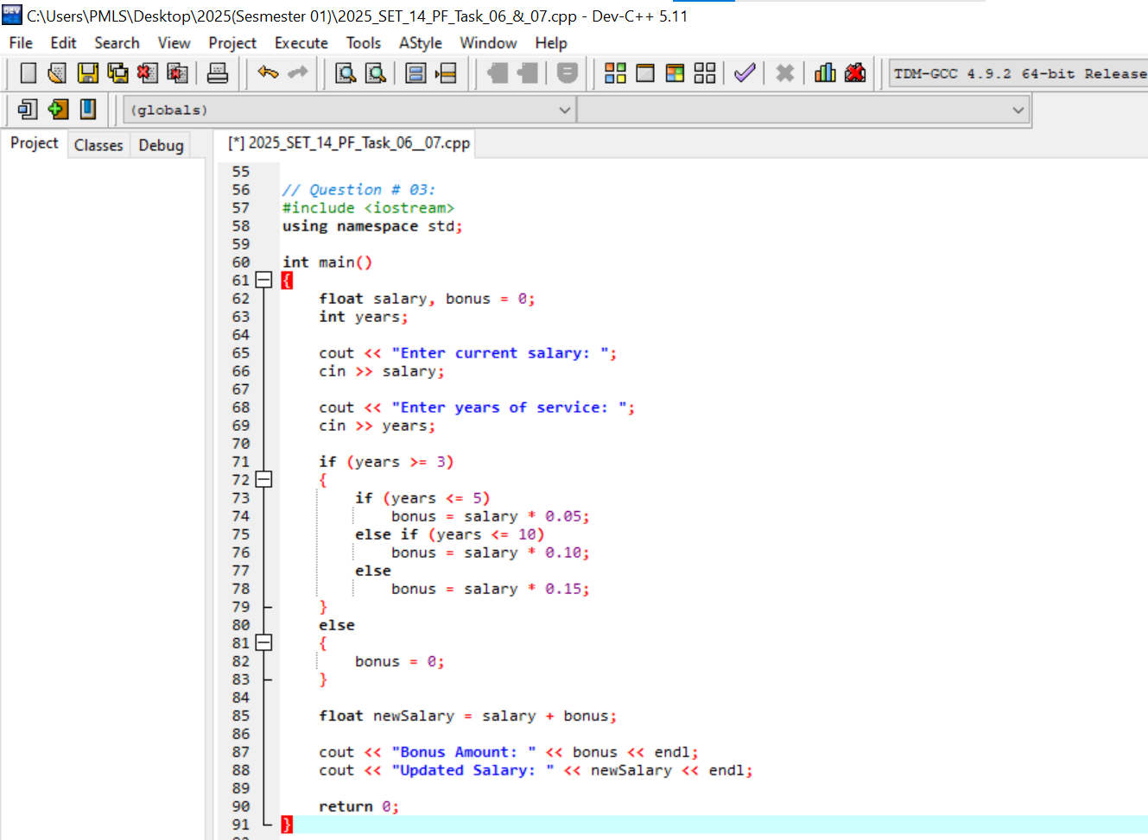
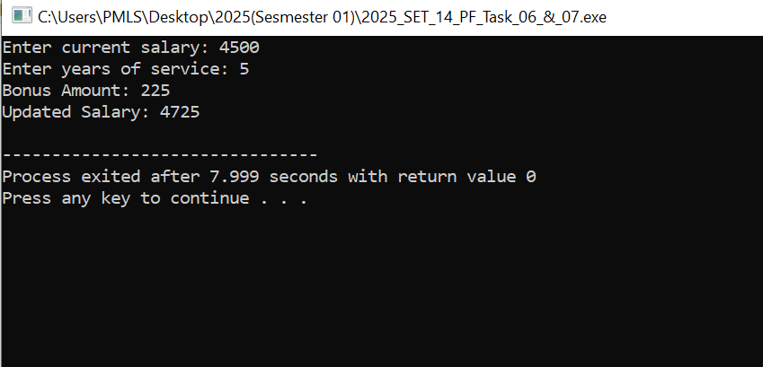
Question # 04:
Problem Statement:
A company wants to calculate the final salary of its employees automatically.
Each employee is assigned to a job level:
• Level 1 → Salary = 120,000
• Level 2 → Salary = 85,000
• Level 3 → Salary = 60,000
• Level 4 → Salary = 40,000
The employee also gets an experience allowance:
• 15 years or more → 25% bonus
• 10–14 years → 15% bonus
• 5–9 years → 10% bonus
• Less than 5 years → No bonus
If the employee is working in a remote area, they receive an extra 8% remote bonus on basic salary. After adding all bonuses, the company deducts tax based on total salary:
Final Salary Tax
≥ 150,000 30%
60,000 – 99,999 10%
100,000 – 149,999 20%
Below 60,000 No tax




